MULTILATERAL EXAM
PHYSICS FORM 1
SECTION A (55 MKS)
constant g= 10n/kg
- (a)Define physics. (1mk)
Physics is the study of matter and its relation to energy
(b) Give two examples of everyday phenomena which can be explained using physics (2mks)
- eclipse
- lightning
- rainbow
- mirage
- falling of bodies towards the ground
- seasonal occurrence of tides in the sea
- rising up of liquid through a drinking straw
- the crackling sound produced when removing a nylon cloth from the body (any two)
- (a).State two branches of physics and state what each is involved in (4mks)
- Mechanics: study of motion of bodies under influence of forces
- Electricity and magnetism: deals with relationship between electric currents and magnetic fields and their applications.
- Thermodynamics: study of transformation of heat to and from other forms of energy.
- Geometric optics: study of the behaviour of light as it transverses various media.
- Waves: study of propagation of energy through space.
- Atomic physics: study of the behaviour of particles constituting the nucleus and the accompanying energy changes.
(b)State the relationship between physics and
  - mathematics (1mk)
Many concepts in physics are expressed mathematically or laws and principles in physics are expressed inform of equation.
  - Religion (1mk)
Systems in the universe reveal great orderliness which can be traced back to the creator/God.
- (a)What is a laboratory (2mks)
It is a room designed and equipped for doing experiments in the course of studying science subjects.
(b)Name three major components / requirements an average laboratory should have (3mks)
- Gas piping
- Electrical energy supply network
- Water piping system
- Chemicals
- Apparatus
(c) State four basic rules which must be observed in laboratory use (4mks)
- Windows and doors must be kept open while working in the lab
- Any instructions given must be followed carefully
- Electrical switches, gas and water taps should be turned off when not in use
- Hands must be dry when handling electrical apparatus and not splashing water to electrical sockets
- All apparatus must be cleaned and returned to correct location of storage after use.
- Any waste after an experiment must be disposed of appropriately
- Floors and working surfaces should be kept dry (any 4)
(d) State one accident that may occur to a student in the lab in the course of doing an experiment and state the first aid measure to administer (2mks)
Cut: seek assistance to stop bleeding and dress up the wound immediately
Burns: quickly run cold water over the affected part as you seek help for further treatment
Poisoning: assistance should be sought immediately.
Eye damage due to dangerous chemicals: the eye should be washed off immediately with a lot of water
Electric shock: putting off the main switch before treating for the shock
- (a) The following table shows the seven basic physical quantities in physics. Fill in the blank spaces (7mks)
Basic physical quantities | SI Unit | Symbol of units
Length | Metre | M
Mass | Kilogram | Kg
Time | Second | s
Electric current | Ampere | A
Thermodynamic temperature | Kelvin | K
Luminous intensity | Candela | cd
Amount of substance | mole | mol
(b) Volume and density are derived quantities. show how each is obtained from the basic physical quantities (2mks
  - Volume = length X length X length or length x breadth x height
  - Density =$\frac{mass}{ length X length X length}$
- (a) State any one instrument we can use to measure length (1mk
- Ruler
- Tape measure
(b) Convert each of the following into units indicated
  - 20mm into m (1mk)
=$\frac{20}{ 10 x 100}$
= 0.02 m

  - 120cm into km (1mk)
=$\frac{120}{100 x 1000}$
= 0.0012 km
  - 15km into m (1mk)
= 15 x 1000
=15000m
- (a)Define AREA, stating its SI units (2mks)
Area is the measure of surface, expressed in square metres
(b) The diameter of a measuring cylinder is 28mm. determine the base area of the cylinder (take $π$ to be $\frac{22}{7}$) (2mks)
Area = ${πr}^{2}= \frac{22}{7} x \left(\frac{28}{2}\right)x (\frac{28}{2}$)
= $\frac{22}{7}$ x 14 x 14
= 616mm²

- (a)Define VOLUME, stating its SI units (2mks)
Volume is the amount of space occupied by matter, expressed in cubic metres
(b)State any two measuring devices you can use to measure volume of a liquid (2mks)
- Measuring cylinder
- Pipette
- Burette
- Volumetric flask
- Beaker
(c) A block of glass is 5.0cm long 4.0cm wide and 2.5cm high. Calculate the volume of the block (2mks)
Volume = l x b x h
= 5 x 4 x 2.5
= 50cm³
- (a)State the instrument used to measure mass( 1Mk)
Beam balance / lever balance/ electronic balance
(b) Convert each of the following as indicated
  - 25 tonnes into kilogrammes(1Mk)
25 x 1000 = 25000 kg
  - 1.25 Kg into mg (1Mk)
1.25 x 1000x 1000mg
=1,250,000mg
- (a) A liquid of mass 187.5g is put in a container 5cm long ,2cm wide and 7.5 cm calculate the density of liquid ( 3mks)
Density of liquid = $\frac{mass of liquid}{volume of liquid}$
Volume of liquid = l x w h
= 5 x 2 x 7.5
= 75cm³
^{Density =} $\frac{187.5}{75}$
= 2.5 g/cm³
(b) The water level in a burette is 30cm³.if 55drops of water fall the burette and the
final water level becomes 23.4 cm³, calculate the average volume of one drop
of water (3mks)
Volume of 55 drops = 30 - 23.4
= 6.6cm³
Vol. of 1 drop =$\frac{6.6}{55}$
= 0.12 cm³

(c) (i) Define time (1Mk)
This is a measure of duration of an event.
(ii) A form one student timed his classmates running round the schools
400mtrack for 5times and found that the fastest runner clocked
400seconds. Determine the average time, the fastest runner took to finish
1round. (2mks).
5 rounds = 400 sec
I round = $\frac{400}{5}$
=80 seconds

SECTION B (45 MKS)

- (a) Define FORCE, stating its S.I .units (2mks).
A force is a push or pull, expressed in newtons.
- When a force acts a on a body (stationary or in motion) what are the 4 likely effects on such a body (4mks).
- A stationery body will start moving
- A moving body will move faster /accelerate
- A moving body will move slower / decelerate
- A moving body will stop moving
- A moving body will change direction
- A stationery body will be distorted ( changed in shape) (any 4 correct)
(Any 4)
- (a) Define the following forces ;
  - Tension force ( 1Mk)
It is the pull or compression of a string or spring at both ends
  - Upthrust force (1Mk)
It is the upward force acting on an object immersed in a fluid (liquid or gas)
  - Cohesive force (1Mk)
It is force of attraction between molecules of the same kind
  - Frictional force (1Mk)
It is the force that opposes relative motion between two surfaces in contact
  - Centripetal force (1Mk)
It the force which constrains a body in circular path or orbit the force directed towards the centre of the circular path as the body moves round the path
(b) A form one student dipped three narrow tubes of different size of
bore in beaker containing water as shown.
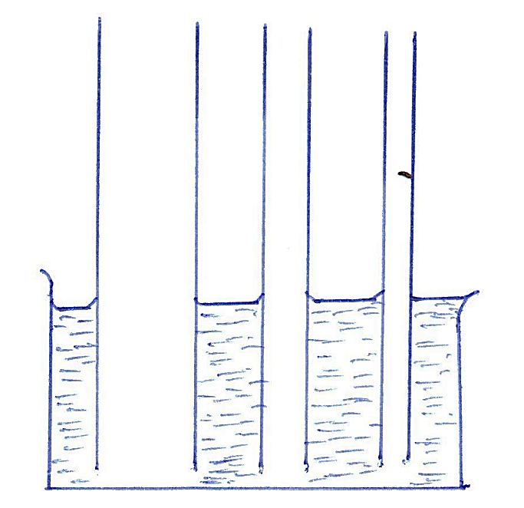

- Indicate the levels of the water in the tubes after the water entered the tubes and showing clearly the shape of the meniscus in each tube(3mks)
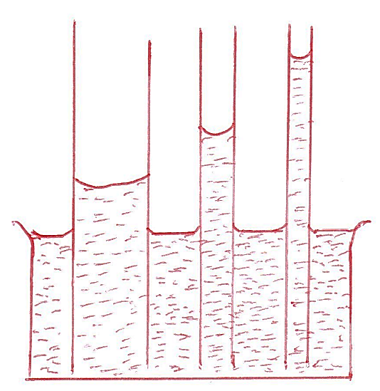
- Give an explanation of the above behaviour of water in the tubes (2mks)
Water rises up the tube because adhesive forces are greater than cohesive forces, therefore water want to be in contact with glass walls more than be in contact with own molecules.

(c) State the factors which affect the surface tension of a liquid and explain how each factor affect the force (4mks)
- Temperature: rise in temperature lowers the surface tension
- Impurities: reduce the surface tension of a liquid.
12. (a) Define weight , stating its SI units (2mks)
Weight is a measure of the pull of gravity on a body expressed in newtons or weight is the force of attraction exerted on a body by the earth and directed towards the centre of the earth expressed in newtons.
(b)With different masses spring balance calibrated in newtons and retort stand, a form one student hanged the masses to obtain their respective weights and recorded in the following table
Mass, m (grams) | 20 | 40 | 60 | 80 | 100 | 120
Mass, m (kg) | 0.02 | 0.04 | 0.06 | 0.08 | 0.10 | 0.12
Spring balance reading (weight)

- Complete the table by filling in the values Y weight in each case (3mks)

Mass, m (grams) | 20 | 40 | 60 | 80 | 100 | 120
Mass, m (kg) | 0.02 | 0.04 | 0.06 | 0.08 | 0.10 | 0.12
Spring balance reading (weight) | 0.2 | 0.4 | 0.6 | 0.8 | 1 | 1.2

- Calculate the average values of weight ( 2mks)
=$\frac{0.2+0.4+0.6+0.8+1+1.2}{6}$ =0.7N
- (a)Differentiate between mass and weight (5mks)
Mass | Weight
- Quantity of matter in a body  - Measured in kilograms  - Same everywhere  - Measured using a beam balance  - Has magnitude only | - Pull of gravity on a body  - Measured in newtons  - Changes from place to place  - Measured using a spring balance  - Has both magnitude and direction

(b) (i) Define vector quantity (1Mk)
Is a quantity which has direction and magnitude
(ii) Scalar quantity (1Mk)
Is a quantity which has magnitude only but no direction.
- (c) Determine the resultant force for each of the following; (3Mks)
(i)
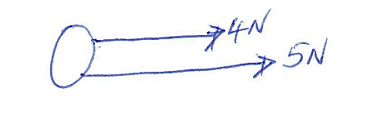
4 +5 = 9N
(ii)
6 -2=4N
(iii)
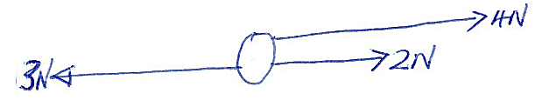
(4+2) - 3 =3N

14. (a) Define pressure, stating its SI units (2mks)
Is force acting perpendicularly per unit area expressed in newtons per square
metre
(b) A block of wood measuring 4m long 3 m wide and 2m high has a mass of 84kilogram. If the block of wood is resting on the ground determine
(i)The area of the face which would exert the greatest pressure on the ground (2mks)
3m x 2m =6m²
(ii) The greatest pressure exerted on the ground. (4mks)
Pressure = force / area
= Weight/ area
=Weight = m/g
= 84 x 10
=840
= 840/6
=140 N/m²

