Term 1 – 2024

GEOGRAPHY (312)

FORM THREE (3)

Time: 2 ¾ Hours

Name: …………………………………………………………. Adm No: ……………….
School: ……………………………………………………….. Class: …………………..
Signature: …………………………………………………….. Date: ……………………

INSTRUCTIONS TO CANDIDATES:

- This paper consists of two sections: A and B
- Answer all the questions in section A
- Answer question 6 and any two questions from section B
- All answers must be written in the answer booklet provided

SECTION A: 25 MARKS
Answer all the questions from this section.
1. (a) Name two layers of discontinuity in the interior of the earth. (2 marks)
(b) State three characteristics of the mantle. (3 marks)
2. (a) Differentiate between epicenter and seismic focus. (2 marks)
(b) State three major earthquake seismic zones in the world. (3 marks)
3. (a) Define the term climax vegetation. (2 marks)
(b) Mention three factors that influence vegetation distribution. (3 marks)
4. (a) A part from soil creep, state two other forms of slow mass wasting. (2 marks)
(b) Outline three evidences of soil creep. (3 marks)
5. a) Name two major forest blocks found along the Kenyan coast. (2 marks)
b) State three factors contributing to depletion of forests in Kenya. (3 marks)
SECTION B: 75MARKS
Answer question 6 and any other two questions from this section.

6. Study the map of Kisumu East 1:50,000 (Sheet 116/2) provided and answer the questions that follow:
- Give the magnetic variation of the Kisumu East map (2marks)
- Give the longitudinal extent of the area covered by the map (2 marks)
- Name three human made features in the grid square 0084 (3marks)
- Identify two methods used to show relief on the map. (2 marks)
- Calculate the area occupied by the drainage feature on the south western end of the area covered by the map and give your answer in km². (3marks)
- Name two drainage features found on the area covered by the map. (2marks)
- Enlarge the area bound by Easting 00 to 03 and Northing 82 to 84 twice and on it mark and name: (5marks)
- River Luando
- All weather road, bound surface B25/3
- Seasonal swamp
- School at Olendu
- Describe the relief of the area covered by the map. (3marks)
- Citing evidences from the map, give three social functions of Kisumu Municipality. (3marks)

7. a) i. What is weathering? (2marks)
ii. Explain three factors which influence the type and rate of weathering (6marks)
b) List down five processes of chemical weathering (5marks)
c) Explain three ways in which people cause weathering. (6marks)
d) Explain the effect of weathering on the following
i) Tourism (2marks)
ii) Soil formation (2marks)
iii) Building industry (2marks)

8. (a) (i) What is an orogeny? (2 marks)
(ii) Give two factors that influence the folding process of rocks. (2 marks)

(b) The diagram below shows some types of folds. Use it to answer the question (i) and (ii).

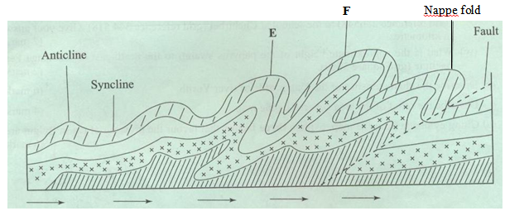

(i) Name the types of folds marked E and F. (2 marks)
(ii) Describe how an overthrust fold is formed. (4 marks)
(c) Name the any of countries in which the following fold mountains are found. (i) Atlas (1 mark)
(ii) Alps (1 mark)
(iii) Himalayas (1 mark)
(iv) Andes (1 mark)
(d) (i) Apart from fold mountains, name three other features resulting from folding. (3 marks)
(ii) Explain four ways in which fold mountains influence climate. (8 marks

9. (a) (i) Name three types of minerals. (3 marks)
(ii) State three ways in which minerals occur. (3 marks)
(b) (i) Describe shaft mining method. (5 marks)
(ii) Outline three challenges faced by shaft miners. (3 marks)
(c) Explain four problems facing the mining industry in Kenya. (8 marks)
(d) Highlight three ways in which mining derelicts can be reclaimed. (3 marks)

10.(a) i) Define a forest. (2marks)
ii) Name two indigenous soft wood trees in Kenya. (2marks)
(b) i) Explain three advantages of planted softwood forests in Kenya. (6marks)
ii) Explain four problems facing commercial exploitation of tropical hardwood forests (8marks)
(c) Compare soft wood forests in Kenya and those in Canada under the following headings:
i) Type of trees (2marks)
ii) Method of exploitation. (2marks)
(d) State three methods used by the government of Kenya to conserve the mau forest. (3marks)

