Term 1 – 2024

GEOGRAPHY (312)

FORM THREE (3)

Time: 2 ¾ Hours

MARKING SCHEME
SECTION A. (25 MKS)
1. (a) Two layers of discontinuity. (2 mks)
- Moho - discontinuity / mohorovicic discontinuity.
- Gutenberg discontinuity. (2 x 1 = 2 mks)
(b) Characteristics of the mantle. (3 mks)
- Has a thickness of about 2900 km.
- Has an average density of 3.0 - 3.3 gm / cc.
- Temperatures are extremely high (10000C)
- Dominant minerals are iron and magnesium.(olivine)
- It is made up of upper mantle and lower mantle. (Any first 3 x 1 = 3 mks)

2. (a)* Seismic focus refers to the place in the interior of earth where earthquake waves originate from while Epicenter is the point vertically above the focus on the earth surface where the earthquake wares are first experienced / felt. (1x2=2 mks)
(b) Seismic zones. (3 mks)
- The Circum Pacific Belt.
- Along The Great Rift Valley
- The Mid Atlantic Ocean Belt.
- The Mediterranean Belt. (Any first 2 x 1 = 2 mks)

3. (a) Climax vegetation refer to the plant cover that has reached its maturity without interference by human beings. (1x2=2 mks)

(b) Factors influencing vegetation distribution. (3 mks)
- Relief - Soils - Rainfall
- Altitude - Temperature (any first 3 x 1 = 3 mks)
4. (a) Slow mass wasting. (2 mks)
- Rock creep - Solifluction.
- Rock creep - Talus creep
(any first 2 x 1 = 2 mks)
(b) Evidences of soil creep. (3 mks)
- Bent tree trunks.
- Bent utility poles.
- Bent walls / cracks on the walls.
- Terraces on the foot of the slope.
- Soil accumulated on the foot of the slope. (any first 3 x 1 = 3 mks)

5a) Name two major forest blocks found along the Kenyan coast. (2mks)
- Shimba Hills
- Tana River
- Arabuko Sokoke
- Mangrove Forests
- Kaya Forest (any 2x1=2)
b) State three factors contributing to depletion of forests in Kenya. (3mks)
- natural calamities that destroy forests
- pest and diseases eg. Aphids
- development of towns results in destruction of forests
- increased population creating demand for more land for agriculture
- illegal logging / charcoal burning.
- Uncontrolled fires.
- Excision of forest resources for settlements. Etc (any 3x1=3)

6. Study the map of Kisumu East 1:50,000 (Sheet 116/2) provided and answer the questions that follow:
- Give the magnetic variation of the Kisumu East map (2marks)
- 2⁰32’
- Give the longitudinal extent of the area covered by the map (2 marks)
- 34⁰45’E to 35⁰00’/15’ 34⁰45’ to 34⁰53’/8’
- Name three human made features in the grid square 0084 (3marks)
- School
- All weather road, bound surface
- Church
- houses
- Identify two methods used to show relief on the map. (2 marks)
- Contours
- Trigonometric stations
- Rock/cliff drawing
- Calculate the area occupied by the drainage feature on the south western end of the area covered by the map.
(3marks)
- Number of full squares = 2
- Number of half squares = 14 ÷2 =7
- Total =9km²
- Name two drainage features found on the area covered by the map. (2marks)
- Rivers
- Lakes
- Swamps evidence must be given to score
- Enlarge the area bound by Easting 00 to 03 and Northing 82 to 84 twice and on it mark and name: (5marks)
- River Luando
- All weather road, bound surface B25/3
- Seasonal swamp
- School at Olendu
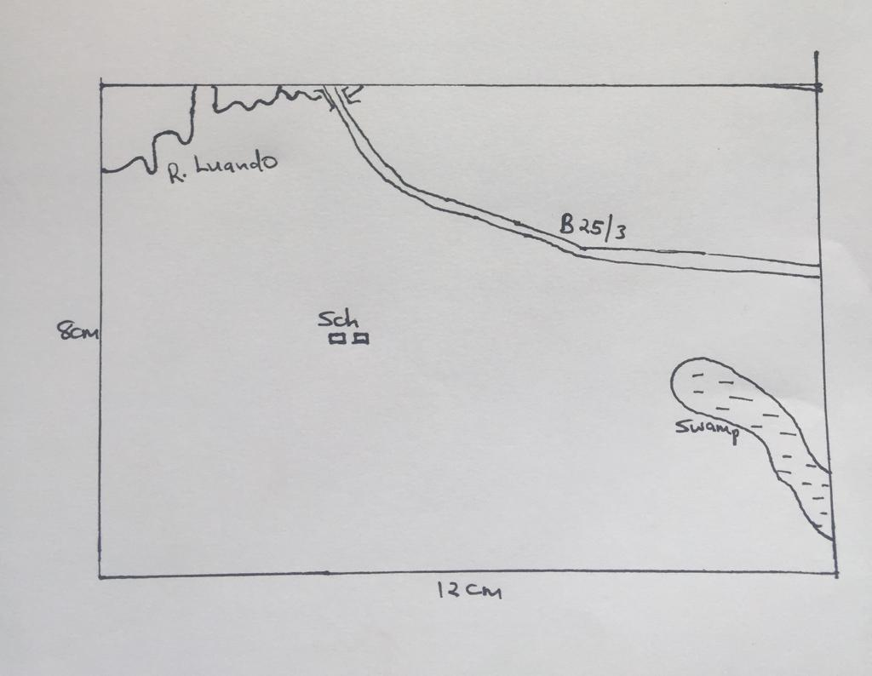
- Describe the relief of the area covered by the map. (3marks)
- There is an escarpment on the northern part of the area covered by the map/Nyando escarpment
- The south eastern part of the area covered by the map is a plain/Kano plain
- There are many river valleys on the North Western part of the area covered by the map
- The area covered by the map generally slopes from the North East towards the South West.
- The highest point of the area covered by the map has an altitude of 1872m asl
- The lowest point of the area covered by the map has an altitude of 1140m asl.
Any 3x1=3mks
- Citing evidences from the map, give three social functions of Kisumu Municipality. (3marks)
- Educational center evidenced by schools
- Religious center evidenced by churches
- Residential center evidenced by housing units/houses
- Recreational center evidenced by stadium
- Medical center evidenced by hospitals

Any 3x1=3mks

7. (a)
- What is weathering? 2marks
- Weathering is the breaking down / disintegration of rocks or near the earth’s surface in site by physical or chemical process.
(1x2=2mks)

- Explain three factors which influence the type and rate of weathering 6marks
- Climate – different regions of the world experience different climatic conditions and have the weathering process also vary.
- Topography – weathering processes are faster on steep slopes than on lowlands. This is because the weathered materials are washed away quickly exposing the rock surface to more agents of weathering.
- Nature of the rock- dark rocks absorbs more heat than shiny rocks and hence have greater chances of breaking up due to excessive expansion and contraction.
- Living organisms / flora and fauna- the roots of big plants cause the rocks to crack / bacteria also facilitate chemical decay or rocks through release of organic acids
(3x2=6mks)
(b) List down five processes of chemical weathering 5marks
- Solution
- Carbonation
- Hydrolysis
- Hydration
- Oxidation
(5x1=5mks)
(c) Explain three ways in which people cause weathering. 6marks
- people mechanically break up rocks by blasting them using explosives / quarrying / exploding bombs on them
- during mining / quarrying, rocks are scooped and even removed
- rocks are broken up during building and construction activities / simple digging / movement of heavy machinery like caterpillar
- People may pollute river water which in turn ends up reacting with the rocks leading to chemical weathering of such rocks.
- When people pollute the air, acid rain may result
- This may react with some minerals in the rocks causing chemical weathering. (3 x 2 = 6marks)
(d) Explain the effect of weathering on the following
i) Tourism 2marks
- Features created through weathering e.g. granitic tors are tourist attractions
ii) Soil formation 2marks
- Weathering is responsible for the breakdown of rocks which leads to the formation of soil.
iii) Building industry 2marks
- The weathering of rocks results in new products such as clay which is used for making bricks used for building.
- Sand, which is a product of weathering of granites, is essential in the building industries.

8. (a) (i) What is an orogeny? (2 marks)
- A fold mountain building period. (1x2=2mks)
ii) Give two factors that influence the folding process of rocks. (2 marks)
- The strength/intensity/magnitude of the compressional forces.
- The nature of the sedimentary rocks/The age of the rocks (2x1=2mks)
(b) The diagram below shows some types of folds. Use it to answer the question (i) and (ii).
(i) Name the types of folds marked E and F. (2 marks)
E - Overfold
F - Recumbent fold
(ii) Describe how an overthrust fold is formed. (4 marks)
- Layers of rocks of the earth’s crust are subjected to compressional forces.
- Intense folding result in the formation of an overfold.
- With increased pressure, the overfold results in the formation of recumbent fold producing a thrustplane.
- The upper part of the recumbent fold slides forward over the lower part along the fault plane resulting to the formation of an overthrust fold.
(4x1=4mks, steps must follow order)
(c) Name the countries in which the following fold mountains are found.
(i) Atlas (1 mark)
- Western Sahara/ Morocco/ Algeria (any 1x1=1mk)
(ii) Alps (1 mark)
- Austria/ Switzerland/ Italy/ France/ Leichstein.(any 1x1=1mk)
(iii) Himalayas (1 mark)
- India/Pakistan/Afghanistan/ Bhutan/ Nepal/ China. (any 1x1=1mk)
(iv) Andes (1 mark)
- Chile/ Peru/ Bolivia/ Argentina/ Venezuela/ Ecuador/ Colombia (any 1x1=1mk)
(d) (i) Apart from fold mountains, name three other features resulting from folding. (3 marks)
- Synclinal valleys/depressions
- Rolling plains
- Ridges
- Intermontane basins
- Intermontane plateaus (Any 3x1=3mks)
(ii) Explain four ways in which fold mountains influence climate. (8 marks)
- The slopes of mountains which face the sun receive direct sunshine /and are warmer.
- Mountain slopes cause the development of local winds due to variation in pressure between the mountain top and the valley bottom.
- The windward slopes of mountains receive high rainfall due to orographic effect.
- Atmospheric pressure reduces with increasing attitude along a mountain slope.
- Temperature decreases with increasing /altitude along a mountain slope.
(4x2=8mks)
9.
. (a)(i) Types of minerals
-Metallic -Non-metallic -Energy minerals (Any 3 x 1 = 3mks)
(ii) Occurrence of minerals
-Veins and lodes -Beds and seams
-Alluvial deposits -Weathering products (Any 3 x 1 = 3mks)
(b) (i) Shaft mining method
-A vertical shaft is sunk /dug.
-Horizontal tunnels are dug
-Props are used to support the roof of the horizontal tunnel.
-Light railway line/conveyer belt is laid along the floor of the horizontal tunnel.
-Mineral ores are blasted.
-Cages/cranes are used to transport the ores to the earth’s surface.
NB: SEQUENCE MUST BE FOLLOWED TO SCORE
(ii) Challenges faced by shaft miners
-Sometimes mines get flooded with subterranean water.
-There are occasional emissions of poisonous gases in the mines.
-The dust produced causes respiratory diseases.
-Sometimes tunnels collapse causing death of miners. (Any 3 x 1 = 3mks)
(c) Problems facing the mining industry in Kenya
-Some minerals are found in remote/inaccessible areas which make them difficult/exploitation.
-Pollution of the areas by noise/blasts/smoke/waterproofs is all health hazards.
-The country faces shortage/inadequate capital for exploitation.
-Shortage of skilled personnel hence country relies on expatriates who remit their salaries and dividends to their foreign countries.
-Land use conflict e.g. Titanium mining in Kwale between Tiomin Company and the local people delays/hinders mining. (Any 4x 1 = 4mks)
(d) Reclamation of mining derelicts
-Planting trees -Creating a park to attract tourists
-Introducing for settlement/farming -Refilling the holes. (Any 3 x 1 = 3mks)
10

(a) i) A forest is a continuous and extensive land covered with a close stand of tall trees, usually of commercial value. (2Marks)
ii) Indigenous soft wood trees in Kenya.
- Podo
- Cedar
- African pencil any 2 x 1 = 2mks)
(b) i) Advantages of planted softwood forests in Kenya.
- Fast maturing hence more profitable to plant
- Easy to maintain and exploit because they are planted in rows
- Grows uniformly since they are grown at the same time hence easy to exploit
- Normally of same species hence easy to exploit
- Found near roads hence easy to transport the products (any 3 x 2 = 6Marks)
ii) Problems facing commercial exploitation of tropical hardwood forests.
- Climbers interferes with felling operations.
- Forests may be inaccessible due to wet tropical conditions
- Trees take long to mature hence discourage exploiters.
- Trees have thick stems / buttress root system which makes cutting difficult.
- The forest is thick, hence hard to penetrate. (any 4 x 2 =8Marks)
(c) i) In Kenya trees are both exotic and indigenous while in Canada, all the tree species are indigenous. (2Marks)
ii) In Kenya, commercial cutting of trees is done mainly by axes, hard saws and power saws while in Canada trees are felled mainly using power saws.
- In Kenya transportation of logs is done using tractors, lorries, trucks and trains, while in Canada, logs are transported using several ways including skidding along ice (during winter) (2Marks)
(d) Methods used by the government of Kenya to conserve the man forest.
- Re-afforestation programme
- Displacing people from the forest.
- Banning exploitation of trees from the main forest.
- Educating people on the importance of Mau forest. (any 3 x 1 = 3Marks)

