**Term 1 - 2024**

**GEOGRAPHY (312)**

**FORM ONE (1)**

**Time: 1 ¾ Hours**

**Name**: …………………………………………………………. **Adm** **No**: ……………….

**School**: ……………………………………………………….. **Class**: …………………..

**Signature**: …………………………………………………….. **Date**: ……………………

**INSTRUCTIONS TO STUDENTS**

* *This paper has* ***two*** *sections:* ***A*** *and* ***B***
* *Answer* ***ALL*** *the questions.*
* *All the answers must be written on the foolscaps provided.*
* *Candidates must answer the questions in English.*

**FOR EXAMINER’S USE ONLY**

|  |  |  |  |
| --- | --- | --- | --- |
| **Section** | **Questions** | **Maximum Score** | **Candidate’s**  **Score** |
| **A** | **1 - 5** | **25** |  |
| **B** | **6** | **25** |  |
| **7** | **25** |  |
| **Total Score** | | **75** |  |

***This paper consists of 4 printed pages. Candidates should check the question paper to ascertain that all pages are printed as indicated and that no pages are missing.***

**SECTION A**

**Answer ALL the questions**

1. The diagram below shows the internal structure of the earth. Use to answer question (a) and (b).
   1. Identify:

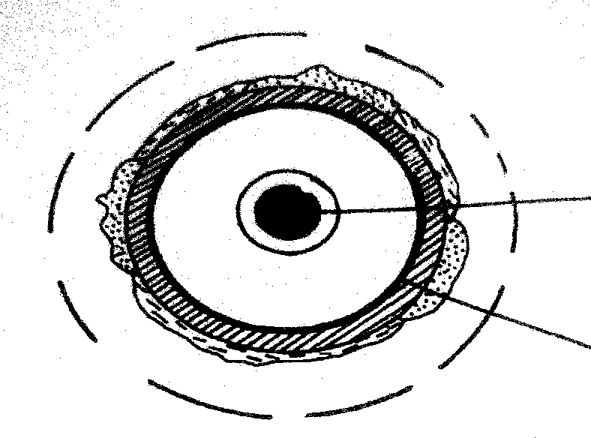

**Q**

**P**

**Inner core**

1. the layer marked **P**.
2. the zone of discontinuity marked **Q**.
   1. Give **four** characteristics of the core.
3. (a) Describe the solar system?

(b) Name three natural satellites.

(1 mark)

(1 mark)

(3 marks)

(2 marks)

(3 marks)

1. (a) Give two effects of rotation of the earth. (2 marks)

(b) State four reasons why the study of geography is important. (4 marks)

1. The diagram below represents the structure of the atmosphere.

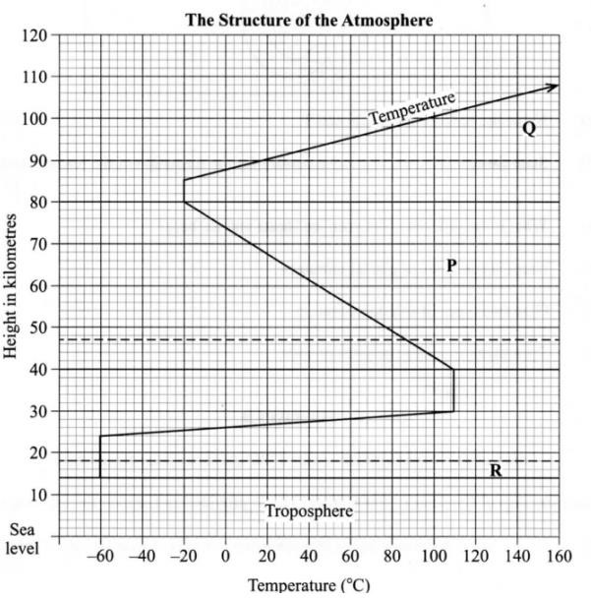

* 1. Name:
     1. The parts marked P and Q. (2 marks)
     2. The layers of discontinuity marked R. (1 mark)
  2. State two characteristics of the troposphere. (2 marks)

1. (a) Define the term environment. (2 marks)

(b) Name two types of environment. (2 marks)

**SECTION B**

**Answer ALL the questions.**

1. (a) (i) Define the term geography. (2 marks)

(ii) Give three branches of geography. (3 marks)

1. Explain the relationship between geography and the following disciplines;
2. Chemistry. (2 marks)

ii) Agriculture. (2 marks)

1. Explain three reasons why the interior of the earth is still hot. (6 marks)
2. (i) Describe the formation of the earth according to Passing Star Theory. (4 marks)

(ii) State two weaknesses of above theory. (2 marks)

1. Name any four weather elements. (4 marks)
2. a) i) What is a weather station? (2 marks)

ii) State four factors influencing the siting of a weather station. (4 marks)

1. Explain how the following factors affect temperature:
2. Aspect. (2 marks)

ii) Ocean currents. (2 marks)

iii) Altitude. (2 marks)

1. Study the diagram below and use it to answer the questions that follow.



1. Label the parts marked X, Y and Z (2 marks)
2. Identify areas in Western Kenya where the phenomenon shown in the diagram above commonly occurs. (1 marks)
3. With aid of a well labeled diagram, describe formation of relief rainfall. (6 marks)
4. Give four reasons why weather forecasting is important. (4 marks)