**Term 1 - 2024**

**GEOGRAPHY (312)**

**FORM ONE (1)**

**Time: 1 ¾ Hours**

**MARKING SCHEME**

**SECTION A**

**Answer ALL the questions**

1. The diagram below shows the internal structure of the earth. Use to answer question (a)

and (b).



**Q**

**P**

**Inner core**

1. Identify:
2. the layer marked **P**. (1 mark)

*mantle*

1. the zone of discontinuity marked **Q**. (1 mark)

*Gutenberg discontinuity*

1. Give **four** characteristics of the core. (3 marks)

* *Divided into inner and outer layers*
* *Has a density of about 17g/cm3*
* *Inner layer is solid*
* *Outer layer is molten*
* *Has high temperature*
* *Dominant minerals are iron and nickel*

2. (a) Describe the solar system? (2 marks)

* *This refers to the sun, the planets and other heavenly bodies revolving around the sun.*

(b) Name three natural satellites. (3 marks)

* *The Galilean Sisters*
* *Moons*
* *Calisto*
* *Make-make*
* *Triton*

3. (a) Give two effects of rotation of the earth. (2 marks)

* *Causes day and night*
* *Causes a difference in time between any two longitudes*
* *Causes rise and fall in tides*
* *Causes deflection of winds and ocean currents*

(b) State four reasons why the study of geography is important. (4 marks)

* *creates international awareness*
* *helps learners acquire skills like observation, map reading and interpretation.*
* *Promotes positive attitudes towards management and conservation of environment*
* *Enables learners to be good time managers through drawing work schedule for fieldwork.*
* *It is an entry into various careers*

1. The diagram below represents the structure of the atmosphere. 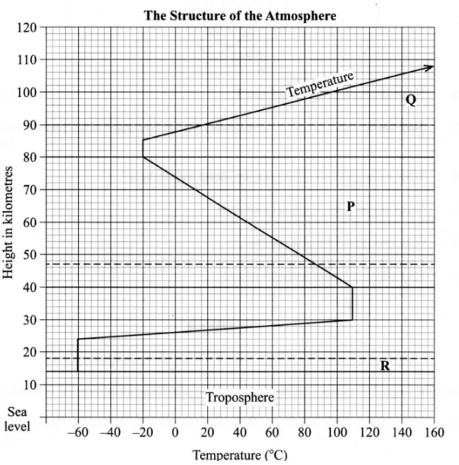

(a)Name:

(i) The parts marked P and Q. (2 marks)

* *P – mesosphere*
* *Q - thermosphere*

(ii) The layers of discontinuity marked R. (1 mark)

* *R - Tropopause*

(b) State two characteristics of the troposphere. (2 marks)

* *Has most weather making elements*
* *Temperature drops with increase in height*
* *Wind speed increases with rise in altitude*
* *Pressure drops with increase in altitude*

1. (a) Define the term environment. (2 marks)

* *The sum total of the surrounding which has influence of development and behaviour of an organism.*

(b) Name two types of environment. (2 marks)

* *physical environment*
* *human environment*

**SECTION B**

**Answer ALL the questions.**

1. (a) (i) Define the term geography. (2 marks)

* *The scientific study of earth as home of man.*

(ii) Give three branches of geography. (3 marks)

* *Physical geography*
* *Human and economic geography*
* *Practical geography*

(b) Explain the relationship between geography and the following disciplines;

(i) Chemistry. (2 marks)

* *Knowledge of chemistry is used to understand the chemical properties of rocks and minerals.*

(ii) Agriculture. (2 marks)

* *The study of climate helps to understand the distribution of various agricultural systems in the world.*

1. Explain three reasons why the interior of the earth is still hot. (6 marks)

* *The weight of the overlying crustal rocks exerts great pressure in the interior of the earth generating heat.*
* *The slow cooling process of the interior of the earth compared to the exterior since the formation of the earth has led to retention of heat.*
* *Radioactivity in the interior of the earth during nuclear fission generate a lot of heat.*

1. (i) Describe the formation of the earth according to Passing Star Theory. (4 marks)

* *A star with greater gravitational force than that of the sun passed near the sun.*
* *It pulled materials from the sun.*
* *Heavier materials coalesced and formed the interior of the earth.*
* *Lighter materials remained to form gases and the atmosphere.*

(ii) State two weaknesses of above theory. (2 marks)

* *The origin of the star is not mentioned.*
* *Hot gaseous materials from the sun would have dispersed rather than condense.*

1. Name any four weather elements. (4 marks)

* *Sunshine*
* *Atmospheric pressure*
* *Wind*
* *Temperature*
* *Precipitation*
* *Cloud cover*
* *Humidity*

7. a) i) What is a weather station? (2 marks)

* *A place set aside for observing, measuring and recording of weather elements.*

ii) State four factors influencing the siting of a weather station. (4 marks)

* *A place with clear view of the surrounding.*
* *A place far from tall trees and buildings.*
* *A relatively level area free from flooding.*
* *A fenced area for security purposes.*

b) Explain how the following factors affect temperature:

(i) Aspect. (2 marks)

* *Slopes facing the sun are warmer than those facing away from the sun.*

(ii) Ocean currents. (2 marks)

* *Warm moist onshore winds become chilly upon crossing cold ocean currents thus lowering temperature of adjacent land areas.*

(ii) Altitude. (2 marks)

* *High altitudes have low temperatures because of thin atmosphere allowing terrestrial radiation to escape.*
* *Low altitudes have high temperatures due to thick atmospheric concentration blocking terrestrial radiation from escaping.*

c) Study the diagram below and use it to answer the questions that follow.



1. Label the parts marked X, Y and Z (2 marks)

* *X – sea breeze*
* *Y – Rising warm moist air*
* *Z – Descending cold air*

1. Identify areas in Western Kenya where the phenomenon shown in the diagram above commonly occurs. (1 marks)

* *Lake Victoria region*

c) With aid of a well labeled diagram, describe formation of relief rainfall. (6 marks)

* *During the day, land heats faster than the sea.*
* *Low pressure is created over the land as the sea surface remains under high pressure.*
* *Moist wind moves from the sea to the land.*
* *It meets a hill and rises up.*
* *In the process it cools, condenses and forms clouds on the windward side.*
* *Later when the clouds are too heavy they fall back as relief rainfall.*

d) Give four reasons why weather forecasting is important. (4 marks)

* *Used by farmers to plan their activities.*
* *Helps in planning for sporting activities.*
* *Used in aviation to plan take off and landing of aircrafts.*
* *Used in designing of clothes and houses.*