NAME____________________________________CLASS________ADM No.____________
END OF TERM ONE 2024 EXAMINATIONS
GEOGRAPHY FORM THREE
TIME: 2 Hrs. 30 mins
INSTRUCTIONS TO CANDIDATES
- Write your name and admission number in the spaces provided at the top of the page\
- Answer all the questions in section A. In section B answer question 6 and any other two questions from this section.
- All answers must be written in the answer booklet provided.
- This paper consists of 5 printed pages.
- Candidates should check the question paper to ascertain that all the pages are printed as indicated and that no question is missing.

 | MAXIMUM SCORE | CANDIDATE’S SCORE
SECTION A | 25
QUESTION 6 | 25
 | 25
 | 25
TOTAL | 100

SECTION A: Answer all the questions in this section
1.a) Name the biggest planet in the solar system. (1mark)
b) State four characteristics of the core. (4mks)
2.a) Differentiate between the terms Environment and Ecology. (2 marks)
b) State three sub-branches of human geography. (3 marks)
3.a) State three causes of earth movements. (3 marks)
b) Name two main earthquake zones in the world. (2 marks)
4.a) Outline three ways Geography is related to Agriculture (3 marks)
b) State two areas of study of practical geography. (2 marks)

5.a) Differentiate between weathering and mass wasting (2 marks)
b) Apart from plants give three other factors that influence the rate of weathering. (3 marks)

SECTION B: Answer question 6 and any other two from this section
6.Study the map of Mumias sheet index no. 101/2 provided and answer the following questions
- (i) Give the six-figure grid reference of the trigonometrical station I0I T 6 to the northern part of the map extract. (2marks)
(ii) Identify three man-made features in the grid square 6541 (3marks)
(iii) Identify the adjoining sheet to the North –East of Mumias map (1mark)
- Draw a cross section from Easting 60 along Northing 30 up to the end of the map. (Grid reference 600300 to 669300). (4 marks)
On the cross section, mark and label the following
- Dry weather road (1 mark)
- River (1mark)
- Papyrus swamp vegetation (1mark)

- i) Describe the drainage of the area covered by the map. (5 marks)
(ii) Describe the relief of the area covered by the map. (4marks)
- Citing evidence from the map, identify three social services found in the area covered by the map. (3marks)
7.a) (i) Name three minerals mined through placer method (3 marks)
(ii) Name Three Diamond mining areas in South Africa. (3 marks)
iii) State three ways in which mining derelicts can be reclaimed(3Marks)
b) Explain four ways in which mining promotes industrialization in Kenya. (8 marks)
- Explain Four Problems facing the mining industry in Kenya. (8 Marks)
8.a) i) Differentiate between a watershed and a confluence. (2 marks)
ii) Describe two processes though which a river erodes its channel. (4 marks)
b) The diagram below shows a water fall. Use it to answer question (b) (i)
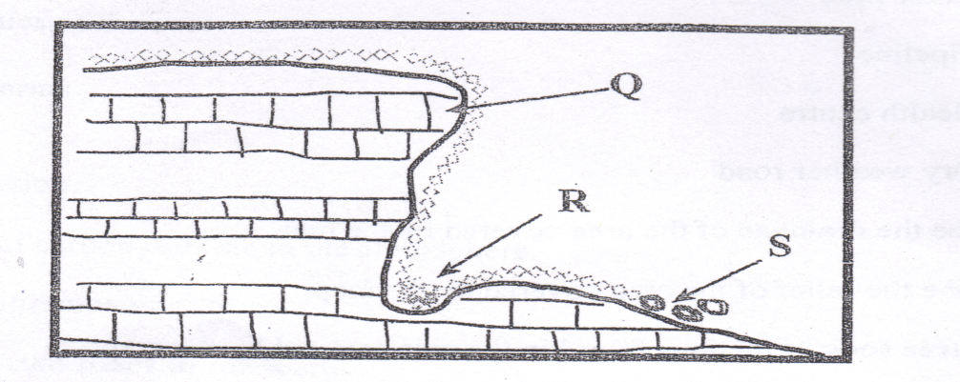

- Name the parts marked Q, R and S. (3mks)

- Explain two causes of river rejuvenation. (4marks)

- Name two features resulting from river rejuvenation. (2marks)
c) Using well –labeled diagrams, describe how an ox-bow lake is formed. (6marks)
d) Your Geography class intends to carry out a field study on an ox-bow lake a long river Tana. Give four reasons for dividing the class into groups. (4marks)
9.(a) Name three areas where Mountain forests are found in Kenya. (3 Marks)
b) i) Give Five Characteristics of Mountain Forests (5 Marks)
ii) What is Agro Forestry? (2 Marks)
iii) Give five reasons why Agro-forestry is encouraged in Kenya. (5 Marks)
c)Explain four Biotic factors that influence distribution of forests. (8 Marks)
- Name two forest reserves found in Coastal region of Kenya. (2 Marks)
10.a) (i) Define the term faulting. (2marks)
(ii) Name three featured formed as a result of faulting. (3marks)

b) i) State three characteristics of the Gregory Rift Valley. (3marks)
(ii) Give three theories that explain the origin of the Rift Valley. (3marks)
(iii) Explain four ways in which faulting influence drainage. (8marks)
c) A form 4 geography class of Mwarano Secondary School carried out a field study on the section of the Rift Valley in Kenya.
(i) State three preparations they had before the study. (3marks)
(ii) State three ways of data recording activities used during the study. (3marks)

