MARKING SCHEME
END OF TERM ONE 2024 EXAMINATIONS
GEOGRAPHY FORM THREE
TIME: 2 Hrs. 30 mins
SECTION A: Answer all the questions in this section
1.a) Name the biggest planet in the solar system. (1mark)
- Jupiter
b) State four characteristics of the core. (4mks)
- It is made of two parts/ inner core and outer core
- Outer core is made up molten rocks
- The inner core is solid
- It is made up of iron and nickel
- Temperature ranges from 3700ºC to 6000ºC
- Average density ranges from 10gm/cc to 15gm/cc
(4x 1mk = 4marks )
2.a) Differentiate between the terms Environment and Ecology. (2 marks)
- Environment is the external conditions that surround an organisms/ external condition that influence the development and behavior of an organism While Ecology is the set of these external surroundings that influence the development and behavior of a specific living organism. (1x2mks=2 Marks)
b) State three sub-branches of human geography. (3 marks)
- Population geography/Demography
- Medical geography
- Political geography
- Economic geography
- Historical geography (3x1mk=3 marks)

3.a) State three causes of earth movements. (3 marks)
- Isostatic adjustment
- Convectional current in the mantle
- Gravitative pressure
- Magma movement within the crust. (3 x 1mk = 3 marks)
b) Name two main earthquake zones in the world. (2 marks)
- The circum-pacific belt
- The Mid-Atlantic Ridge
- Rift valley
- Mediterranean – Himalayan belt (2 x 1mk = 2marks)

4.a) Outline three ways Geography is related to Agriculture (3 marks)
- Geography deals with the study of climate and weather which is important in planning agricultural activities such as planting and harvesting.
- Geography studies the relief of an area which helps identify suitable areas for various agricultural activities.
- Geography describes and explains agricultural systems, their distribution and differences in terms of development.
- Geography deals with type of soils which influences types of crops to be grown.
(3x1mk=3 Marks)

b) State two areas of study of practical geography. (2 marks)
- Fieldwork
- Photograph work
- Statistical methods
- Maps and mapwork (2x1mk=2 marks)

5.a) Differentiate between weathering and mass wasting (2 marks)
- Weathering is the breaking and decomposition of rocks at or near the earth surface in situ while mass wasting is the movement of weathered rock materials downslope under the influence of gravity. (1x2mks=2 marks)
b) Apart from plants give three other factors that influence the rate of weathering. (3 marks)
- Nature of rock/rock structure/rock texture/chemical composition of the rock
- Slope/gradient of the land
- Climate/rainfall/temperature changes
- Human/animals activities
- Time (3x1mk=3 marks)

SECTION B: Answer question 6 and any other two from this section
6.Study the map of Mumias sheet index no. 101/2 provided and answer the following questions
- (i) Give the six-figure grid reference of the trigonometrical station I0I T 6 to the northern part of the map extract. (2marks)
- 533433 (2 marks)
(ii) Identify three man-made features in the grid square 6541 (3marks)
- All weather loose surface road
- Bridge
- Settlement units/market (3 x 1mk = 3 marks)

(iii) Identify the adjoining sheet to the North –East of Mumias map (1mark)
- Bungoma 88/3 (1 mark)

- Draw a cross section from Easting 60 along Northing 30 up to the end of the map. (Grid reference 600300 to 669300). (4 marks)
On the cross section, mark and label the following
- Dry weather road (1 mark)
- River (1mark)
- Papyrus swamp vegetation (1mark)
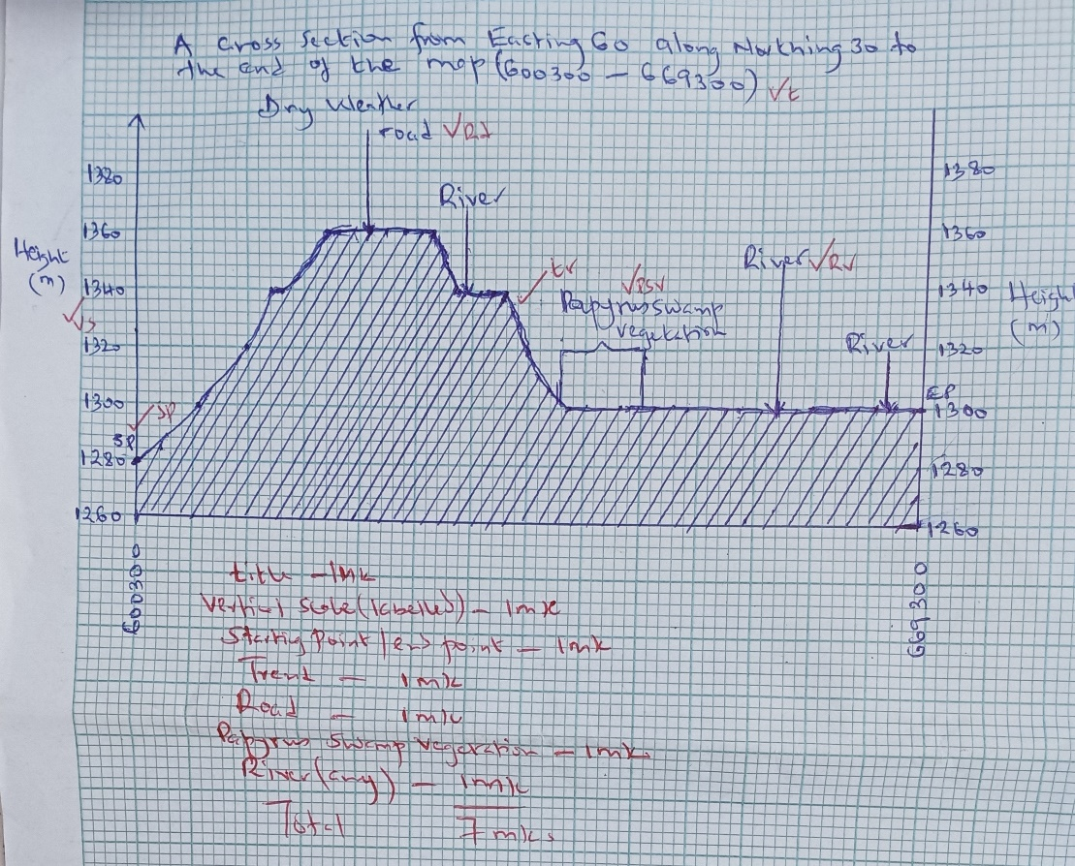

- i) Describe the drainage of the area covered by the map. (5 marks)
  - The main river draining the area covered by the map is R. Nzoia
  - There are many rivers draining the area covered by the map
  - Most rivers in the area are permanent
  - The rivers and the tributaries have formed dendritic drainage patterns
  - There are many seasonal swamps
  - The main river [Nzoia] flows from North East to South West
  - River Nzoia has river braids
  - There are many dams and reservoirs in the area covered by the map
(5 x 1mk = 5 marks)

(ii) Describe the relief of the area covered by the map. (4marks)
- The relief of the area has been dissected by river valleys
- The land rises from South West to North East
- The lowest point is 1220m above sea level/ The lowest point is to the SW part of the map
- The highest point is 1368m above sea level
- The area is generally low lying
- The area is gently sloping
- There are many river valleys
(4x 1mk = 4 marks

- Citing evidence from the map, identify three social services found in the area covered by the map. (3marks)
- Educational services-----schools
- Healthcare/medical services---dispensary/health centre/hospital
- Religious services-------convent
(3 x 1mk = 3 marks)

7.a) (i) Name three minerals mined through placer method (3 marks)
- Gold
- Tin
- Platinum
(3 x 1=3 Marks)
(ii) Name Three Diamond mining areas in South Africa. (3 marks)
- Orange Free State
- Transvaal
- Koffiefounten
- Jagersfontein
- Kimberley
- Pretoria (3x1mks=3 Marks)

iii) State three ways in which mining derelicts can be reclaimed(3Marks)
- Planting trees.
- Creating a park to attract tourists.
- Introducing aquaculture.
- Landscaping for settlement or farming.
- Refilling the holes. (3x1=3 Marks)

b) Explain four ways in which mining promotes industrialization in Kenya. (8 marks)
- Some minerals provide essential raw materials for some manufacturing industries.
- Minerals are exported to earn the country foreign exchange used for development of industries.
- Mining stimulates development of roads/ railway which promotes industrial growth.
- Mining attracts settlement/ development of towns which attract industrial development.
- Mining has stimulated the growth of related industries that supply inputs/ services.
- Mining creates employment raising the living standards of people creating demand for industrial products.
(4x2mks =8 Marks)
- Explain Four Problems facing the mining industry in Kenya. (8 Marks)
- Inadequate capital for the exploitation of mineral has led to reliance on loans from the developed countries. Loans may not always be available, so exploitation may be delayed.
- Foreign companies manage most of the mining activities. They remit some export revenues to their countries, thus reducing the country’s export earnings. This has hampered the development of the mining industry.
- Remoteness and poor transport systems hinder exploitation of minerals in that areas with mineral deposits are inaccessible.
- Insufficient skilled personnel in Kenya leading to dependency on expatriates for prospecting minerals and mining reducing profits accrued from mining.
- Kenya has small mineral deposits which are uneconomical to work on.
- Lack of sufficient power supply in remote areas where minerals are found, which is necessary for mining activities.
- Land use conflicts which affect mining e.g. in Kwale between Tiomin (Canadian company) and the local people due to inadequate compensation. (4x2mks =8 Marks)

8.a) i) Differentiate between a watershed and a confluence. (2marks)
- A water shed is a ridge/ highest area separating two river channels/basins/valleys while a confluence is the point where a river tributary joins the main river. (1x2mks=2 marks)
ii) Describe two processes though which a river erodes its channel. (4mks)
- Abrasion/corrasion - is an erosion process where the river water uses the bad/materials it is transporting to scrub, polish, grid the river banks and the river bed.
- Solution/corrosion – Solution is the process where as a river flows its water dissolves soluble minerals and salts from the river bed and river banks
- Hydraulic action/quarrying – process where the force of water as it flows is thrown to the cracks of rocks of the river bed and banks crating pressure causing cracking
- Attrition – Eroded particles collide with each other hence reducing in sizes.
(Process – 2 marks, Description – 2 marks, Total – 4 Marks)
b) The diagram below shows a water fall. Use it to answer question (b) (i)
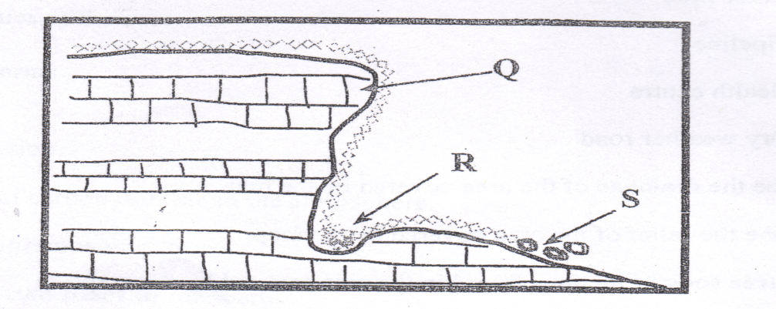

- Name the parts marked Q, R and S. (3mks)
Q – Resistant rock (1mark)
R – Plunge pool (1mark)
S – Rock boulder/debris (1mark)

- Explain two causes of river rejuvenation. (4marks)
- Increase in the river discharge/volume (static rejuvenation caused by increased rainfall in the catchments area, river capture or melt of glacier causing the river to renew its erosive power.
- Changes in the base level (dynamic rejuvenation) may be caused by uplift or subsidence of land causing the river to renew its erosive power
- Change in rock resistance from hard to soft increasing the river’s erosive power. (2x2mks=4marks)

- Name two features resulting from river rejuvenation. (2marks)
- Abandoned meanders
- Knick points
- River terraces
- Incised meanders/ingrown meanders/entrenched meanders.
(2 x 1mk = 2 marks)
c) Using well –labeled diagrams, describe how an ox-bow lake is formed. (6marks)
- The river starts to meander from one end of the valley to the other. The river deposits in the inner bank and erodes the outer bank.
- continued erosion and deposition leads to the formation of a pronounced meander to form a neck / narrow land
- With time the river erodes off the meander neck to form a short cut abandoning the former long channel
- The abandoned meander forms a crescent shaped water body known as Ox-bow Lake

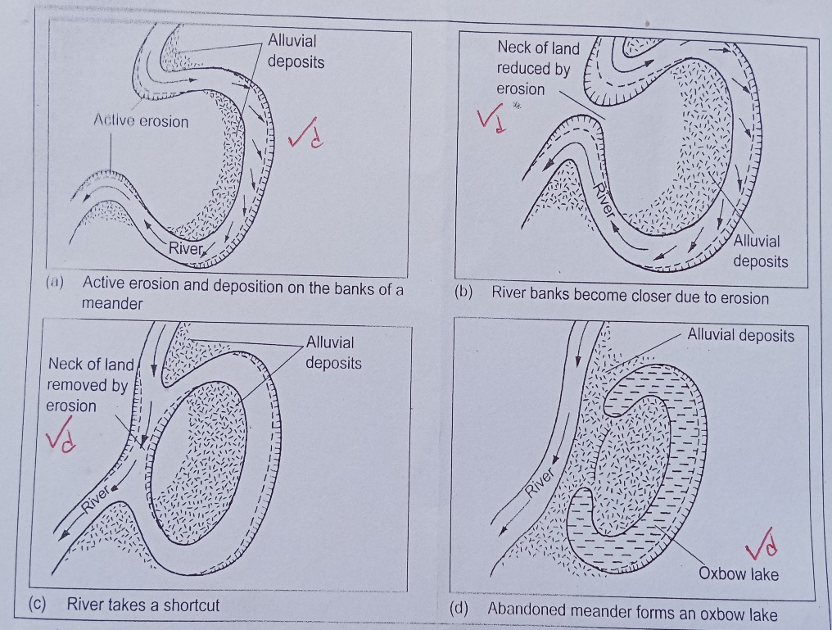

(Diagrams – 4 marks, Description – 4 marks, Total - 8marks)
d) Your Geography class intends to carry out a field study on an ox-bow lake a long river Tana. Give four reasons for dividing the class into groups. (4marks)
- It creates order
- To cover a wide area within a short time
- To avoid overcrowding and injuries
- To ensure maximum participation of all students.
(4x1mk=4marks)
9.(a) Name three areas where Mountain forests are found in Kenya. (3 Marks)
- Mt. Kenya
- Mt. Elgon
- Aberdares
- Mau
- Nandi
- Kakamega forests
- Marsabit forest
- Iveti
- Mbooni. (3 x1mk=3 Marks)

b) i) Give Five Characteristics of Mountain Forests (5 Marks)
- Forests are evergreen.
- Trees are closely spaced with a variety of species.
- Trees are tall and form a dense canopy.
- Main tree species are podo, cedar, oak and camphor.
- Indigenous hardwoods are Olive, Meru oak, Mvule, Elgon teak and Camphor.
- Indigenous softwoods are Podocarpus, African pencil, Cedar and Bamboo.
- Planted exotic hardwoods are Eucalyptus and Silver oak.
- Planted exotic softwoods are Pine, Cypress, Fir and Wattle.
(5 x 1mk=5 Marks)
ii) What is Agro Forestry? (2 Marks)
- It is the deliberate growing of trees and crops/ keeping livestock on a piece of land. (1x2mks=2 Marks)
iii) Give five reasons why Agro-forestry is encouraged in Kenya. (5 Marks)
- To ensure continuous supply of wood fuel/ conserve forest.
- Provides raw materials for industries.
- To conserve soil.
- To provide fruits for human consumption.
- Farm products are a source of income to farmers.
- Provide fodder for animals.
- Trees act as wind breakers/ shade for young plant.
(5 x 1mk=5 Marks)
c)Explain four Biotic factors that influence distribution of forests. (8 Marks)
- Afforestation/ re-afforestation/ agroforestry creates a forest in an area.
- Deforestation/ shifting cultivation reduces forest cover on earth surface.
- Forest fires reduce areas under forest cover.
- High demand for wood fuel/ timber has led to cutting down of trees.
- Areas which are gazetted as forest reserves are prohibited from human settlement.
- Some wild animals like elephants destroys forests.
- Population pressure has led to clearing of some forested areas for settlement/ cultivation.(4x2MK= 8 Marks)

- Name two forest reserves found in Coastal region of Kenya. (2 Marks)
- Arabuko Sokoke in Kilifi County.
- Shimba hills forest.
- Kalibasi and Kaya forests in Kwale.
- Boni/ Dodori forest.
- Mangrove forest. (2x1mk=2 Marks)
10.a) (i) Define the term faulting. (2marks)
- It is the fracturing/cracking of the crustal rocks of the earth, due to tectonic forces. (1x2mks=2marks)
(ii) Name three featured formed as a result of faulting. (3marks)
- Faults
- Rift valleys
- Block /horst mountains/fault blocks
- Tilt blocks
- escarpment/fault scarps
(3 x 1mk = 3 marks)
b) i) State three characteristics of the Gregory Rift Valley. (3marks)
- The width varies from place to place
- The width of the escarpment varies
- Has uneven floor
- Has numerous lakes on its floor
- Has volcanic mountains e.g. Suswa and Longonot
(3 x 1mk = 3 marks)
(ii) Give three theories that explain the origin of the Rift Valley. (3marks)
- By compressional theory
- By tension theory
- By Anti-clinal arching theory
(3 x 1mk = 3 marks)
(iii) Explain four ways in which faulting influence drainage. (8marks)
- When faulting occurs across a river the displacement of land can form a water fall hence river rejuvenation.
- Rift valleys form basins where water collects to form lakes.
- Land uplifting due to faulting may change rivers direction.
- Some rivers may flow along a fault line- fault guided drainage patterns
- . (4 x 2mks=8marks)
c) A form 4 geography class of Mwarano Secondary School carried out a field study on the section of the Rift Valley in Kenya.
(i) State three preparations they had before the study. (3marks)
- Got permission from the school administration on the intended visit
- Researched on secondary sources like books/ journals.
- Assembled necessary equipment like note books, pens and cameras
- Formulated objectives/hypotheses for the study.
- Prepared questionnaires.
- Prepared working schedule
- Carried out a reconnaissance/pre-visit.
(3 x 1mk = 3 marks)
(ii) State three ways of data recording activities used during the study. (3marks)
- Tape recording
- Taking photographs/video recording
- Filling in questionnaires
- Taking notes
- Drawing maps/Sketches
(3 x 1mk = 3 marks)

