MURANGA SOUTH
MULTILATERAL EXAMINATIONS
FORM 2 END OF TERM ONE 2024.
INSRUCTIONS: ANSWER ALL THE QUESTIONS IN THE SPACES PROVIDED.
TIME: 2.30HRS.
1.Draw a diagram to show a simple fold, on it mark and name.
- An anticline
- A limb
- A syncline
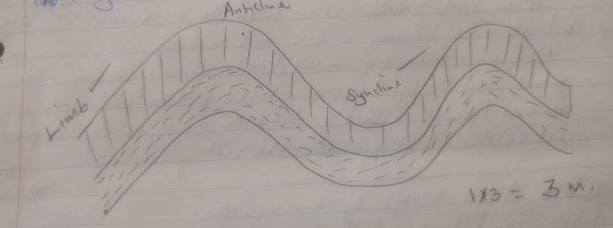 (1x3=3mks)

b.) Name two fold mountains in Africa.
- Atlas
- Caperanges
(2 x 1=2mks)
c.) Name the types of rocks which results from the metamorphism of;
- Granite – Gneiss
- Clay – Slate (2 x 1=2mks)

2a.) What is magma.
Magma is the molten rock under the earth crust
(2mks)

b.) Differentiate between a sill and a dyke
A sill is a near horizontal / tabular sheet of igneous rock formed from solidified magma intruded bedding planes, while a dyke is a sheet of intrusive rock which cuts near vertical / discordantly across the bedding planes. (4mks)

c.) State three causes of earthquakes.
- Collision between tectonic plates.
- Faulting / cracking of rocks.
- Movement of magma within the crust / violent volcanic eruption.
- Adjustment of rocks as a result of stress.
- Excessive energy release.
- Gravitative pressure.
- Explosions caused by man. (3x 1=3mks)

d.) Give three effects of earthquakes in built up area.
- Collapsing / cracking of buildings.
- Loss of life; human, animals and plants.
- Disruption of transport and communication lines.
- Outbreak of fire.
- Avalanches and landslides may cover built up areas.
- Tsunamis may cover / drown coastal settlements. (3x 1=3mks)

3a.) Identify three mountain building periods.
- Charnian orogeny.
- Harcynian orogeny.
- Caledonian orogeny.
- Alpine orogeny.
(3 x1=3mks)
b.) Give three reasons why there is no vegetation on top of MT Kenya
- Very low temperatures which inhibits plants growth.
- Thin soil which cannot support growth.
- Presence of frozen surface.
- Precipitation is in form of snow. (3 x 1=3mks)

c.) Define vulcanicity?
It’s the process through which molten rocks, ashes, steam and gaseous materials are forced out by pressure from the interior of the surface. (2mks)

4a.) Define reasons as why Stevenson screen has the following characteristics.
- Painted white.
To ensure that there is no absorption of warmth as this would interfere with temperature reading. (2mks)
ii. It is raised 121 cm above the ground.
To prevent contact with direct radiation from the earths surface. (2mks)

b.) Mention three characteristics of ITCZ.
- Is an area of low pressure due to intense heating from the overhead sun.
- It is a zone that moves from tropical of cancer to Capricon following the overhead sun.
- It is a region where the northeast and southwest wind converge.
- Region has high temperature. (3 x 1=3mks)

c.) Give three methods of weather forecasting.
- Ancient method.
- Weather lure
- Modern method (3 x 1=3mks)

5. Define term faulting.
It’s the fracturing of rocks due to tensional forces. (2mks)

b.) Give three causes of faulting.
- Tension force
- Compressional force
- Sheer / tear or slip force (3 x 1=3mks)

c.) With an aid of well drown and labelled diagram, explain the formation of rift valley by anticlinal arching.
- These is formed as a result of regional up warping where sedimentary rocks are pushed upwards as a re3sult of compressional force.
- This lead to the bending of rock layers into a big arch (anticline)
- Gapping cracks develops at the crest of the arch due to tensional force at the top
- The middle block sinks forming a rift valley e.g. Rhine rift valley
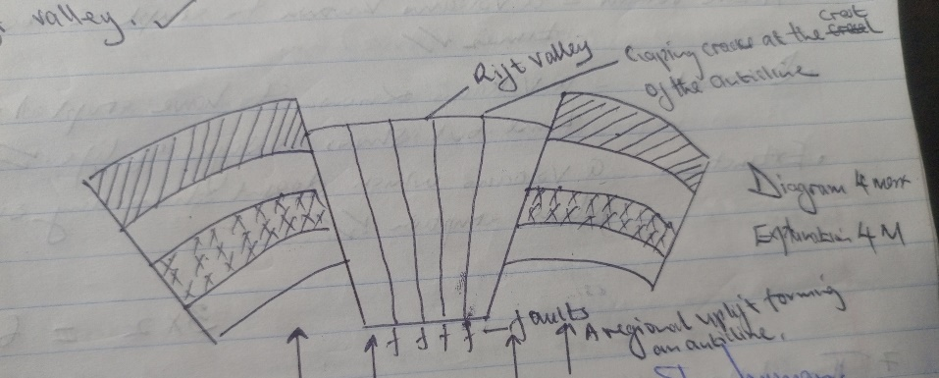
d.) Give three negative effects of faulting to human.
- Disrupting of transport lines, like roads, railways and pipelines that is brought about when some sections of land become disjoined as a result of faulting.
- Distructio0n of properties and loss of life if land is displaced across a building, it can collapse leading to loss of life.
- It is very difficult and expensive to construct powerline, pipes and others across fault scarps.
(3 x1=3mks)
6a.) Name three elements of weather.
- Temperature
- Pressure
- Wind
- Precipitation
- Clouds
- Sunshine (3 x 1=3mks)
b.) Name three types of rainfall.
- Relief rainfall / orographic
- Convectional rainfall
- Frontal rainfall / cyclonic (3 x 1=3mks)

c.) Distinguish between active, dormant and extinct volcanoes.
- Active volcano – a volcano known to erupt in recent times.
- Dormant – a volcano known to have erupted in recent time but shows no signs of life.
- Extinct – a volcano which doesn’t show any signs of future eruption. (2x3=6mks)

7. The table below shows the temperature and rainfall fingers for a weather station in Kenya. Use it to answer the following questions.
Month | J | F | M | A | M | J | J | A | S | O | N | D
Temp⁰c | 16.2 | 16.5 | 17.1 | 17.1 | 16.1 | 15.2 | 15.2 | 15.0 | 16.0 | 16.1 | 16.1 | 16.3
Rainfall | 100 | 104 | 175 | 232 | 323 | 218 | 196 | 231 | 196 | 152 | 127 | 71

1.Calculate:
- The mean annual temperature for the station.
16.2+16.5+17.14
17.14+16.1+15.2+15.2+15.0+16.0+16.1+16.1+16.3
=192.912÷12 =16.07 or 16.1⁰c (2mks)
- The temperature range for the station
17.1⁰c – 15.0⁰C = 2.0⁰C (2mks)
- The total amount of rainfall received in the station.
100+104+175+232+323+218+196+231+196+152+127+71=2125mm (2mks)
- The mean annual rainfall for the station.
The annual rainfall 2125÷12=177.08mm (2marks)
8. What is rock?
Its any naturally formed solid aggregated or a naturally occurring solid material composed of mineral particles cemented together. (2mks)

b.) Give two characteristics of sedimentary rocks.
- Some sedimentary rocks contain fossils
- The rocks have cleavage or are foliated or have planes
- They are laid I n the horizontal layers or are stratified (2 x 1= 2marks)

c.) Name two types of scale.
- Statement scale
- Representative fraction ratio (R.F)
- Linear scale (2x 1= 2marks)
d.) Convert the following R.F and the statement 1:50,000cm.
1cm represent 50,000cm
50,000 cm =(50,000÷100,000) KM =0.5km
1cm represents 0.5km
(2marks)

- Between Asteroids and comets.
Differentiate Asteroids are small planets like heavenly bodies revolving around the sun between Mars and Jupiter on their orbits while comets are small heavenly bodies revolving around the sun crossing orbits of planets and have a tail and a head made of frozen ice and dust. (2marks)
- Name two theories that attempt to explain the origin of the earth and solar system.
- Nabula cloud theory
- Passing star theory (2 x 1=2marks)
- You are planning to carry out a field study on rocks within the local environment.
- List two methods you would use on rocks within the local environment.
- Field sketching
- Mapping
- Tabulation
- Tallying
- Taking photographs
- Note taking
- Labeling of samples
- Filling in questionnaires (2 x 1=2marks)
- State three problems you are likely to encounter.
- Fatigue t\due to difficult terrain
- Some areas maybe too remote with very few vehicles going to some areas
- Unfavorable weather conditions such as heavy rainfalls or extremely high temperature.
- Difficult in breaking some rocks.
- Accidents may occur while handling delicate equipment’s or walking over difficult terrain.
- Difficult in identifying some rocks.
- Attack by world animals (3 x 1= 3marks)

- State two economic uses of rocks you are likely to identify.
- They form spectacular sceneries which act as tourist attraction site
- Act as water reservoirs
- They weather down to form fertile soils for agriculture
- Provide building /construction materials
- Some rocks crutain valuable minerals that can be exploited for industries
- Various salts are obtained from rock hence providing salt leaks for livestock /human being.
- Some rock can be used for fuel eg coal and petroleum
- some Rock provide raw materials for industries
- Some rocks are used for making carvings (2 x 1=2marks)
d) Identify two branches of geography
- Physical geography
- Practical geography
- Human and economic geography
(2 x 1= 2mks)

10. List down five types of folds
- Simple asymmetrical folds
- Asymmetrical folds
- Overfold
- Isoclinal folds
- Recumbent folds
- Nappe /over thrust
- Anticlinorium synclinoriuns complex (5 x 1=5marks)

This is the last printed page

