NAME………………………………………….ADM……………….CLASS………….
MURANGA SOUTH MULTILATERAL JOINT EXAM
END TERM 1 2024
GEOGRAPHY FORM ONE
TIME 2 $\frac{1}{2}$ HRS
INSTRUCTIONS: ANSWER ALL THE QUESTIONS IN THE SPACE PROVIDED.

1a) What is the relationship between geography and mathematics (4 marks)

b) Outline three reasons why it is important to study geography (6 marks)

c) Distinguish between geography and environment (2 marks)

d) Name three sub-divisions of physical geography (3 marks)

2a) Give two dates in a year during which the number of hours of night and day are equal in both the north and south poles /hemispheres. (2 marks)

b) What is solar system (2 marks)

c) Name four components/members of Solar system (4 marks)

3) Name two theories that explain the origin of the earth and the solar system (2 marks)

b) Name four layers of the atmosphere (4 marks)

c) The diagram below represents in the internal structure of the earth. Use it to answer question that follow.
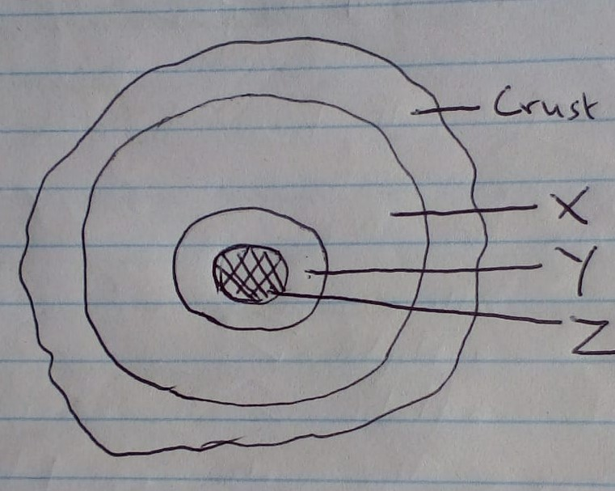
Name the parts marked X, Y and Z. (3 marks)

d) Define the term rotation of the earth (2 marks)

e) State three effects of the rotation of the earth (3 marks)

4a) Define the term weather. (2 marks)

b) Define the term atmosphere. (2 marks)

c) Give three reasons why the interior of the earth is very hot. (6 marks)

d) Give three characteristics of comets (3 marks)

5a) Outline three proofs that shows the shape of the earth is spherical. (6 marks)

b) Name the two layers of discontinuity in the internal structure of the Earth. (2 marks)

c) Name four elements of Weather. (4 marks)

6 a) i) List down the planets in the solar system in order from the sun. (8 marks)

ii) Name one planet without a natural satellite. (1mark)

b) Outline four weaknesses of passing star theory. (8 marks)

c) Name three forces that resulted in to the spherical shape of the earth. (3 marks)

d) Name the major branches of Geography. (3 marks)

e) Define the following aspects of environment. (4 marks)
i) Ecology

ii) Habitat

7 a) Give the two words that form the word Geography and give their meaning. (4 marks)

b) Name three areas studied under Geomorphology. (3 marks)

c) Describe the following;
- Meteor (2 marks)

- Meteorite (2 marks)

