MURANGA SOUTH MULTILATERAL JOINT EXAM
END TERM 1 2024
GEOGRAPHY FORM ONE
TIME 2 $\frac{1}{2}$ HRS
INSTRUCTIONS: ANSWER ALL THE QUESTIONS IN THE SPACE PROVIDED.

1a) What is the relationship between geography and mathematics (4 marks)
- Mathematics principles and formulae are used in geography to calculate distances or area and population density.
- Geography information can be analyzed or presented accurately through the application of mathematics techniques.
- Direction and bearing concepts from geography are applied in mathematics to solve mathematics problems (2 x 2mks=4marks)

b) Outline three reasons why it is important to study geography (6 marks)
- It helps to develop skills like map reading/drawing
- It enables the learner to understand /appreciate different environmental influences
- It encourages international awareness /co-operation
- It enables the learners to explain the origin of earth /landform and the solar system
- It enables the development of career opportunities eg. Pilots, civil engineers, geography teachers etc. (3x2mks=6 marks)

c) Distinguish between geography and environment (2 marks)
- Geography is the study of earth as a home of man while environment means all external conditions surrounding an organism (and which have an influence over its behavior or activities). ( 2 marks)
d) Name three sub-divisions of physical geography (3 marks)
- Geomorphology
- Climatology/meteorology
- Hydrology
- Pedology
- Biogeography
- Hydrology
- Oceanography (3x1mk=3marks)

2a) Give two dates in a year during which the number of hours of night and day are equal in both the north and south poles /hemispheres. (2 marks)
- 21st March
- 23rd September (2x1mk=2marks)
b) What is solar system
- Solar system refers to a group of heavenly bodies comprising the sun, eight planets, dwarf planets, moons and others orbiting around the sun. (1x2mks=2 marks)

c) Name three components/members of Solar system (3 marks)
- The sun
- The planets
- Natural satellites /moon
- Asteroids / Planetoids
- Meteors / meteorites /meteoroids
- Comets (3x1mk=3 marks)
3) Name two theories that explain the origin of the earth and the solar system (2 marks)
- Passing star theory /big bang theory
- Nebula cloud theory
- collision theory
- Supernova theory (2x1mk=2 marks)

b) Name four layers of the atmosphere (4 marks)
- Troposphere
- Stratosphere
- Mesosphere
- Thermosphere/ionosphere(4x1mk=4 marks)

c) The diagram below represents in the internal structure of the earth. Use it to answer question that follow.
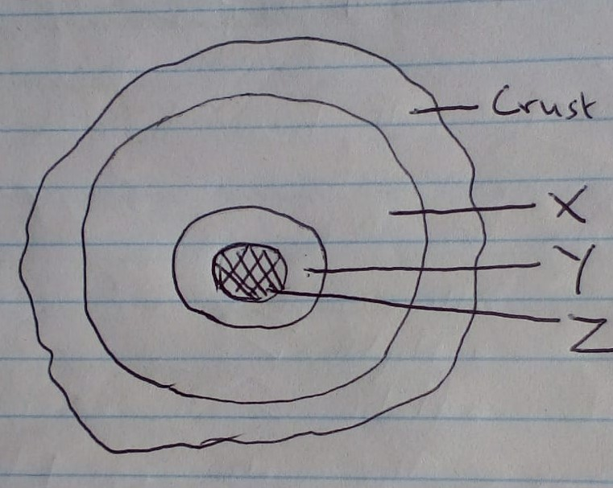
Name the parts marked X, Y and Z. (3 marks)
- X----Mantle
- Y----Outer core
- Z----Inner core

d) Define the term rotation of the earth (2 marks)
- It is the spinning of the earth on its axis (within a period of 24 hours)
e) State three effects of the rotation of the earth (3 marks)
- Causes the occurrence of day and night
- Causes deflection of winds and ocean currents
- Causes rising and falling of ocean tides
- Causes the variation in time at different longitudes
- Causes difference in atmospheric pressure on the surface of the earth
- Cause variation in the speed of air masses (3x1mk=3marks)
4a) Define the term weather. (2 marks)
- Is the condition of the atmosphere for a specific place at a specific time/ for a short period of time usually one day (1x2mks=2 marks)
b) Define the term atmosphere. (2 marks)
- Is a thin layer of gases and vapour that surround the earth and is held onto it by the force of gravity. (1x2mks=2 marks)
c) Give three reasons why the interior of the earth is very hot. (3 marks)
- Due to the overlying materials that exert great pressure which generates a lot of heat
making the interior very hot
- Hot materials that broke away from the sun and the passing star to form the planet cooled at a slower rate in the interior than at the exterior.
- Radioactivity (3x1mk=3 marks)

d) Give three characteristics of comets (3 marks)
- They are made up of frozen gases/dust/small rocks particles
- They have a head and tail
- They move along an oval – shaped/elliptical orbit
- They cross orbits that are followed by the planets (3x1mk=3 marks)

5a) Outline three proofs that shows the shape of the earth is spherical. (6 marks)
- Circumnavigation of earth along a straight path leads one to starting point from the opposite direction
- Photographs taken from satellite clearly show the earth is spherical
- The gradual emergence of a ship approaching the shore
- During lunar eclipse spherical shaped shadow of the earth is casted on the moon
- The earth is a planet and all planets are spherical
- The different times during which the sun rises and sets in the different parts of the world.
- The earths horizon appears/ curved when viewed from a high point (3x2mks=6marks)

b) Name the two layers of discontinuity in the internal structure of the Earth. (2 marks)
  - Mohorovicic discontinuity
  - Gutenberg discontinuity. (2x1mk=2marks)

c) Name four elements of Weather. (4 marks)
- Temperature
- Rainfall
- Humidity
- Wind
- Atmospheric pressure
- Cloud cover (4x1mk=4marks)
6 a) List down the planets in the solar system in order from the sun.
- Mercury.
- Venus.
- Earth.
- Mars
- Jupiter.
- Saturn
- Neptune.
(NB)-Order must be followed to score. (8x1mk=8 marks)

ii) Name one planet without a natural satellite. (1mark)
- Mercury
- Venus (1x1mk=1mark)
b) Give four weaknesses of passing star theory. (8 marks)
- Chances of another star passing near the sun are minimum.
- Origin of the sun is not explained
- Hot gaseous material should have dispersed rather than condense due the prevailing high temperature environment.
- The material should have followed the star as it had greater gravitational pull.
- The effect of star setting planets on their orbits would have reduced as the star was moving away. (4x2mks=8 marks)

c) Name three forces that resulted in to the spherical shape of the earth. (3 marks)
  - Gravitational force
  - Centripetal force
  - Centrifugal force. (3x1mk=3 marks)

d) Name the major branches of Geography.
- Physical Geography
- Human and Economic Geography
- Practical Geography. (3x1mk=3 marks)

e) Define the following aspects of environment. (4 marks)
i) Ecology
ii) Habitat
- Ecology- it is the study of the interrelationships between organisms and their environment.
- ii) Habitat- a home of an organism that provides its necessities for its survival. (2x2mks=4 marks)

7 a) Give the two words that form the word Geography and give their meaning. (4 marks
- Geo-means Earth
- Graphein-means to write, draw or to describe. (2x2mks=4 marks)

b) Name three areas studied under Geomorphology. (3 marks)
- The earth and solar system
- The internal structure of the earth
- Rocks and minerals
- Internal land forming processes/endogenic processes
- External land forming processes/exegetic processes
- Drainage. (3x1mk=3 marks)

c) Differentiate between a Meteor and Meteorites
- A meteor is a streak of light (shooting star) in the sky on clear night produced when a meteoroid, as it moves at high speed, burns into ashes as it experiences friction with the earth’s atmosphere while meteorite is that meteoroid that fails to burn up completely as it passes through the atmosphere and lands on the earth’s surface as a huge rock. (1x4mks=4marks)

