(Kenya Certificate of Secondary Education)
Physics paper one
232/1
Form 3 2024

Name………………………………….……………………………… Date………………
Candidate’s Signature: ………...……. Stream .................. Adm No..................

TIME: 2 hours

Instructions to candidates

- This paper consists of two sections A and B.
- Answer all the questions in the two sections in the spaces provided after each question
- All working must be clearly shown.
- Electronic calculators, mathematical tables may be used.
- All numerical answers should be expressed in the decimal notations.
- You may use:
- ‘gravitational acceleration, g, as 10m/s²
- Atmospheric pressure = 100, 000 Pa
- Density of water = 1g/cm³
- Density of air = 1.25kg/m³
- Density of mercury = 13 600kg/m³

For Examiner use only
SECTION | QUESTION | MAX MARKS | CANDIDATE’S SCORE
A | 1 – 13 | 25
B | 14 | 11
 | 15 | 13
 | 16 | 11
 | 17 | 10
 | 18 | 11
 | TOTAL | 80

SECTION A (25 MARKS)
- The figure 1 below shows a measuring cylinder, which contains water initially at level A. A solid of mass 10g is immersed in the water, the level rises to B.

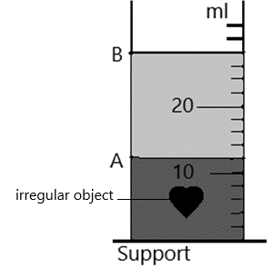

Figure 1

Determine the density of the solid [Give your answer to 1 decimal point.] [3marks]

- Figure 2 (a) and (b) below shows capillary tubes inserted in mercury and water respectively.
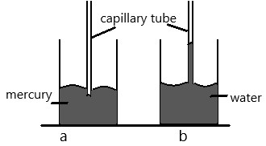

Figure 2
It is observed that in water the meniscus in the capillary tube is higher than the meniscus in the beaker. While in mercury the meniscus in the capillary tube is lower than the meniscus in the beaker. Explain these observations. [2marks]

- A hole of area 2.0 cm² at the bottom of a tank 2.0 m deep is closed with a cork. Determine the force on the cork when the tank is filled with water. [3 marks]

- In the set up shown in the figure 3 below, water near the top of the boiling tube boils while at the bottom remains cold.
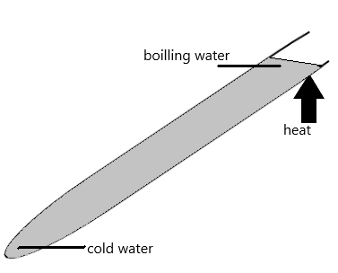
Figure 3
Give a reason for the observation. [1 mark]

- State any means of increasing the sensitivity of a liquid – in – glass thermometer. [1 mark]

- State one method of minimising friction between solid surfaces. [1 mark]

- Define the term Centre of gravity of a body. (1 mark)

- The diagram below shows apparatus used to observe the behaviour of smoke particle in air.
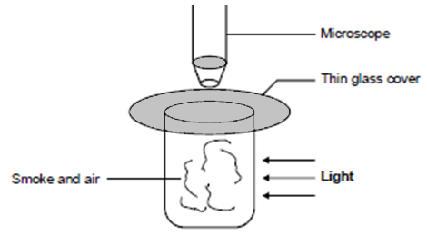

Figure 4

- Why are smoke particles suitable for use in this experiment? (1 mark)

- State and explain the behaviour of the smoke particles (2 marks)

- A student recorded the following measurements while using a meter rule: 5.32 cm, 4.9 cm and 8.013 cm. Which is the correct reading? Explain your answer (2 marks)

- The figure below shows a wine glass. State and explain how the stability of the glass is affected if it is filled with wine. (2 marks)
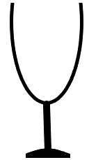

Figure 5

- Distinguish between the terms ‘uniform velocity’ and ‘uniform acceleration’ (1 mark)

- The figure 6, below shows a section of a ticker tape. The dots were made at a frequency of 50 Hz. Determine the acceleration of the trolley pulling the tape. (3 marks)
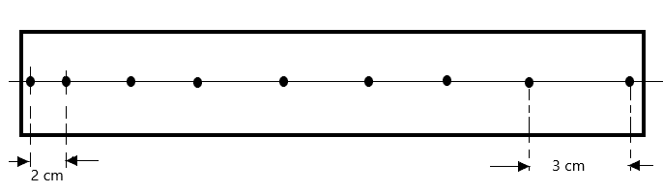

Figure 6

- The diagram below represents a u-shaped glass tube sealed at one end and containing mercury. Determine the pressure of the gas as shown in the diagram below (atmospheric pressure is 100000Pa) (2 marks)

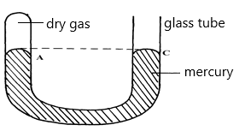

Figure 7

SECTION B. (55MARKS)

- Explain the following terms:
- Streamline flow (1 mark)

- Turbulent flow (1 mark)

- The figure below shows air flowing through a pipe of different cross-section areas. Two pipes A and B are dipped into water as shown.

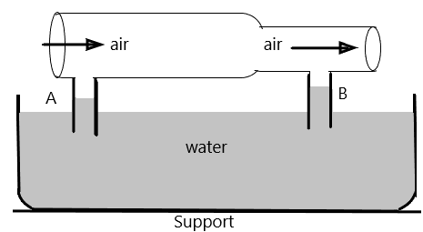
Figure 8
Explain the cause of difference in the levels of water in the pipes A and B. [2marks]

- The figure below shows Bunsen burner. Explain how air is drawn into the burner when the gas tap is opened. [3marks]
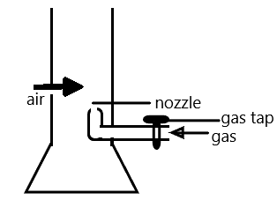

Figure 9

- Water is not suitable for use as a barometric liquid. Explain (2 marks)

- An aerofoil is dragged in the direction shown in air. Draw the arrangement of streamlines below and above the aerofoil (draw at least two lines on either side).
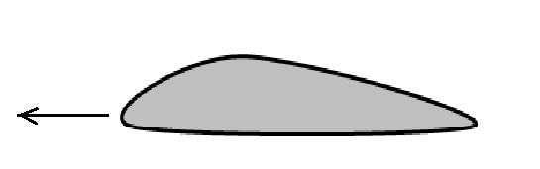
(2 marks)

Figure 10

- Define the following terms: (2 marks)

- Acceleration

- Displacement

- The fig below shows a velocity – time graph for the motion of a certain body.
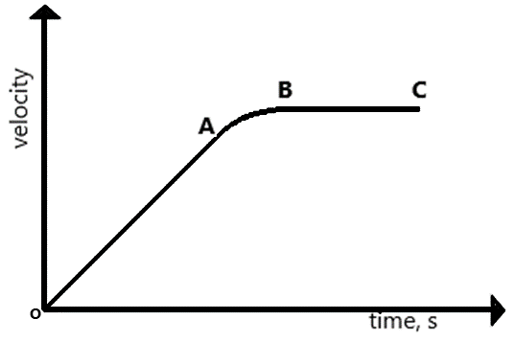
Figure 11
Describe the motion of the body in the region: [3marks]
- OA

- AB

- B C

- A car initially at 10m/s decelerates at 2.5m/s². Determine,

- Its velocity after 1.5 s [2marks]

- The distance travelled in 1.5 s. [2marks]

- The time taken for the car to stop. [2marks]

- The figure below shows the velocity-time graph of the motion of a stone thrown vertically upwards.
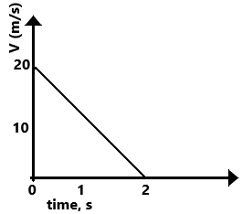

Figure 12

From the graph, determine the maximum height, s reached by the stone.
(Use space alongside the diagram) (2 marks)

- State the principle of moments (1mark)

- A uniform metre-rule balances at the 35cm mark when a mass of 500g is placed at the 25cm mark as shown in the figure 13 below.

Figure 13

Determine:
- The mass of the meter-rule (3 marks)

- With the metre-rule remaining on the knife-edge at the 35 cm mark, a mass of 125g is suspended from the 70 cm mark. The mass of 500g is moved until the rule is balanced. Determine the new position of the 500g mass (3 marks)

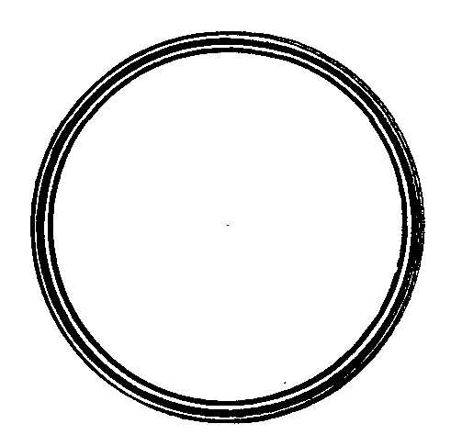
- The figure below shows a ring of a thin steel washer. Determine the centre of gravity of the washer. (2 marks)

Figure 14

- State two ways in which stability of a body can be increased (2 marks)

- State Hooke’s law (1 mark)

- The diagram below shows three identical springs which obey Hooke’s law.
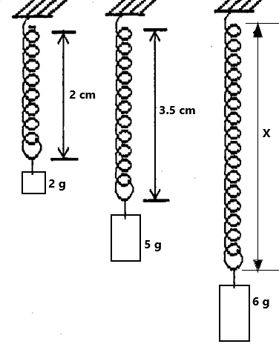

Figure 15

Determine the length X. (3 marks)

- Sketch a graph of length of a helical spring against compressing force until the coils of the spring are in contact (2 marks)

- Distinguish between brittleness and stiffness (2 marks)

- State any two applications of a compressed spring (2 marks)

- State Newton’s Second Law of motion. (1 mark)

- A mass of 60 kg accelerates at 0.3 m/s² when a force of 200N is applied to it. Calculate the force that will make the mass move at uniform velocity. (3 marks)

- A bullet of mass 30 g strikes a stationary wooden block and is completely embedded in it. The centre of mass of the wooden block rises by 0.18 m, figure 16.

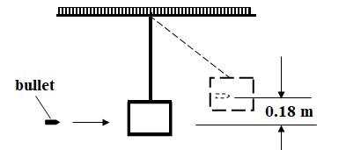

Figure 16

The wooden block has a mass of 370g. Determine the speed of the bullet when it just strikes the wooden block (4 marks)

- Show that the impulsive force on an object can be expressed as F = ma. (2 marks)

