Physics paper one
232/1
Form 3 Term one 2024

MARKING SCHEME
SECTION A (25 MARKS)
- The figure 1 below shows a measuring cylinder, which contains water initially at level A. A solid of mass 10g is immersed in the water, the level rises to B.

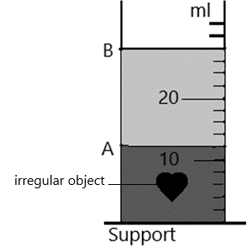

Figure 1

Determine the density of the solid [Give your answer to 1 decimal point.] [3marks]
Volume of object = (28 -12) = 16 cm³ ;

$density=\frac{mass}{volume}=\frac{10}{16} ;=0.625g{cm}^{-3}$ ;

- Figure 2 (a) and (b) below shows capillary tubes inserted in mercury and water respectively.
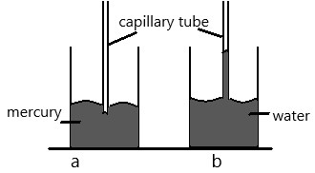

Figure 2
It is observed that in water the meniscus in the capillary tube is higher than the meniscus in the beaker. While in mercury the meniscus in the capillary tube is lower than the meniscus in the beaker. Explain these observations. [2marks]
Adhesive force between water and tube molecules is higher than cohesive force between water molecules hence water rises up the tubes; while cohesive force between mercury molecules is stronger than adhesive force between tube and mercury molecules hence meniscus of mercury sinks lower in the tube;

- A hole of area 2.0 cm² at the bottom of a tank 2.0 m deep is closed with a cork. Determine the force on the cork when the tank is filled with water. [3 marks]
$pressure=hρg=2×1000×10=20000Pa$ ;
$force=pressure×area=20000×2×{10}^{-4};=4N$ ;

- In the set up shown in the figure 3 below, water near the top of the boiling tube boils while at the bottom remains cold.
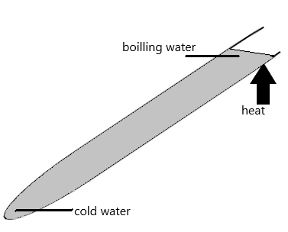
Figure 3
Give a reason for the observation. [1 mark]
Water is a poor conductor of heat hence does not allow transmission of heat down the tube to warm the water

- State any means of increasing the sensitivity of a liquid – in – glass thermometer. [1 mark]
Reduce thickness of the wall of the bulb ;

- State one method of minimising friction between solid surfaces. [1 mark]
- Oiling/greasing
- smoothening

- Define the term Centre of gravity of a body. (1 mark)
The point where the resultant force on a body (weight) appear to act from ;

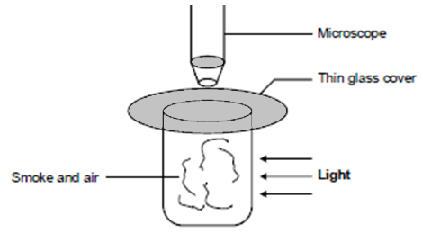
- The diagram below shows apparatus used to observe the behaviour of smoke particle in air.

Figure 4

- Why are smoke particles suitable for use in this experiment? (1 mark)
Smoke particles are light so easily suspended in air ;

- State and explain the behaviour of the smoke particles (2 marks)
Smoke particles are in constant random motion; the smoke particles are being hit by air particles in random motion;

- A student recorded the following measurements while using a meter rule: 5.32 cm, 4.9 cm and 8.013 cm. Which is the correct reading? Explain your answer (2 marks)
4.9 cm; because the accuracy of a metre-rule is 0.1 cm, it is not possible to accurately read more than 1 decimal point from it;

- The figure below shows a wine glass. State and explain how the stability of the glass is affected if it is filled with wine. (2 marks)
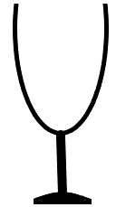
Stability reduces; filling it with wine raises the position of its centre of gravity; hence lowering its stability.

Figure 5
- Distinguish between the terms ‘uniform velocity’ and ‘uniform acceleration’ (1 mark)
Uniform velocity refers to the constant change of displacement with time while uniform acceleration is the constant change of velocity with time;

- The figure 6, below shows a section of a ticker tape. The dots were made at a frequency of 50 Hz. Determine the acceleration of the trolley pulling the tape. (3 marks)

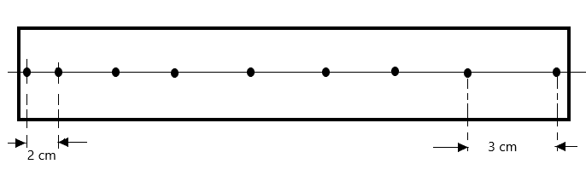

Figure 6

Time for 1 tick = $\frac{1}{50}=0.02 s$
Initial velocity, u = $\frac{2}{0.02}=100 cms^{-1}$ , final velocity, v = $\frac{3}{0.02}=150 cms^{-1}$ ;
Acceleration = $\frac{v-u}{t}=\frac{150-100}{(0.02*7)} ;=357.14cms^{-2}$ = 3.571 m/s² ;

- The diagram below represents a u-shaped glass tube sealed at one end and containing mercury. Determine the pressure of the gas as shown in the diagram below. (2 marks)
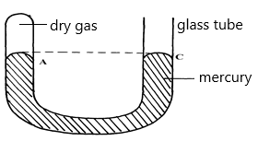

Figure 7

Pressure at A = pressure at C ;
But pressure at C = atmospheric pressure
Therefore, pressure of gas = 100000 Pa ;

SECTION B. (55MARKS)

- Explain the following terms:
- Streamline flow (1 mark)
A type of flow where Speed and direction of particles passing through a point is constant (similar)

- Turbulent flow (1 mark)
A type of flow where Speed and direction of particles passing through a point vary with time

- The figure below shows air flowing through a pipe of different cross-section areas. Two pipes A and B are dipped into water as shown.

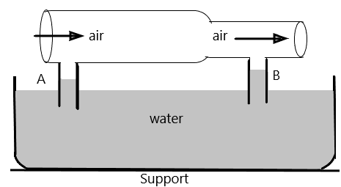
Figure 8
Explain the cause of difference in the levels of water in the pipes A and B. [2marks]
Speed of air above tube B is higher than A. This causes a corresponding lower pressure above tube B than A; the greater pressure difference in tube B causes water to rise more in tube B than in tube A ;

- The figure below shows Bunsen burner. Explain how air is drawn into the burner when the gas tap is opened. [3marks]
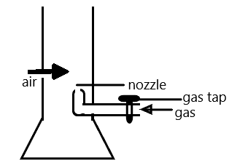
Air speed is higher at the nozzle; this reduces the pressure above the nozzle below atmospheric pressure; the pressure difference provides the force which sucks the air into the Bunsen burner;

Figure 9

- Water is not suitable for use as a barometric liquid. Explain (2 marks)
Water has a low density; which gives a bigger (longer) barometric height hence bulky barometer ;

- An aerofoil is dragged in the direction shown in air. Draw the arrangement of streamlines below and above the aerofoil (draw at least two lines on either side).
(2 marks)

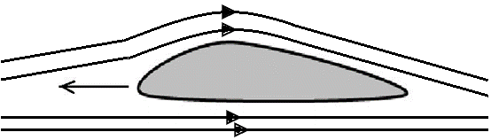
Figure 10

- Define the following terms: (2 marks)

- Acceleration
Rate of change of velocity with time ;

- Displacement
Distance moved by a body in particular direction ;

- The fig below shows a velocity – time graph for the motion of a certain body.
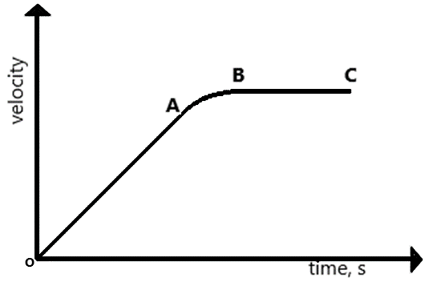
Figure 11

Describe the motion of the body in the region: [3marks]
- OA
The body moves at constant acceleration;

- AB
The body moves at variable velocity;

- B C
The body moves at constant velocity (zero acceleration);

- A car initially at 10m/s decelerates at 2.5m/s². Determine,

- Its velocity after 1.5 s [2marks]
$V=u+at$

$V=10+2.5 (1.5)$ ; = 10.75 m/s ;

- The distance travelled in 1.5 s. [2marks]

$V^{2}=U^{2 }-2as$

$10.75=100-2(2.5)S$ ;

$5S=89.25 therefore, S= \frac{89.25}{5}=17.85 m$ ;

- The time taken for the car to stop. [2marks]
$V=U-at$
$0=10-2.5t$ ;
$t=\frac{10}{2.5}=4 second$ ;

- The figure below shows the velocity-time graph of the motion of a stone thrown vertically upwards.
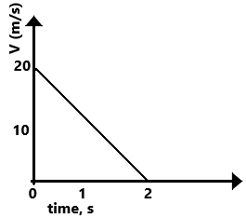
$s=ut-\frac{1}{2}gt^{2}$

$s=20\left(2\right)-\frac{1}{2}\left(10\right)\left(2^{2}\right)$ ;

$therefore, s=40-20=20 m$ ;

Figure 12
From the graph, determine the maximum height, s reached by the stone.
(Use space alongside the diagram) (2 marks)

- State the principle of moments (1mark)
For a system in equilibrium, the sum of clockwise moments about a point is equal to the sum of anti-clockwise moment about the same point ;

- A uniform metre-rule balances at the 35cm mark when a mass of 500g is placed at the 25cm mark as shown in the figure 13 below.

Figure 13

Determine:
- The mass of the meter-rule (3 marks)
At equilibrium: sum of clockwise moment = sum of anti-clockwise moment
$5×0.1=W×0.15$ ;
$W=\frac{5×0.1}{0.15}=3.333N$ ;
$mass of rule=\frac{3.333}{10}=0.3333kg$ ;

- With the metre-rule remaining on the knife-edge at the 35 cm mark, a mass of 125g is suspended from the 70 cm mark. The mass of 500g is moved until the rule is balanced. Determine the new position of the 500g mass (3 marks)

At equilibrium: sum of clockwise moment = sum of anti-clockwise moment
$\left(1.25×0.35\right)+\left(3.333×0.15\right)=(5×d)$ ;;

$0.4375+0.49995=5d$

$d=\frac{0.93745}{5}=0.18749$ Therefore, position is 18.75 cm from the pivot ;
$(accept 16.25 cm from the zero mark)$

- The figure below shows a ring of a thin steel washer. Determine the centre of gravity of the washer. (2 marks)

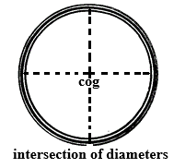
Figure 14
- State two ways in which stability of a body can be increased (2 marks)
- Lower the position of the centre of gravity ;
- Increase the area of the base of the body ;

- State Hooke’s law (1 mark)
For an elastic material, the extension is directly proportional to the stretching force provided the elastic limit is not exceeded ;

- The diagram below shows three identical springs which obey Hooke’s law.
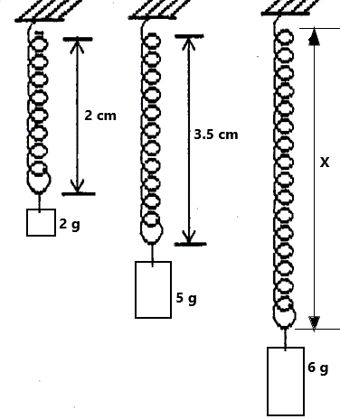
$F=ke, 0.03=k(0.015)$
$k=\frac{0.03}{0.015}=2Nm^{-1} ;$
$e=\frac{F}{k}=\frac{0.01}{2}=0.005 m$ = 0.5 cm ;
Therefore, X = (3.5 + 0.5) = 4.0 cm ;

Figure 15

Determine the length X. (3 marks)

- Sketch a graph of length of a helical spring against compressing force until the coils of the spring are in contact (2 marks)
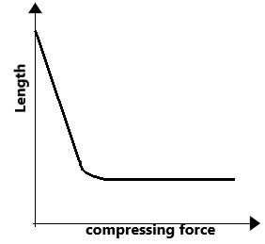

- Distinguish between brittleness and stiffness (2 marks)
Brittleness is the quality of a material which leads to breakage just after the elastic limit is reached; while stiffness is the resistance a material offers to forces which tend to change its shape or size ;
- State any two applications of a compressed spring (2 marks)
- Top pan balance
- Shock absorber in vehicles

- State Newton’s Second Law of motion. (1 mark)
The rate of change of momentum of a body is directly proportional to the resultant external force producing the change and it takes place in the direction of the force;

- A mass of 60 kg accelerates at 0.3 m/s² when a force of 200N is applied to it. Calculate the force that will make the mass move at uniform velocity. (3 marks)

$resultant force, F=ma$ = $60×0.3=18 N$ ;
$friction, F_{r}=\left(200-18\right)=182 N$ ;
$at zero acceleration, applied force=friction$
Hence, the force = 182 N ;

- A bullet of mass 30 g strikes a stationary wooden block and is completely embedded in it. The centre of mass of the wooden block rises by 0.18 m, figure 16.

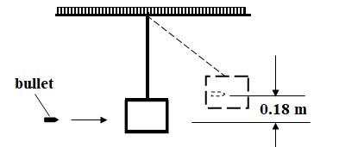

Figure 16

The wooden block has a mass of 370g. Determine the speed of the bullet when it just strikes the wooden block (4 marks)

Kinetic energy lost = potential energy gained ;
$\left(\frac{1}{2}×0.03×v^{2}\right)+\left(\frac{1}{2}×0.37×0\right)=(0.4×10×0.18)$ ;;
$v^{2}=\frac{0.72×2}{0.03}$ = 48
$therefore, v=6.928$ m/s ;

- Show that the impulsive force on an object can be expressed as F = ma. (3 marks)

Impulse = change in momentum

$Ft=(mv-mu)$ ;

$Ft=m (v-u)$

Therefore, impulsive force, F = $m(\frac{v-u}{t})$ ;
But $\frac{v-u}{t}=a$

Hence, F = ma ;

