Term 1 - 2024
DRAWING AND DESIGN (449)
FORM THREE (3)
Time: 2½ Hours

Name: …………………………………………………………. Adm No: ……………….
School: ……………………………………………………….. Class: …………………..
Signature: …………………………………………………….. Date: …………………...

FOR EXAMINERS USE ONLY
1 | 2 | 3 | 4 | 5 | 6 | 7 | 8 | 9 | 10 | 11 | 12 | 13 | 14 | TOTAL

INSTRUCTIONS TO CANDIDATES.
You should have the following for this examination:
- Drawing instruments
- 3 sheet of drawing paper size A3
This paper consists of TWO sections A and B.
Answer ALL the questions in section A and B.
Questions in section A must be answered in A₄ drawing papers provided.
Questions in sections B and C should be answered on the A3 drawing papers provided.
All dimensions are in millimeters unless otherwise stated.
Candidates may be penalized for not following the instructions given in this paper.

SECTION A (50 marks)
Answer ALL the questions in this section in the spaces provided.
- (a) sketch each of the following conventions (2marks)
- Hidden details
- Folding lines
- Centre line
- Cutting plane.
(b) State the meaning of each of the following conventions.((2 marks)
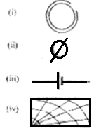
- With the aid of sketches, describe the use and construction of a Tee-square indicating the materials used. (3 marks)
Uses

Construction

- (a). Give the following information regarding parastatal organizations in Kenya with respect to: (3 marks)
- Ownership
- Management
- Services

- Describe each of the following manufactured boards: (3 marks)
- Plywood
- Chip Board
- Block Board

- Fig 1 shows the front elevation of a tilted right hexagonal pyramid of side 30mm (6 marks)
- Copy the given front elevation
- Draw the plan
- Draw the left end elevation of the pyramid
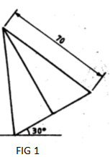
- Draw full size, a pentagon ABCDE having the following dimensions: sides AB= 70mm, BC= 60mm, CD=65mm, EA=45mm, diagonals AC=100mm AD=90mm and Angle AED=90⁰. (7 marks)

- Exploded Pictorial drawing of a dovetail joint is shown in Fig 2, assemble the parts and draw the following views. ( 6 marks)
- Front Elevation in the direction of arrow A
- End Elevation in the direction of arrow B
- The Plan
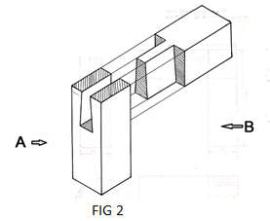

- Fig 3. Shows three views of a block drawn in first angle projection. Make a sketch of the block in two point perspective with Y as the lowest point ( 7 marks)
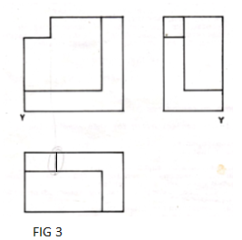
- Draw a square of equal area to the triangle XYZ in figure 4. (5 marks)
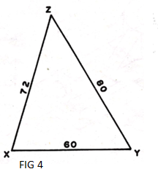

- Two views of a machine component are shown 5 draw the object in oblique cabinet projection .( 6marks)
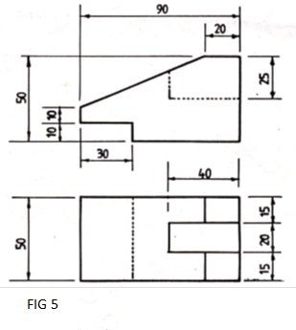
Section B (20 marks)
This question is compulsory and students are advised to spend not more than one hour
- Figure 6 shows pulley support bracket drawn in first angle projection. Assemble the parts and draw full size the following views in first angle projection:
(a) Sectional front elevation along the cutting plane x-x
(b) Plan in first angle projection.
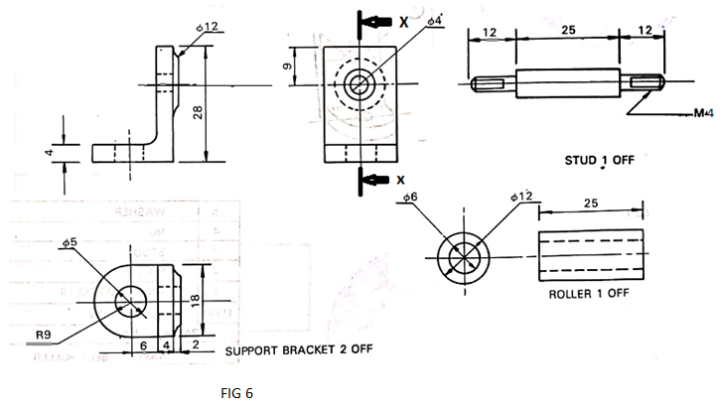

Section C (30 marks)
Answer Any Two questions in this section in the A3 provided
- Figure 7 shows two views of a block. make full size isometric drawing of the block taking corner “A ”as the lowest point (15 marks)
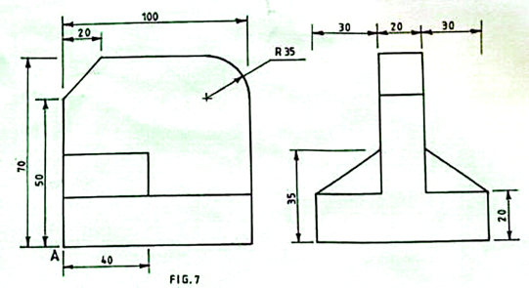
- Figure 8 the front elevation of a truncated pyramid along cutting plane BBThe slider A is constrained to move along groove “XY” tilted at 60⁰. While the crank OB rotates about center “O”. Plot the locus of “D” when OB makes one complete revolution. (15 marks)
AB=90
OB=25
AD=OB
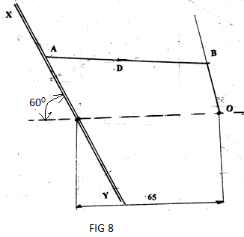

- Figure 9 below shows a block drawn in isometric. (15 marks)
Draw full size in first angle the following views of the block.
- Sectional Front elevation A-A
- End elevation
- The plan
