Kenya Certificate of Secondary Education
TERM 1 EXAMINATIONS 2024
Chemistry
FORM 3
MARCH 2024 TIME: 2 Hours

Name: ………………………………………….....…… Adm No: ………………
Class: ………………Candidate’s Signature: ……………. Date: …../…/2024.

Instructions to candidates
- Write your name and admission number in the spaces provided above.
- Sign and write the date of the examination in the spaces provided above
- Answer ALL questions in this paper
- All working MUST clearly be shown in the spaces provided in this booklet.
- Non-programmable silent electronic calculators and KNEC mathematical tables may be used except where stated otherwise.
- Candidates should check the question paper to ensure that all the 12 pages are printed as indicated, and that no questions are missing.

FOR EXAMINER’S USE ONLY.
Question | Maximum score | Candidate’s score
1 − 29 | 80

- The figure below represents a chromatogram of sugar, caffeine and blackcurrant drink. Study it and use the information to answer the questions that follow.
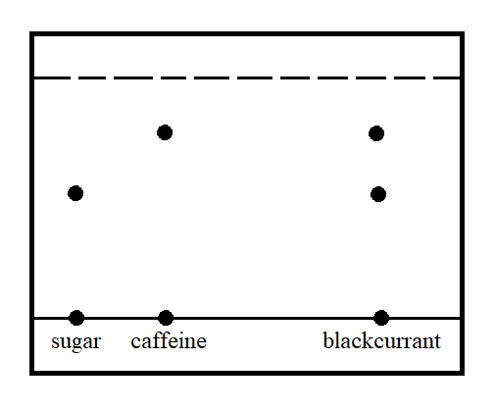
- State two properties that make it possible to separate the substances using this method. (1 mark)
…………………………………………………………………………………………………
…………………………………………………………………………………………………
- Water is not commonly used as a solvent in paper chromatography. State a reason for this. (1 mark)
…………………………………………………………………………………………………
…………………………………………………………………………………………………
- Atoms W, and Z are representations of elements in the periodic table. Their valences are 1 and 3 respectively. Write the formulae of their compounds in the table below. (3 marks)
 | W | Z
Formula of oxide
Formula of Hydrogen Carbonate
Formula of chloride

- The diagram below represents a filter paper that was placed in a certain part of a Bunsen burner flame. Study it and use it to answer the questions that follow.
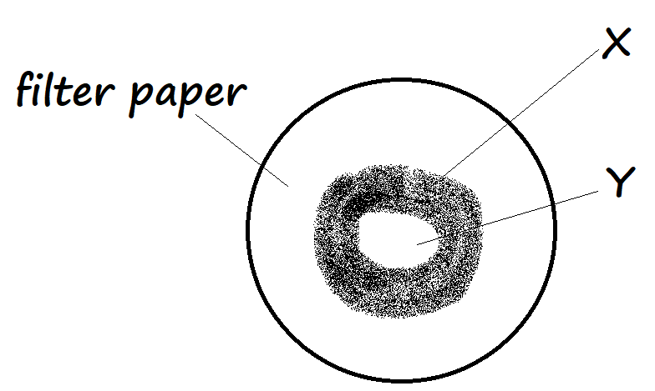
- Which flame was most likely being investigated? (1 mark)
…………………………………………………………………………………………………
- State the likely zones that resulted in the regions marked X and Y, stating the reason for your answer in each case (4 marks)
X ………………………………………………………………………………………………..
…………………………………………………………………………………………………..
Y ………………………………………………………………………………………………..
…………………………………………………………………………………………………..
- Equal volumes of air was passed through two separate combustion tubes A and B. Tube A was packed with magnesium powder and Tube B packed with zinc powder. If the tubes were each heated when air was being passed through, and the resulting air collected, from which tube was the smallest volume of gas collected? Explain. (2 marks)
………………………………………………………………………………………………………
………………………………………………………………………………………………………
………………………………………………………………………………………………………

- When a pink solid V is heated strongly it breaks down to form droplets of a colourless liquid, and a pale blue residue Y. When the liquid droplets were added back to residue Y, the pink colour of V was regained.

- Identify:
- Solid V (½ mark)
………………………………………………………………………………………….......
- Solid Y (½ mark)
………………………………………………………………………………………….......
- What type of change does residue Y undergo when the colourless liquid was added back? Explain. (1 mark)
…………………………………………………………………………………………………..
…………………………………………………………………………………………………..
- State one application of the change illustrated by solid V and residue Y (1 mark)
…………………………………………………………………………………………………..
- A sample of water at sea level was found to boil at temperatures between 102.5ºC and 104.5ºC. Explain this observation. (2 marks)
…..…………………………………………………………………………………………………..
…..…………………………………………………………………………………………………..

- The diagram below represents a newly erected iron pillar to support a pier on the shallow parts of an ocean. The iron pillar is connected to a bar of copper as shown.
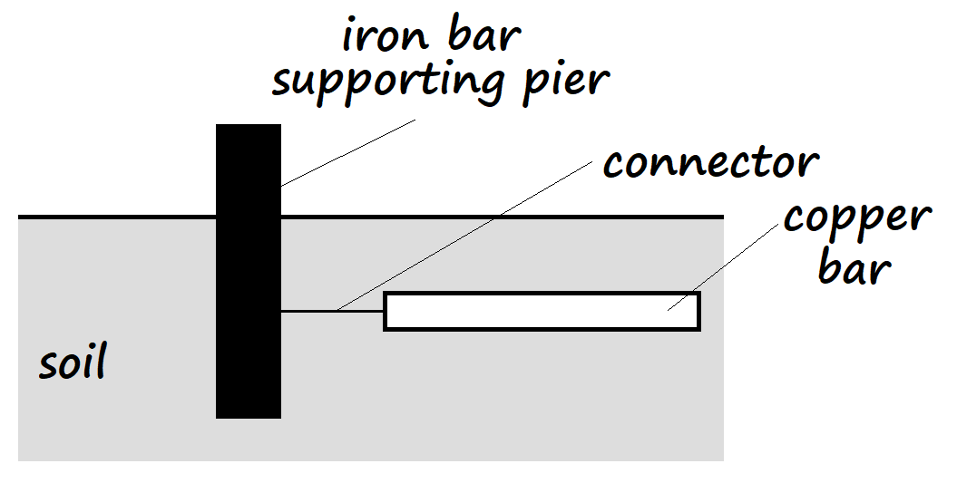

- What may have been the intended purpose of the bar of copper? (1 mark)
…..………………………………………………………………………………………………
…………………………………………………………………………………………………..
- State and explain the expected observation after two weeks, in the setup above. (2 marks)
…..……………………………………………………………………………………………..
…..……………………………………………………………………………………………..
- A student represented an atom of element J using the diagram below.
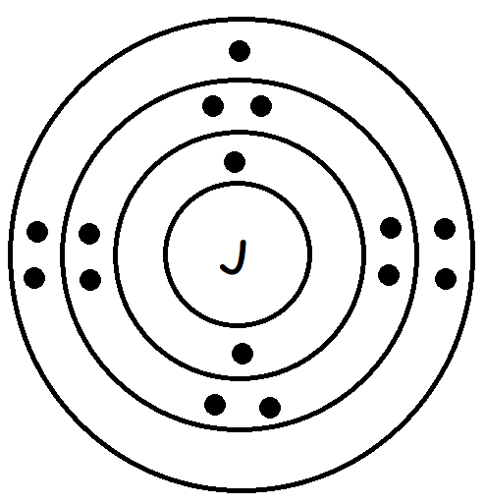
- Write an equation for the formation of a stable ion of element J (1 mark)
…..………………………………………………………………………………..……………..

- Write the valency of element J and the oxidation number of its ion (1 mark)
Valency ……………………………………………………………………………………….
Oxidation number……………………………………………………………………………..
- When the oxide of metal D is heated in the presence of metal S, the oxide is reduced. The oxide of metal S is not reduced when heated together with metal F and with metal D. The oxide of metal F is reduced by metal S and not by metal D. Arrange the three metals horizontally, in their order of decreasing reactivity. (1 mark)
…..…………………………………………………………………………………………………..
…..…………………………………………………………………………………………………..

- Calculate the number of nitrogen atoms that are found in 1.4g of nitrogen gas (2 marks)
(N = 14, L = 6.023X10²³)
…..…………………………………………………………………………………………………..
…..…………………………………………………………………………………………………..
…..…………………………………………………………………………………………………..
- Give the name of the processes that occur when the following substances are left in open watch glasses overnight:
- Concentrated sulphuric (VI) acid (1 mark)
…..………………………………………………………………………………………………
…..……………………………………………………………………………………………..
- Sodium carbohydrate decahydrate (1 mark)
…..……………………………………………………………………………………………..
…..……………………………………………………………………………………………..
- Alkali earth metals conduct electricity in the solid state but their compounds do not. Explain this observation (2 marks)
…..…………………………………………………………………………………………………..
…..…………………………………………………………………………………………………..
- In an experiment, ammonium chloride was heated in a test tube. When a moist red litmus paper was placed in the rim of the test tube, the paper first changed blue then changed back to red. Explain this observation. (2 marks)
…..…………………………………………………………………………………………………..
…..…………………………………………………………………………………………………..
- The electron arrangement for elements represented by letters W, X, Y and Z are as shown below
W: 2.8.6 X: 2.8.2 Y: 2.8.1 Z: 2.8.8
- Select the element which forms:
- A divalent anion (1 mark)
…..……………………………………………………..…………………………………..
- A partially soluble hydroxide (1 mark)
…..…………………………………………………………………………………………..
- Which element has the largest atomic radius? Explain (2 marks)
…..………………………………………..……………………………………………………..
…..……………………………………………………………………………………..………..
- White crystals of sugar change to a black solid when mixed with excess concentrated sulphuric (VI) acid. Explain this observation (1 mark)
…..…………………………………………………………………………………………………..
…..…………………………………………………………………………………………………..
- Nitrogen gas can be obtained through fractional distillation of liquefied air or by heating ammonium nitrate. The nitrogen obtained from fractional distillation of liquefied air is heavier than that extracted from ammonium nitrate. Explain. (2 marks)
…..…………………………………………………………………………………………………..
…..…………………………………………………………………………………………………..
- The figure below is a sketch for the cooling curve for water. Study it and use it to answer the questions that follow.
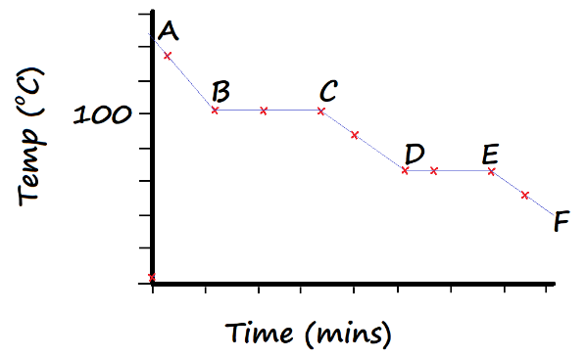
- In terms of Kinetic Theory, explain what happens to the molecules of water in region CD. (2 marks)
…..……………………………………………………………………………………………..
…..……………………………………………………………………………………………..
- In what physical state is water in the region AB? (1 mark)
…..……………………………………………………………………………………………..
- A bottle containing a stock solution of nitric (V) acid has a label with the following information:
Density: 1.44gcm⁻³
Formula mass: 63g/mole
Percentage purity: 65%
- Determine the concentration of this stock solution in moles per litre (2 marks)
…..……………………………………………………………………………………………..
…..……………………………………………………………………………………………..
…..……………………………………………………………………………………………..
- Calculate the concentration of a nitric (V) acid solution prepared by adding distilled water to 20cm³ of the stock acid solution to make 250cm³ of solution (2 marks)
…..……………………………………………………………………………………………..
…………………………………………………………………………………………………..
…………………………………………………………………………………………………..

- State any two differences between a luminous flame and a non-luminous flame (2 marks)
…..……………………………………………………………………………………………..
- A luminous flame produces bright yellow light. Explain this observation. (2 marks)
…..……………………………………………………………………………………………..
…………………………………………………………………………………………………..
- The setup below is a boiling tube inverted over a basin of chlorine water
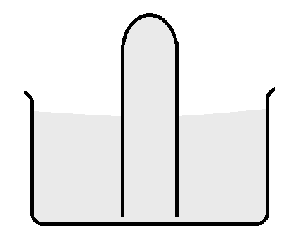
- State two observations that would be made when the setup is exposed to sunlight (2 marks)
…..………………………………………………………………………………………………
…………………………………………………………………………………………………..

- Write a chemical equation for the reaction that occurs in a) above (1 mark)
…..……………………………………………………………………………………………..

- A 5.0g sample of calcium carbonate powder was allowed to react with 25cm³ of a 1.2M hydrochloric acid solution until there was no further reaction. Calculate the mass of calcium carbonate that remained unreacted (3 marks)
(Ca = 40, C = 12, O = 16)
…..…………………………………………………………………………………………………..
…..…………………………………………………………………………………………………..
…..…………………………………………………………………………………………………..
- The diagram below represents one of the allotropes of carbon.
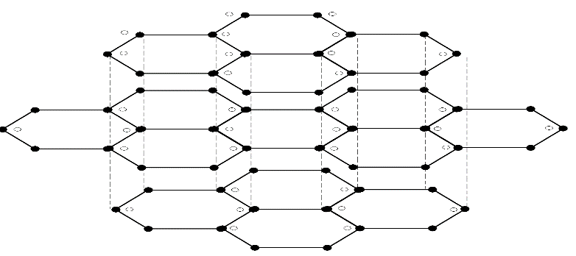
- Define the term ‘allotrope’ (1 mark)
………………………………………………………………………………………………….
…..……………………………………………………………………………………………..
- The structure has other particles represented with open dots as shown. How do these particles become a part of the structure of the allotrope? (2 marks)
…..……………………………………………………………………………………………..
…..……………………………………………………………………………………………..

- State one use of this allotrope that does not rely on the presence of the particles mentioned in b) above (1 mark)
…..……………………………………………………………………………………………..
…..……………………………………………………………………………………………..
- 50cm³ of carbon (IV) oxide diffuses through a porous boundary in 15 seconds. Calculate the time taken by 75cm³ of nitrogen (IV) oxide to diffuse through the same porous boundary under similar conditions (2 marks)
(C = 12, O = 16, N = 14)
…..…………………………………………………………………………………………………..
…..…………………………………………………………………………………………………..

- In terms of structure and bonding, explain why water has a boiling point of 100ºC while ethanol has a boiling point of 78.2ºC (2 marks)
…..……………………………………………………………………………………………..
…..……………………………………………………………………………………………..
…..……………………………………………………………………………………………..
- Using dots (•) and crosses (×) to represent electrons, draw the structure of silicon (IV) oxide and label all the bonds that would hold together four units of the compound. (2 marks)

- A fixed mass of a gas occupied a volume of 96cm³ at 70ºC and 700mmHg pressure. Calculate the volume that the gas would occupy at s.t.p. (2 marks)
…..…………………………………………………………………………………………………..
…..…………………………………………………………………………………………………..
…..…………………………………………………………………………………………………..
- Molten lead (II) chloride is known as a binary electrolyte. State the meaning of the term ‘binary electrolyte’. (1 mark)
…..…………………………………………………………………………………………………..
…..…………………………………………………………………………………………………..
- Magnesium and aluminium are both period 3 metals. Magnesium chloride converts to gas at 1437ºC while aluminium chloride converts to gas at 183ºC.
- Give a reason for this disparity in temperatures for change in state. (2 marks)
…..……………………………………………………………………………………………..
…..……………………………………………………………………………………………..
- Magnesium chloride conducts electricity in one of its physical states while aluminium chloride does not conduct electricity in all its physical states. Explain this observation. (2 marks)
…..……………………………………………………………………………………………..
…..……………………………………………………………………………………………..
- State and explain the effects of solutions of magnesium chloride and aluminium chloride on both red and blue litmus papers (2 marks)
…..……………………………………………………………………………………………..
…..……………………………………………………………………………………………..
…..……………………………………………………………………………………………..
- When 100cm³ of a gaseous hydrocarbon C_{x}H_{y} burns in 400cm³ of oxygen, 100cm³ of that oxygen remains unused. 200cm³ of carbon (IV) oxide and 200cm³ of steam is formed.
- Determine the equation for the reaction from the information given (2 marks)
…..……………………………………………………………………………………………..
…………………………………………………………………………………………………..
- Determine the values of x and y (2 marks)
…..……………………………………………………………………………………………..
…..……………………………………………………………………………………………..
- Write ionic equations for the following reactions:
- Sodium sulphate solution and lead (II) nitrate solution (1 mark)
…..……………………………………………………………………………………………..

- Magnesium ribbon and iron (II) sulphate solution, when magnesium sulphate solution is formed. (1 mark)
…..………………………………………………………………………………………………

