Kenya Certificate of Secondary Education
TERM 1 EXAMINATIONS 2024

232 Composite Chemistry FORM 3
FEBRUARY/MARCH 2024 TIME: 2 Hours

MARKING GUIDE

- The figure below represents a chromatogram of sugar, caffeine and blackcurrant drink. Study it and use the information to answer the questions that follow.
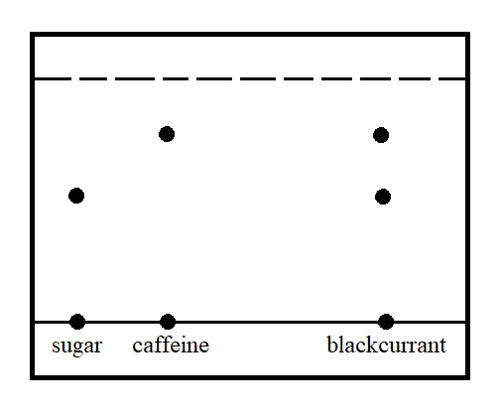
- State two properties that make it possible to separate the substances using this method. (1 mark)
Solubility of the substance in the solvent
Adsorbence of the substance on the adsorbent material
- Water is not commonly used as a solvent in paper chromatography. State a reason for this. (1 mark)
Some substances have low solubility in water hence are not properly separated
- Atoms W, and Z are representations of elements in the periodic table. Their valences are 1 and 3 respectively. Write the formulae of their compounds in the table below. (3 marks)
 | W | Z
Formula of oxide | W₂O | ZO
Formula of Hydrogen Carbonate | WHCO₃ | Z(HCO₃)₂
Formula of chloride | WCl | ZCl₂
Half mark for each correct formula

- The diagram below represents a filter paper that was placed in a certain part of a Bunsen burner flame. Study it and use it to answer the questions that follow.
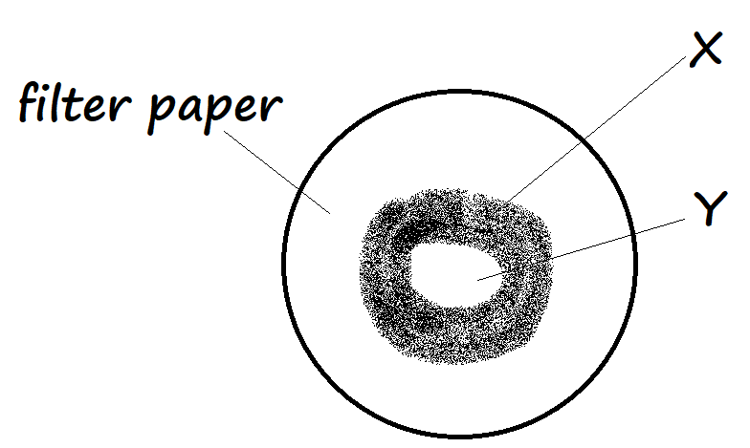
- Which flame was most likely being investigated? (1 mark)
Non luminous flame
- State the likely zones that resulted in the regions marked X and Y, stating the reason for your answer in each case (4 marks)
X Pale blue zone Complete burning occurs [hence charring]

Y Almost colourless region No burning occurs/It consists of unburnt gases
- Equal volumes of air was passed through two separate combustion tubes A and B. Tube A was packed with magnesium powder and Tube B packed with zinc powder. If the tubes were each heated when air was being passed through, and the resulting air collected, from which tube was the smallest volume of gas collected? Explain. (2 marks)
Tube A. Magnesium reacts with both nitrogen and oxygen from air while zinc only reacts with oxygen.
- When a pink solid V is heated strongly it breaks down to form droplets of a colourless liquid, and a pale blue residue Y. When the liquid droplets were added back to residue Y, the pink colour of V was regained.

- Identify:
- Solid V (½ mark)
Hydrated cobalt (II) chloride
- Solid Y (½ mark)
Anhydrous cobalt (II) chloride
- What type of change does residue Y undergo when the colourless liquid was added back? Explain. (1 mark)
Temporary chemical change. A new substance is formed when the initial solid is heated, and the initial substance regained when water is added to the residue.
- State one application of the change illustrated by solid V and residue Y (1 mark)
As a chemical test for the presence of water.
- A sample of water at sea level was found to boil at temperatures between 102.5ºC and 104.5ºC. Explain this observation. (2 marks)
The water contained impurities and therefore boiled over a range of temperatures.
- The diagram below represents a newly erected iron pillar to support a pier on the shallow parts of an ocean. The iron pillar is connected to a bar of copper as shown.
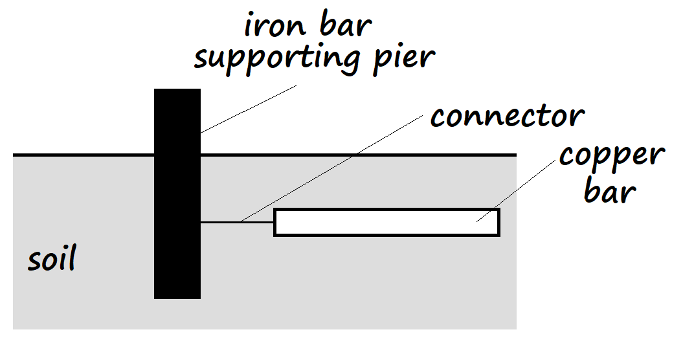
- What may have been the intended purpose of the bar of copper? (1 mark)
To protect the iron bar from rusting
- State and explain the expected observation after two weeks, in the setup above. (2 marks)
The iron bar rusted [intensely]. Copper is below iron in the reactivity series and therefore did not protect the iron bar from the saline ocean water which accelerated rusting.

- A student represented an atom of element J using the diagram below.
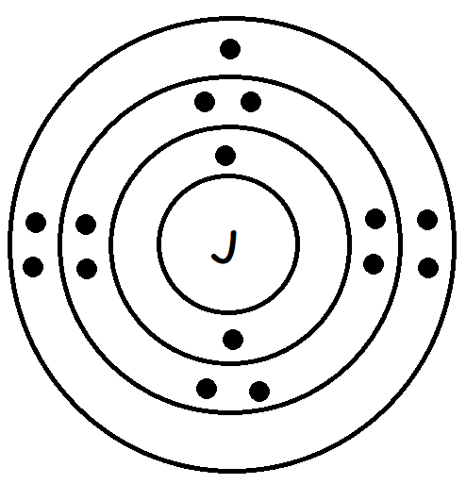
- Write an equation for the formation of a stable ion of element J (1 mark)
J + 2e⁻ J²⁻
Accept: S + 2e⁻ S²⁻
- Write the valency of element J and the oxidation number of its ion (1 mark)
Valency 2
Oxidation number -2 reject 2-
- When the oxide of metal D is heated in the presence of metal S, the oxide is reduced. The oxide of metal S is not reduced when heated together with metal F and with metal D. The oxide of metal F is reduced by metal S and not by metal D. Arrange the three metals horizontally, in their order of decreasing reactivity. (1 mark)
S > F > D
- Calculate the number of nitrogen atoms that are found in 1.4g of nitrogen gas (2 marks)
(N = 14, L = 6.023X10²³)
28g N₂ contains 6.023X10²³ molecules
1.4g N₂ contains ${1.4}/{2.8}$ X 6.023X10²³
= 3.0115X10²² molecules

But 1 molecule contains 2 atoms
3.0115X10²² molecules contain 3.0115X10²² X 2
= 6.023X10²³ atoms
- Give the name of the processes that occur when the following substances are left in open watch glasses overnight:
- Concentrated sulphuric (VI) acid (1 mark)
Hygroscopy
- Sodium carbohydrate decahydrate (1 mark)
Efflorescence
- Alkali earth metals conduct electricity in the solid state but their compounds do not. Explain this observation (2 marks)
The metals have delocalised electrons in their solid state hence conduct but their compounds mostly have strong ionic bonds hence no mobile ions in their solid state.
- In an experiment, ammonium chloride was heated in a test tube. When a moist red litmus paper was placed in the rim of the test tube, the paper first changed blue then changed back to red. Explain this observation. (2 marks)
Ammonium chloride decomposed to form ammonia gas and hydrogen chloride gas. Ammonia gas travels faster and first changes moist red litmus paper blue; hydrogen chloride gas travels slower hence changes the now moist blue litmus paper to red.
- The electron arrangement for elements represented by letters W, X, Y and Z are as shown below
W: 2.8.6 X: 2.8.2 Y: 2.8.1 Z: 2.8.8
- Select the element which forms:
- A divalent anion (1 mark)
W
- A partially soluble hydroxide (1 mark)
X
- Which element has the largest atomic radius? Explain (2 marks)
Y. It has the fewest number of protons for the same number of energy levels as the others // It has the weakest effective nuclear force of attraction.
- White crystals of sugar change to a black solid when mixed with excess concentrated sulphuric (VI) acid. Explain this observation (1 mark)
The concentrated sulphuric (VI) acid removes the elements of water//dehydrates the sugar, leaving only the element carbon, which is black.
- Nitrogen gas can be obtained through fractional distillation of liquefied air or by heating ammonium nitrate. The nitrogen obtained from fractional distillation of liquefied air is heavier than that extracted from ammonium nitrate. Explain. (2 marks)
Nitrogen gas obtained from fractional distillation of liquefied air contains some noble gases, hence heavier; while nitrogen gas obtained by heating ammonium nitrate is more pure hence lighter.
- The figure below is a sketch for the cooling curve for water. Study it and use it to answer the questions that follow.
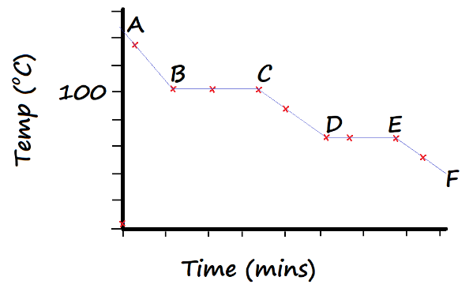
- In terms of Kinetic Theory, explain what happens to the molecules of water in region CD. (2 marks)
The vibration between molecules becomes less vigorous to allow the bond between the atoms to be strengthened.

- In what physical state is water in the region AB? (1 mark)
Gaseous state
- A bottle containing a stock solution of nitric (V) acid has a label with the following information:
Density: 1.44gcm⁻³
Formula mass: 63g/mole
Percentage purity: 65%
- Determine the concentration of this stock solution in moles per litre (2 marks)
1cm³ contains 1.44g HNO₃
1000cm³ contains 1000 X 1.44 = 1440g [half mark]

Impure mass 100% = 1440g
Pure mass 65% = $\frac{65}{100}$ X 1440g = 936g [half mark]

If 63g 1 mole
936g $\frac{936}{63}$ = 14.86 moles per litre [half mark at X-multiplication & half at correct answer]
- Calculate the concentration of a nitric (V) acid solution prepared by adding distilled water to 20cm³ of the stock acid solution to make 250cm³ of solution (2 marks)
14.86 X 20 = 250 X M₂
M₂ = $\frac{14.86 X 20}{250}$ = 1.1889M
OR
M₂ = $\frac{Student^{'}s ans in \left(a\right) X 20}{250}$ = Ans

- State any two differences between a luminous flame and a non-luminous flame (2 marks)
-Luminous has 4 zones, while non-luminous has 4 zones
-luminous flame produces soot while a non-luminous flame does not
-Luminous flame produces a lot of light while a non-luminous flame produces little light
- A luminous flame produces bright yellow light. Explain this observation. (2 marks)
The flame contains hot unburnt carbon particles which glow to produce yellow light.
- The setup below is a boiling tube inverted over a basin of chlorine water
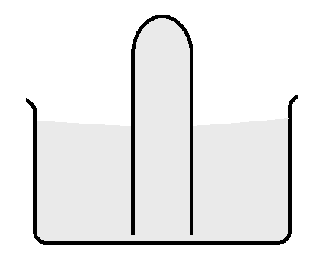
- State two observations that would be made when the setup is exposed to sunlight (2 marks)
-The pale yellow solution would change to colourless
-A colourless gas that rekindles a glowing splint is observed at the top of the boiling tube.
- Write a chemical equation for the reaction that occurs in a) above (1 mark)
2HClO _{(aq)} 2HCl _{(aq)} + O_{2 (g)}
- A 5.0g sample of calcium carbonate powder was allowed to react with 25cm³ of a 1.2M hydrochloric acid solution until there was no further reaction. Calculate the mass of calcium carbonate that remained unreacted (3 marks)
(Ca = 40, C = 12, O = 16)
Moles HCl = $\frac{1.2 X 25}{1000}$ = 0.03 moles
2 moles HCl reacts with 1 mole CaCO₃
0.03 moles HCl reacts with $\frac{0.03 X 1}{2}$ = 0.015 moles CaCO₃
Mass CaCO₃ reacting = moles X molar mass = 0.015 X 100 = 1.5g
Mass remaining = 5.0g – 1.5g = 3.5g
- The diagram below represents one of the allotropes of carbon.
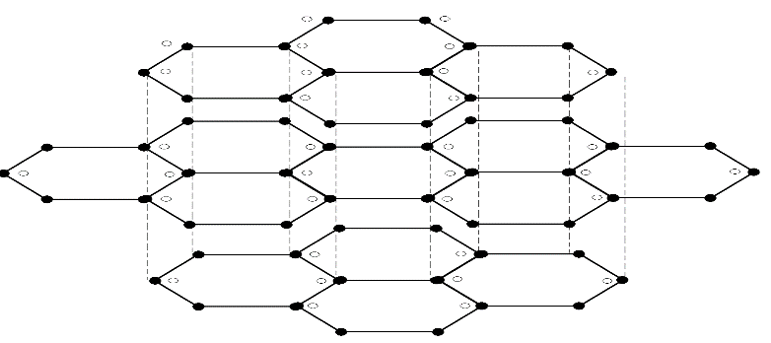
- Define the term ‘allotrope’ (1 mark)
Are different forms of an element existing in the same physical state.
- The structure has other particles represented with open dots as shown. How do these particles become a part of the structure of the allotrope? (2 marks)
Only 3 of the four valence electrons of carbon are used in bonding. One electron becomes delocalised.
- State one use of this allotrope that does not rely on the presence of the particles mentioned in b) above (1 mark)
Used as a lubricant
- 50cm³ of carbon (IV) oxide diffuses through a porous boundary in 15 seconds. Calculate the time taken by 75cm³ of nitrogen (IV) oxide to diffuse through the same porous boundary under similar conditions (2 marks)
(C = 12, O = 16, N = 14)
RCO₂ = $\frac{50}{15}$ = 3.333cm³/s M_{CO2} = 12 + 2(16) = 44 M_{NO2} = 14+2(16) = 46
R_{NO2} = R_{CO2} $÷$ $\sqrt{\frac{MNO2}{MCO2}}$ = 3.333 $÷$ $\sqrt{\frac{46}{44}}$ = 3.4790
T_{NO2} = V_{NO2} $÷$ R_{NO2} = $\frac{75}{3.4790}$ = 22.01s

- In terms of structure and bonding, explain why water has a boiling point of 100ºC while ethanol has a boiling point of 78.2ºC (2 marks)
Water and ethanol both have hydrogen bonding and weak Van der Waal’s forces. However, water has more hydrogen bonding than ethanol per molecule hence higher boiling point.
- Using dots (•) and crosses (×) to represent electrons, draw the structure of silicon (IV) oxide and label all the bonds that would hold together four units of the compound. (2 marks)
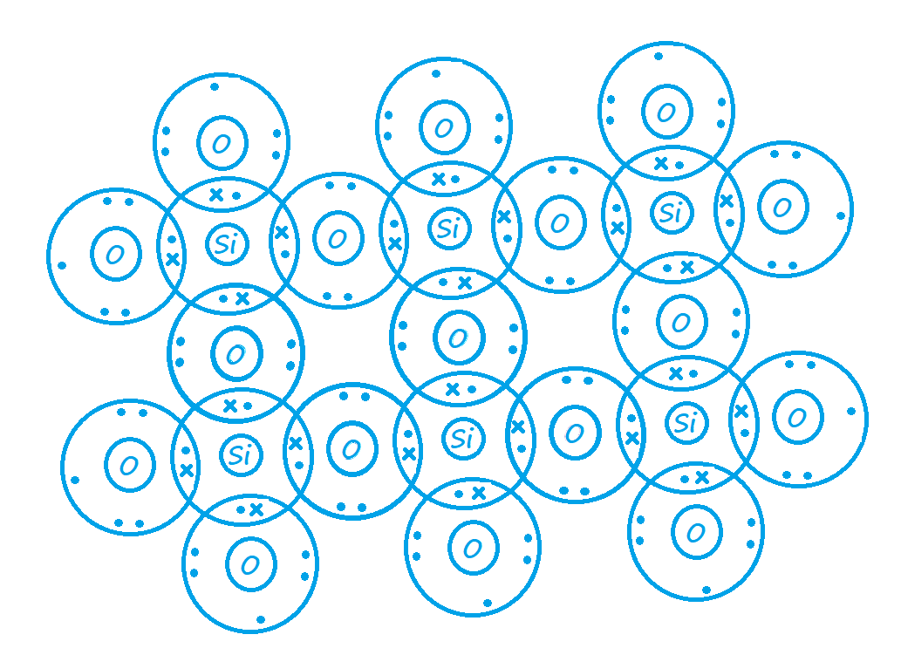
- A fixed mass of a gas occupied a volume of 96cm³ at 70ºC and 700mmHg pressure. Calculate the volume that the gas would occupy at s.t.p. (2 marks)
. $\frac{P1 V1}{T1}$ = $\frac{P2 V2}{T2}$ and s.t.p. = 273K and 760mmHg
$\frac{700 X 96}{(70+273)}$ = $\frac{760 X V2}{273}$
V₂ = $\frac{700 X 96 X 273}{\left(70+273\right)X 760}$ = 70.38cm³
- Molten lead (II) chloride is known as a binary electrolyte. State the meaning of the term ‘binary electrolyte’. (1 mark)
An electrolyte that has only one type of anion and one type of cation.
- Magnesium and aluminium are both period 3 metals. Magnesium chloride converts to gas at 1437ºC while aluminium chloride converts to gas at 183ºC.
- Give a reason for this disparity in temperatures for change in state. (2 marks)
Magnesium chloride has a giant ionic structure with strong ionic bonds while aluminium chloride has a simple molecular structure with weak Van der Waal’s forces of attraction.
- Magnesium chloride conducts electricity in one of its physical states while aluminium chloride does not conduct electricity in all its physical states. Explain this observation. (2 marks)
Magnesium chloride has a giant ionic structure with mobile ions in its molten state, while aluminium chloride has a simple molecular structure and lacks delocalised electrons and mobile ions.
- State and explain the effects of solutions of magnesium chloride and aluminium chloride on both red and blue litmus papers (2 marks)
Red litmus paper remains red and blue litmus paper remains blue in magnesium chloride solution while red litmus paper remains red and blue litmus paper changes red in aluminium chloride solution. Magnesium chloride only dissolves in water to form a neutral solution while aluminium chloride hydrolyses in water to form an acidic solution.
- When 100cm³ of a gaseous hydrocarbon C_{x}H_{y} burns in 400cm³ of oxygen, 100cm³ of that oxygen remains unused. 200cm³ of carbon (IV) oxide and 200cm³ of steam is formed.
- Determine the equation for the reaction from the information given (2 marks)
C_{x}H_{y} | + | O₂ |  | CO₂ | + | H₂O
100cm³ |  | 400-100 |  | 200 |  | 200
$$\frac{100}{100}$$ |  | $$\frac{300}{100}$$ |  | $$\frac{200}{200}$$ |  | $$\frac{200}{200}$$
1 |  | 3 |  | 2 |  | 2

C_{x}H_{y} + 3O₂ 2CO₂ + 2H₂O
- Determine the values of x and y (2 marks)
C_{X} = 2C x = 2
H_{y} = 2H₂ = 4H y = 4
- Write ionic equations for the following reactions:
- Sodium sulphate solution and lead (II) nitrate solution (1 mark)
Pb²⁺_{(aq)} + SO₄²⁻_{(aq)} PbSO_{4 (s)}
- Magnesium ribbon and iron (II) sulphate solution, when magnesium sulphate solution is formed. (1 mark)
Mg _{(s)} + Fe²⁺_{(aq)} Mg²⁺_{(aq)} + Fe _{(s)}

