**NAME: ……………………………………………….. ADMNO: ………………………………….**

**SCHOOL: ……………………………………………...SIGNATURE: ………………………………**

**DATE: ……………………………**

**PAPER 1**

**BIOLOGY FORM 3 TERM 1**

**(THEORY)**

**MARCH, 2024 - 2 HOURS**

**INSTRUCTIONS TO CANDIDATES**

1. Write your name, admission number and school in the spaces provided above
2. Sign and write the date of the examination in the spaces provided above
3. Answer ALL the questions in the spaces provided on the question paper
4. Candidates should check the question paper to ascertain that all the pages are printed as indicated and that no questions are missing.
5. Candidates should answer the questions in English

**FOR EXAMINER’S USE ONLY**

|  |  |  |  |  |  |  |  |  |  |  |  |  |  |  |  |
| --- | --- | --- | --- | --- | --- | --- | --- | --- | --- | --- | --- | --- | --- | --- | --- |
| **1** | **2** | **3** | **4** | **5** | **6** | **7** | **8** | **9** | **10** | **11** | **12** | **13** | **14** | **15** | **16** |
|  |  |  |  |  |  |  |  |  |  |  |  |  |  |  |  |

|  |  |  |  |  |  |  |  |
| --- | --- | --- | --- | --- | --- | --- | --- |
| **17** | **18** | **19** | **20** | **21** | **22** | **23** | **GRAND TOTAL** |
|  |  |  |  |  |  |  |  |

***This paper consists of 11 printed pages***

**Answer all the questions in the spaces provided.**

1. Explain the following in a predator- prey relationship in a natural habitat. (2 marks)
2. Predators have frontal eyes.

………………………………………………………………………………………………………………………………………………………………………………………………………………………………

1. Some predators stalk, approach and attack the prey against the direction of wind flow.

………………………………………………………………………………………………………………………………………………………………………………………………………………………………

1. The diagram below represents the transverse section through a part of a plant and a structure, K, obtained from the same section.

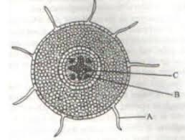 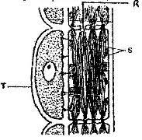

**K**

1. i) Identify the part labelled **A**. (1 mark)

…………………………………………………………………………………………………………

ii) State the function of the part labelled **A**. **(**1 mark)

…………………………………………………………………………………………………………………………………………………………………………………………………………………………

1. Identify the class of the plant from which the section was obtained. (1 mark)

………………………………………………………………………………………………………….

Reason. (1 mark)

…………………………………………………………………………………………………………………………………………………………………………………………………………………………

1. Identify the organ of the plant from which the section was obtained. (1mark)

…………………………………………………………………………………………………………..

Reasons. (2 marks)

…………………………………………………………………………………………………………………………………………………………………………………………………………………………

1. Which label on the section correctly represents the part from which structure K was obtained. (1mark)

…………………………………………………………………………………………………………..

1. State one way in which part labelled T in structure K is structurally adapted to support the function of K. (1 Mark)

………………………………………………………………………………………………………….

1. The diagram below represents the cross section of a normal artery and the changes on its size, A and B under different environmental conditions.

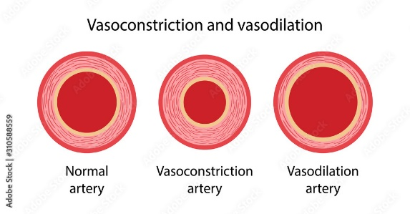 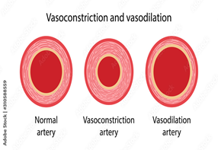 

1. B.
2. i) State the environmental condition under which the change represented by A is expected. (1 mark)

…………………………………………………………………………………………………………………

ii) Suggest the internal body temperature of the person whose artery is represented by A. (1 mark)

…………………………………………………………………………………………………………………

iii) State one physical activity that may trigger the artery size to change as represented in A. (1 mark)

………………………………………………………………………………………………………………..

1. What name is given to the phenomena represented by B. (1 mark)

…………………………………………………………………………………………………………………

1. i) Suggest the volume of urine produced by a person during the condition where the artery changes to size B.

……………………………………………………………………………………………………. (1 mark)

ii) Explain your answer in 3. c) i) above. (2 marks)

……………………………………………………………………………………………………………………………………………………………………………………………………………………………………

1. Name the most appropriate method that could be used to estimate the population size of the following organisms. (2 marks)
2. Grasshoppers in the school field.

……………………………………………………………………………………………………….

1. Different plant species along the slope of a hill.

………………………………………………………………………………………………………..

1. Explain the reason for the following during preparations of fresh microscope slide in a light microscope.
2. Thin sectioning. (2 marks)

……………………………………………………………………………………………………….

……………………………………………………………………………………………………….

1. Staining. (1 mark)

……………………………………………………………………………………………………….

1. Give two reasons why the light stage of photosynthesis is useful for the dark stage. (2 marks)

…………………………………………………………………………………………………………………………………………………………………………………………………………………………………….

1. State two observable features of a male cone that would make it easy for a student to identify it positively on a tree. (2 marks)

……………………………………………………………………………………………………………………………………………………………………………………………………………………………………

1. Explain the role of the following in protecting the body against invasion of disease causing organisms.
2. Gastric secretions. (2 marks)

……………………………………………………………………………………………………………………………………………………………………………………………………………………

1. Clotting of blood. (2marks)

…………………………………………………………………………………………………………………………………………………………………………………………………………………….

1. State two functions of lysosomes. (2 marks)

……………………………………………………………………………………………………………………………………………………………………………………………………………………………………

1. During an experiment, it was found that germinating bean seeds released 9.0 cm3 of Carbon (IV) Oxide while 8.8cm3 of Oxygen was consumed.
2. Calculate the RQ. (2 marks)
3. Identify the respiratory substrate. (1 mark)

………………………………………………………………………………………………………..

1. Identify the parts of the mammalian heart that plays the following roles.
2. Slows down the rate of pumping of blood. (1 mark)

…………………………………………………………………………………………………………..

1. Prevents over dilation of the heart. (1 mark)

………………………………………………………………………………………………………….

1. Prevents backflow of blood during contraction of the ventricles. (2 marks)

…………………………………………………………………………………………………………………………………………………………………………………………………………………….

1. The diagram below represents an apparatus used to collect specimen for study.

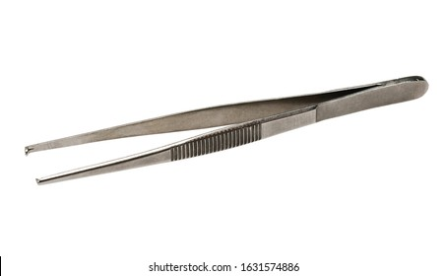

1. Identify the apparatus. (1 mark)

……………………………………………………………………………………………………………

1. Name one specimen in each case below where the use of the apparatus is recommended. (2 marks)

Plant specimen…………………………………………………………………………………………..

Animal specimen. ………………………………………………………………………………………

1. Name one other apparatus that would be used together with the apparatus above to further enhance protection of the hands. (2 marks)

…………………………………………………………………………………………………………

1. The cardiac muscles are said to be myogenic. What is the meaning of the term myogenic. (1 mark)

………………………………………………………………………………………………………….....

1. A student mixed a sample of urine from a patient with Benedict’s solution and boiled the mixture.

the colour changed to orange.

1. Name the food substance that was present in the urine. (1 mark)

………………………………………………………………………………………………………..

1. Identify the disease that the patient was suffering from (1 mark)

……………………………………………………………………………………………………….

1. Name the organ in the patient may not be functioning properly? (1 mark)

……………………………………………………………………………………………………….

1. Name three plant leaf excretory products. (3 marks )

………………………………………………………………………………………………………………………………………………………………………………………………………………………………………………………………………………………………………………………………………………………

1. Explain the importance of the grana in the process of photosynthesis. . (2 marks)

…………………………………………………………………………………………………………………………………………………………………………………………………………………………………......

1. Name **two** cell structures that synthesize the following cell organelles. (2 marks)
2. Ribosomes (1 mark)

…………………………………………………………………………………………………………..

1. Lysosomes (1 mark)

…………………………………………………………………………………………………………

1. The diagram below represents a skull of a certain animal.

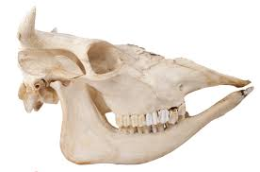

1. i) State the likely mode of nutrition for the animal from which the skull was obtained. (1 mark)

……………………………………………………………………………………………………………

ii) Give two reasons for your answer in 18 a i) above. (2 marks)

…………………………………………………………………………………………………………………………………………………………………………………………………………………….

1. With a reason identify the class of the animal from which the skull was obtained. (2 marks)

Class …………………………………………………………………………………………………….

Reason ……………………………………………………………..........................................................

…………………………………………………………………………………………………………..

1. Study the diagram below of a flower obtained from a plant.

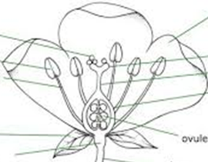

1. The following key may be used to identify the plant on which the flower is growing.

1 a) Petals separate from sepals …………………………………………. go to 2.

b) Petals and sepals joined …………………………………………….. Plant P.

2 a) Flower with four stamens …………………………………………… Plant Q.

b) Flower with more than four stamens …………………………………go to 3.

3 a)Ovary as tall as wide …………………………………………………Plant R.

b) Ovary taller than wide ………………………………………………. go to 4.

4 a) Flower has two petals ……………………………………………… Plant S.

b) Flower has more than two petals …………………………………... Plant T.

i) Use the dichotomous key to identify the plant from which the flower was obtained. (1 mark)

………………………………………………………………………………………………………….

ii) Write the steps followed to identify the plant. (1 mark)

………………………………………………………………………………………………………….

1. Use the observable features in the flower to identify the class of the plant from which it was obtained.

Class ……………………………………………………………………………………………. (1mark)

Reason ………………………………………………………………………………….............

………………………………………………………………………………………………… (1 mark)

1. Form 2 students set up an experiment on diffusion as shown below. The set up was left to stand for 15 minutes.

Partially permeable material



Mixture of protein solution and protease

Water at 37 oC

1. What does the partially permeable material represent in a cell. (1 mark)

……………………………………………………………………………………………………………

1. Give a reason for keeping the water at Water at 37 oC. (1 mark)

………………………………………………………………………………………………………………………………………………………………………………………………………………………………

1. The students carried out a test for proteins using the **contents of the partially permeable material** after the 15 minutes. Suggest the conclusions made. (1 mark)

………………………………………………………………………………………………………….

Explain your answer in 20 c) above. (1 mark)

………………………………………………………………………………………………………………………………………………………………………………………………………………………………

1. Amino acids were found to be present in the water. Explain its source and presence there. (2 marks)

………………………………………………………………………………………………………………………………………………………………………………………………………………………………

1. Name the carbohydrate storage compounds in the following: (2 marks)
2. Plant cells ………………………………………………………………………………………………
3. Fungi …………………………………………………………………………………………………...
4. a) Give two structural features that distinguish phagocytes from lymphocytes. (2 marks)

……………………………………………………………………………………………………………………………………………………………………………………………………………………………………

b) Identify one immunisable disease in Kenya. (1 mark)

………………………………………………………………………………………………………………….

1. State the causative agents of:
2. Cholera. (1 mark)

………………………………………………………………………………………………………….

1. Amoebic dysentery. (1 mark)

…………………………………………………………………………………………………………..