TERM ONE EXAMINATION 2024
FORM THREE

442/1 - ART AND DESIGN - Paper 1

MARKING SCHEME
________________________________________

Name………………………………………….………… Class…………………….................

Admin …………..……..………..…..…. Date……………….……………………………
_______________________________________________________________

Instructions to candidates

- Write your name, Class, house and date in the spaces provided above
- This paper consists of three sections A and B.
- Answer all questions in sections.
- Answers to all the questions must be written in the spaces provided.
- Where drawings and diagrams are appropriate, they should be included within the text of your answers
- Candidates should check the question paper to ascertain that all the pages are printed as indicated and that no questions are missing.
- Candidates should answer the questions in English
________________________________________________________________

For Examiner’s Use Only

Section | Question | Maximum score | Score
A | 1 | 25
B | 2-5 | 20
C | 6/7/8 | 15
Max. Score Paper 1 |  | 60

Candidates should check the question paper to ascertain that
All the pages are printed as indicated and that no questions are missing

SECTION A (25MARKS)
Answer all the questions in this section.

1 [a] which stage of drawing is the art work below? [1mk]

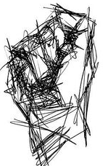Drawing as a sketch

[b]Any two shading techniques and how they can be employed in the above composition.
Most relevant from the above sketch stage are
-Hatching
-Cross hatching-well illustrated drawing [2mks@= 4mks]
Can also accept any other of the shading techniques from stippling/pointillism, block/smooth.etc

[c]With reference to the letter fonts below,
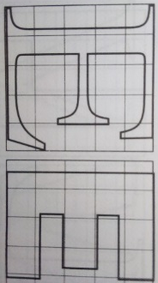
Sans serif
Serif
Sans –Letters without sharp edges/projections while serif are sharp edges of a letter form/font (2marks)

[d]Below is an art work in progress.

- The process-Printing (1mark)
- Technique: stencil printing (1mark)

[e]The chart below illustrates a colour triangle where ‘O’ is for Orange. Label the colours ABC. [3mks]

Red

Purple O
Green

Blue Y

A-Red
B-Purple
C-Blue
(ii)Type of colours BOD- Secondary colours [1mk]

[h] Three types of balance
Symmetrical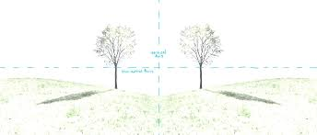
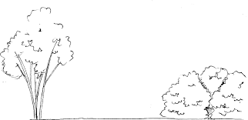 Radial
Asymmetrical
[Each should be well illustrated (3 marks)

[i]Any two types of texture (2marks]
Visual/simulated
Tactile/actual

[j]Tone-Degree of darkness/lightness of a surface, shadow-a dark image created by light rays being obstructed
by a shape/object. (2mks)
[b] Define a portrait
Category of human figure drawing from the head to torso [1mk]

SECTION B Answer all question [25 MARKS]
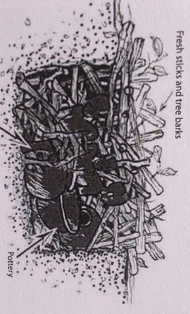
- Name the art process and the technique being used
Process firing clay/ceramic items in a kiln (1mark)
Technique…Traditional/open pit/wood fired/born fire kiln (1mark)

- Relevance of performing the process above.
Increase durability
More resistance to water and porosity.
Improve on aesthetic value
For vitrification reasons (2marks)

[c] Any other two types of the activity apart from the one mentioned in 2a above [2mks]
Electric, Gas, Saw dust kilns.[any 2=2mks]
3. Study the weave structures below.

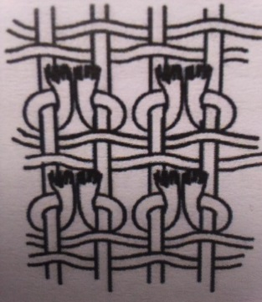
B
A
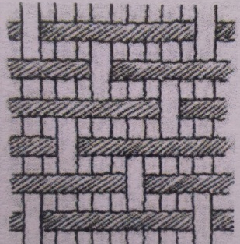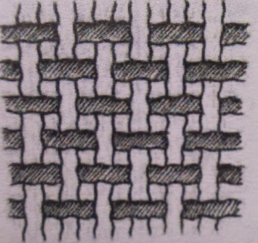
D
C

(a) Techniques a-d. (4marks)
[A]…Ghiordes knot
[B]…Twinning/Horizontal twinning [C]…Twilling.
[D] Plain/Tabby/Balanced weave

4. [a] Differentiate warp from weft faced fabrics. Warp faced fabrics are weave structure where the warp threads are more dominant and easily identifiable/seen while in weft faced fabrics, weft threads dominate the weave structure.(2marks)

[b] Two weaving defects and the causes and the causes [4mks]
Sagging-Loosened warp and wefts
Waisting-too tight efts and loose warps.

5[a] Study the composition below.

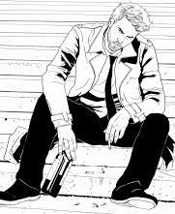

Analyse the use of the following principles in the composition above in terms of.

(ii)Subject matter…-depressed/deep thoughts (1 mark)

(i)Mood. Gloomy/sad//unhappy (1 mark)

(iii)Category/type of drawing-Human figure drawing/full figure drawing… (1 mark)

(6) The most outstanding
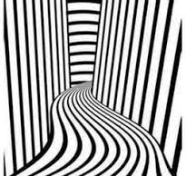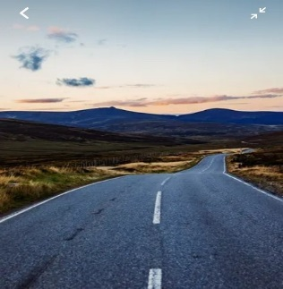

(i)Element -Lines [1mk]
Principle-Rhythm and movement. [1mk]
ii] How has the element above been used to create depth?
Lines have been used to show perspective here they tend to reduce in size and visibility is unclear to almost varnish in the farthest background [1mk]

[iii]Three ways of creating rhythm/movement [3mks]
Repetition,
Progression.
Alteration.

SECTION C [15 marks] Attempt only One question.

6. a] Difine the following giving two examples of each:
(i) Visual symbols-Symbols used to communicate non verbally, interpreted by sight to convey message e.g. road signs, sports signs, environmental, etc. (3mks)
- Cooperate Identities-A collection of visual elements used to communicate and convey companies philosophy missions, directions, visions etc e.g .Business cards, Memos, brochures letter heads, career bags, etc. (3mks)
- Identification symbols-Symbols/images that represent something, differentiate companies or organizations from each other e.g. logos, trademarks, emblems, badges, etc. (3mks)

[b] Three types of traffic control signs giving one example for each and its symbolic colour.
_Traffic Light Signals – light signals which light in sequence for the purpose of controlling movement of vehicles
Green-signals and Okays movement
Amber-alerts the motorist for readiness either to go or stop
Red-Signals for a stop.

_Road signs:
-prohibitive/ mandatory signs: these are mostly in circular shape. Red circle with black sign inside. Or blue circle with a white sign inside. They instruct motorists and road users on what to do.

-Warning signs.-these are triangular shaped. Red triangle with black signs inside. They are meant to caution road users of causes of danger ahead on the road.

_ Carriageway, pavement and Kerb Markings. Examples include lines painted on the surface of the road, double lines, longitudinal lines set alongside the direction of the traffic flow

7(a) Relief sculptures-A 3D art work that expresses emotions, ideas and feelings, seen/felt and expressed only on one side while the negative side id blocked. {3mk]
(b) 6 elements of a sculpture
Voids, Solids, Contours, planes, texture, colour (3mks)
(c)Explain the process of making a sculpture in round using Papier mache
-Obtain the tools and materials such as buckets, used old news print.
-Prepare an armature from the sketch of the required sculpture
-Superimpose/lay some news prints on the armature as a foundation
-Add the mashed paper/papier mache carefully and confidently as the shape builds up to the required size and form
-Add the details and precision
-Let it dry for some days
-Apply colour and decoration as required
-Mount, Exhibit and display to serve the purpose [9mks]

8(a) Explain the use of the following tools in mosaic work:
(i)Pliers-For clasping, holding and cutting materials into size such as glasses and other pieces
(ii) Spatula for Spreading adhesive evenly on to the support.
(iii) Stanley knife-Cutting tool for tesseraes and other small cubes and materials to be applied. (3mks)
(b) Two locally founded adhesive that can be used in mosaic art works
Wheat flour
Cow gum
Tree sap e.g. rubber and blue gum. (2mks)
c) Mosaic Collage
-Mono-media - Multi-media
-Juxtaposition -Superimposition
-Colour is emphasized - Texture is emphasized
-Materials are cut regular in shape -Irregular
-Shimmering effect -Textural effect (5mks)
(d) The process of making newspaper collage
> Obtain the tools and materials needed-used news prints and magazines, glue, scissors supports such as card boards, plywood, etc.
> Sketch the design/composition on the support as required.
>Apply the adhesive according to the outlined sketches following the outlined tones as per the inspiration
Continue until the whole composition is complete and apply finishing techniques- varnishing, mounting…
>Exhibit and display for critique and serving the intended purpose. [1mk @=5mks]

The end

