Name: …………………………………………………………………….…………….
Date………………Candidate’s Signature: ……….……. stream ....................Adm.no..................
PHYSICS
THEORY
Time: 2 hours
April 2024
Kenya Certificate of Secondary Education
FORM 2 PHYSICS
END TERM 1 2024
Instructions to Candidates
- Write your name, admission number, class and signature in the spaces provided at the top of the page. This paper consists of two sections; A and B.
- Answer ALL the questions in the spaces provided.
- Mathematical tables and electronic calculator may be used.
- All working MUST be clearly shown.
- This paper consists of 15 printed pages.
- Candidates should answer the questions in English and check to ensure that no question(s) is missing.
FOR EXAMINER’S USE ONLY

SECTION | QUESTIONS | MAXIMUM SCORE | CANDIDATE’S SCORE
A | 1 – 13 | 25
B | 14 | 11
 | 15 | 12
 | 16 | 11
 | 17 | 10
 | 18 | 11
TOTAL SCORE |  | 80

This paper consists of 15 printed pages. Candidates should check and ascertain that all questions are printed as indicated and that no questions are missing. TURN OVER

SECTION A (25 MARKS)
Answer all the questions in this section in the spaces provided.
- Figure 1 shows a section of a Vernier calipers used to measure the external diameter of a tube. The Vernier calipers has a zero error of 0.3cm. Determine the actual diameter of the tube. (1 mark)
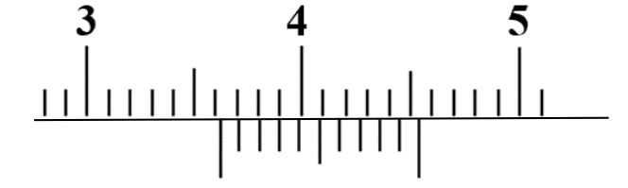
Figure 1
……………………………………………………………………………………………………………………………………………………………………………………………………… ……………………………………………………………………………
- A student used a container of mass x grams in an experiment to determine the density of a liquid. The following data was obtained:
Mass of empty container = xg
Mass of container when full of water = 80g
Mass of container when full of the liquid = 70g
The student obtained the density of the liquid to be$0.8g/{{cm}^{3}}$ . If the density of water is $1g/{{cm}^{3}}$, determine the value of x. (3 marks)
………………………………………………………………………………………………………………………………………………………………………………………………………………………………………………………………………………………………………………………

- Figures 2 shows two layers, A and B, of ice of equal thickness formed in a frozen pond
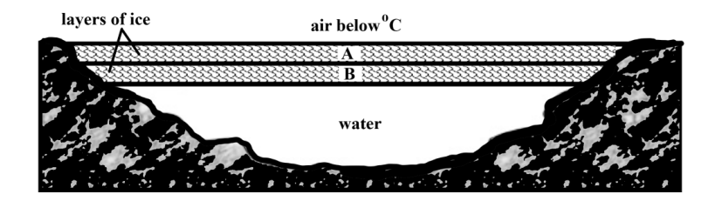
Figure 2
It is observed that layer B took longer to form even when the air above the pond remained at the same low temperature. Explain this observation. (2 marks.) ………………………………………………………………………………………………………………………………………………………………………………………………………………………………………………………………………………………
- Figure 3 shows two containers filled with equal volume of hot water.
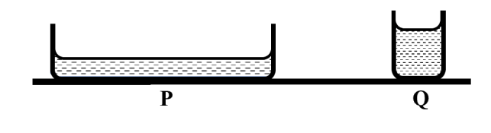
Figure 3
State, with a reason, in which container will water cool faster. (2 marks) ………………………………………………………………………………………………………………………………………………………………………………………………………………………………………………………………………………………………………………………

- Figure 4 shows a uniform horizontal beam of mass 5 kg pivoted at one end. The beam is supported by a spring and loaded with a mass of 2 kg.
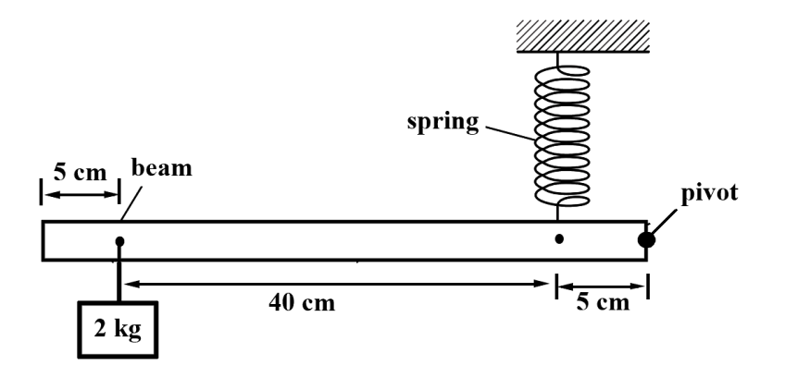
Figure 4
Calculate the tension in the spring when the beam is horizontal. (2 marks) ………………………………………………………………………………………………………………………………………………………………………………………………………………………………………………………………………………………………………………………………………………………………………………………………………………………………
- The set up in figure 5 was used to compare the rates of diffusion of ammonia and hydrochloric acid. In the experiment, cotton wool soaked in ammonia solution placed in one end of a long tube and cotton wool soaked in hydrochloric acid in the other end. A white ring forms in the tube as shown in the diagram.
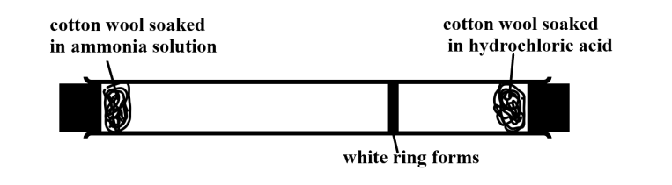
Figure 5
State with a reason which gas diffused faster. (2 marks) ………………………………………………………………………………………………………………………………………………………………………………………………………………………………………………………………………………………………………………………

- When a person carries a load in one arm, the other arm swings away from the body and the torso bends away from the load as shown in figure 6.
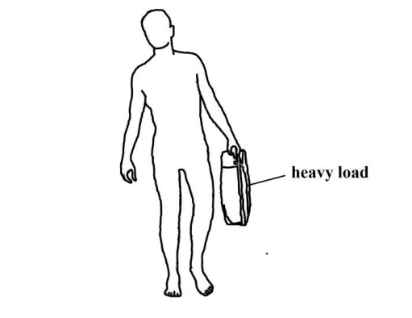
Figure 6
Explain why this is necessary. (2 marks) ……………………………………………………………………………………………………… ……………………………………………………………………………………………………… ………………………………………………………………………………………………………
- Oil accidentally spills in the sea and spread to form a monolayer film of area $2×{10}^{12}{cm}^{2}$. The oil molecule has a thickness of $5×{10}^{-19}m$.Determine the volume of the oil that spilt. (2 marks)
…………………………………………………………………………………………………………….…………………………………………………………………………………………………………………………………………………………………………………….…………………………………………………………………………………………………………………….
- A negatively charged rod is brought slowly towards the cap of a highly positively charged leaf electroscope. State and explain the observation made. (2 marks) ……………………………………………………………………………………………………………………………………………………………………………………………………………………………………………………………………………………………………………………………………………………………………………………

- A person standing out in the garden at night is observed to have two shadows of different sharpness. Explain this observation. (1 mark) ………………………………………………………………………………………………………………………………………………………………………………………………………………………………………………………………………………………
- The magnetic field lines between the poles of two bar magnets, X and Y, are shown in Figure 7 below.
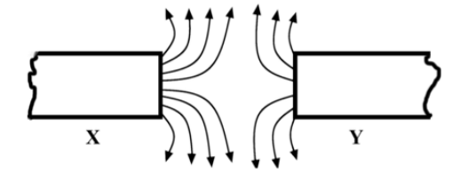
Figure 7
State with a reason which magnet is stronger. (2 marks). ………………………………………………………………………………………………………………………………………………………………………………………………………………………………………………………………………………………………………………………
- Figure 8 shows some water trapped on a canvas tent.

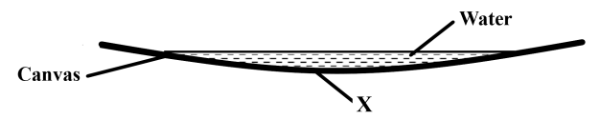
Figure 8
(i) Give a reason why water is trapped on the canvas. (1 mark) ………………………………………………………………………………………………………………………………………………………………………………………………………………

(ii) State and explain what is observed when soap is smeared at a point X on the lower side of the canvas. (2 marks) ………………………………………………………………………………………………………………………………………………………………………………………………………………………………………………………………………………………………………………………

- Explain why brakes fail in a hydraulic brake system when air gets in to the system.
(1 mark)
.......................................................................................................................................................................................................................................................................................................................................................................................................................................

SECTION B (55 MARKS)
Answer all the questions in this section in the spaces provided
- a) Other than being not visible give another reason why water is not a good barometric liquid. (1 mark) ………………………………………………………………………………………………………………………………………………………………………………………………………………………………………………………………………………………
b) State the principle of transmission of pressure in fluids. (1 mark)
.......................................................................................................................................................................................................................................................................................................................................................................................................................................

c) Figure 9 shows a hydraulic lift in a car repair workshop.

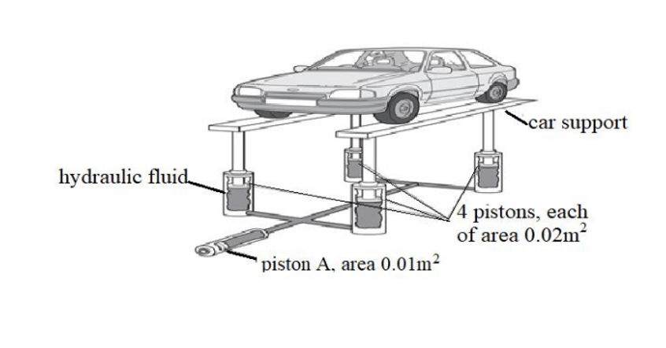
Figure 9
The hydraulic fluid transmits the pressure caused by piston A, equally to each of the four pistons holding up the car supports. The pressure throughout the fluid is the same. A force of 1000 N on piston A is just enough to raise the car.

Determine;
- The pressure caused by piston A on the hydraulic fluid. (2 marks) ……………………………………………………………………………………………………………………………………………………………………………………………………………………………………………………………………………………………………………………………………………………
- The total upward force caused by the fluid. (3 marks) ……………………………………………………………………………………………………………………………………………………………………………………………………………………………………………………………………………………………………………………………………………………
- The weight of each of the two car supports is 1000 N. Calculate the mass of the car. (2 marks) ……………………………………………………………………………………………………………………………………………………………………………………………………………………………………………………………………………………………………………………………………………………
c) State two properties to be considered when choosing the hydraulic fluid used in this system.
(2 marks)
………………………………………………………………………………………………………………………………………………………………………………………………………………………………………………………………………………………………………………………

- a) A solar panel is mounted on the roof of a house. Figure 10 shows a section through part of the solar panel.

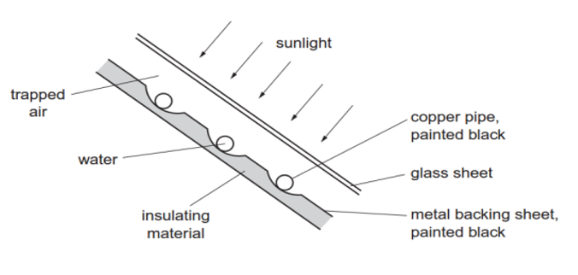
Figure 10

A pump makes water circulate through the copper pipes. The water is heated by passing through the solar panel. (a) give a reason for the following;
- the pipes are made of copper. (1 mark) …………………………………………………………………………………………………………………………………………………………………………………………
- the pipes and the metal backing sheet are painted black. (1 mark) …………………………………………………………………………………………………………………………………………………………………………………………
(iii) an insulating material is attached to the metal backing sheet. (1 mark) …………………………………………………………………………………………………………………………………………………………………………………………………………

b) The water in the set up in figure 11 is heated until it starts boiling.
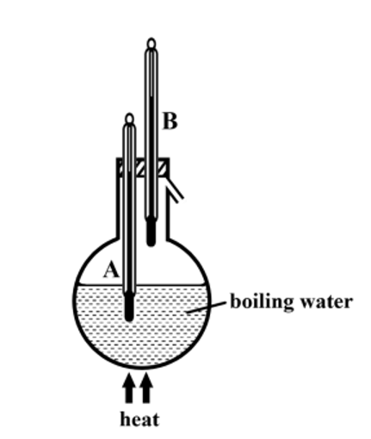
Figure 11

It is observed that the reading of thermometer A is higher than that of thermometer B. Explain this observation. (2 marks)

…………………………………………………………………………………………………………………………………………………………………………………………………………
c) Differentiate between heat and temperature. (2 marks)
....................................................................................................................................................................................................................................................................................................................................................................................................................................................................................................................................................................................

d) Figure 12 shows an inverted flask fitted with a capillary tube dipped into a water which is at room temperature.
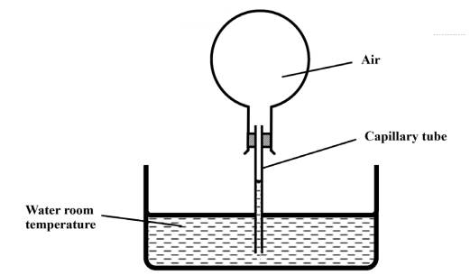
Figure 12
Explain what is observed when the flask is held with warm hands. (3 marks) …………………………………………………………………………………………………………………………………………………………………………………………………………………………………………………………………………………………………………………….………………………………………………………………
e) Figure 13(a) shows a setup with identical glass bulbs P and Q, filled with air and connected by a U-tube containing
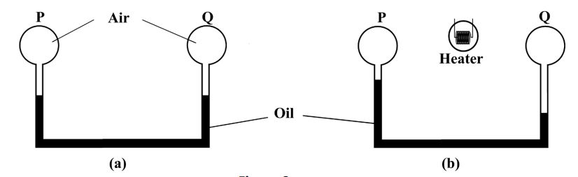
Figure 13
In figure 13(b) shows the same setup after an electric heater placed in the space between P and Q, is switched on for a few minutes. Explain the possible cause of the differences in oil levels in figure 13(b). (2 marks) ………………………………………………………………………………………………………………………………………………………………………………………………………………………………………………………………………………………………………………………
- a.) Figure 14 below show a mirror with the lower end pivoted to a wall and the other end suspended using a flexible rubber band 20cm long such that it makes an angle of${35}^{°}$ with the wall.
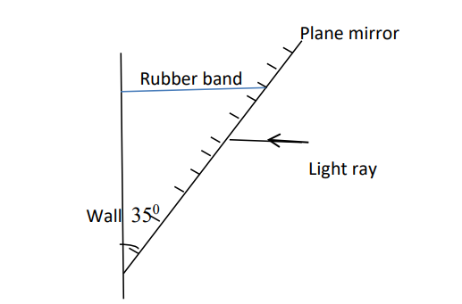
Figure 14
In a hot afternoon, the rubber band stretches by 22.12mm, a ray of light strikes the mirror horizontally. Calculate the angle between the horizontal and the new reflected ray.
(3 marks) ………………………………………………………………………………………………………………………………………………………………………………………………………………………………………………………………………………………………………………………………………………………………………………………………
b.) State two differences between images formed by pinhole camera and a Plane mirror. (2marks)
................................................................................................................................................................................................................................................................................................................................................................................................................................................................................................................................................................................................

c.) Figure 15 shows an object O placed between plane mirrors inclined at right angles.
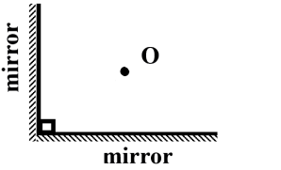
Figure 15
Determine the number of images formed. (2 marks)
………………………………………………………………………………………………………………………………………………………………………………………………………………………………………………………………………………………………
d) Describe the image formed by a plane mirror. (2 marks)
……………………………………………………………………………………………………………………………………………………………………………………………………………………………………………………………………………………………… e.) A student placed three cards each with a small hole at the Centre in a straight line as shown below.
Figure 16
- State the aim of the experiment. (1 mark)
.................................................................................................................................................................................................................................................................................................................................................................................................................................................................................

(ii) If one of the cards was displaced slightly to the left, state what would be observed. (1 mark)
....................................................................................................................................................................................................................................................................................................................................................................................................................................................................................

- a.) Figure 17 shows two insulated and uncharged metal spheres X and Y in contact. A positively charged rod is held near X and then the spheres are moved apart.
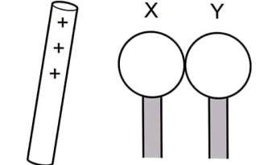
Figure 17
- In the space provided on the right side of figure 2, draw diagrams to show the charge on X and Y. (2 marks)
- Identify the method of charging used in figure 17 above. (1 mark)
........................................................................................................................................................................................................................................................................................................................
- A car battery requires topping up with distilled water occasionally.
- State why topping up is necessary. (1 mark) …………………………………………………………………………………………………………………………………………………………………………
- State why distilled water is used. (1 mark) …………………………………………………………………………………………………………………………………………………………………………
- Give one advantage of alkaline battery over lead acid accumulator. (1 mark). …………………………………………………………………………………………………………………………………………………………………………
- Calculate the amount of charge passing through a point in a circuit if a current of 5A flows for 1.5 minutes. (3 Marks)
....................................................................................................................................................................................................................................................................................................................................................................................................................................................................................
- Give a reason why it is not advisable to smoke a cigarette near a charging battery.
(1 mark)
....................................................................................................................................................................................................................................................................................................................................................................................................................................................................................
- a.) State two properties of magnets. (2marks)
....................................................................................................................................................................................................................................................................................................................................................................................................................................................................................

- Given a bar magnet, a steel bar and a string describe a simple experiment to distinguish between the magnet and the steel bar. (3 marks)
............................................................................................................................................................................................................................................................................................................................................................................................................................................................................................................................................................................................................................................................................................................................................................................................................

- Figure 18 shows a magnetic material being magnetized
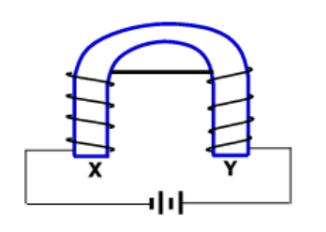
Figure 18
Identify the polarities of X and Y. (2mks)
........................................................................................................................................................................................................................................................................................................................
d.) The figure below shows two pins hanging from a magnet. Explain why they do not hang vertically downwards. (2 marks)
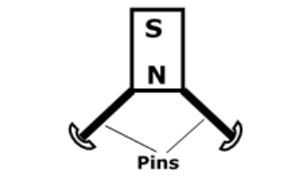

Figure 19

....................................................................................................................................................................................................................................................................................................................................................................................................................................................................................

e.) Figure 20 shows a graph of magnetization against magnetizing current for two materials A and B
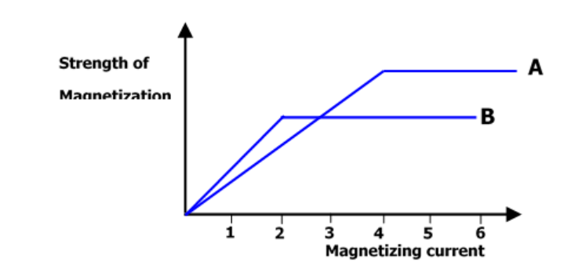
Figure 20
- State with a reason, the material which is more suitable for use in a transformer to concentrate the magnetic fields. (2marks)
....................................................................................................................................................................................................................................................................................................................................................................................................................................................................................

#END#

