Kenya Certificate of Secondary Education
PHYSICS
FORM 2 PHYSICS
MARKING SCHEME
END TERM 1
SECTION A (25 MARKS)
Answer all the questions in this section in the spaces provided.
- Figure 1 shows a section of a Vernier calipers used to measure the external diameter of a tube. The Vernier calipers has a zero error of 0.3cm. Determine the actual diameter of the tube. (1 mark)
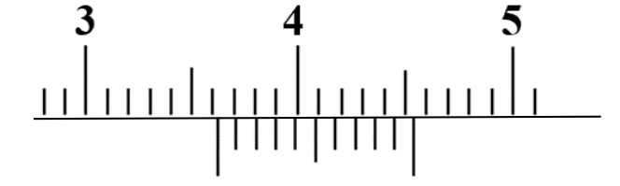
Figure 1
$3.63-0.3=3.33cm$
- A student used a container of mass x grams in an experiment to determine the density of a liquid. The following data was obtained:
Mass of empty container = xg
Mass of container when full of water = 80g
Mass of container when full of the liquid = 70g
The student obtained the density of the liquid to be$0.8g/{{cm}^{3}}$ . If the density of water is $1g/{{cm}^{3}}$, determine the value of x. (3 marks)

$$volume=\frac{mass}{density},( \frac{70-x}{0.8}=\frac{80-x}{1})$$
$$70-x=0.8\left(80-x\right);70-x=64-0.8$$
$$70-x=64-0.8x;70-64=x-0.8x;6=0.2x$$
$x=30g$

- Figures 2 shows two layers, A and B, of ice of equal thickness formed in a frozen pond
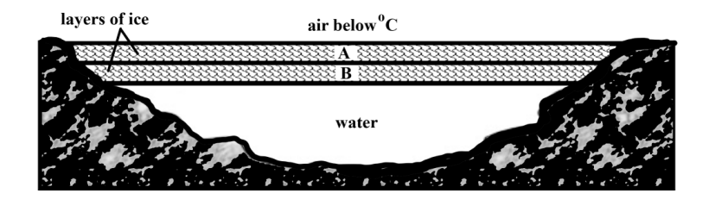
Figure 2
It is observed that layer B took longer to form even when the air above the pond remained at the same low temperature. Explain this observation. (2 marks.)
Ice is a poor thermal conductor. Layer A lowers the rate of conduction of heat from water to air.
- Figure 3 shows two containers filled with equal volume of hot water.
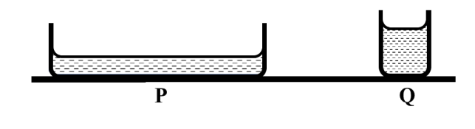
Figure 3
State, with a reason, in which container will water cool faster. (2 marks)
Container P.
The rate of emission of radiant heat is greater or the rate of evaporation is higher.
- Figure 4 shows a uniform horizontal beam of mass 5 kg pivoted at one end. The beam is supported by a spring and loaded with a mass of 2 kg.
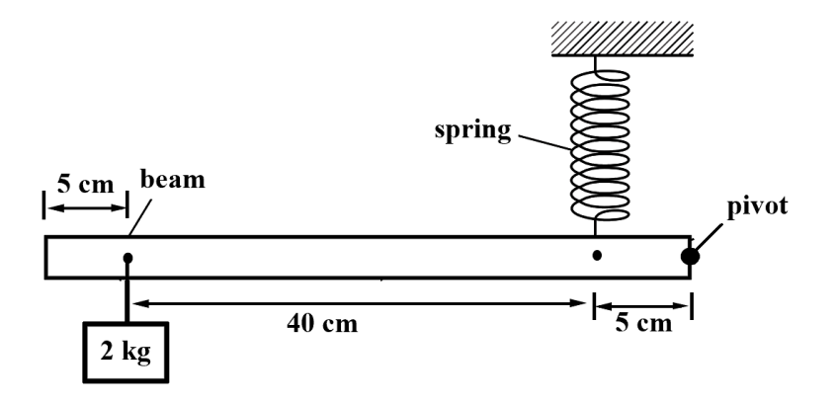
Figure 4
Calculate the tension in the spring when the beam is horizontal. (3 marks)

$$Taking moments about the pivot,$$
$Sum of clockwise moments=Sum of anticlockwise moments.$
$0.05m×T=(0.45m×20N)+(0.25×50N)$
$0.05T=21.5;T=430N$

- The set up in figure 5 was used to compare the rates of diffusion of ammonia and hydrochloric acid. In the experiment, cotton wool soaked in ammonia solution placed in one end of a long tube and cotton wool soaked in hydrochloric acid in the other end. A white ring forms in the tube as shown in the diagram.
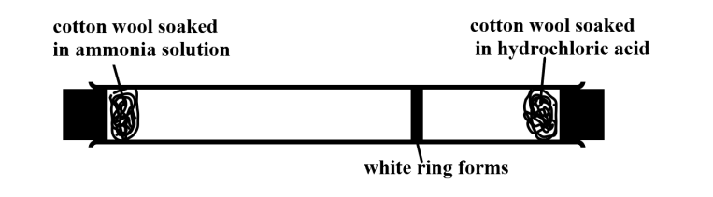
Figure 5
State with a reason which gas diffused faster. (2 marks)
Ammonia. Its molecules less dense than hydrochloric acid gas

- When a person carries a load in one arm, the other arm swings away from the body and the torso bends away from the load as shown in figure 6.
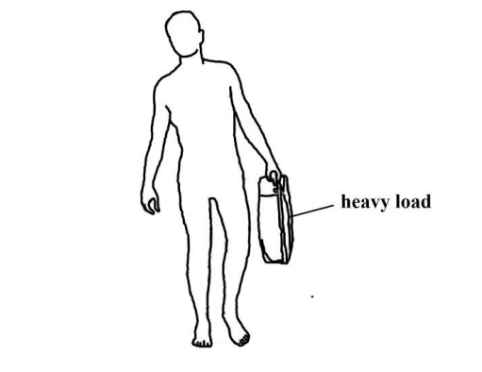
Figure 6

Explain why these is necessary. (2 marks)
To maintain stability.
This ensures that the vertical line through the center of gravity does not fall outside the base area.
- Oil accidentally spills in the sea and spread to form a monolayer film of area $2×{10}^{12}{cm}^{2}$. The oil molecule has a thickness of $5×{10}^{-19}m$. (2 marks)
$$volume=area of il patch×thickness of oil molecule$$
$volume=(2×{10}^{8}m^{2})×(5×{10}^{-19}m$)

$volume=1×{10}^{-10}m^{3}$
- A negatively charged rod is brought slowly towards the cap of a highly positively charged leaf electroscope. State and explain the observation made. (2 marks)

The leaf divergence first reduces but as the rod comes nearer, it diverges more.
The negative rod attracts the protons from the plate and the leaf making the electroscope neutral. On moving it much closer the divergence increase because the strong negative charges attract more protons from the leaf and plate making them more positive.
- A person standing out in the garden at night is observed to have two shadows of different sharpness. Explain this observation. (2 marks)
This is because, the center of the shadow receives no light at all from the light source. Light from some parts of the extended source of light reaches the other parts of the shadow on the ground, but this light is cut off by the body, resulting in a partial shadow at the edges.
- The magnetic field lines between the poles of two bar magnets, X and Y, are shown in Figure 7 below.
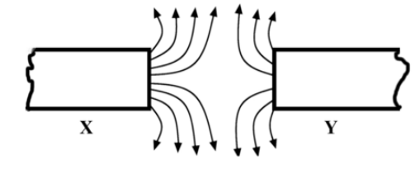
Figure 7
State with a reason which magnet is stronger. (2 marks).
x.
The field lines are more and closer together where the field is stronger.

- Figure 8 shows some water trapped on a canvas tent.

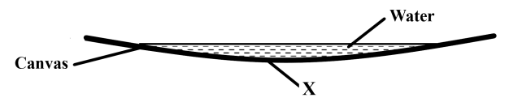
Figure 8
(i) Give a reason why water is trapped on the canvas. (1 mark)
This is due to surface tension.
(ii) State and explain what is observed when soap is smeared at a point X on the lower side of the canvas. (2 marks)
Water seeps through the canvas. Soap acts an impurity and weakens the surface tension.
- Explain why brakes fail in a hydraulic brake system when air gets in to the system.
(1 mark)
Air is compressible and does not transmit pressure.

SECTION B (55 MARKS)
Answer all the questions in this section in the spaces provided
- a) Other than being not visible give another reason why water is not a good barometric liquid. (1 mark)

Water has a relatively lower density and rises to great heights under atmospheric pressure.

b) State the principle of transmission of pressure in fluids. (1 mark)
pressure applied at one part in a fluid is transmitted equally to all other parts of the
enclosed fluid.

c) Figure 9 shows a hydraulic lift in a car repair workshop.
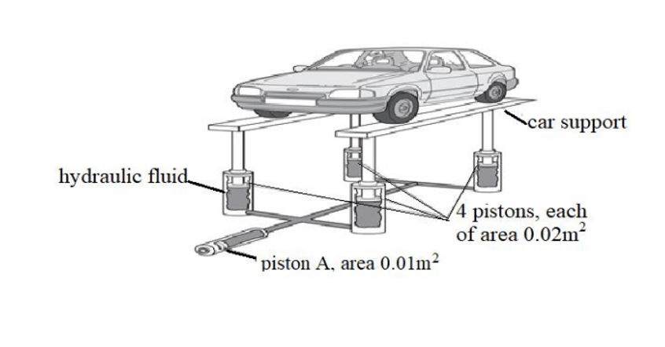
Figure 9
The hydraulic fluid transmits the pressure caused by piston A, equally to each of the four pistons holding up the car supports. The pressure throughout the fluid is the same. A force of 1000 N on piston A is just enough to raise the car.
Determine;

- The pressure caused by piston A on the hydraulic fluid. (2 marks)

$$P=\frac{F}{A}=\frac{1000}{0.01}=100,000pascals$$
- The total upward force caused by the fluid. (3 marks)
$F=P×A,$
$Force for 1 piston=100000×0.02=2000N$
$Total upward force=2000×4=8000N$

- The weight of each of the two car supports is 1000 N. Calculate the mass of the car. (2 marks)
$Weight of car=8000-\left(2×1000\right)=6000N$
Mass of car= 600kg
c) State two properties to be considered when choosing the hydraulic fluid used in this system.
(2 marks)
. Incompressible, non-corrosive, low melting point and high boiling pointAny 2 correct.
- a) A solar panel is mounted on the roof of a house. Figure 10 shows a section through part of the solar panel.

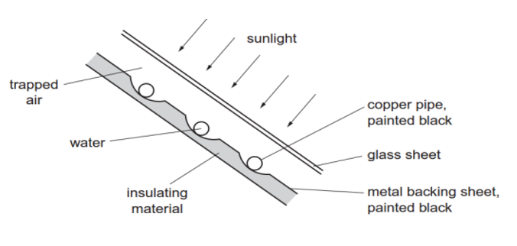
Figure 10
A pump makes water circulate through the copper pipes. The water is heated by passing through the solar panel. (a) give a reason for the following;
- the pipes are made of copper. (1 mark)
Copper is a good conductor of heat.
- the pipes and the metal backing sheet are painted black. (1 mark)
Black surface is a better absorber of radiant heat.
(iii) an insulating material is attached to the metal backing sheet. (1 mark)
To minimize heat loss.
b) The water in the set up in figure 11 is heated until it starts boiling.
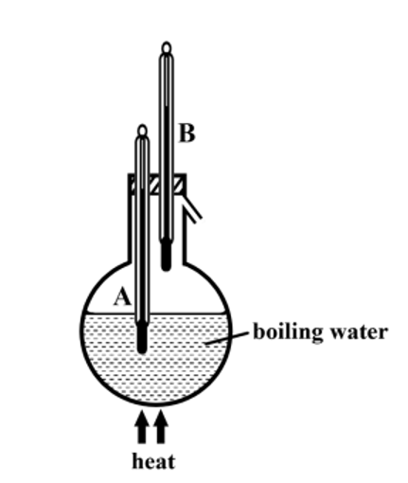
Figure 11

It is observed that the reading of thermometer A is higher than that of thermometer B. Explain this observation. (2 marks)
Due to impurities in water, the water has a higher boiling point than steam at the same pressure.
c) Differentiate between heat and temperature. (2 marks)
The degree (extent) of coldness or hotness of a body on some chosen scale is called the temperature of the body while Heat is a form of energy which passes from a body at a higher temperature to a body at a lower temperature.

d)Figure 12 shows an inverted flask fitted with a capillary tube dipped into a water which is at room temperature.
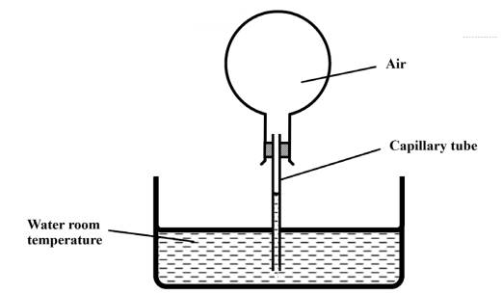
Figure 12
Explain what is observed when the flask is held with warm hands. (3 marks)
The level in the capillary tube rises then falls, the flask expands first, then air has a higher rate of expansion.
e) Figure 13(a) shows a setup with identical glass bulbs P and Q, filled with air and connected by a U-tube containing
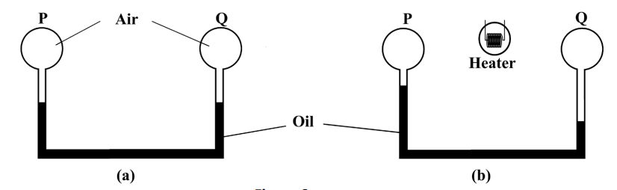
Figure 13
In figure 13(b) shows the same setup after an electric heater placed in the space between P and Q, is switched on for a few minutes. Explain the possible cause of the differences in oil levels in figure 13(b). (2 marks)
The heater is closer to Q than P. The rate of transfer of radiant heat to Q is higher than to P.
- a.) Figure 14 below show a mirror with the lower end pivoted to a wall and the other end suspended using a flexible rubber band 20cm long such that it makes an angle of${35}^{°}$ with the wall.
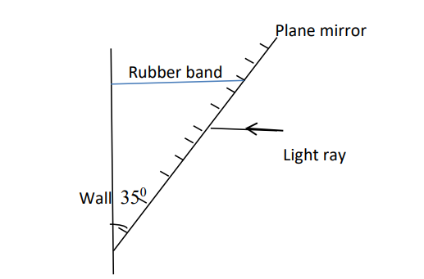
Figure 14
In a hot afternoon, the rubber band stretches by 22.12mm, a ray of light strikes the mirror horizontally. Calculate the angle between the horizontal and the new reflected ray.
(3 marks)
$$New angle between wall and mirror after string stretching, tan 35°=\frac{20}{h}.$$
$$h=28.56cm$$
$$\tan{∅=\frac{22.212}{28.56}}$$
$∅=37.9°$
$New angle of incidence=90-37.9=52.1°$
$Angle of incidence=angle of reflection=52.1°$

b.) State two differences between images formed by pinhole camera and a Plane mirror. (2marks)
Plane mirror images are virtual while pinhole camera produces real images.
Plane mirror images are upright while pinhole camera images are inverted.
Pinhole camera images are magnified and diminished whereas plane mirror images are same size as object.
c.) Figure 15 shows an object O placed between plane mirrors inclined at right angles.
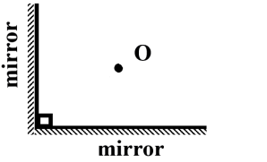
Figure 15
Determine the number of images formed. (2 marks)
$$n=\frac{360}{∅}-1,n=\frac{360}{90}-1,n=4-1,n=3images$$
d) Describe the image formed by a plane mirror. (2 marks)
Upright/erect, same size as object, virtual, laterally inverted. any two correct
e.) A student placed three cards each with a small hole at the Centre in a straight line as shown below.
Figure 16
- State the aim of the experiment. (1 mark)
To show that light travels in a straight line.
(ii) If one of the cards was displaced slightly to the left, state what would be observed. (1 mark)
When the cardboard is displaced by moving it slightly to the one side, the eye will not see the
lamp.
- a.) Figure 17 shows two insulated and uncharged metal spheres X and Y in contact. A positively charged rod is held near X and then the spheres are moved apart.
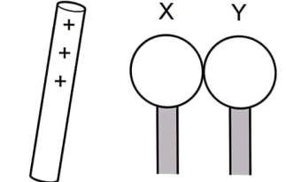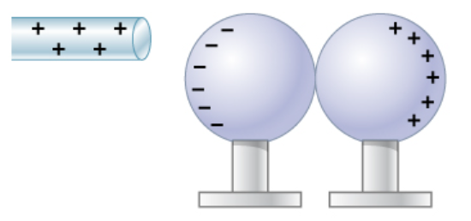
Figure 17
- In the space provided on the right side of figure 2, draw diagrams to show the charge on X and Y. (2 marks)
- Identify the method of charging used in figure 17 above. (1 mark)
Charging by separation method.

- A car battery requires topping up with distilled water occasionally.
- State why topping up is necessary. (1 mark)
The addition of distilled water into a lead acid accumulator to improve on the ion concentration.
- State why distilled water is used. (1 mark)
Distilled water has been filtered to remove metals and minerals that may interfere with the process of the accumulator.
- Give one advantage of alkaline battery over lead acid accumulator. (1 mark).
They have a much longer life than the lead-acid ones.
They supply larger amounts of current and for a longer period.
Can be left unused for months without any damage

- Calculate the amount of charge passing through a point in a circuit if a current of 5A flows for 1.5 minutes. (3 Marks)

$$Q=It,=5×1.5×60=450 coulombs$$

- Give a reason why it is not advisable to smoke a cigarette near a charging battery.
(1 mark)
Batteries produces explosive gases i.e hydrogen gas, therefore sparks and flame from burning cigarettes can ignite fire.
- a.) State two properties of magnets. (2marks)
Directional property. Pole property/magnets have poles.
- Given a bar magnet, a steel bar and a string describe a simple experiment to distinguish between the magnet and the steel bar. (3 marks)
Suspend both the magnet and the steel bar in the earth’s magnetic field. Change their rest position and note the direction in which each will rest. Repeat this procedure several times and record the direction. It is noted that the bar magnet rests in the North – south diction each time it is disturbed while the steel bar rests in different directions each time.
- Figure 18 shows a magnetic material being magnetized
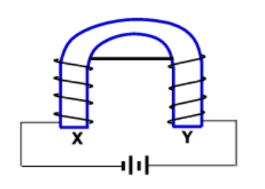
Figure 18
Identify the polarities of X and Y. (2mks)
X: South pole Y: South pole
b.) The figure below shows two pins hanging from a magnet. Explain why they do not hang vertically downwards. (2 marks)
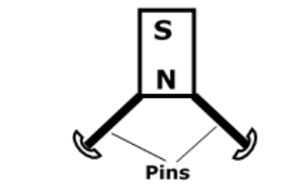

Figure 19
The pins are magnetized by induction acquire similar poles at the ends hence they repel each other

c.) Figure 20 shows a graph of magnetization against magnetizing current for two materials A and B
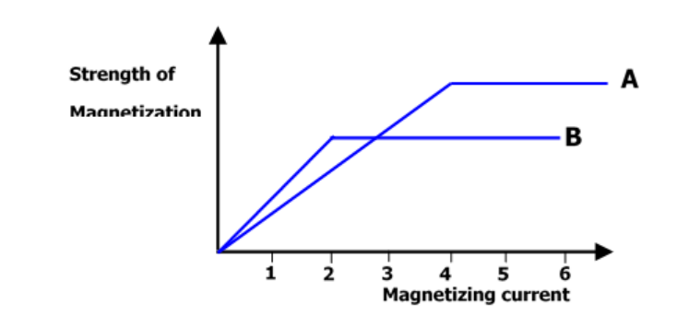
Figure 20
- State with a reason, the material which is more suitable for use in a transformer to concentrate the magnetic fields. (2marks)
B – It is easily magnetized (it’s a soft magnetic material)
#END#

