Kenya Certificate of Secondary Education

GEOGRAPHY

TERM 1 2024

FORM TWO

MARKING SCHEME

1. a) Name three sub branches of Physical Geography (3marks)

* Geomorphology
* Climatology
* Biogeography
* Hydrology
* Geology
* Pedology

b) Explain the relationship between geography and mathematics (2 Marks)

* Mathematics principles/formulae are used in geography to calculate distance/area/population density.
* Geography information can be analyzed/presented accurately through the application of mathematical techniques such as graphs
* Geographical concepts are applied in calculating direction/bearing in mathematics.

2. a) Name two planets that do not have natural satellites (2 Marks)

* Mercury
* Venus

b) Use the diagram below to answer the following questions



i) Name the parts marked A, B, and C. (3 marks)

* A- Moon
* B- Earth
* C- Penumbra

ii) Apart from the occurrence of eclipses, state two other effects of the movement of the earth round the sun. (2 marks)

* It causes the four seasons.
* It causes varying length of day and night.
* It causes the change in the position of midday sun at different times of the year.

b) i. Describe the passing The passing star theory (4marks)

* This theory suggests that a star with a greater gravitational pull than the sun passed near the sun.
* As a result, it drew off a stream of gaseous materials from the sun.
* These material split, cooled and condensed to form planets.
* The planets were then set in orbit around the sun by the passing star.
* Some smaller materials also cooled and condensed to form other heavenly bodies like the moon and asteroids that were also set in their orbits.

ii. State three weaknesses of the passing star theory (3marks)

* The theory does not explain the origin of the sun and the star.
* Chances of another star approaching the sun are minimal.
* High temperature materials drawn from the sun or star would disperse in space rather than condense.
* The sun could be broken up by gravitational force generated by the star hence materials could not condense to form planets.
* The effects of the star setting planets on their orbit could have reduced as the star was moving away.

c) What is the local time at Kinshasa 150E when local time at Malindi 400E is 12:00 noon?

(3marks)

Solution

Change in Longitude = ${40}^{0}-{15}^{0}={25}^{0}$

Time difference; $1^{0}=4min$

${ 25}^{0}=25×4=100\min{=1hr 40min}$

Time at Kinshasa =12.00 noon – 1hr 40min = 10:20a.m.

3. a) Using a well labelled diagram describe the occurrence of the relief rainfall (6marks)

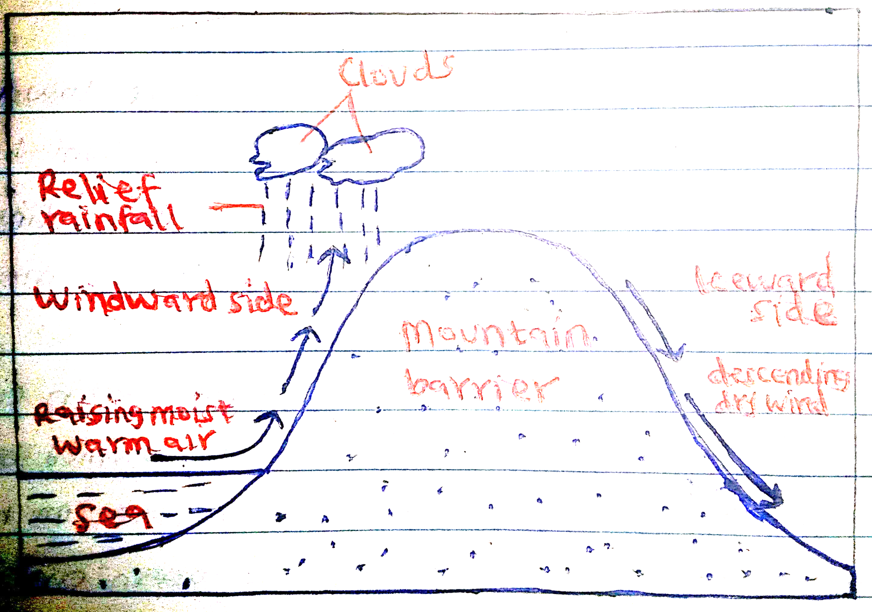

b) Name three places in Kenya where the rainfall above may be experienced (3marks)

* Kisii
* Kericho
* Bungoma
* Kirinyaga
* Nyeri

c) State three problems associated with the convectional rainfall (3Marks)

* The torrential rains cause floods which displace people.
* The hailstones destroy crops.
* The strong winds blow off roofs of houses.
* The strong winds uproot trees.
* Lightning strikes causes deaths of people and animals and drying of trees.

d) The table below shows mean monthly temperature of Thika town use it to answer the following questions.

|  |  |  |  |  |  |  |  |  |  |  |  |  |
| --- | --- | --- | --- | --- | --- | --- | --- | --- | --- | --- | --- | --- |
| Month | J | F | M | A | M | J | J | A | S | O | N | D |
| Temp ⁰c | 19 | 21 | 21 | 24 | 26 | 18 | 17 | 17 | 19 | 20 | 25 | 28 |

Calculate

i. ) the mean monthly temperature for Thika town (2 marks)

mean monthly temperature= 213/12=17.750

ii) the annual range of temperature (2marks)

28-17=11⁰c

4 a) i. Define the term minerals (2marks)

* Mineral is an inorganic substance occurring naturally beneath/ at earth’s surface.

ii. Mention the types of minerals.

* Metallic minerals
* Non-metallic minerals

b) List three examples of extrusive igneous rocks (3marks)

* Rhyolite
* Andesite
* Basalt
* Obsidian
* Scoria
* Trachyte

c) Differentiate between the processes of formation of plutonic and volcanic rocks (2marks)

* Plutonic rocks form from magma which cools slowly and solidifies within cracks and chambers in the earth’s crust while volcanic rocks form from the lava that cools fast and solidifies onto the surface of the earth.

d) Explain reasons why coral rocks are widespread at the coast (6marks)

* Salty water favors growth of coral polyps.
* Warm water for the growth of coral polyps.
* Clear water which is free from silt or mud favor coral polyp’s growth.
* Shallow water to which sunlight can penetrate for coral polyps’ growth.
* Well oxygenated water for coral polyps’ growth.

e) Why is industrial diamond used in shaping hard stones and metals? (2marks)

* Because it is the hardest mineral/It does not break easily.

5.a) Explain the factors that determine the formation of landforms by internal land forming processes (8marks)

* Nature of rocks i.e. soft rocks are more elastic hence easily forms landforms compared to hard/rigid rocks.
* Age of rocks i.e. young rocks are elastic hence easily forms landforms compared to old rocks.
* Type of earth movement involved i.e. horizontal and vertical earth movement forms different landforms.
* The intensity and scale of the forces involved i.e. strong tectonic forces easily forms different landforms compared to weak tectonic forces

b) Explain FOUR causes of earth movement. (8marks)

* Magma Movement within the earth’s crust

Molten rock (magma) is forced to intrude into the earth’s crust through a line of weakness causing displacement.

The crustal rocks are forced to move/give way to intruding magma as their place is taken over by the intruding magma.

* Convectional currents in the mantle.

The high temperatures in the interior of the earth cause molten magma in the upper mantle to develop strong convectional currents.

The currents move laterally and vertically (in circular motion), exerting a frictional drag on the crustal rocks causing them also to move.

* Gravitative pressure/gravitational force.

Large quantities of magma that escape from the upper mantle to the surface leave behind large voids/hollows.

Force of gravity then acts on the crustal rocks overlying the voids, exerting pressure on the rocks.

Eventually the overlying crustal rocks crumble inwards to fill up the voids/hollows below, this leads to vertical displacement of rocks.

* Isostatic adjustments.

Isostasy is the state of equilibrium/balance that exits between the lighter continental crust/SIAL and the denser oceanic crust/SIMA.

Erosion of continental landmasses makes them thinner and lighter. The eroded materials are deposited on the seabed making the oceanic crust denser. This loses the balance that existed between the continental and oceanic crusts.

* To restore this state of balance, the continental crust moves upwards while the oceanic crust sinks into the mantle.

c) State four evidences supporting the Continental Drift Theory (4 marks)

* The jig-saw fit of the continental margins as adjacent continents can easily fit into each other e.g. the North eastern coast of South America easily fits into the west coast of Africa. This shows that the two continents were once one landmass.
* Geological evidence where xistence of rocks which are similar in their formation/structure/types/age along margins of different continents (sharing an ocean). Some geological structure can be traced from one continent to another.
* Paleontological evidence as there are similarities between the fossils of flora and fauna found on both sides of Atlantic Ocean.
* The Mid-Atlantic Ridge evidence as there are continuous mountain ranges made up of young volcanic rocks at the mid-Atlantic.
* Paleomagnetic evidence where minerals with same alignment are found in different continents adjacent to one another.
* Sea floor spreading evidence seen as the shores of Red Sea exhibits evidence of having undergone lateral displacement.
* Paleoclimatological evidence where there are similarities in the past climate in the different parts of the world. Presence of ancient glacial deposits in the southern continents.
* Matching fold mountain zones. The location of major fold mountains of the world/the bend of folds/the age of the Fold Mountains are similar.

d) List the types of plate boundaries (3marks)

* Extension plate boundary.
* Compressional plate boundary.
* Transform fault plate boundary.

6) a) Differentiate between folding and faulting (2marks)

* Folding is the bending of young sedimentary rocks either upwards or downwards due to compressional forces WHILE Faulting is a process of fracturing/ breaking/ cracking of crustal rocks due to tectonic forces

b) Draw a diagram to show parts of a fold (5marks)

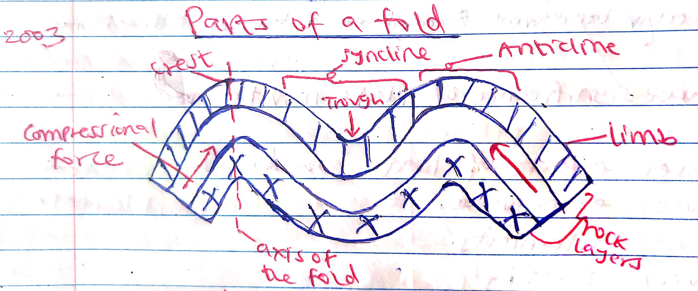

c) i. Name the types of folds (4marks)

* Simple/symmetrical fold
* Asymmetrical fold/ monoclonal fold
* Over fold
* Recumbent fold
* Nappe/ Over thrust fold
* Isoclinal fold
* Anticlinorium and synclinorium complex

ii. Describe the formation of fold mountain (8marks)

* The crustal rocks are subjected to compressional forces. They bend upwards and downwards to form an extensive depression/geosyncline on the earth’s surface.
* The geosyncline is the filled with water to form a large waterbody such as sea/ocean.
* The surrounding uplands were intensively eroded and the resultant sediments deposited in the geosyncline in layers.
* The accumulation of sediments and weight caused the geosyncline to subside/sink into the mantle.
* Continued accumulation of sediments in the geosyncline resulted into the formation of thick layers.
* Further subsidence of the geosyncline triggers off compressional forces which cause the sediments to fold.
* The folded layers of sediments in the geosyncline are thrust upwards to form Fold Mountains along the edges of the geosyncline (due to closeness of the source of the forces).

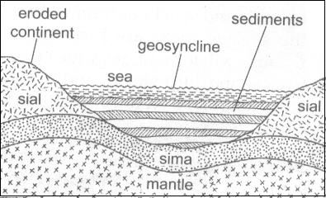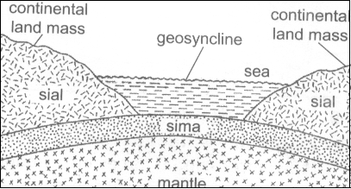

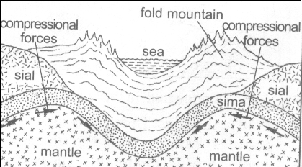

d) State the effects of folding on physical environment

* Fold Mountains receive heavy rainfall which give rise to rivers.
* Fold Mountains create heavy rainfall in the windward slopes and little rainfall on the leeward slopes.
* The heavy rainfall on the windward side leads to growth of thick forests.
* The process of folding creates crustal weakness which triggered off volcanic activities.