Name………………………………… Adm No…………………/…….Class……….
School…………………………………………………………Date ………………………….
Student’s Signature…………………………………….
Form 2
Drawing and Design
TERM ONE 2024
Time Allowed 2 ½ Hours
FOR EXAMINERS USE ONLY
1 | 2 | 3 | 4 | 5 | 6 | 7 | 8 | 9 | 10 | 11 | 12 | 13 | 14 | TOTAL

INSTRUCTIONS TO CANDIDATES.
- You should have the following for this examination:
  - Drawing instruments
  - 3 sheet of drawing paper size A3
  - Answer all questions in the A3 papers provided

- All dimensions are in millimeters unless otherwise stated.

- Define the following terms
(a) What is a Quadrilateral? (1 mark)

(b) Assembly drawing (1 mark)

- State any four areas which are involved in research and analysis of design item. (2 marks)

- (a) illustrate using sketches how to determine the following sizes of drawing papers
A₁, A₂, A3, A₄. (2 marks)

(b) State four main ways of communicating ideas in design process (2 marks)

- Illustrate three ways of dimensioning a diameter of a circle. (3 marks)

- Construct a rectangle measuring 70mm by 30mm and convert to a square of equal area.
(6 marks)

- Join the lines drawn below with an arc of radius 50mm (4 marks)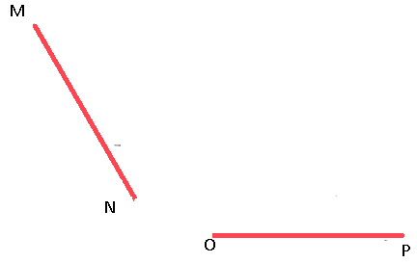
- Figure 1 below shows a pictorial view of a block.
Using a third angle projection, sketch in good proportion the orthographic views of the block. (6 marks)
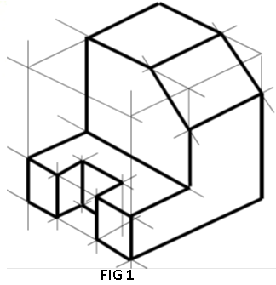
- Figure 4 shows three views of a block drawn in first angle projection.
In good proportion, sketch two possible pictorial views of the block in oblique projection. (10 marks)
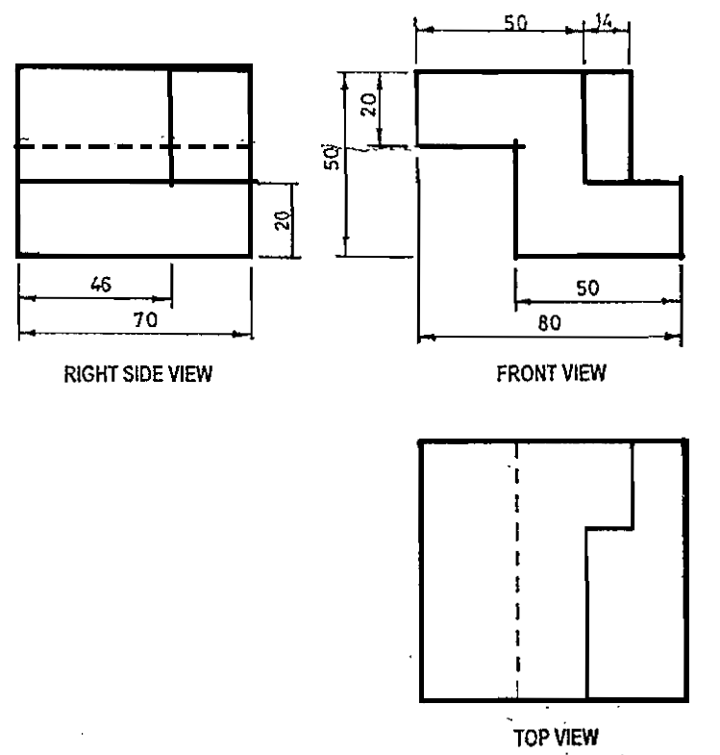
- Construct a diagonal scale to read up to (1/100)th of a metre and long enough to measure up to 6 m. Take RF ¼ 1:50 and mark on the scale a distance of 4.58 m. (6 marks)

- construct a regular heptagon inside a circle whose diameter is 60 mm. (6 marks)

- Figure 5 shows two views of a block drawn in first angle projection. Draw the block in two point perspective taking X as the lowest point.
(6 marks)
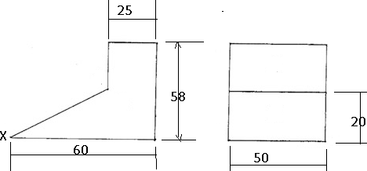

- Fig 6 below shows a block drawn in oblique, draw the following views in third angle orthographic projection and dimension fully. (15 marks)
- Front Elevation
- End Elevation
- Plan

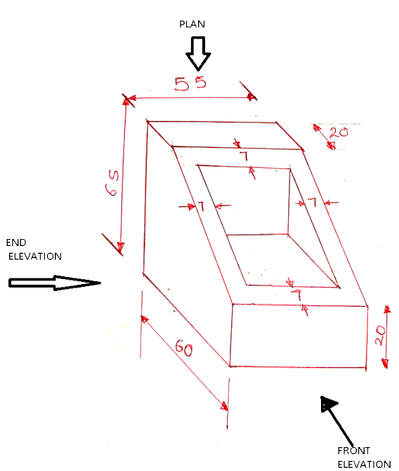

- Figure 5 shows two views of a machine component drawn in first angle.
Draw the block in isometric projection. (15 marks)
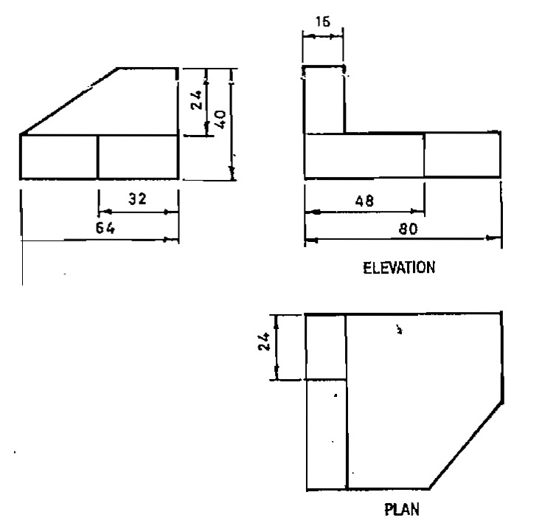

- Figure 2 below shows a reciprocating water pump system.
Draw the locus of point “C” when the crank BO makes one complete revolution given that B is pin jointed to AC and A is allowed to move horizontally. (15 marks)

