**FORM 2 TERM ONE 2024**

**DRAWING AND DESIGN**

**Marking scheme**

1. Define the following terms

(a) What is a Quadrilateral? (1 mark)

Is a plane figure bounded by four straight sides with the sum of all interior angles adding up to 3600.

(b) Assembly drawing (1 mark)

A drawing that shows the various parts of a machine in their correct working locations.

1. State any four areas which are involved in research and analysis of design item. (2 marks)

* function,
* strength of materials,
* shape and form,
* jointing
* shaping and forming
* fitting safety
* surface finish
* economics

1. (a) illustrate using sketches how to show the following sizes of drawing papers

A1, A2, A3, A4. (2 marks)

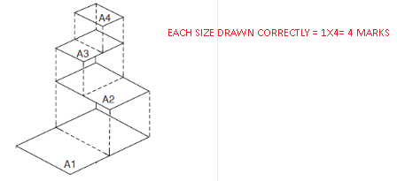

(b) State four main ways of communicating ideas in design process (2 marks)

* Sketches
* Words
* Diagrams
* Models / mock ups
* Exploded drawings

1. Illustrate three ways of dimensioning a diameter of a circle. (3 marks)



1. Construct a rectangle measuring 70mm by 30mm and convert to a square of equal area. (6 marks)



* Construction of a rectangle= 2 marks
* Extension of base by width=1 mark
* Bisection of new base= 2 marks
* Semi-circle= 2 marks
* One side of square= 1 mark
* Correct square= 2 marks

TOTAL= 6 MARKS

1. Join the lines drawn below with an arc of radius 50mm (4 marks)

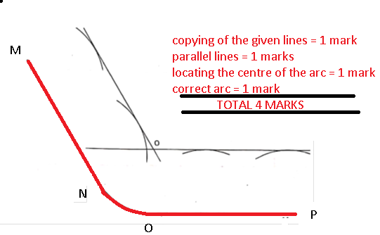

1. **Figure 1** below shows a pictorial view of a block.

Using a third angle projection, sketch in good proportion the orthographic views of the block. (6 marks)

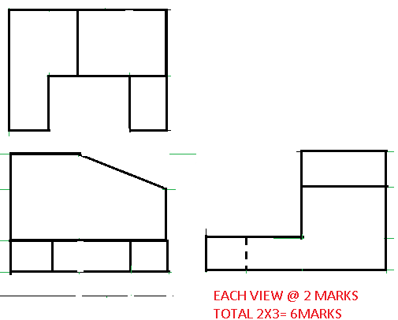

1. Figure 4 shows two views of a block drawn in first angle projection.

In good proportion, sketch two possible pictorial views of the block in oblique projection. (10 marks)

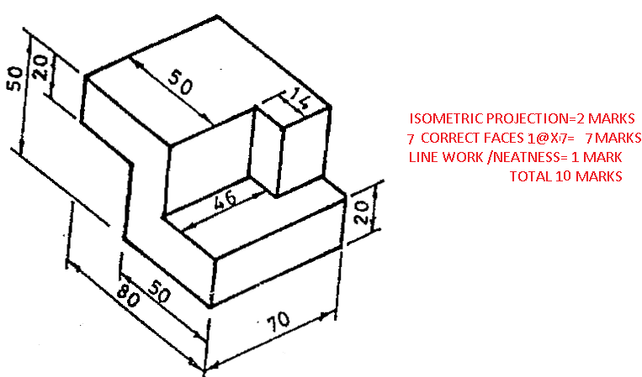

1. Construct a diagonal scale to read up to (1/100)th of a metre and long enough to

measure up to 6 m. Take RF ¼ 1:50 and mark on the scale a distance of 4.58 m. (6 marks)

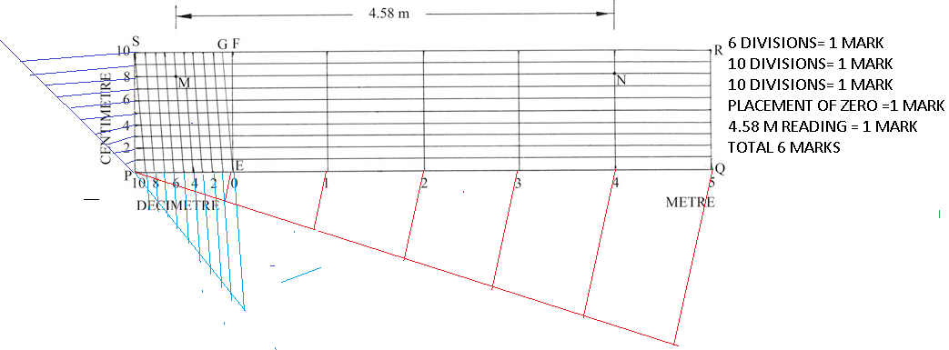

1. construct a regular heptagon inside a circle whose diameter is 60 mm. (6 marks)

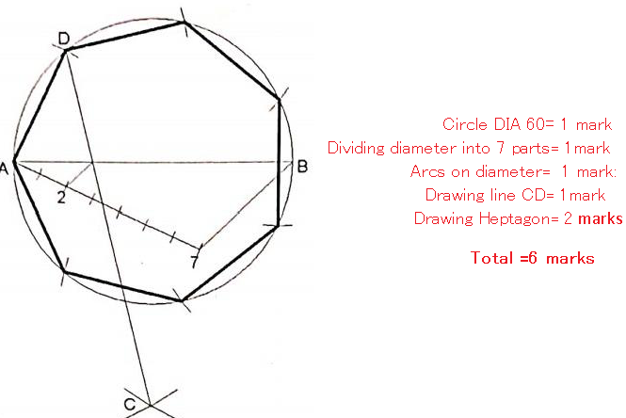

1. Figure **5** shows two views of a block drawn in first angle projection. Draw the block in two point perspective taking **X** as the lowest point. (6 marks)

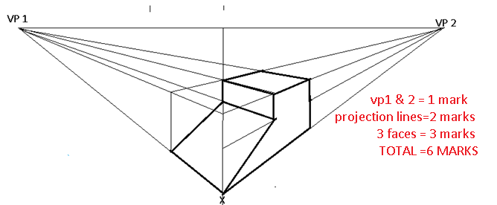

1. Fig 6 below shows a block drawn in **oblique**, draw the following views in third angle orthographic projection and dimension fully. (15 marks)

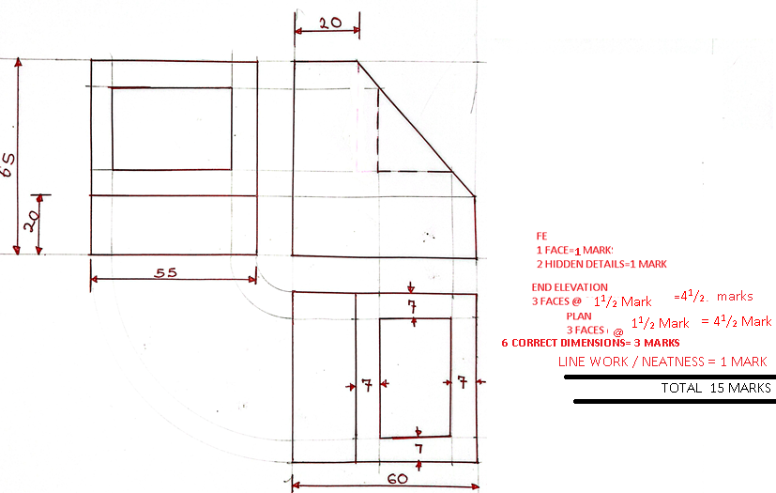

1. **Figure 5**  shows two views of  a machine component drawn in first angle.

Draw the block in isometric projection. **(15 marks)**

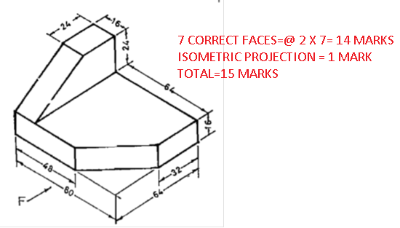

1. Figure **2** below shows a reciprocating water pump system.

Draw the locus of point **“C”** when the crank **BO** makes one complete revolution given that **B** is pin jointed to **AC** and **A** is allowed to move horizontally. (15 marks)

