Name: …………………………………………………………………………………………….
Admno: ……………………………………………………… Class ……………………………

CHEMISTRY
TERM ONE 2024
TIME: 2 HOURS

FORM 2
END EXAMINATION

INSTRUCTIONS:
- Write your name and other details on the space provided above
- Answer all the questions in the spaces provided for each question.
- All working must be clearly shown where necessary.
- Mathematical tables and non-programmable electronic calculators may be used.
For Examiners Use Only

Questions | Total marks | Student’s score
1 - 19 | 80

- (a) Define the term ionization energy. (1 mark)
……………………………………………………………………………………………………………………………………………………………………………………………………………………
(b) The table below shows the 1st ionization energy for elements F, G and H.
Element | 1st ionization energy
F | 494
G | 519
H | 418
- Which element has the smallest radius? Explain. (1 mark)
……………………………………………………………………………………………………………………………………………………………………………………………………………………
- Which element is the most reactive? Explain. (1 mark)
……………………………………………………………………………………………………………………………………………………………………………………………………………………
- (a) Give the meaning of the term isotopes. (1 mark)
……………………………………………………………………………………………………………………………………………………………………………………………………………………
(b) Calculate the percentage abundance of lithium - 7 and lithium - 6 given that the relative atomic mass of lithium is 6.94. (2 marks)

- (a) The atomic number of element Q is 16. Write the electron arrangement of the ion Q²⁻. (1 mark)
……………………………………………………………………………………………………………………………………………………………………………………………………………………

(b) Write the formula for the compound formed when sodium reacts with element Q. (1 mark)
…………………………………………………………………………………………………………
(c) To which group and period of the periodic table does element Q belong? (1 mark).
Group……………………………………………………………………………………………………
Period……………………………………………………………………………………………………

- The table below shows the behaviour of some metals W, X, Y and Z. Study it and answer the following questions.
Metal | Appearance on exposure to air | Reaction with water | Reaction with hydrochloric acid
W | Slowly tarnishes | Slow | Vigorous
X | No change | Does not react | Does not react
Y | Slowly turns white | Vigorous | Violent
Z | No change | No reaction | Reacts moderately

- Arrange the metals in order of their reactivity starting with the least reactive. (1 mark)
………………………………………………………………………………………………………………………………………………………………………………………………………………………………
- Name a metal that is likely to be X. (1 mark)
………………………………………………………………………………………………………………………………………………………………………………………………………………………………
- Metal Z is in group II of the periodic table. Write an equation for the reaction of metal Z with dilute hydrochloric acid. (1 mark)
………………………………………………………………………………………………………………………………………………………………………………………………………………………………

- (a) Give the meaning of the term indicator. (1 mark)
………………………………………………………………………………………………………………………………………………………………………………………………………………………………

(b) Classify the following substance as acidic, basic or neutral. Wood ash, lemon juice and common salt. (3 marks)
Acid | Base | Neutral

- Crystals of iron (III) chloride were heated in a test tube.
- Give the name of the process that takes place. (1 mark)
………………………………………………………………………………………………………………………………………………………………………………………………………………………………
- Name two other substances that undergo the process named in (a) above. (1 mark)
………………………………………………………………………………………………………………………………………………………………………………………………………………………………
- Write an equation to represent the process. (1 mark)
………………………………………………………………………………………………………………………………………………………………………………………………………………………………
- A student accidentally mixed two solids of sodium chloride and copper (II) oxide.
- What is the colour of: (1 mark)
- Sodium chloride?
………………………………………………………………………………………………………………
- Copper (II) oxide?
………………………………………………………………………………………………………………

- Describe a procedure that can be used to obtain the two solids separately. (2 marks)
………………………………………………………………………………………………………………………………………………………………………………………………………………………………
- The table below represents part of the periodic table. The letters are not actual symbols of the elements. Study it and answer the questions that follow.
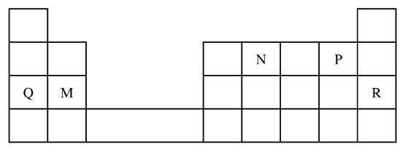
- State the most unreactive element. (1 mark)
………………………………………………………………………………………………………………………………………………………………………………………………………………………………
- Compare the atomic radius of element N and P. Explain. (1 mark)
………………………………………………………………………………………………………………………………………………………………………………………………………………………………
- Write the formula of the nitride of M. (1 mark)
………………………………………………………………………………………………………………………………………………………………………………………………………………………………

- Sketch the cooling curve of pure water starting from 110ºC to -10ºC. (2 marks)

- An ion is a particle formed when an atom either gains or loses electrons. Draw the structure of the most stable ions of the following elements.
- Sodium (1 mark)

- Oxygen (1 mark)

- nitrogen (1 mark)

- In an experiment, a burning magnesium ribbon was lowered into a gas jar full of oxygen gas.
- State the observation made. (1 mark)
………………………………………………………………………………………………………………………………………………………………………………………………………………………………
- Write the equation for the reaction that takes place. (1 mark)
………………………………………………………………………………………………………………………………………………………………………………………………………………………………
- Give one use of the product formed from the reaction. (1 mark)
………………………………………………………………………………………………………………………………………………………………………………………………………………………………
- A burning candle was placed in a bell jar containing sodium hydroxide solution as follows.
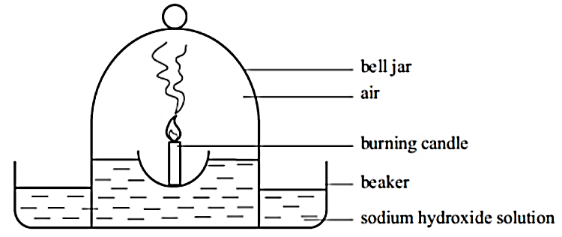
(a) Draw another diagram to show what you would expect after 2 minutes. (2 marks)

(b) Explain the observations in 12 (a) above. (2 marks)
………………………………………………………………………………………………………………………………………………………………………………………………………………………………

- The set-up below was used in an experiment to determine the conditions necessary for rusting.
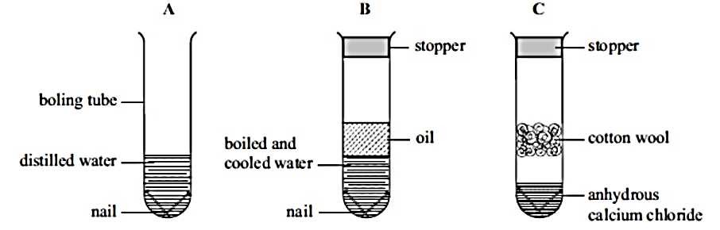
- In which set-up will the iron nails rust? Explain. (2 marks)
………………………………………………………………………………………………………………………………………………………………………………………………………………………………
- A large piece of magnesium buried in the ground and connected to an underground iron pipe prevents the corrosion of the iron pipes. Explain. (1 mark)
………………………………………………………………………………………………………………………………………………………………………………………………………………………………

- Describe an experiment that can be used to investigate that there is an increase in mass when magnesium is burnt in air. (3 marks)
………………………………………………………………………………………………………………………………………………………………………………………………………………………………………………………………………………………………………………………………………………………………………………………………………………………………………………………………
- A piece of sodium metal was placed in a beaker half-full of water.
- State two observations that were made. (2 marks)
………………………………………………………………………………………………………………………………………………………………………………………………………………………………
- Explain the observations you have mentioned in (a) above. (2 marks)
………………………………………………………………………………………………………………………………………………………………………………………………………………………………

- Write an equation for the reaction that takes place. (1 mark)
………………………………………………………………………………………………………………………………………………………………………………………………………………………………
- A few drops of phenolphthalein indicator were added to the resulting solution. State and explain the observations that were made. (2 marks)
………………………………………………………………………………………………………………………………………………………………………………………………………………………………
- What observations would be made if a piece of calcium metal was used in the experiment instead of sodium metal? (2 marks)
………………………………………………………………………………………………………………………………………………………………………………………………………………………………
- Study the information in the table below and answer the following questions.
Substance | Solubility in water | Solubility in ethanol | Effect on heating
Sodium chloride | Soluble | Insoluble | No effect
Candle wax | Insoluble | Soluble | Melts into a thick liquid and vapourises
Sand | Insoluble | Insoluble | No effect
Solid aluminium chloride | Soluble | Insoluble | Sublimes

- Describe how a mixture of sodium chloride and sand can be separated. (3 marks)
………………………………………………………………………………………………………………………………………………………………………………………………………………………………………………………………………………………………………………………………………………………………………………………………………………………………………………………………
- A student was given a mixture of solid aluminium chloride and wax and asked to separate the mixture.
- Explain why is not advisable to heat the mixture to separate it. (1 mark)
………………………………………………………………………………………………………………………………………………………………………………………………………………………………
- Explain how the mixture can be separated. (3 marks)
………………………………………………………………………………………………………………………………………………………………………………………………………………………………………………………………………………………………………………………………………………………………………………………………………………………………………………………………
- State one application of the following methods of separation. (3 marks)

- Crystallisation…………………………………………………………………………………
- Solvent extraction……………………………………………………………………………..
- Filtration ………………………………………………………………………………………

- Matter can be classified as pure substances or mixtures.
- Give the meaning of the following terms that relate to matter. (4 marks)
- Atom
………………………………………………………………………………………………………………………………………………………………………………………………………………………………
- Element
………………………………………………………………………………………………………………………………………………………………………………………………………………………………
- Compound
………………………………………………………………………………………………………………………………………………………………………………………………………………………………
- Molecule
………………………………………………………………………………………………………………………………………………………………………………………………………………………………
- Write the chemical formulae of the following compounds. (4 marks)
- Sodium chloride
- Ammonium sulphate

- Ammonia gas

- Sulphuric (VI) acid

- Nitrogen (IV) oxide

- Give the meaning of the term oxidation number. (1 mark)
………………………………………………………………………………………………………………………………………………………………………………………………………………………………
- Acids and some metals react to give a colourless gas.
- Identify solution G and gas X in the following reaction. (2 marks)
Dilute sulphuric (VI) acid + zinc granules → solution G + gas X
Solution G: ……………………………………………………………..
Gas X: …………………………………………………………………
- Write the chemical equation for the reaction taking place in (a) above. (1 mark)
………………………………………………………………………………………………………………………………………………………………………………………………………………………………

- The table below shows pH values of solutions A, B, C, D and E
Solution | pH
A | 5.2
B | 12.0
C | 2.0
D | 9.8
E | 7.0
- Which of the solutions is likely to be: (2 marks)
- Ammonia solution…………………………………
- Sodium hydroxide…………………………………
- Hydrochloric acid…………………………………
- Ethanoic acid……………………………………..
- Which pH values represent: (5 marks)
- A weak acid……………………………………
- A strong acid…………………………………..
- A neutral solution……………………………..
- A weak base…………………………………..
- A strong base………………………………….
This is the last printed page.

