CHEMISTRY FORM TWO
TERM ONE 2024
TIME: 2 HOURS
MARKING SCHEME

- (a) Define the term ionization energy. (1 mark)
The minimum amount of energy required to remove an electron from the outermost energy level of an atom in the gaseous state.
(b) The table below shows the 1st ionization energy for elements F, G and H.
Element | 1st ionization energy
F | 494
G | 519
H | 418
- Which element has the smallest radius? Explain. (1 mark)
G. it has the highest 1st ionization energy.
- Which element is the most reactive? Explain. (1 mark)
H. It has the lowest 1st ionization energy.
- (a) Give the meaning of the term isotopes. (1 mark)
Atoms of the same element with the same atomic number but different mass numbers.
Or
Atoms of the same element with the same number of protons but different number of neutrons.
(b) Calculate the percentage abundance of lithium - 7 and lithium - 6 given that the relative atomic mass of lithium is 6.94. (2 marks)

- (a) The atomic number of element Q is 16. Write the electron arrangement of the ion Q²⁻. (1 mark)
2.8.8
(b) Write the formula for the compound formed when sodium reacts with element Q. (1 mark)
Na₂Q
(c) To which group and period of the periodic table does element Q belong? (1 mark).
Group………VI
Period…………3
- The table below shows the behaviour of some metals W, X, Y and Z. Study it and answer the following questions.
Metal | Appearance on exposure to air | Reaction with water | Reaction with hydrochloric acid
W | Slowly tarnishes | Slow | Vigorous
X | No change | Does not react | Does not react
Y | Slowly turns white | Vigorous | Violent
Z | No change | No reaction | Reacts moderately

- Arrange the metals in order of their reactivity starting with the least reactive. (1 mark)
X, Z, W, Y
- Name a metal that is likely to be X. (1 mark)
Copper or silver or gold or platinum
- Metal Z is in group II of the periodic table. Write an equation for the reaction of metal Z with dilute hydrochloric acid. (1 mark)
Z(s) + 2HCl (aq) → ZCl₂ (aq) + H₂(g)
- (a) Give the meaning of the term indicator. (1 mark)
A substance that shows a definite colour in an acid and another definite colour in a base.

(b) Classify the following substance as acidic, basic or neutral. Wood ash, lemon juice and common salt. (3 marks)
Acid | Base | Neutral
Lemon juice | Wood ash | Common salt

- Crystals of iron (III) chloride were heated in a test tube.
- Give the name of the process that takes place. (1 mark)
Sublimation
- Name two other substances that undergo the process named in (a) above. (1 mark)
Iodine, benzoic acid crystals, aluminium chloride.
- Write an equation to represent the process. (1 mark)
FeCl₃ (s) → FeCl₃ (g)
- A student accidentally mixed two solids of sodium chloride and copper (II) oxide.
- What is the colour of: (1 mark)
- Sodium chloride?
White
- Copper (II) oxide?
Black
- Describe a procedure that can be used to obtain the two solids separately. (2 marks)
Add water to the mixture and stir. Filter to obtain copper (II) oxide as the residue and sodium chloride solution as the filtrate. Rinse the residue with distilled water and dry it between filter papers. Heat the filtrate to evaporate the water and remain with solid sodium chloride.

- The table below represents part of the periodic table. The letters are not actual symbols of the elements. Study it and answer the questions that follow.
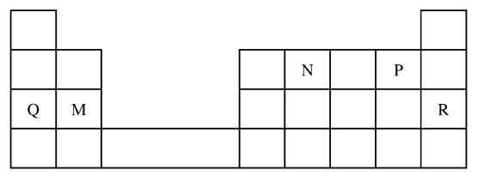
- State the most unreactive element. (1 mark)
Element R
- Compare the atomic radius of element N and P. Explain. (1 mark)
P has a smaller atomic radius than N. Element P has more protons and hence stronger nuclear force of attraction that pulls the electrons closer to the nucleus.
- Write the formula of the nitride of M. (1 mark)
M₃N₂
- Sketch the cooling curve of pure water starting from 100ºC to -10ºC. (2 marks)

- An ion is a particle formed when an atom either gains or loses electrons. Draw the structure of the most stable ions of the following elements.
- Sodium (1 mark)

- Oxygen (1 mark)

- nitrogen (1 mark)

- In an experiment, a burning magnesium ribbon was lowered into a gas jar full of oxygen gas.
- State the observation made. (1 mark)
Magnesium burns with a bright white flame.
- Write the equation for the reaction that takes place. (1 mark)
2Mg (s) + O₂(g) → 2MgO(s)
- Give one use of the product formed from the reaction. (1 mark)
Used to make heat-resistant bricks.
Used to make anti-acid medicine or tablets.

- A burning candle was placed in a bell jar containing sodium hydroxide solution as follows.
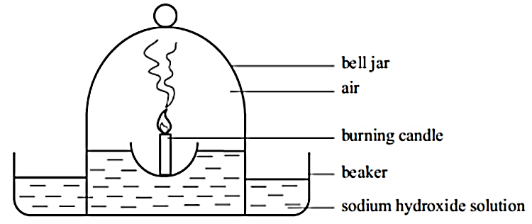
(a) Draw another diagram to show what you would expect after 2 minutes. (2 marks)

(b) Explain the observations in 12 (a) above. (2 marks)
The candle goes off due to the depletion of oxygen in the air. The level of sodium hydroxide rises in the bell jar. This is because the candle uses up the oxygen in the air leaving a partial vacuum. The greater atmospheric pressure pushes the sodium hydroxide into the bell jar.
- The set-up below was used in an experiment to determine the conditions necessary for rusting.
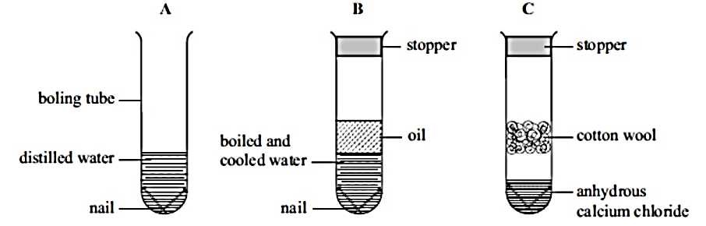
- In which set-up will the iron nails rust? Explain. (2 marks)
Set up A. The presence of both water and air(oxygen) in the distilled water causes the nails to rust.
- A large piece of magnesium buried in the ground and connected to an underground iron pipe prevents the corrosion of the iron pipes. Explain. (1 mark)
Magnesium is more reactive than iron and hence it will corrode instead of iron.
- Describe an experiment that can be used to investigate that there is an increase in mass when magnesium is burnt in air. (3 marks)
Weigh a clean piece of magnesium. Weigh an empty crucible and lid. Place the magnesium in the crucible and cover it with the lid. Place it on a tripod stand with a pipe-clay triangle. Heat the crucible strongly. Occasionally, lift the crucible lid carefully to let in air. Ensure no solid is lost in the process. Once the reaction is over. Allow the set-up to cool and weigh the crucible and its contents. Calculate the mass of magnesium and compare it with the mass of the product. The product will have more mass than magnesium.
- A piece of sodium metal was placed in a beaker half-full of water.
- State two observations that were made. (2 marks)
Sodium darts on the surface of water producing a hissing sound. It melts into a silvery ball. A colourless gas is produced.
- Explain the observations you have mentioned in (a) above. (2 marks)
Sodium reacts vigorously with water producing hydrogen gas (colourless gas) at a fast rate and hence the hissing sound. It melts into a silvery ball since the reaction produces a lot of heat.
- Write an equation for the reaction that takes place. (1 mark)
2Na(s) + 2H₂O (l) → 2NaOH (aq) + H₂ (g)
- A few drops of phenolphthalein indicator were added to the resulting solution. State and explain the observations that were made. (2 marks)
Phenolphthalien turns pink. Sodium hydroxide formed is an alkali.
- What observations would be made if a piece of calcium metal was used in the experiment instead of sodium metal? (2 marks)
Calcium metal will sink to the bottom of the beaker. A steady stream of bubbles of a colourless gas are seen. A white suspension is formed.
- Study the information in the table below and answer the following questions.
Substance | Solubility in water | Solubility in ethanol | Effect on heating
Sodium chloride | Soluble | Insoluble | No effect
Candle wax | Insoluble | Soluble | Melts into a thick liquid and vapourises
Sand | Insoluble | Insoluble | No effect
Solid aluminium chloride | Soluble | Insoluble | Sublimes

- Describe how a mixture of sodium chloride and sand can be separated. (3 marks)
Add water to the mixture and stir. Filter the mixture to obtain sodium chloride as the filtrate and sand as the residue. Heat the filtrate to obtain sodium chloride solid. Collect the two solids separately.
- A student was given a mixture of solid aluminium chloride and wax and asked to separate the mixture.
- Explain why is not advisable to heat the mixture to separate it. (1 mark)
The wax will melt into a thick liquid and vapourise making it difficult to separate from the aluminium chloride that sublimes.
- Explain how the mixture can be separated. (3 marks)
Add ethanol to the mixture and stir. Candle wax will dissolve but not aluminium chloride. Filter the mixture to obtain aluminium chloride as the residue and a solution of candle wax in ethanol as the filtrate. Leave the filtrate under the sun the ethanol evaporates leaving behind the candle wax.
- State one application of the following methods of separation. (3 marks)
- Crystallisation…extraction of sugar from sugarcane and extraction of salt from sea water.
- Solvent extraction…Obtaining cooking oil from nuts and seeds.
- Filtration …water treatment and domestic water filters
- Matter can be classified as pure substances or mixtures.
- Give the meaning of the following terms that relate to matter. (4 marks)
- Atom
The smallest particle of an element that can take part in a chemical reaction.
- Element
A pure substance that cannot be split into any simpler substances by chemical means.
- Compound
A pure substance that consists of two or more elements chemically combined.
- Molecule
The smallest particle of an element or compound that can exist separately.
- Write the chemical formulae of the following compounds. (4 marks)
- Sodium chloride

- Ammonium sulphate

- Ammonia gas

- Sulphuric (VI) acid

- Nitrogen (IV) oxide

- Give the meaning of the term oxidation number. (1 mark)
The oxidation number of an element shows that number of electrons that have been removed or added to it to attain its present state.
- Acids and some metals react to give a colourless gas.
- Identify solution G and gas X in the following reaction. (2 marks)
Dilute sulphuric (VI) acid + zinc granules → solution G + gas X
Solution G: Zinc sulphate
Gas X: Hydrogen gas
- Write the chemical equation for the reaction taking place in (a) above. (1 mark)
Zn (s) + H₂SO₄ (aq) → ZnSO₄ (aq) + H₂(g)
- The table below shows pH values of solutions A, B, C, D and E
Solution | pH
A | 5.2
B | 12.0
C | 2.0
D | 9.8
E | 7.0
- Which of the solutions is likely to be: (2 marks)
- Ammonia solution - D
- Sodium hydroxide- B
- Hydrochloric acid- C
- Ethanoic acid- A
- Which pH values represent: (5 marks)
- A weak acid……pH 5.2
- A strong acid…pH 2.0
- A neutral solution…pH 7.0
- A weak base…pH 9.8
- A strong base…pH12.0
This is the last printed page.

