Term 1 - 2024
BIOLOGY
FORM TWO

Time: 2 Hours

Name: …………………………………………………………. Adm No: ……………….
School: ……………………………………………………….. Class: …………………..
Signature: …………………………………………………….. Date: …………………...

INSTRUCTIONS TO CANDIDATES
- Write your name, admission number and school in the spaces provided above
- Sign and write the date of the examination in the spaces provided above
- Answer ALL the questions in the spaces provided on the question paper
- Candidates should check the question paper to ascertain that all the pages are printed as indicated and that no questions are missing.
- Candidates should answer the questions in English

Max Score | Student’s Score
80

Answer all the questions provided.
- Why does the fluid of transport in insects loosely called blood lack of pigment equivalent to haemoglobin? (2 marks)
…………………………………………………………………………………………………………………………………………………………………………………………………….

- Study the diagram below to answer the questions that follow.
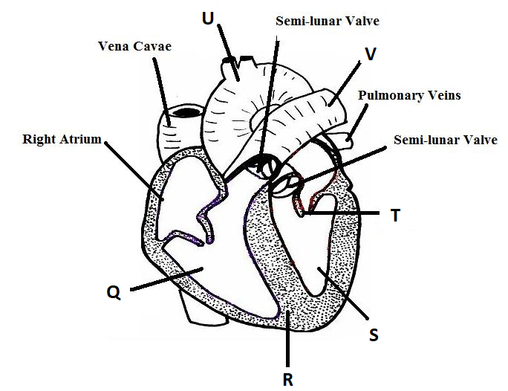
- What is the role of sino atrio node of the heart? (2 marks)
…………………………………………………………………………………………………………………………………………………………………………………………
- Differentiate between components of part labelled U and V. (2 marks)
U | V

- In developing foetus, blood in structure Q and S mix. Name the structure responsible for this kind of mixing. (1 mark)
………………………………………………………………………………………………………………………………………………………………………………………………
- Name the congenital disease that comes as a result of the structure named above not able to restore itself after birth. (1 mark)
………………………………………………………………………………………

- Identify part labeled R. (1 mark)
………………………………………………………………………………………………
………………………………………………………………………………………………
- Below is an equation showing a certain metabolic process.
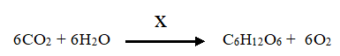

- Name the process shown above. (1mark)
…………………………………………………………………………………………………………………………………………………………………………….
- Name the requirement labeled X. (1mark)

……………………………………………………………………………………………………………………………………………………………………………..
- State three substances with the same formula C₆H₁₂O₆ as in above equation.
(3 marks)
……………………………………………………………………………………………………………………………………………………………………………………………………………………………………………………………………..

- Name the organ, tissue, cells and organelle where the reaction shown above takes place. (4 marks)
Organ
Tissue
Cell
Organelle
- The diagram below represents a structure of xylem vessel. Study it to answer the questions that follow.
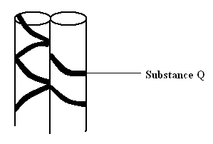

- Name substance Q. (1 mark)

……………………………………………………………………………………….
- How is the above structure adapted to its function. (1 marks)

…………………………………………………………………………………..

- State two functions of roots in plants. (2 marks)
……………………………………………………………………………………………
………………………………………………………………………………………………

- Name another cell that forms the Xylem tissue other than xylem vessel. (1 mark)
………………………………………………………………………………………..

- The diagram below represents a stage in the digestion of food along gastrointestinal track.
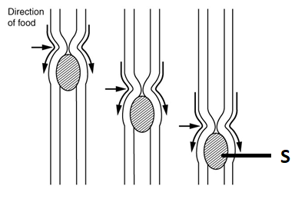
- By what mode does the represented organism feed? (1 mark)

………………………………………………………………………………………………
What is the name given to the:
- Wave of muscular contraction above. (1 mark)
………………………………………………………………………………………………

- The substance named S. (1 mark)
………………………………………………………………………………………………………………………………………………………………………………………………
- Name three parts of alimentary canal represented by the above drawing. (3 mark)
………………………………………………………………………………………………………………………………………………………………………………………………………………………………………………………………………………………………

- The process shown below takes place during the digestion of Lipids.
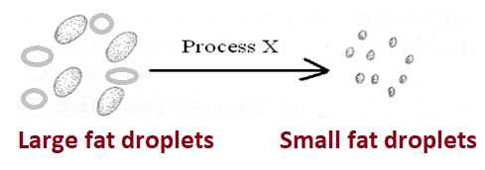

Where does it take place in mammals and what is its importance? (2 marks)

………………………………………………………………………………………………………………………………………………………………………………………………
- State the two differences in Monocotyledonous stem and Dicotyledous stem.
(2 marks)
Monocotyledonous | Dicotyledonous

- The figure below shows an experimental set – up to investigate a certain aspect of transport in plants. A set up that was used to investigate a certain process in plants is shown in the diagram below.
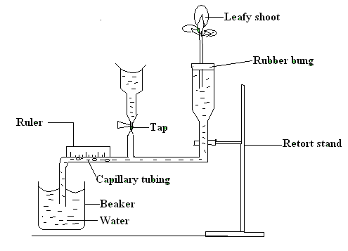
- What process was being investigated? (1 mark)

…………………………………………………………………………………………………………………………………………………………………………………….

(b) (i) State two precautions that should be taken when setting up the experiment.
2 marks)

……………………………………………………………………………………..

- Give a reason for each precaution stated in b (i) above. (2 marks)

……………………………………………………………………………………
…………………………………………………………………………………….

(d) State three environmental factors that influence the process under investigation.
(3 marks)
…………..…………………………………………………………………
…………………………………………………………………………….
……………………………………………………………………………
- Giving reason explain the difference you would expect if the measurements were
repeated under the following conditions:-
- Shoot is placed near a heat source. (1 mark)

…………………………………………………………………..
(ii) Shoot enclosed in a polythene bag. (1 mark)

…………………………………………………………………..

(iii) The set-up was placed in a dark room. (1 mark)

…………………………………………………………………..
- Shoot is placed in a current of air create by fan. (1 mark)

………………………………………………………………..
  - Some of the leaves were removed. (1 mark)

………………………………………………………………………
- The diagram below shows single circulation in a fish.

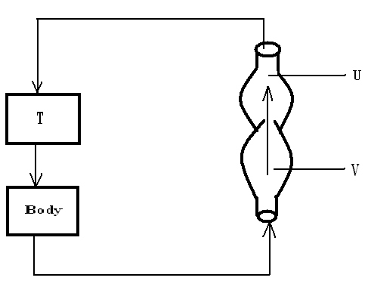
(a) Name the parts labeled T, U and V. (3 marks)

T …………………………………………………………………….

U …………………………………………………………………….

V …………………………………………………………………….

(b) How is the type of circulation different from that found in man. (1 mark)

……………………………………………………………………………………

(8) The diagram below represents part of a phloem tissue. Study it to answer the question
that follow.

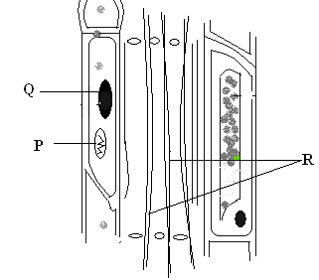
(a) Name the structures labeled P, Q and R. (3 marks)

P ………………………………………………………………….
Q ………………………………………………………………….
R ………………………………………………………………….
(b) State the function of the phloem tissue. (1 mark)

……………………………………………………………………………….
(c) (i) State how the functioning of the phloem tissue is affected if the
companion cell is destroyed. (1 mark)

……………………………………………………………………………………..
- Give a reason for your answer. (1 mark)

………………………………………………………………………………………………

.
9 (a) Give a summary of the following processes of photosynthesis.

(i) Light stage. (4 marks)

……………………………………………………………………………………………………….

……………………………………………………………………………………………………….

………………………………………………………………………………………………………

(ii) Dark stage. (1 marks)

…………………………………………………………………………………………………………………………………………….

……………………………………………………………………………………………………………………………………………
- What do you understand by the following terminologies.
Open circulatory system (1 mark)
……………………………………………………………………………………………………………………………………………………………………………
- Closed circulatory system (1 mark)
………………………………………………………………………………………
………………………………………………………………………………………

- The diagram below represents a transverse section through a plant organ.

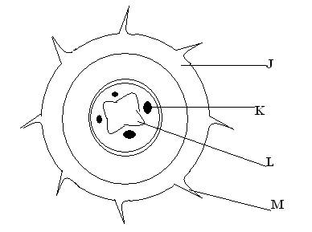
(a) From which plant organ was the section obtained? (1 mark)

………………………………………………………………………………………………………………………………………………………………………………………………

(b) Give two reasons for your answer in (a) above. (2 marks)

………………………………………………………………………………………………………………………………………………………………………………………………

(c) Name the labeled parts J, K , L and M. (4 marks)

J …………………………………………………………………………………….
K …………………………………………………………………………….........
L ……………………………………………………………………………………
M …………………………………………………………………………………..

- Study the diagram below and use it to answer the questions that follow.

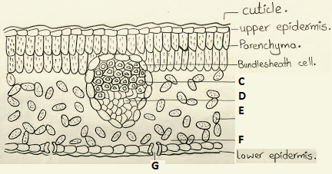
- Name the organ shown in the drawing above. (1 mark)
………………………………………………………………………………………………

- Identify the parts labeled C and D. (2 marks)
………………………………………………………………………………………………
………………………………………………………………………………………………

- Explain the concept of transpirational pull as it may takes place in the structure drawn above. (3 marks)
………………………………………………………………………………………………………………………………………………………………………………………………………………………………………………………………………………………………………………………

- Name three forces responsible for movements of water and mineral ions in a stem of a tall plant. (3 marks)
……………………………………………………………………………………..
……………………………………………………………………………………..
……………………………………………………………………………………..

