Term 1 - 2024
BIOLOGY
FORM TWO

Marking Scheme
Answer all the questions provided.
- Why does the fluid of transport in insects loosely called blood lack of pigment equivalent to haemoglobin? (2 marks)
- pigments in blood are meant to transport O₂ and CO₂
- O₂ is conducted directly to tissues by the tracheoles.

- Study the diagram below to answer the questions that follow.
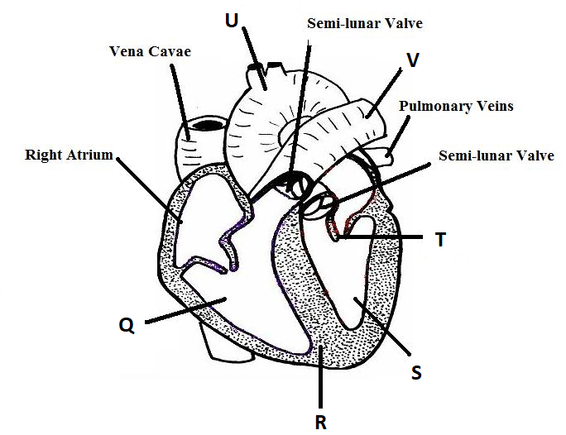
- What is the role of sino atrio node of the heart? (2 marks)
- cardiac muscles has SAN/sino-artrio node; that initiate heart beat/contraction of heart muscles/cardiac muscles;

- Differentiate between components of part labelled U and V. (2 marks)
U - Aorta | V- Pulmonary artery
- Blood flow at higher pressure | - Blood flows at lower pressure;
- Oxygenated blood | - Deoxygenated blood;

- In developing foetus, blood in structure Q and S mix. Name the structure responsible for this kind of mixing. (1 mark)
- Foramen ovale;
- Name the congenital disease that comes as a result of the structure named above not able to restore itself after birth. (1 mark)
- Blue babies;
- Identify part labeled R. (1 mark)
- Interventricular septum;
- Below is an equation showing a certain metabolic process.
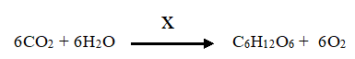

- Name the process shown above. (1mark)
- Photosynthesis;
………………………………………………………………………….
- Name the requirement labeled X. (1mark)
- Sunlight;
…………………………………………………………………………………………………
- State three substances with the same formula C₆ H₁₂ O₆ as in above equation.
(3 marks)
- Glucose; fructose; galactose;
- Name the organ, tissue, cells and organelle where the reaction shown above takes place. (4 marks)
Organ
Tissue
Cell
Organelle
- The diagram below represents a structure of xylem vessel. Study it to answer the questions that follow.
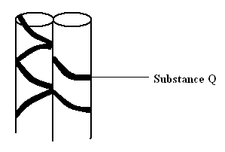

- Name substance Q. (1 mark)

- Lignin;

- How is the above structure adapted to its function. (1 marks)
- They are hollow tubes;
- They are made of dead cells placed end to end.;
- Walls thickened with lignin to prevent them from collapsing as water is being transported up the plant;

- State two functions of roots in plants. (2 marks)
- Stoage; anchorage of plants onto the soil; - perennation; - gaseous exchange;

- Name another cell that forms the Xylem tissue other than xylem vessel. (1 mark)
- Tracheids;
- The diagram below represents a stage in the digestion of food along gastrointestinal track.
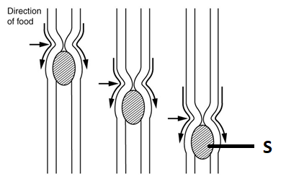
- By what mode does the represented organism feed? (1 mark)
………………………………………………………………………………………………
- Holozoic;
What is the name given to the:
- Wave of muscular contraction above. (1 mark)
- Peristalsis;
- The substance named S. (1 mark)
- Bolus;
- Name three parts of alimentary canal represented by the above drawing. (3 mark)
……………………………………………………………………………………………………………
- Oesephagus; intestines; rectum;

- The process shown below takes place during the digestion of Lipids.
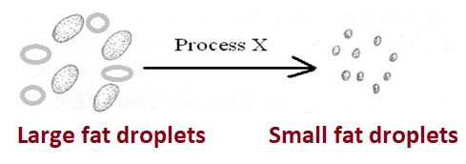

Where does it take place in mammals and what is its importance? (2 marks)

- Duodenum;
- State the two differences in Monocotyledonous stem and Dicotyledous stem.
(2 marks)
Monocotyledonous | Dicotyledonous
- Vascular bundles scattered | - vascular bundles are few and arranged in a ring near the epidermis
- some have hollow pith or pith is absent | - pith large and well developed;
- no cambium layer therefore cannot  undergo secondary growth | - presence of cambium therefore  - undergoes secondary growth;

- The figure below shows an experimental set – up to investigate a certain aspect of transport in plants. A set up that was used to investigate a certain process in plants is shown in the diagram below.
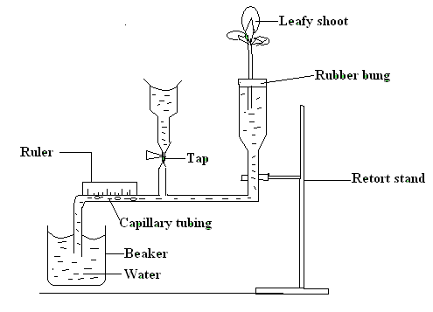
- What process was being investigated? (1 mark)
- rate of transpiration;

(b) (i) State two precautions that should be taken when setting up the experiment.
2 marks)
- The shoot should be cut under water;
- Shoot - glass tube junction should be bunged;

- Give a reason for each precaution stated in b (i) above. (2 marks)
- To prevent air from entering the xylem;
- To make it airtight;

(d) State three environmental factors that influence the process under investigation.
(3 marks)
High ight intensity; - high temperature; - wind;
- Giving reason explain the difference you would expect if the measurements were
repeated under the following conditions:-
- Shoot is placed near a heat source. (1 mark)

- The bubble moves faster; as evaporation increased with increase in temperature;
(ii) Shoot enclosed in a polythene bag. (1 mark)

- The bubble moves slower; as moisture/ humidity increased lowering saturation deficit, hence reducing transpiration;

(iii) The set-up was placed in a dark room. (1 mark)
- The bubble moves slower; as more stomata close in darkness;

- Shoot is placed in a current of air create by fan. (1 mark)
- The bubble moves faster; as drought reduced the saturation deficit

  - Some of the leaves were removed. (1 mark)
- bubble move at a slower rate since removal of some leaves reduced surface area;

- The diagram below shows single circulation in a fish.

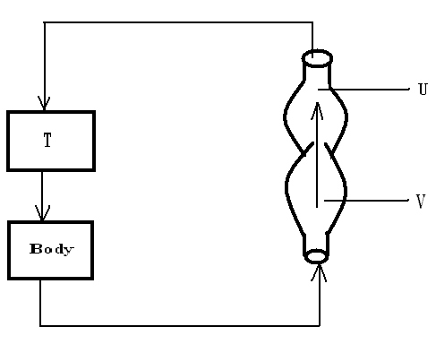
(a) Name the parts labeled T, U and V. (3 marks)

T – Gills;
U - Ventricle;
V – Auricle;

(b) How is the type of ciculation different from that found in man. (1 mark)

- In human, they exhibit double circulatory system;

(8) The diagram below represents part of a phloem tissue. Study it to answer the question
that follow.

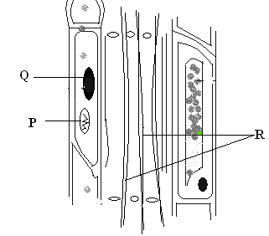
(a) Name the structures labeled P, Q and R. (3 marks)
P - Mitochondrion; rej Mitochondria
Q - Nucleus; rej Nuclei
R -Cytoplasmic strands/ cytoplasmic filaments;
(b) State the function of the phloem tissue. (1 mark)

- Translocation;
(c) (i) State how the functioning of the phloem tissue is affected if the
companion cell is destroyed. (1 mark)

- Translocation stops;

- Give a reason for your answer. (1 mark)
- Companion cells has the mitochondria that produce the energy required for the active transport that facilitate the process OWTTE
9 (a) Give a summary of the following processes of photosynthesis.

(i) Light stage. (4 marks)
- it takes place in grana; when chlorophyll molecules absorbs light; it is used to split up water molecules into hydrogen ions; and oxygen gas; This is known as photolysis; max 4 marks

(ii) Dark stage. (1 marks)

- Carbin (IV) oxide combines with Hydrogen ions from the light stage forming glucose;

- What do you understand by the following terminologies.
Open circulatory system (1 mark)
- The transport fluid is contained in the general body cavity/ coelom/ sinuses
- Closed circulatory system (1 mark)
- The transporting fluid (blood) is conveyed in special tubes referred to as blood vessels;

- The diagram below represents a transverse section through a plant organ.

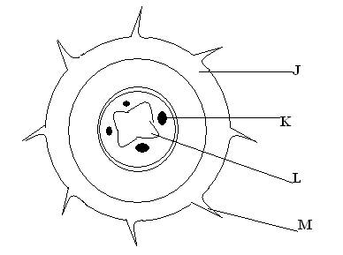
(a) From which plant organ was the section obtained? (1 mark)

- roots;
(b) Give two reasons for your answer in (a) above. (2 marks)

- Star-shaped xylem; root hairs resent; absence of pith;

(c) Name the labeled parts J, K , L and M. (4 marks)

J – epidermis;
K – phloem;
L – xylem;
M – root hair; rej root hairs

- Study the diagram below and use it to answer the questions that follow.

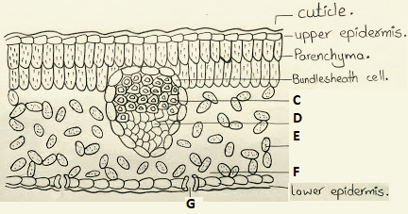
- Name the organ shown in the drawing above. (1 mark)
- Leaf;
- Identify the parts labeled C and D. (2 marks)
C- Xylem;
D – Phloem;
- Explain the concept of transpirational pull as it may takes place in the structure drawn above. (3 marks)
Energy from the sun causes evaporation of water; increasing the diffusion gradient between the atmosphere and the mesophyll cells which leads to water vapour diffusing into the atmosphere; The mesophyll cells draw water from the xylem; The water from the xylem is replaced by a continuous column of water known as transpiration stream moving up the roots,;

- Name three other forces responsible for movements of water and mineral ions in a stem of a tall plant. (3 marks)
- Cohesion; adhesion; root pressure;

