TERM ONE EXAMINATION 2024
FORM TWO

ART AND DESIGN

Time: 2hrs
_________________________________________

Name………………………………………….………………………..Class…………………….................

Admin No …………..……..………..…..………………….Date……………….……………………………
_______________________________________________________________
Instructions to candidates
- Write your name, Class, house and date in the spaces provided above
- This paper consists of two sections A, and B.
- Answer all questions in sections.
- Answers to all the questions must be written in the spaces provided.
- Where drawings and diagrams are appropriate, they should be included within the text of your answers
- Candidates should check the question paper to ascertain that all the pages are printed as indicated and that no questions are missing.
- Candidates should answer the questions in English
________________________________________________________________

For Examiner’s Use Only

Section | Question | Maximum score | Score
A | 1 | 20
B | 2a | 05
 | 2b | 05
 | 3 | 10
 | 4-6 | 20
Max. Score Paper 1 |  | 60

SECTION A (20MARKS) Answer all the questions in this section.

- Study the artwork below

Analyze the artwork according to the following sub-titles

- Type of Illustration in art work above (1mark)
.

- Theme (1mark)
.

(iii) The style of at (1mark)

(b)(i)Define the term priming as used in painting and state its function (2marks)

[ii] Name two types of washes used in painting. [2mks]

(iii)List any three painting techniques. (3marks)

(d)[i]Identify the tool below and state it function. (2marks)

[ii] Name any other two tools that can be used to perform the function apart from the one above [2mk

(e)List the three approaches to painting (3mrks)

(f)In the space below, draw a table in one-point perspective shhoing the orthogornal lines. (3marks)

Section B [40marks]
Answer all questions.]

2[a]The sketch of a town scape bellow was skatched at a certan level:
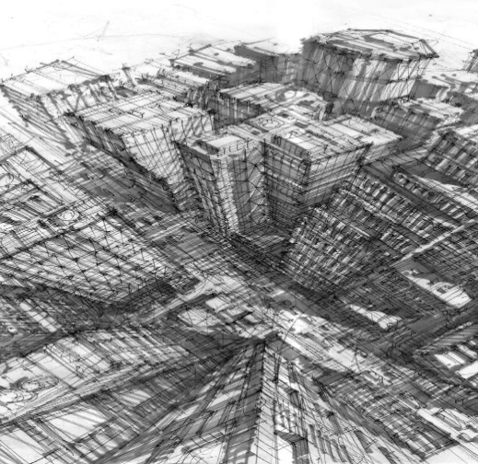

(i)Identify the eye view at which it as sketched (1mk)

[ii] Differentiate between atmospheric and linear perspectives(4mks)

(b) Study the land scape drawing bellow:

Use the drawing above to label the following parts. (5marks)

- Horizon,
- Foreground
- Middle ground
- Background
- Introduce a vanishng point.

3 (a) Define colour as an element of art and design [1mk]

(b) In the space below, draw and plot/label a colour wheel [5mks]

4(a) Define value as an element of art and design. (1mk)

(b) Illustrate the element of tonal variation in the space bellow (4mks)

5(a) Using relevant illustrations, Differentiate between active and passive balance (4mks)

(b)(Identify the type of balance exhibited by nature in the illustration bellow (1mk)

6. Below is a visual symbol

(i) Name the symbol [1mk]

(ii) Function/purpose of the symbol (1mk)

(iii)Name any two traffic light signals and their meaning (2mks)

(b)In the space bellow, draw and label each one of the following symbols: (6mks)
(i) Sports symbol
(ii) Factory symbol
(iii) Environmental symbol.

7. In the space bellow, draw hands tying shoe laces [5mks]

This is the last printed page

