TERM ONE EXAMINATION 2024
FORM TWO

ART AND DESIGN
MARKING SCHEME
_______________________________________________________________
Instructions to candidates
- Write your name, Class, house and date in the spaces provided above
- This paper consists of two sections A, and B.
- Answer all questions in sections.
- Answers to all the questions must be written in the spaces provided.
- Where drawings and diagrams are appropriate, they should be included within the text of your answers
- Candidates should check the question paper to ascertain that all the pages are printed as indicated and that no questions are missing.
- Candidates should answer the questions in English
________________________________________________________________

For Examiner’s Use Only

Section | Question | Maximum score | Score
A | 1 | 20
B | 2a | 05
 | 2b | 05
 | 3 | 10
 | 4-6 | 20
Max. Score Paper 1 |  | 60

SECTION A (20MARKS) Answer all the questions in this section.

- Study the artwork below

Analyse the artwork according to the following sub-titles

- Type of Illustration in the art work above -Silhouette (1mark)

- Theme: Traditional life/traditional music/culture (1mark)
- Style of art -Semi Abstract (1mark)

(b)(i)Priming-Applying an undercoat on the painting ground to reduce absorbency or increase the stability of paint according to the surface quality of the surface being painted on.
Importance of priming a surface before painting. [1mrk]
-To reduce or increase the absorbency of the working surface depending on its surface quality
-Increase stability of the surface (1mk ]
Total=2mks

[ii] Two types of wash as used in painting.
Plain wash
Graded ash [2mks]

(ii)Any three painting techniques
- Brush stroke
- Washout
- Pallet knife
- Mixed media
- Dry pigment
- Dabbing
- Wet on wet (1@=3marks)

(d)[i]The tool and state it function

-Pallet knife
-Used to pick up paints from the pallet and apply it on the painting surface to create forms. (2marks)

[ii] Any other two tools that can be used to perform the function apart from the one above
-Brush
-sponges
Feathers
Sticks
Fingers
Spray can [Any 2=2mks]

(e)Three approaches to painting

From Imagination
From Observation
From memory (3mrks)

f.In the space below, draw a table in one-point perspective (3marks)
The table should be either on normal,worms or birds eye level,provided it the orthogonal lines converge/ varnish towards one point

Section B [40marks] Answer all questions.

[2] (a)The sketch of a town scape bellow was skatched at a certan level:

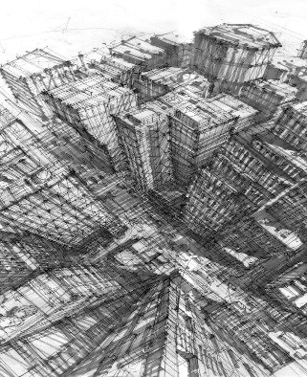

(i)IThe eye level at which it as sketched- Bird’s eye view1mk)

[ii] Atmospheric perspectiveachieved by use of colour contrast/tone,such that obects in the foreground appear in darker values and the shadding/tonning gets lighter and faint as they receed into the background

While linear perspective, features/forms and the sizes as ell aslines in the composition get thinner and closer to the horizon and to the converging point[varnishing point](4mks)

(b) Study the drawing bellow
(i) Cartegorry of drawing:-land scape scenery[1mk]
Horizon
Foreground
Middle ground
Background
Lebelling=4mks

- (a) Colour -An element of art and design that can only be perceived by the sense of sight in the presence of light. a sensation of light rays which has wave length that reflects light on a pigment. [1mk]

(b) A well labelled colour wheel,
May not necessarily be painted but should be Cleary showing primary, secondary and tertiary colours [5mks all well labelled]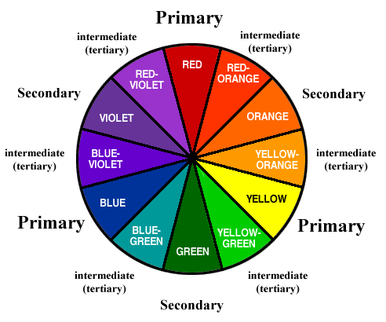
4(a) value-The darkness or lightness of an object/a surface. (1mks)
(b) Any form/style of Illustration of tonal variation =4mks)
Lightest
dark
darker
Very dark/darkest
Lighter
Light
5 (a) Illustration showing, the differentiate between active and passive balance (4mks)
Active/also known as asymmetrical balance is where the elements on either side of the central axis are balanced but not identical, while in passive, it is where elements on either side of the central axis are identical, also known as symmetrical balance. Eg (any relevant illustration to show both asymmetrical and symmetrical balance=2mks)
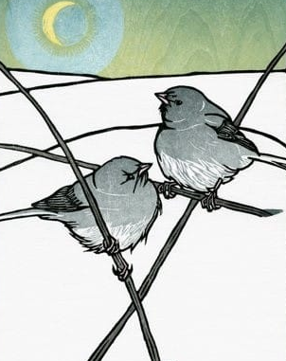Asymmetrical 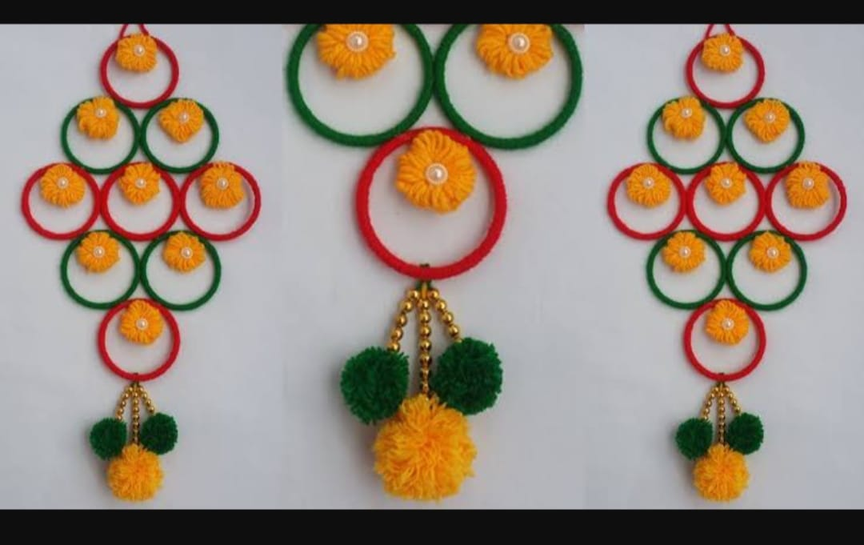Symmetrical

(b)(Identify the type of balance exhibited by nature in the illustration bellow (1mk)
Radial/Radial symmetrical.
6. Below is a visual symbol

(i) Name the symbol-Visual symbol/road sign. [1mk]

(ii) Function/purpose of the symbol It prohibits the motorists from parking at the designated area. (1mk)

(iii)Any two traffic light signals and their meaning
Red- Stop [prohibits the motorists from proceeding]
Amber-Warning/Readiness light- Informs the motorists to be ready either to move or stop.
Green-Informs the motorists to go/move (2mks)

(b)In the space bellow, draw and label each one of the following symbols: (6mks)
(i) Sports symbol-
eg, soccer, swimming, athletics, hockey, basketball, etc
(ii) Factory symbol-bio hazard, flammable, fragile, poisonous, Radioactive, toxic, high voltage, etc.-
(iii) Environmental symbol. Recycling, litter bin/trash bin, tree planting, foot prints/tracks etc. any one and many better illustrated
7. Hands tying shoe laces-[Shape-2mks,
Subject matter 1mk-
Rythm/movt 2mks Total-5mks]

