Name: ………………………………………Admission Number: …………………
School: ……………………………………………….Class………………………………….
Date:……………………………………………………Sign:…………………………………
FORM TWO
AGRICULTURE
TIME: 2 HOURS
INSTRUCTIONS TO CANDIDATE
1. Write your name and admission number in the spaces provided above.
2. Sign and write date of examination in spaces provided.
3. This paper consists of three sections A, B and C.
4. Answer ALL questions in section A,B and C.
5. Candidate must answer the questions in English.
6. All answers should be written in spaces provided.
SECTION | QUESTION | MAXIMUM SCORE | CANDIDATE SCORE
A | 1-17 | 40
B | 18-22 | 20
C | 23-26 | 40
TOTAL |  | 100

SECTION A [40 MARKS]
1. Name four beneficial biotic factors in Agricultural production. (2marks)
…………………………………………………………………………………………………
…………………………………………………………………………………………………
…………………………………………………………………………………………………
…………………………………………………………………………………………………
…………………………………………………………………………………………………
2. State four aspects of rainfall and describe their effect on agricultural activities (2marks)
………………………………………………………………………………………………………………………………………………………………………………………………………………………………………………………………………………………………………………………………………………………………………………………………………..
3. List four methods of fertilizer application (2marks)
………………………………………………………………………………………………………………………………………………………………………………………………………………………………………………………………………………………………………………………………………………………………………………………………………..

4. State and describe three tertiary operations (3marks)
………………………………………………………………………………………………………………………………………………………………………………………………………………………………………………………………………………………………………………………………………………………………………………………………………..

5. State four advantages of drip irrigation (2marks)
……………………………………………………………………………………………………………………………………………………………………………………………………………………………………………………………………………………………………………………………………………………………………………………………………………………………………………………………………………………………………………........................................................................
6. State four characteristics of plants used as green manure (2marks)
……………………………………………………………………………………………………………………………………………………………………………………………………………………………………………………………………………………………………………………………………………………………………………………………………………………………………………………………………………………………………………..................................................................................

7. Differentiate the following terms as used in crop production
i) Thinning and pricking out (2marks)
………………………………………………………………………………………………………………………………………………………………………………………………………………………………………………………………………………………………………..........................................................................................................................................
ii) Nursery bed and seedling bed (2marks)
………………………………………………………………………………………………………………………………………………………………………………………………………………………………………………………………………………………………………………………………………………………………………………………………………..
8. List four fresh market varieties of tomatoes (2marks)
……………………………………………………………………………………………………………………………………………………………………………………………………………………………………………………………………………………………………………………………………………………………………………………………………….............................................................................................................................................................................................

9. Name two types of inventory records that are kept in the farm (2marks)
……………………………………………………………………………………………………………………………………………………………………………………………………………………………………………………………………………………………………..
10. Outline two importance of vegetable crops (2marks)
………………………………………………………………………………………………………………………………………………………………………………………………………………………………………………………………………………………………………………………………………………………………………………………………………..
11. Outline four advantages of seed for crop propagation (2marks)
……………………………………………………………………………………………………………………………………………………………………………………………………………………………………………………………………………………………………………………………………………………………………………………………………….............................................................................................................................................................................................
12.a) Name the most appropriate tools used in the following operations (2marks)
(i) Branding-
…………………………………………………………………………………………………
(ii) Cutting woods along the grains
…………………………………………………………………………………………………
(iii) Removing metal chippings in the field.
…………………………………………………………………………………………………
(iv) Cutting soft branches of coffee during prunning
………………………………………………………………………………………………..
b) Name four complimentary tools in livestock production (2marks)
………………………………………………………………………………………………….…………………………………………………………………………………………………............................................................................................………………………………………………………………………………………………….…………………………………………………………………………………………………..............................................................
13. Outline four ways in which the government policies encourage the growth and development of local Agricultural industries (4marks)
………………………………………………………………………………………………………………………………………………………………………………………………………………………………………………………………………………………………………………………………………………………………………………………………………............................................................................................................................................................

14. Name four soil structures (2marks)
………………………………………………………………………………………………………………………………………………………………………………………………………………………………………………………………………………………………………………………………………………………………………………………………………............................................................................................................................................................
15. Write down one distinguishing characteristic of the following livestock breeds.(2marks)
a) Jersey
……………………………………………………………………………………………………………………………………………………………………………………………………………………………………………………………………………………………
b) Saddleback/Wessex
…………………………………………………………………………………………………………………………………………………………………………………………………….............................................................................................
c) Earlops
……………………………………………………………………………………………………………………………………………………………………………………………………............................................................................................

d) Toggenburg
……………………………………………………………………………………………………………………………………………………………………………………………………............................................................................................
16. Give four advantages of organic farming (2marks)
………………………………………………………………………………………………………………………………………………………………………………………………………………………………………………………………………………………………………………………………………………………………………………………………………..............................................................................................................................................................................................
17. Name two agricultural activities that make Agriculture as an art (1mark) …………………………………………………………………………………………………………………………………………

SECTION B(20 MARKS)
18. A farmer wishes to prepare 100kg starter meal containing 20% DCP using wheat containing 10% DCP and sunflower cake 35% DCP. Using the Pearson’s Square Method, show how that ration is computed (5marks)

19. The diagram below show various nursery propagation practise. Study them carefully and answer the questions that follow
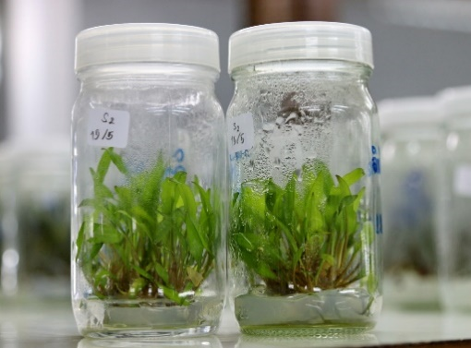
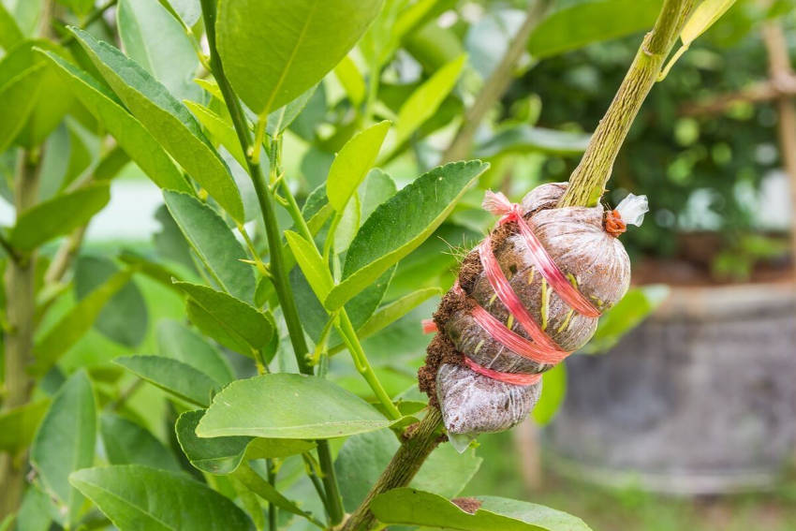
M
O
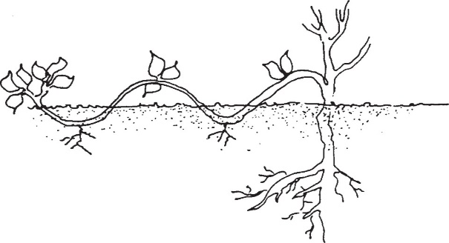
N
i) Name the practice labelled (3marks)
M………………………………………………… N…………………………………………………
O-……………………………………………………

ii) State two importance of carrying out practice M (1mark)
…………………………………………………………………………………………………
iii) State two advantages of practice N, over other propagation practices. (1mark)
……………………………………………………......................................................................
……………………………………………..................................................................................
20. The diagram below illustrates the stages of life cycle of a tick. Study the diagram and answer the following questions that follows
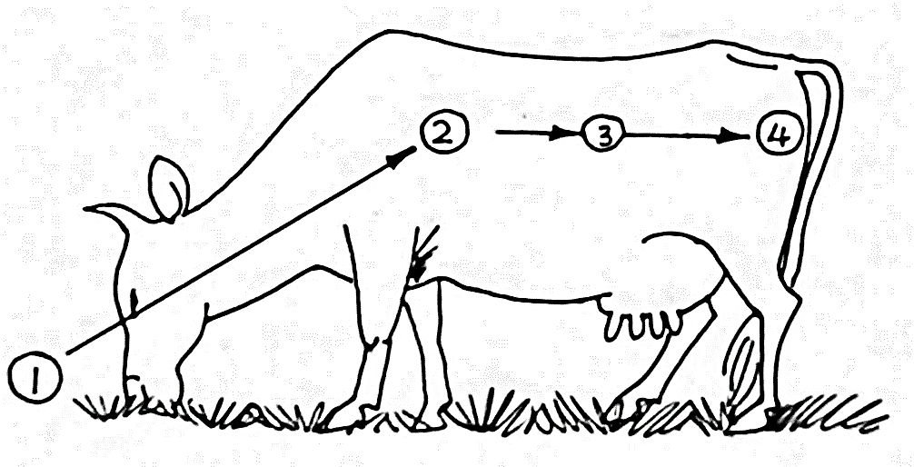
a) Describe the development of tick at 1, 2, 3 and 4 (4marks)
………………………………………………………………………………………………………………………………………………………………………………………………………………………………………………………………………………………………………………………………………………………………………………………………………............................................................................................................................................................
b) Classify the tick on the basis of the life cycle (1mark)
…………………………………………………………………………………………………………………………………………………………………………………………………
21. Name two functions of calcium in dairy cows (2marks)
…………………………………………………………………………………………………………………………………………………………………………………………………......
22. Give three characteristics of succulent roughages (3marks)
………………………………………………………………………………………………………………………………………………………………………………………………………………………………………………………………………………………………………………………………………………………………………………………………………….

SECTION C (40 MARKS)
23.a) Explain why minimum tillage is recommended (5marks)
……………………………………………………………………………………………………………………………………………………………………………………………………………………………………………………………………………………………………………………………………………………………………………………………………………………………………………………………………………………………………………………………………………………………………………………………………………………………………………………………………………………………………………………………………………………………………………………………………………………………………………………………………………………………………………………………………………………………………………………………………………………………………………………………………………………………………………………………
b) State five Uses of water in the farm (5marks)
………………………………………………………………………………………………………………………………………………………………………………………………………………………………………………………………………………………………………………………………………………………………………………………………………………………………………………………………………………………………………………………………………………………………………………………………………………………………………………………………………………………………………………………………………………………………………………………………………………………................................................................................................................................................
24. Describe five field management practises for tomatoes (10marks)
………………………………………………………………………………………………………………………………………………………………………………………………………………………………………………………………………………………………………………………………………………………………………………………………………………………………………………………………………………………………………………………………………………………………………………………………………………………………………………………………………………………………………………………………………………………………………………………………………………………………………………………………………………………………………………………………………………………………………………………………………………………………………………………………………………………………………………………………………………………………………………………………………………………………………………………………………………………………………………………………….
25. Describe five methods of farming (10 marks)
………………………………………………………………………………………………………………………………………………………………………………………………………………………………………………………………………………………………………………………………………………………………………………………………………………………………………………………………………………………………………………………………………………………………………………………………………………………………………………………………………………………………………………………………………………………………………………………………………………………………………………………………………………………………………………………………………………………………………………………………………………………………………………………………………………………………………………………………………………………………………………………………………………………………………………………………………………………………………………………………….
26. State and give examples of five predisposing factors of livestock (5marks)
………………………………………………………………………………………………………………………………………………………………………………………………………………………………………………………………………………………………………………………………………………………………………………………………………………………………………………………………………………………………………………………………………………………………………………………………………………………………………………………………………………………………………………………………………………………………………………………………………………………………………………………………………………………………………………………………………………………………………………………………………………………………………………………………………………………………………………………………………………………………………………………………………………………………………………………………………………………………………………………………….
………………………………………………………………………………………………………………………………………………………………………………………………………………………………………………………………………………………………………

b) Give importance of keeping livestock healthy (5marks)
………………………………………………………………………………………………………………………………………………………………………………………………………………………………………………………………………………………………………………………………………………………………………………………………………………………………………………………………………………………………………………………………………………………………………………………………………………………………………………………………………………………………………………………………………………………………………………………………………………………………………………………………………………………………………………………………………………………………………………………………………………………………………………………………………………………………………………………………………………………………………………………………………………………………………………………………………………………………………………………………….
…………………………………………………………………………………………………………………………………………………………………………………………………….
…………………………………………………………………………………………………………………………………………………………………………………………………….
…………………………………………………………………………………………………………………………………………………………………………………………………….
…………………………………………………………………………………………………………………………………………………………………………………………………….
…………………………………………………………………………………………………………………………………………………………………………………………………….
…………………………………………………………………………………………………………………………………………………………………………………………………….
…………………………………………………………………………………………………………………………………………………………………………………………………….
………………………………………………………………………………………………………………………………………………………………………………………………………………………………………………………………………………………………………

