Name………………………………….Date………………Candidate’s Signature: ………...…….
Stream ..................Adm.No..................

PHYSICS THEORY
Time: 2 hours
April 2024
Kenya Certificate of Secondary Education
PHYSICS
FORM 1 PHYSICS
END TERM 1
Instructions to Candidates
- Write your name, admission number, class and signature in the spaces provided at the top of the page.
- Answer ALL the questions in the spaces provided.
- All working MUST be clearly shown.
- This paper consists of 8 printed pages.
- Candidates should answer the questions in English and check to ensure that no question(s) is missing.
FOR EXAMINER’S USE ONLY

QUESTIONS | MAXIMUM SCORE | CANDIDATE’S SCORE
1-18 | 60

This paper consists of 8 printed pages. Candidates should check and ascertain that all questions are printed as indicated and that no questions are missing. TURN OVER

Answer all the questions in this section in the spaces provided.
- What is Physics? (1 mark)
………………………………………………………………………………………………………………………………………………………………………………………………………………
- State and explain any two branches of physics. (4 marks)
………………………………………………………………………………………………………………………………………………………………………………………………………………………………………………………………………………………………………………………………………………………………………………………………
- Explain the relationship between Physics and:
- Religious studies. (1 mark)
………………………………………………………………………………………………………………………………………………………………………………
- Biology. (1 mark)
………………………………………………………………………………………………………………………………………………………………………………
- Geography. (1 mark)
………………………………………………………………………………………………………………………………………………………………………………………………………………………………………………………………………
- Distinguish between derived physical quantities and basic physical quantities giving examples in each. (4 marks)
………………………………………………………………………………………………………………………………………………………………………………………………………………………………………………………………………………………………………………………………………………………………………………………………………………………………………………………………………………………………

- The diagram in figure 1 below shows a piece of sewing thread wound 12 times on a ruler.
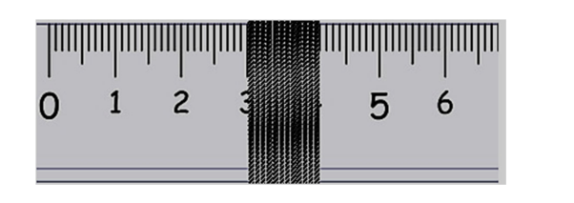
Figure 1
Determine the thickness of the sewing thread. (3 marks)
………………………………………………………………………………………………………………………………………………………………………………………………………………………………………………………………………………………………………………………………………………………………………………………………………………………………………………………………………………………………………………………………………
- a) Draw a $50{cm}^{3}$ burette containing water of volume $28.2{cm}^{3}$. (2 marks)

b) If 60 drops of water fell from the burette above, the final level of water was $42{cm}^{3}$.Calculate the volume of one drop. (3 marks)
………………………………………………………………………………………………………………………………………………………………………………………………………………………………………………………………………………………………………………………………………………………………………………………………………………………………………………………………………………………………………………………………………
- Define density and state its S.I units. (2 marks)
………………………………………………………………………………………………………………………………………………………………………………………………………………………………………………………………………………………………………………………

- Figure 2 below shows a girl viewing an overhead tank carrying a liquid of mass 8,400 kg. the tank is calibrated in $m^{3}$. 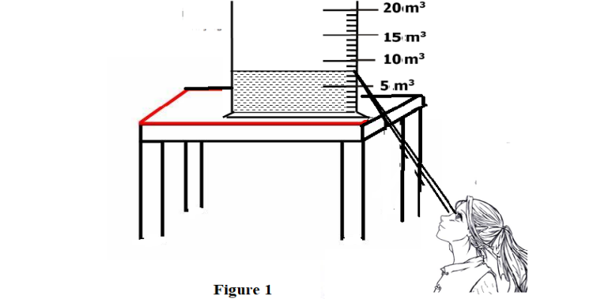
Figure 2

The girl read the volume from the tank and then used it for further calculation.
Determine;
- The volume of the liquid in the overhead tank in ${cm}^{3}$. (2 marks)
………………………………………………………………………………………………………………………………………………………………………………………………………………………………………………………………………………………………………………………

- The density of the liquid as obtained by the girl. (3 marks)
………………………………………………………………………………………………………………………………………………………………………………………………………………………………………………………………………………………………………………………
- Explain why, while working in the laboratory it is advisable to:
- NOT touch exposed electrical wires. (1 mark)
………………………………………………………………………………………………………………………………………………………………………………………………………………

- NEVER taste, drink or eat anything in the laboratory. (1 mark)
………………………………………………………………………………………………………………………………………………………………………………………………………………
- Define force and state its S.I units. (2marks)
………………………………………………………………………………………………………………………………………………………………………………………………………………
- Two horizontal springs are attached to a block, resting on a frictionless surface, as shown in figure 3 below. A force of 100N pulls on one spring. The block does not move. Find the value of the force on the other spring. (2 marks)
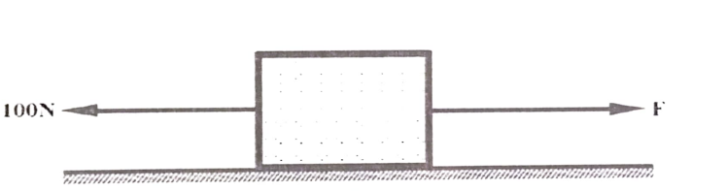
Figure 3
……………………………………………………………………………………………………………………………………………………………………………………………………
- State 3 effects of a force. (3 marks)
………………………………………………………………………………………………………………………………………………………………………………………………………………………………………………………………………………………………………………………………………………………………………………………………………………………………………………………………………………………………………………………………………
- Name any two instruments you would use to measure mass in the laboratory. (2 marks)
………………………………………………………………………………………………………………………………………………………………………………………………………………………………………………………………………………………………………………………
- An astronaut has a mass of 65Kg on earth’s surface.
Calculate:
- His weight on earth , given that earths gravitational field strength is $10N/{Kg}$.
(2 marks)
…………………………………………………………………………………………………………………………………………………………………………………….
- His mass on the moon. (Give a reason for your answer.) (2 marks)
……………………………………………………………………………………………………………………………………………………………………………………
- The gravitational field strength of the moon, where his weight was determined to be 108.33N. (2 marks)
………………………………………………………………………………………………………………………………………………………………………………………………

- Estimate the area of the irregular surface shown in the figure 4 below by counting the small squares. The area of one complete square is 1cm². (3 marks)
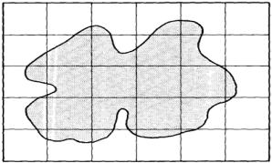
Figure 4
………………………………………………………………………………………………………………………………………………………………………………………………………………………………………………………………………………………………………………………
- In an experiment to determine the density of sand using a density bottle, the following measurements were recorded;
$$Mass of empty density bottle=43.2g$$
$$Mass of density bottle full of water=66. 4g$$
$$Mass of density bottle with some sand=67.0g$$
$$Mass of density bottle with the sand filled up with water=82.3g$$
Use the above data to determine the following:
- Mass of the water that completely filled the density bottle. (1 mark)
………………………………………………………………………………………………………………………………………………………………………………………………
- Volume of water that completely filled the density bottle
(density of water = 1.0 gcm⁻³) (2 marks)
………………………………………………………………………………………………………………………………………………………………………………………………

- Volume of the density bottle. (1 mark)
………………………………………………………………………………………………………………………………………………………………………………………………

- Mass of sand. (1 mark)
………………………………………………………………………………………………………………………………………………………………………………………………

- Mass of water that filled the space above the sand. (1 mark)
………………………………………………………………………………………………………………………………………………………………………………………………

- Volume of sand. (2 mark)
………………………………………………………………………………………………………………………………………………………………………………………………

- Density of the sand. (2 marks)
………………………………………………………………………………………………………………………………………………………………………………………………

- Explain why it is easier to ride a bicycle round a bend on a road if the surface is dry than when it is wet. (1 mark)
………………………………………………………………………………………………………………………………………………………………………………………………………………………………………………………………………………………………………………………………………………………………………………………………
- Define pressure and state its SI units. (2 marks)
………………………………………………………………………………………………………………………………………………………………………………………………

END.

