Kenya Certificate of Secondary Education
PHYSICS
FORM 1 PHYSICS
END TERM 1 2024

Answer all the questions in this section in the spaces provided.
- What is Physics? (1 mark)
Physics is defined as the study of matter and its relation to energy.
- State and explain any two branches of physics. (4 marks)
- Mechanics; It deals with the study of motion under the influence of force.
- Electricity and magnetism; It deals with relationship between electric field and magnetic field and their applications in the working of motor, microphones, electro-magnets etc.
- Heat and Thermodynamics; It deals with the transformation of heat to and from other forms of energy and the accompanying changes in pressure, volume etc.
- Geometric optics; It deals with the behavior of light as it passes through various media.
- Waves; It deals with propagation of energy through space and effects such as reflection, diffraction of light and sound waves.
- Atomic physics; It is deals with the study of the behavior of particles constituting the nucleus (Centre) of the atom and their accompanying energy changes.
Any two correctly identified and explained.

- Explain the relationship between Physics and:
- Religious studies. (1 mark)
The study of Physics comes up with findings which are agreement with religion, that the orderliness in the universe can be traced back to the creator. The earth faithfully maintains its rotation so that the sun will always rise from the East and never from the West among many other wonders of creation.

- Biology. (1 mark)
Knowledge of lenses studied in physics has led to the manufacture of microscopes used in the study of the cell and diseases.

- Geography. (1 mark)
Accurate use of weather instruments like thermometer, wind vane, rain gauges etc. require physics knowledge. or
Concepts like heat transfer by convection which explain the formation of convectional rainfall and pressure variation can be best explained in physics.
- Distinguish between derived physical quantities and basic physical quantities giving examples in each. (4 marks)
Basic physical quantities are quantities that cannot be obtained from other physical quantities e.g. (Length, Mass, Time, Electric currents, Thermodynamic temperature, Luminous intensity, Amount of substance) while derived physical quantities are quantities obtained by multiplication or division of other physical quantities e.g. (area, volume, work, density, momentum etc.)
- The diagram in figure 1 below shows a piece of sewing thread wound 12 times on a ruler.
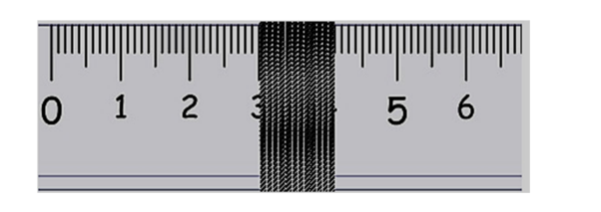
Figure 1

Determine the thickness of the sewing thread. (3 marks)
$$Thicknes=\frac{length}{number of turns}=\frac{4.1-3.0}{12}=\frac{1.1}{12}=0.0917cmanswer in decimals$$

- a) Draw a $50{cm}^{3}$ burette containing water of volume $21{.8cm}^{3}$. (2 marks)

In a burette,
Final burette reading- initial reading = volume
21.8=50-x
X=50-21.8
X=28.2
for correct level 28.2
for correct callibration

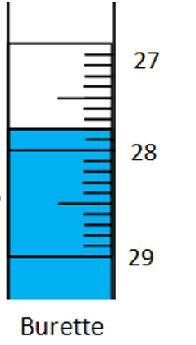
b) If 60 drops of water fell from the burette above, the final level of water was $42{cm}^{3}$.Calculate the volume of one drop. (3 marks)
$$Volume of 60 drops=initial volume-final volume;42-28.2=13.8$$
$$volume of 1 drop=\frac{13.8}{60}=0.23{cm}^{3}$$

- Define density and state its S.I units. (2 marks)
It is defined as the mass per unit volume of a substance.
the SI unit of density is the kilogram per cubic meter
- Figure 2 below shows a girl viewing an overhead tank carrying a liquid of mass 8,400 kg. the tank is calibrated in $m^{3}$. 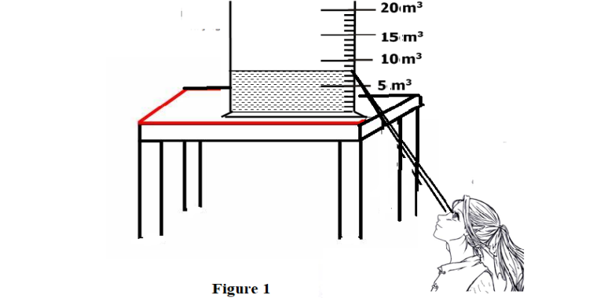
Figure 2

The girl read the volume from the tank and then used it for further calculation.
Determine;
- The volume of the liquid in the overhead tank in ${cm}^{3}$. (2 marks)
$$Reading=8m^{3}$$
$$converting to {cm}^{3}=8×1,000,000=8,000,000{cm}^{3}$$

- The density of the liquid as obtained by the girl. (3 marks)
$$density=\frac{mass}{volume}=\frac{8400}{8}=1050{kg}/{m^{3}}$$
- Explain why, while working in the laboratory it is advisable to:
- NOT touch exposed electrical wires. (1 mark)
this can also cause an electric shock
- NEVER taste, drink or eat anything in the laboratory. (1 mark)
This is to avoid the risk of consuming dangerous or poisonous materials or substances.
- Define force and state its S.I units. (2marks)
A force is a push or pull. The SI unit of force is the newton (N).
- Two horizontal springs are attached to a block, resting on a frictionless surface, as shown in figure 3 below. A force of 100N pulls on one spring. The block does not move. Find the value of the force on the other spring. (2 marks)
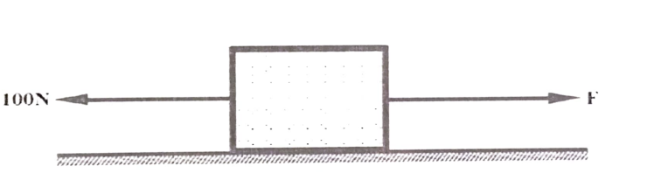
Figure 3
$$100+F=0$$
F=-100, NEGATIVE indicates opposite direction.
Also accept=100N

- State 3 effects of a force. (3 marks)
(i) Make a stationary object start moving or increase the speed of a moving object. (ii) Slow down or stop a moving object. (iii) Change the direction of a moving object. (iv) Distort (change the shape of) an object.
- Name any two instruments you would use to measure mass in the laboratory. (2 marks)
I. Top pan balance
II. Beam balance
III. Lever balance
Any two correct
- An astronaut has a mass of 65Kg on earth’s surface.
Calculate:
- His weight on earth , given that earths gravitational field strength is $10N/{Kg}$.
(2 marks)
$$weight,w=mass,m ×gavitational field strength,g.:65×10=650N$$

- His mass on the moon. (Give a reason for your answer.) (2 marks)
Mass on the moon =65kg
Mass is constant/does not vary from place to place
- The gravitational field strength of the moon, where his weight was determined to be 108.33N. (2 marks)
$$g=\frac{weight,w}{mass,m};\frac{108.33}{65}=1.6667N/{kg}$$
- Estimate the area of the irregular surface shown in the figure 4 below by counting the small squares. The area of one complete square is 1cm². (3 marks)
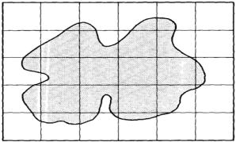
Figure 4
$$Area=\left(number of complete squares+\frac{1}{2}×number of incomplete squares\right)area of one square$$
A$rea=\left(4+\frac{1}{2}×22 \right)×1 {cm}^{2}$
$$Area=15 {cm}^{2}$$

- In an experiment to determine the density of sand using a density bottle, the following measurements were recorded;
$$Mass of empty density bottle=43.2g$$
$$Mass of density bottle full of water=66. 4g$$
$$Mass of density bottle with some sand=67.g$$
$$Mass of density bottle with the sand filled up with water=82.3g$$
Use the above data to determine the following:
- Mass of the water that completely filled the density bottle. (1 mark)
$$mass of water=66.4g-43.2g=23.2g$$

- Volume of water that completely filled the density bottle. (2 marks)
$$volume=\frac{mass of water}{density }=\frac{23.2}{1}=23.2{cm}^{3}$$
- Volume of the density bottle. (1 mark)
$$volume of water=volume of bottle=23.2{cm}^{3}$$
- Mass of sand. (1 mark)
$$mass of sand=67-43.2=23.8g$$
- Mass of water that filled the space above the sand. (1 mark)
$$Mass of water above sand=82.3-67=15.3g$$

- Volume of sand. (2 mark)
$$volume of sand=23.2-15.3=7.9$$

- Density of the sand. (2 marks)
$$density=\frac{mass}{volume} =\frac{23.8}{7.9}=3.012658g/{{cm}^{3}}$$

- Explain why it is easier to ride a bicycle round a bend on a road if the surface is dry than when it is wet. (1 mark)
A bicycle skids off the road when it is wet due to reduced frictional force that makes the road slippery.

- Define pressure and state its SI units. (2 marks)
Pressure refers to force acting perpendicularly per unit area
SI unit of pressure is the newton per square meter (N/m²) or the pascal (Pa).

- What is the reason why a trailer carrying heavy loads have many wheels? (2 marks)
The many wheels increase the area of contact between the lorry and the road which reduces the pressure exerted by the lorry on the road. This prevents the trailer from sinking as it moves and also minimizes road damage.

