121/ 1 Mathematics Paper 1
FORM 1 2024
END TERM 1 – Time: 2 ½ hours

Name …………………………………………….……… Admission Number…………………………..

Candidate’s Signature ………………….…...……….. Date ……………………………………

Instructions to candidates
- Write your name, admission number and class in the spaces provided above.

- The paper contains two sections: Section I and Section II.

Answer ALL the question
- s in Section I and ANY FIVE questions from Section II.

- All working and answers must be written on the question paper in the spaces provided below each question.

- Marks may be awarded for correct working even if the answer is wrong.
- Negligent and slovenly work will be penalized.

- Non-programmable silent electronic calculators and mathematical tables are allowed for use.

- This booklet contains 17 printed pages. Please confirm that all the pages exist and are properly printed before starting the exam.

For Examiner’s use only
Section I

1

2

3

4

5

6

7

8

9

10

11

12

13

14

15

16

Total

Section II

17

18

19

20

21

Total

Grand Total %

1

SECTION I (50 MARKS)

Answer all the questions in this section.

1. Write the following numbers in words (3 marks)

- 900079

- 17006952

- 3000020739

2. Find the sum of all prime numbers between 0 and 50. (3 marks)

3. State the place values of the following digits in 52368700941 i. 6: ________________________________________ ii. 5: ________________________________________

(4 marks)

iii. 2: ________________________________________

iv. 9: ________________________________________

2

4. The sum of four consecutive numbers is 102. Find the numbers.

5. Arrange the following fractions in descending order. | 2 | , | 4 | , | 7
 | 3 |  | 7 |  | 10

(3 marks)

(3 marks)

6. The GCD and LCM of three numbers are 3 and 504 respectively. If two of the numbers are 24 and 72

respectively, find the least possible value of the third number. (3 marks)

3

7. Find the perimeter of a square whose area is 289 cm². (3 marks)

- A farmer has four types of animals on his farm. The pie chart below represents the number of animals on the

farm. If the number of goats were 30, calculate the number of camels on the farm. (4 marks)
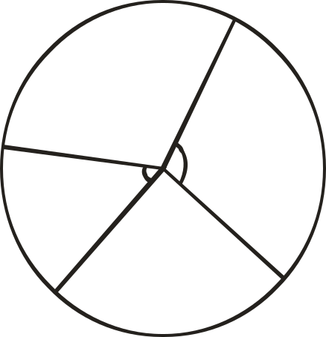

Goats

Cattle
120º

Sheep
130º
xº

(x + 10)º

Camels

9. Factorise 4pqr² + 6p²qr² – 2pq²r² (3 marks)

4

10. Convert | . . | into fraction.
 | 0.427
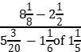

11. Evaluate

12. Work out 1305 (670 235) 6 780 13

13. Is 43516902 divisible by 11? Show your working.

5

(3 marks)

(3 marks)

( 3 marks)

(3 marks)

14. Express the following in terms of their prime factors. (3 marks)

- 72

- 686

- 1152

15. Evaluate 55.31 + 100.184 – 143.9455 leaving your answer in standard form. (3 marks)

16. Show that 35600 is divisible by 8 and not 3. (3 marks)

6

 | SECTION II (50 MARKS)
Answer any FIVE questions in this section.
17. Use squares and square root tables to solve the following |  |  | (10 marks)
(i) 4.56² - √30.4

- √0.846 + √0.095

- 20.7² - √10486

- 0.7865² - √0.007267

- 7.059² - √1850

7

18. (a) Without using mathematical tables or a calculator, evaluate (5 marks)
² ¹
2⁷−4⁵ ⁺ ₁

- A fruit dealer blends the fruit juice in a common container to the brim before choosing the quantities in which to distribute them. She can pack them in either 20 litres, 24 litres or 36 litres can before selling them. If she chooses 20 litres cans she remains with 13 litres while when she uses 24 litres 17 litres remain in a container and 29 litres remain when distributed in 36 litres cans. Determine the least capacity of her container
in litres. (5 marks)

8

- (a) A mother is three and a half times as old as her daughter now. Five years ago, the sum of their ages was equal to the mother’s age four years from now. Taking the daughter’s present age as d years, find the mother’s
actual age in 15 years. (4 marks)

- Annette has some money in two denominations only. Fifty shillings notes and twenty shilling coins. She has three times as many fifty shilling notes as twenty shilling coins. If altogether she has sh. 3,400, find the number

of fifty shilling notes and 20 shilling coin. (3 marks)

(c) The mean of five numbers is 20. The mean of the first three numbers is 16. The fifth number is greater than

the fourth by 8. Find the fifth number. (3 marks)

9

20. Use number lines to perform the following operations (10 marks)

- (+5) – (3)

- (-4) + (2)

- (+2) + (+5) + (-8)

d) (-3) + (+6)- (-2)

  - (+2) + (-6) – (+3) – (-4)

- (a) The area of a triangle whose height is equal to the length of its base is 40.25 cm². Calculate the length of

the base. (3 marks)

10

(b) Without using a calculator and tables, evaluate | (4 marks)
11.7 x0.036x5.8
130x1.45x7.2

(c ) A vegetable vendor had 1348 cabbages. He sold 750 on the first day and 240 on the second day. He

added 466 to the remaining stock on the third day. (3 marks)

- How many cabbages did he have at the end?

- If he sold the cabbages at a cost of shs 15, how much money did he get?

11

