Term 1 - 2024
DRAWING AND DESIGN (449)
FORM ONE
Time: 2½ Hours

Name: …………………………………… Adm No: ……………….
School: ………………………………………Class: …………………..
Signature: ………………………………………… Date: …………………...

FOR EXAMINERS USE ONLY
 | 1 | 2 | 3 | 4 | 5 | 6 | 7 | 8 | 9 | 10 | 11 | 12 | 13 | 14 | 15 | TOTAL
MAXIMUM | 9 | 6 | 4 | 4 | 5 | 7 | 10 | 8 | 6 | 6 | 6 | 7 | 6 | 6 | 10 | 100
STUDENT’S
SCORE

INSTRUCTIONS TO CANDIDATES.
  - You should have the following for this examination:
    - Drawing instruments
    - 3 sheet of drawing paper size A3
  - This paper consists of TWO sections A and B.
  - Answer ALL the questions in section A and B.
  - Questions in section A must be answered in the spaces provided.
  - Questions in section B should be answered on the A3 drawing papers provided.
  - All dimensions are in millimeters unless otherwise stated.
  - Candidates may be penalized for not following the instructions given in this paper.

- (a)State any six general objectives of drawing and design as a subject. (6 marks)

(b) Name three instruments used in linear measurement (3 marks)

- Indicate the sizes of the following drawing papers (6 marks)

Paper name | size
 | LENGTH | WIDTH
A₅
A₄
A₃
A₂
A₁
A₀

- Differentiate between the following terms as used in engineering. (4 marks)
- Technical drawing

- Artistic drawing

- List four aims of technical drawing. (4mks)

- state where each of the following types of lines are used (5mks)
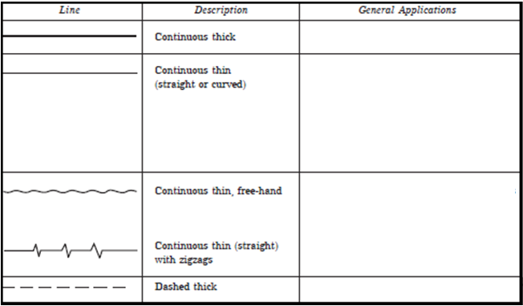

- (a) Give one reason why the following are used in drawing. (4marks)
    - Symbols and abbreviations

    - Lettering

(b)State three factors that contribute to quality drawing. (3 marks)

- Construct the following angles using a pair of compass , a pencil and a ruler only (10 marks)

- 60⁰

- 30⁰

- 90⁰

- 37.5⁰

- 45⁰

- (a). Name four types of triangles and state their characteristics (8 marks)

- Sketch the following types of drawing instruments pictorially (6 marks)
  - Eraser

  - Pair of compasses with a pencil attached

- Construct a square whose diagonal is 65mm (6mks)

- From the given line AB, illustrate how a line can be proportionally sub- divided into 10 equal portions. (6mks).

A B

- Construct a kite when given the lengths of the diagonals as 71 mm and 53mm and the point of intersection is 53mm from one end of the longer diagonal. (7mks)

- Construct an isosceles triangle with a base measuring 62mm and an altitude of 50mm (6mks)

- What do the following symbols represent? ( 10 marks)

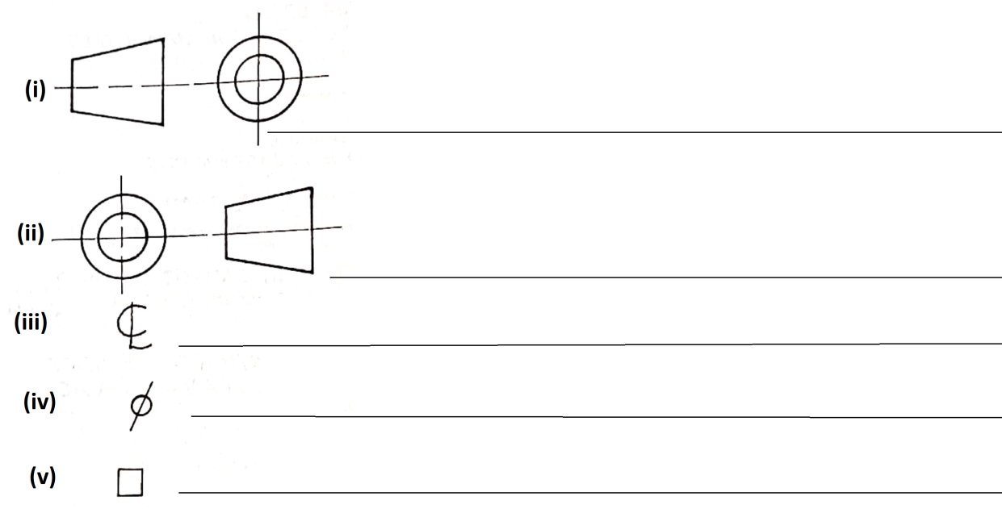
- Draw the three views of the block shown below in first angle projection (6 marks)

