Term 1 - 2024
DRAWING AND DESIGN (449/1)
FORM ONE
Marking Scheme
- (a)State any six general objectives of drawing and design as a subject. (6 marks)
- Communicate engineering concepts using technical drawing as a language
- Interpret visualized ideas correctly so as to realize functional designs.
- Demonstrate an ability to present ideas in 2D @ 3D
- Undertake income generating activities relevant to the community in the field of drawing and design
- Attain a firm foundation for further training and education
- Observe safety in the disposal of waste materials
(b) Name three instruments used in linear measurement (3 marks)

- Ruler
- Tape measure
- Vernier calipers
- Tee-Square

- Indicate the sizes of the following drawing papers (6 marks)

Paper name | Size
 | LENGTH | WIDTH
A₅ | 297 | 210
A₄ | 420 | 297
A₃ | 297 | 420
A₂ | 840 | 594
A₁ | 841 | 594
A₀ | 1189 | 841

- Differentiate between the following terms as used in engineering. (4 marks)
- Technical drawing
- Artistic drawing
Artistic drawings are subjectively interpreted;
Technical drawings are understood to have one intended meaning.
- List four aims of technical drawing. (4mks)
- Speed
- Accuracy
- Neatness
- Technique

- state where each of the following types of lines are used (5mks)
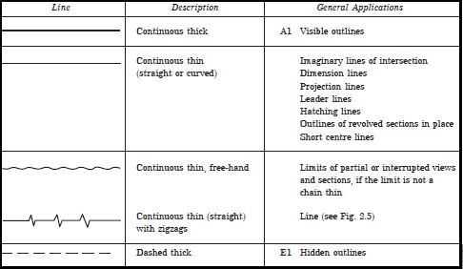
1 Correct Use @ 1mark
Total 1x5 = 5 Marks
- (a) Give one reason why the following are used in drawing. (4marks)
    - Symbols and abbreviations
To eliminate too many notes
    - Lettering
Provides brief but clear information which is not easily conveyed by the drawing
(b)State three factors that contribute to quality drawing. (3 marks)
- cleanliness
- proper use of drawing instruments
- maintenance of the drawing instruments
- Construct the following angles using a pair of compass , a pencil and a ruler only (10 marks)

- 60⁰
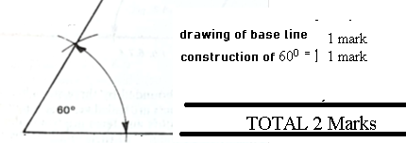

- 30⁰
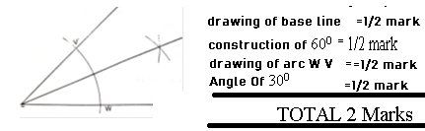

- 90⁰

- 37.5⁰

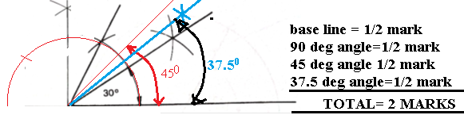

- 45⁰
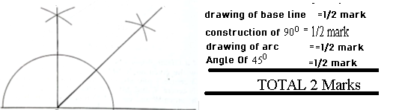

- (a). Name four types of triangles and state their characteristics (8 marks)
- Right angled triangles (Only One Angle Is At 90⁰)
- Scalene ( None Of The Sides Or Angle Are The Same)
- Equilateral ( All Sides Are Equal, All Angles Are At 60⁰)
- Isosceles( Two Sides Are Equal, Two Angles Are Equal)
Naming Of Triangles 1@ =1x4=4 Marks
Characteristics@1 =1x 4= 4 Marks
Total =8 Marks
- Sketch the following types of drawing instruments pictorially (6 marks)
  - Eraser
  - Pair of compasses with a pencil attached
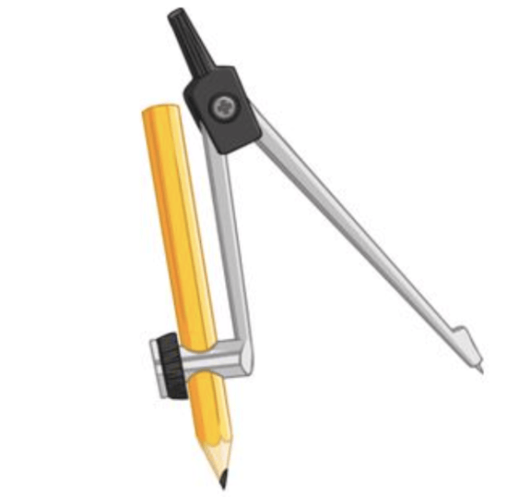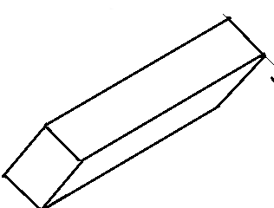
Correct Pictorial Of Each Instrument @ 3 Each Marks
Total= 6 Marks

- Construct a square whose diagonal is 65mm (6mks)
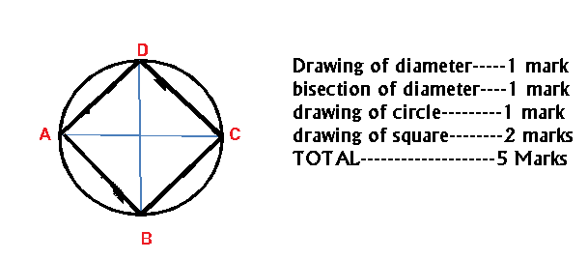

- From the given line AB, illustrate how a line can be proportionally sub- divided into 10 equal portions. (6mks).
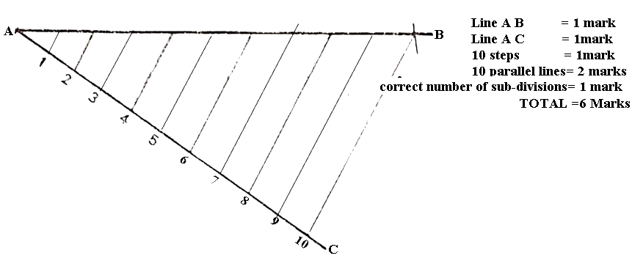
- Construct a kite when given the lengths of the diagonals as 71 mm and 53mm and the point of intersection is 53mm from one end of the longer diagonal. (7mks)
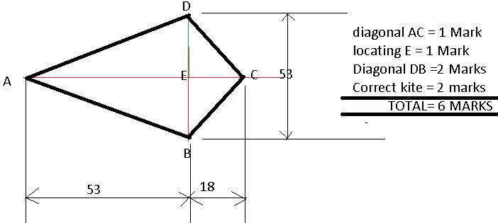

- Construct an isosceles triangle with a base measuring 62mm and an altitude of 50mm (6mks)

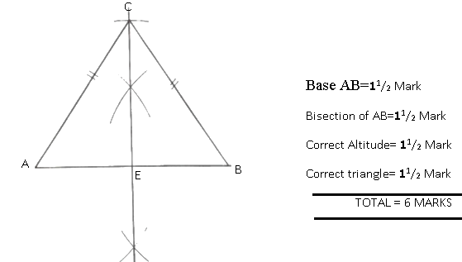

- What do the following symbols represent? ( 10 marks)

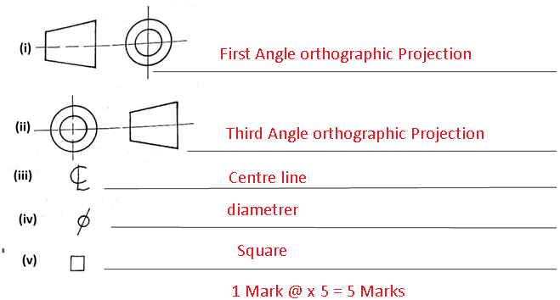

- Draw the three views of the block shown below in first angle projection (6 marks)
