COMPUTER STUDIES
Term 1 2024 Series
Form One
Answer all the questions
- Define the following Terms as used in Computer studies
- Data
- Raw facts that do not have much meaning to the user
- Information
- Processed data that is meaningful to the user
- ICT
- It is the integration of information and telecommunication facilities /resources to facilitate transfer of information from one point to another
Award 2marks each max 6
- Mention five examples of peripheral devices
- Monitor
- Speaker
- Mouse
- Keyboard
- Scanner
- Microphone
- Gamming pad
- Touchpad
- Projector
- Printer
- Digitizer
- Camera
Award 1mark each max 5
- List five components/ devices housed within the computer system unit
- Fan
- Heat sink
- Hard drive
- DVD drive
- RAM modules
- Expansion slot
- Motherboard
- CMOS battery
- Processor
Award 1mark each max 5
- With an aid of a diagram state the difference between analog and digital data
Analog | Digital
- Continuous in nature | - Discrete in nature
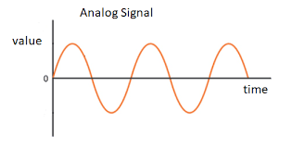 | 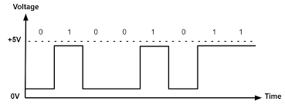
Award 2mark for description max 2
Award 1mark each for correct diagram max 2

- Give five challenges experienced by users of first generation computer
- Computer consumed a lot of power
- Computer generate a lot of heat
- Very large in size
- Very slow in processing
- Limited memory capacity
- Unreliable due breakdown of the vacuums tubes
- Limited programming capabilities
- Difficult to operate
Award 1mark each max 5

- State five characteristics of fifth generation computers
- Massive storage capacity
- Extremely fast when processing data
- Superior hardware and software
- Produce negligible heat
- Support artificial intelligence
- Relatively small in size
Award 1 mark each max 5
- Mention three hardware technology difference between first generation and third generation computers
- First generation computers used vacuum tubes while third generation computers used integrated circuit.
- First generation computers used punch cards for input while third generation computers used keyboards
- First generation computers used printouts for output while third generation computers used monitors
Award 1mark each max 3

- Mention four ways of controlling dust levels in a computer lab
- Placing the door mats at the entrance
- Put curtains and blinders at the windows
- Clean the computer lab regularly
- Dust the computers and computer accessories using blower regularly
- Cover the computers with dust cover while not in use
Award 1 mark each max 4

- Give four types of Keyboards
- Onscreen keyboard
- Brailed Keyboard
- Flexible Keyboard
- Ergonomic Keyboard
- Wireless Keyboard
- Traditional Keyboard
Award 1 mark each max 4

- State the functions of the following mouse skills
- Double click
- Open the selected item folder, folder or application
- Right click
- Opens the context menu, which provides operations that pertain to the menu
- Drag and Drop
- Moves a computer files folder or images from one place to another by clicking on them with the mouse and moving them across the screen.
Award 2 marks each max 6
- State five ways of enforcing security in computer laboratories established in learning institutions (5marks)
- Have grilled doors and windows
- Employ security officer
- Install CCTV cameras
- Install Alarm systems
- Use of swipe cards to restrict access by unauthorized users
- Use of Biometric systems for user authentication
- Use tracking system
Award 1mark each max 5

- Mention three functions of Uninterruptible Power Supply
- Provide temporary power when there is a power blackout
- Warn the user by beeping to notify him or her about the power loss
- Regulate power from unstable source
Award 1mark each max 3
- Use abacus to represent the following numbers

- 2370
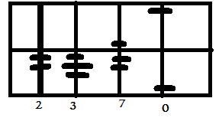
Award 2marks for correct diagram max 2
- 0967
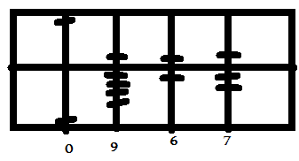
Award 2marks for correct diagram max 2

- Name three electronic pathway used by computer components mounted on motherboard to exchange signals
- Control bus
- Address bus
- Data bus
Award 1mark each max 3
- State three characteristics of Dynamic Random Access Memory
- DRAM is slower
- DRAM is cheap
- DRAM require refreshing
- DRAM is constructed using Capacitors and Transistors
- DRAM require more power
Award 1 mark each max 3
- List three examples of toggle keys found on a standard keyboard
- Num Lock
- Caps Lock
- Scroll lock
- Insert Key
Award 1 mark each max 3
- Identify the function of each key represented by the symbols shown below

- Move the cursor on a straight line at a specific interval
Award 2marks max 2

- Delete characters from right to left
Award 2marks max 2

- Mention five disadvantages of using computers in organizations
- Power dependent
- Security threats
- Computer breakdown
- Create unemployment
- High initial cost
Award 1 mark each max 5

- Why is Charles Babbage considered as the father of computers
- Considered as the father of computer because the idea or concept used in Analytical and difference engine were borrowed and used in developing modern computers
Award 2marks max 2
- Name three non-electronic devices used to perform arithmetic manipulations before electronic computer were invented
- Napier’s Bone
- Abacus
- Slide Rule
- Pascaline Machine
- Weaving loom
Award 1 mark each max 3
- State five ways of using computers in learning institutions like schools
- Teachers communicate with parents via email, whattapps, email and bulk sms
- CCTV cameras are installed in school for security and for monitoring students
- Computer program like Rolan, Spreadsheet are used to store and analyze academic data
- Student do research on the internet
- Computer simulation are used to carry experiments
- Parents make payments via e-platform
- Computer Aided learning
- Computer Aided Instruction
- E-learning
- Prepare teaching time table using Timetabling programs
- Prepare and keep books of account using accounting software
- Use of Biometric systems to capture attendance
Award 1 mark each max 5
- List five input devices that capture directly from source
- Camera
- QR code scanner
- Finger Print Scanner
- Optical Character Recognition
- Optical Mark Recognition
- Optical Barcode Recognition
- Magnetic Ink Character Recognition
- Magnetic Stripe Recognition
Award 1 mark each max 5
- Name three Arithmetic and Logical operations undertaken by the ALU (6marks)
Arithmetic Operation
- Addition
- Subtraction
- Multiplication
- Division
Logical Operation
- Sorting
- Comparing values
- Matching
Award 1mark each for Arithmetic operation max 3
Award 1 mark each for logical operation max 3
- State two ways in which dampness affects computers that are installed in the Laboratory
- High humidity may cause rusting of metallic parts of the computers
- Very low humidity may cause accumulation of static electricity which is likely to damage computer circuitry
Award 1mark each max 2

