**CHEMISTRY**

**FORM ONE**

**TERM 1**

**TIME: 2 HOURS**

**Name**: …………………………………………………………. **Adm** **No**: ……………….

**School**: ……………………………………………………….. **Class**: …………………..

**Signature**: …………………………………… **Date**: …………………...

*Kenya certificate of secondary education (K.C.S.E)*

INSTRUCTIONS TO CANDIDATES:

1. *Write your name and Admission number in the spaces provided above.*
2. *Answer ALL the questions in the spaces provided.*
3. *Mathematical tables and silent electronic calculators may be used.*
4. *All working must be clearly shown where necessary.*
5. *Students should check the question paper to ascertain that all the pages are printed as indicated and that no questions are missing*

**1.**  Study the figure below and answer questions that follow.

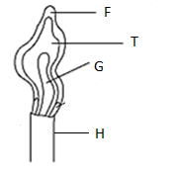

1. Name the type of flame shown and give a reason. (2mks)
2. Name the parts labelled **F** and **G**. (2mks)
3. State the three differences between the two flames of a Bunsen burner. (3mks)

2. State the best method to separate the following mixtures (3mks)

(a) Components of crude oil

(b) benzoic acid and sodium chloride

1. Iron filings and Sulphur

3. Draw and state one use of the following apparatus. (4mks)

(a) Deflagrating spoon

1. Mortar and pestle

4. State three roles of chemistry as a subject to the society (3mks)

5. (a) Define the following terms (3mks)

(i) Drug

(ii)Drug abuse

iii)Chemistry

(b) State two effects of drug abuse to the consumer (2mks)

6. Highlight five laboratory safety rules (5mks)

7. The diagram below shows parts of a Bunsen burner.

A

B

C

1. Name the parts labelled A , B , C (3mark)
2. Give one use of the part labelled A,B,C (3mark)

8. Explain why most laboratory apparatus are made of glass (2mks)

9. (a) Define the term conductor as used in chemistry and give two examples of conductors (3mks)

1. Name two apparatus that are used to measure accurate volume of liquids in the laboratory (2mks)

c) State THREE frequently abused drugs by the Kenyan youth (3mks)

10. (a) A patient was given tablets with prescription 2 x 3 on the envelope. Clearly outline how the patient should take the tablets.

(2 mrk)

1. Two samples of equal volumes of water were put in 250cm³ beaker and heated for 10 minutes. Sample 1 registered a higher temperature than sample 2.

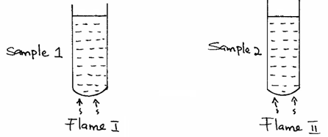

i)State the condition under which flame II is produced in Bunsen burner. (1mrk)

ii) Name the flame used to heat beaker I. Explain your answer (2mks)

11. The apparatus below was used to separate a mixture of water and kerosene.

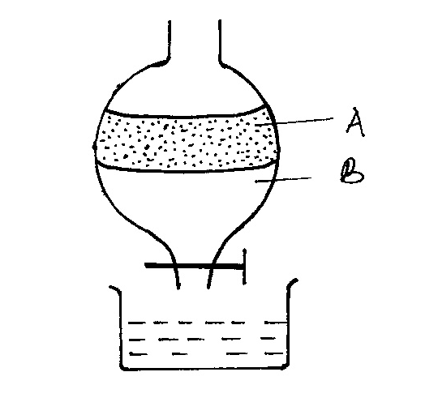

a) State two properties of the liquids that make it possible to separate them using such apparatus. (2 mks)

b) Name the liquids A and B (2mks)

c) give the name of the above method of separation (1mk)

12. Describe the procedure used in separating a mixture of sand, aluminium chloride, iron filings and sodium chloride in the laboratory (5mks)

13. State two laboratory rules to observe when preparing a **poisonous** gas. (2mks)

14. The diagram below shows how muddy water can be made clean. Study it and answer the questions that follow.

(a) Name the apparatus labeled X. (1 mk)

b) Identify the method of separation above (1mk)

(c) Give the advantage of the above process over decantation (1mk )

(d)give one industrial application of the above method (1mk)

15.) The diagram below shows a set up that was used by a student to separate a mixture of water and ethanoic acid. Study it and answer the questions that follow. (Boiling point water = 100OC, ethanoic acid = 118OC)

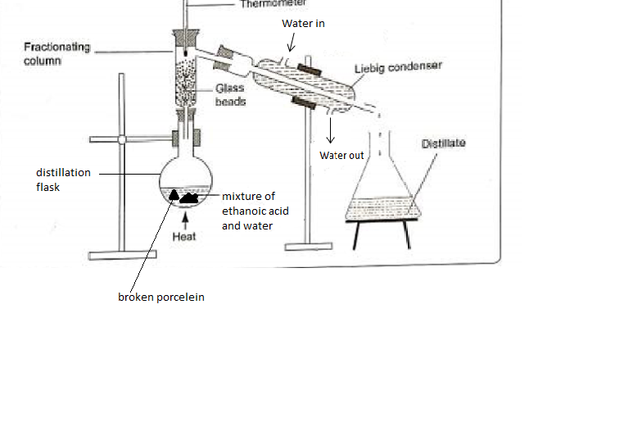

1. State one mistake in the set up. (1mk)
2. Which component of the mixture will be collected first and why? (2mks)

1. What are the roles of the following; (4mks)
2. Thermometer
3. Liebig condenser
4. Fractionating column
5. Glass beads
6. Why is it preferable for the distillation flask to be round- bottomed rather than flat bottomed rather than flat bottomed? (1mk)
7. At what point does one know that the entire first fraction has been removed from the distillation flask. Explain. (2mk)

16. The diagram below shows the relationship between the physical state of matter. Study it and answer the questions that follow;

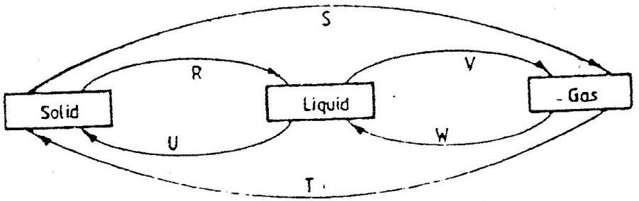

a) Identify the processes R, V, W and U (4mks)

b) Name two substances that can undergo the process represented by process S and T (2mks)