**CHEMISTRY**

**FORM ONE**

**TERM 1**

**TIME: 2 HOURS**

**MARKING SCHEME**

**1.**  Study the figure below and answer questions that follow.

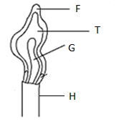

1. Name the type of flame shown and give a reason. (2mks)

**Luminous flame; it has four regions and its large and wavy**

1. Name the parts labelled **F** and **G**. (2mks)

**F- outermost pale blue zone**

**G- almost colourless zone**

1. State the three differences between the two flames of a Bunsen burner. (3mks)

|  |  |
| --- | --- |
| **Luminous** | **Non-luminous** |
| **Large and wavy** | **Short and steady** |
| **Has four zones** | **Has three zones** |
| **Produces soot** | **Does not produce soot** |

2. State the best method to separate the following mixtures (3mks)

(a) Components of crude oil

**Fractional distillation**

(b) benzoic acid and sodium chloride

**Sublimation**

(c) Iron filings and Sulphur

**Use of a magnet**

3. Draw and state one use of the following apparatus. (4mks)

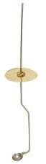(a) Deflagrating spoon

**used for holding substances being burnt**

1. Mortar and pestle

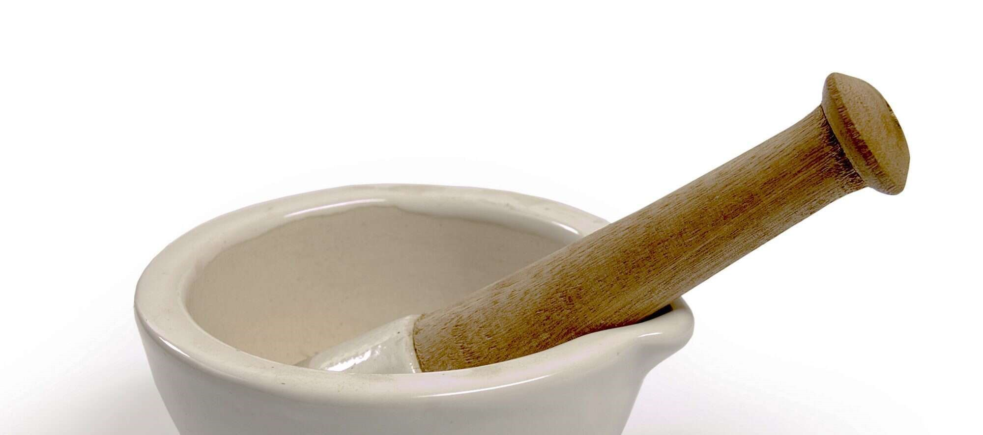

Pestle

Mortar

Pestle is used for crushing substances while in the mortar

4. State three roles of chemistry as a subject to the society (3mks)

* **It helped in manufacture of drugs.**
* **It helped in food production.**
* **It help in manufacture of cheaper alternative fabrics**

5. (a) Define the following terms (3mks)

(i) Drug

**A drug is any natural or man-made substance that when taken into the body alters the normal body functioning**

(ii)Drug abuse

**Drug abuse is the use of a drug for a purpose other than what is meant for or use of overdose or underdose of prescribed drug.**

iii)Chemistry

**It is a branch of science that deals with the study of the structure, properties and composition of matter and the changes that matter undergoes**

(b) State two effects of drug abuse to the consumer (2mks)

* **Stress**
* **Depression**
* **Hallucination**
* **Liver cirrhosis**
* **Dependency**

6. Highlight five laboratory safety rules (5mks)

1. **Never run while in the laboratory because you may trip, fall and injure yourself or other users of the laboratory.**
2. **Never taste or eat anything in the laboratory to avoid poisoning.**
3. **Always consult your teacher before trying any experiment to avoid accidents.**
4. **Label all the chemicals you are using to avoid confusion.**
5. **Always use a clean spatula for scooping a substance from a container to prevent contamination.**
6. **Always hold test-tube or boiling tube using test tube holder when heating to avoid being burned.**
7. **When heating a substance in a test tube or boiling tube, never let the open end face you or anybody else because the liquid may spurt out and cause injury.**
8. **Never look directly into flasks and test-tubes where reactions are taking place, because the chemicals may spurt into your eyes and cause injury**.

7. The diagram below shows parts of a Bunsen burner.

A

B

C

1. Name the parts labelled A , B , C (3mark)

**A- Chimney B- air hole C- base**

1. Give one use of the part labelled A,B,C (3mark)

A**- This is where gas and air mix for combustion**

B**- it allows the air to enter into the chimney and mix with the laboratory gas from the jet.**

C- **It is wide and weighty hence helps to provide support to the burner. It also helps to provide direct contact of the burner with the work surface**

8. Explain why most laboratory apparatus are made of glass (2mks)

1. **Glass are visible or transparent hence the content can be easily seen.**
2. **Glasses are unreactive; that is they do not react with most reagents found in the laboratory.**
3. **Glasses are easy to clean hence minimizes time wastage in cleaning.**

9. (a) Define the term conductor as used in chemistry and give one example of a non-metal that is a conductor (2mks)

**Conductors are substances which allow electrical energy to flow through them**

**Example of non-metal; graphite**

1. Name two apparatus that are used to measure accurate volume of liquids in the laboratory (2mks)

**Burette, pipette volumetric flask and syringe**

1. State THREE frequently abused drugs by the Kenyan Youth (3mks)

**bhang, miraa, heroine, cocaine,**

10. (a) A patient was given tablets with prescription 2 x 3 on the envelope. Clearly outline how the patient should take the tablets. (2 mrk)

**To take 2 tablets after every 8 hours a day**

1. Two samples of equal volumes of water were put in 250cm³ beaker and heated for 10 minutes. Sample 1 registered a higher temperature than sample 2.

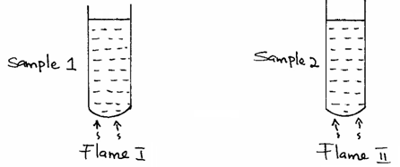

i)State the condition under which flame II is produced in Bunsen burner. (1mrk)

**when the air hole is fully closed**

ii) Name the flame used to heat beaker I. Explain your answer (2mks)

**non-luminous flame; less time used to heat the water**

11. The apparatus below was used to separate a mixture of water and kerosene.

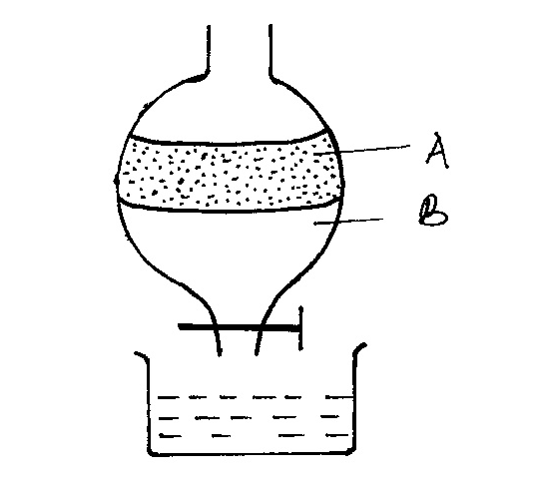

a) State two properties of the liquids that make it possible to separate them using such apparatus. (2 mrks)

**density and immiscibility**

b) Name the liquids A and B (2mks)

**A- kerosene B- water**

c) give the name of the above method of separation (1mk)

**Use of a separating funnel**

12. Describe the procedure used in separating a mixture of sand, aluminum chloride, iron filings and sodium chloride in the laboratory (5mks)

* **Pass a magnet over the mixture to attract the iron fillings**
* **Heat the remaining mixture for aluminium chloride to sublime and be collected as a sublimate**
* **Add water to the remaining mixture and stir for sodium chloride to dissolve**
* **Filter to obtain sand as the residue and sodium chloride solution as the filtrate**
* **Evaporate the filtrate over a water bath to obtain sodium chloride crystals**

13. State two laboratory rules to observe when preparing a **poisonous** gas. (2mks)

* + **Ensure the experiment is done in a fume chamber**
  + **Do not inhale the gases directly**

14. The diagram below shows how muddy water can be made clean. Study it and answer the questions that follow.



(a) Name the apparatus labeled X. (1 mk)

**Filter funnel**

b) Identify the method of separation above (1mk)

**filtration**

(c) Give the advantage of the above process over decantation (1mk)

**In filtration the residue is separate from the filtrate while in decantation some residue will be having the filtrate**

(d) give one industrial application of the above method (1mk)

**Large scale water purification plant**

15.) The diagram below shows a set up that was used by a student to separate a mixture of water and ethanoic acid. Study it and answer the questions that follow. (Boiling point water = 100OC, ethanoic acid = 118OC)

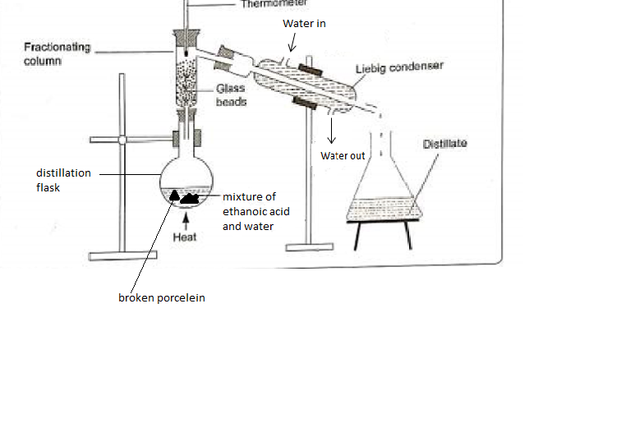

1. State one mistake in the set up. (1mk)

**Water inlet and water outlet were exchanged**

1. Which component of the mixture will be collected first and why? (2mks)

**Water- it has a lower boiling point**

1. What are the roles of the following; (4mks)
2. Thermometer

**To indicate the boiling point of the medium being distilled has been reached**

1. Liebig condenser

**Uses the counter flow principle to cool the vapour efficiently**

1. Fractionating column

**To allow ethanoic acid to condense into liquid and flow back into the flask before the boiling point is reached**

1. Glass beads

**Increase the surface area for condensation**

1. Why is it preferable for the distillation flask to be round- bottomed rather than flat bottomed rather than flat bottomed? (1mk)

**For uniform distribution of heat**

1. At what point does one know that the entire first fraction has been removed from the distillation flask. Explain. (2mk)

**The temperature remains fairly constant until water is distilled off. The temperature starts rising and the distillate collected thereafter is mainly ethanoic acid as the second fraction.**

16. The diagram below shows the relationship between the physical state of matter. Study it and answer the questions that follow;

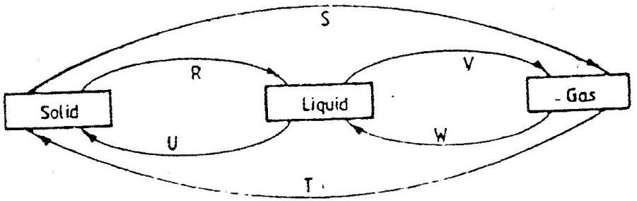

a) Identify the processes R, V, W and U (4mks)

**R- melting**

**V- evaporation**

**W- condensation**

**U- freezing**

b) Name two substances that can undergo the process represented by process S and T (2mks)

**iodine**

**solid carbon (IV) oxide**

**benzoic acid**