Name....................................................................Adm...........................................................
Class.....................................................................Sign.............................................................
AGRICULTURE FORM ONE
TERM 1 2024
DURATION-2HRS
Instructions
- Write your name, class and admission number in the space provided above.
- Write the date of the examination and sign in the space provided above.
- Answer all the questions in the spaces provided.
- You may be penalized for wrong spelling especially technical terms.

Instructions: Answer all questions in the spaces provided
1. Give the meaning of the following words as used in agriculture (6mks)
- Agriculture

- Floriculture

- Apiculture

2. Giving examples, explain why agriculture is both an art and science (6mks)

3. Why is agriculture very important to the economic development of Kenya (5mk)

4. Name and explain four methods of farming (8mks)

5. Give the difference between the following
- Olericulture and pomology (2mks)

- Intensive farming and extensive farming (2mks)

- Pastoralism and aquaculture (2mks)

- Plantation farming and ranching (2mks)

- Small scale farming and large scale farming (2mks)

- What are the advantages of shifting cultivation? (3mks)

- a) What is soil profile? (2mks)

b) Below is a diagram of soil profile, label the parts A to D (4mks)
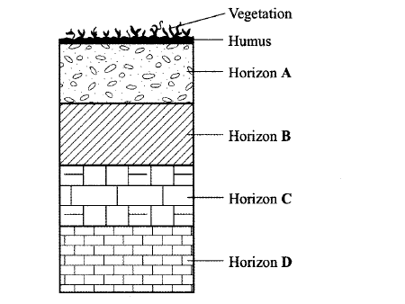
C

- Name four aspects of rainfall that influence agriculture (4mks)

- a) Name four factors that influence soil formation (4mks)

b) Name the three agents of weathering (3mks)

- Name four biotic factors that influence agriculture (4mks)

- State four effects of HIV/ AIDS on agriculture (4mks)

- a) Give the meaning following terms as used in Agriculture (4mks)
A | B
1)Domestication
2)Crop pathology
3)Crop farming
4)Agricultural engineering

b) Name five constituents of soil (4mks)

- State three roles of soil organic matter (3mks)

- State four ways by which wind affects the growth of crops. (5mks)

- State four roles of good soil aeration in crop growth. (4mks)

- Outline four effects of soil organisms which benefit crop growth. (4mks)

- Explain five ways on how government policy improves agricultural production (5mks)

- State four disadvantages of pastoral nomadism system of farming. (4mks)

