Full_Name:…………………………………………………………Class:………….AdmNo:……
Computer Studies
Form 1 End Term 1 Examination – 2024
Time: 2Hours
Instructions: Answer All the Questions in the spaces provided.
1. Define the following terms as applied in computing:
a) Computer [2mks]
______________________________________________________________________________________________________________________________________________________________________
b) Data [2mks]
______________________________________________________________________________________________________________________________________________________________________
c) Information [2mks]
______________________________________________________________________________________________________________________________________________________________________
d) Programs [2mks]
______________________________________________________________________________________________________________________________________________________________________
e) Data processing [2mks]
______________________________________________________________________________________________________________________________________________________________________
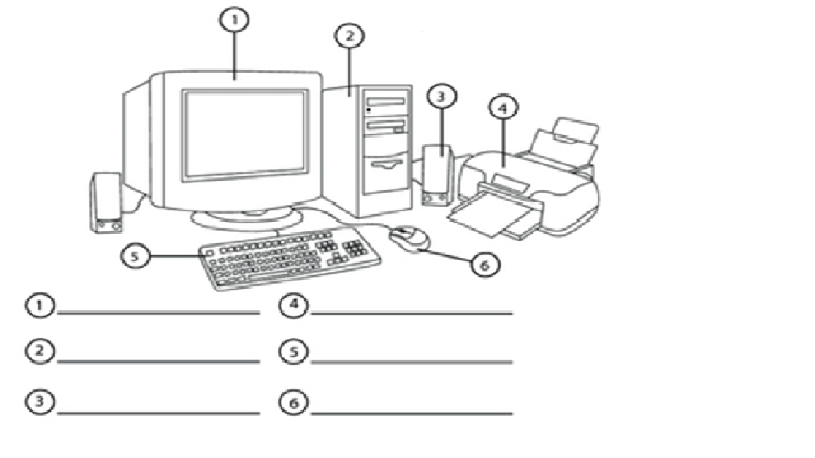
2. The diagram below shows the various parts of a computer system. Study it and name the parts 1-6. [6mks]

3. a) Give four basic functions of a computer. [4mks]
______________________________________________________________________________________________________________________________________________________________________
______________________________________________________________________________________________________________________________________________________________________
b) List six characteristics of a computer. [6mks]
______________________________________________________________________________________________________________________________________________________________________
______________________________________________________________________________________________________________________________________________________________________
______________________________________________________________________________________________________________________________________________________________________
4. Give four reasons why a mobile phone is regarded as a computer. [4mks]
______________________________________________________________________________________________________________________________________________________________________
______________________________________________________________________________________________________________________________________________________________________

5. a) Who is known as the “father of modern computer?” [1mk]
___________________________________________________________________________________
b) Match the generation and the technology used in the table below. [5mks]
Computer Generation | Technology
First Generation | Integrated Circuits
Second Generation | Parallel architecture/Artificial intelligence
Third Generation | Transistors
Fourth Generation | Vacuum tube/thermionic valve
Fifth Generation | Very Large Scale Integrated (VLSI)
c) State five characteristics of the first generation of computers. [5mks]
______________________________________________________________________________________________________________________________________________________________________
______________________________________________________________________________________________________________________________________________________________________
______________________________________________________________________________________________________________________________________________________________________

6. a) State three major ways in which computers can be classified. [3mks]
______________________________________________________________________________________________________________________________________________________________________
______________________________________________________________________________________________________________________________________________________________________
b) For each answer in (a) above, give two examples of computers classified under that category. [6mks]
______________________________________________________________________________________________________________________________________________________________________
______________________________________________________________________________________________________________________________________________________________________
______________________________________________________________________________________________________________________________________________________________________
7. Give and explain six areas where computer are applied or used in the society today. [12mks]
______________________________________________________________________________________________________________________________________________________________________
______________________________________________________________________________________________________________________________________________________________________
______________________________________________________________________________________________________________________________________________________________________
______________________________________________________________________________________________________________________________________________________________________
7. a) What is a system unit? [2mks]
______________________________________________________________________________________________________________________________________________________________________
b) List two types of system units. [2mks]
______________________________________________________________________________________________________________________________________________________________________
c) List six components housed inside the system unit. [6mks]
______________________________________________________________________________________________________________________________________________________________________
______________________________________________________________________________________________________________________________________________________________________
8. a) Define a computer laboratory. [2mks]
______________________________________________________________________________________________________________________________________________________________________

b) State four factors that are considered when setting a computer laboratory. [4mks]
______________________________________________________________________________________________________________________________________________________________________
______________________________________________________________________________________________________________________________________________________________________
___________________________________________________________________________________
c) State four measures that are taken to protect the users in a computer lab. [4mks]
______________________________________________________________________________________________________________________________________________________________________
______________________________________________________________________________________________________________________________________________________________________
______________________________________________________________________________________________________________________________________________________________________
9. Give four ways of classifying the keyboard keys. [4mks]
______________________________________________________________________________________________________________________________________________________________________
______________________________________________________________________________________________________________________________________________________________________
10. a) Define the term booting. [2mks]
______________________________________________________________________________________________________________________________________________________________________
b) Name two types of booting. [2mks]
______________________________________________________________________________________________________________________________________________________________________
11. List four mouse terminologies or operation techniques or skills. [4mks]
______________________________________________________________________________________________________________________________________________________________________
______________________________________________________________________________________________________________________________________________________________________
12. Complete the following abbreviations:
CPU_____________________________________________________________ [1mk]
RAM_____________________________________________________________ [1mk]
VDU_____________________________________________________________ [1mk]
ROM_____________________________________________________________ [1mk]
ICT______________________________________________________________ [1mk]
UPS______________________________________________________________ [1mk]

