Computer Studies Marking Scheme
Form 1 End Term 1 Examination – 2024
Instructions: Answer All the Questions in the spaces provided.
1. Define the following terms as applied in computing:
a) Computer [2mks]
A computer can be defined as an electronic device that accepts user input (data) and processes it under the influence of a set of instructions referred to as programs to produce the desired output (information).
b) Data [2mks]
are the raw facts that may include alphabets, numbers and symbols which may noy make much meaning to the user.
c) Information [2mks]
is the processed data which makes meaning to the user and which can form a basic for decision making.
d) Programs [2mks]
are a set of computer instructions that enable the computer hardware to accomplish a task.
e) Data processing [2mks]
any of many techniques in which data is retrieved, stored, classified, manipulated, transmitted and / or reported in such a way as to generate information especially such processing using computers.
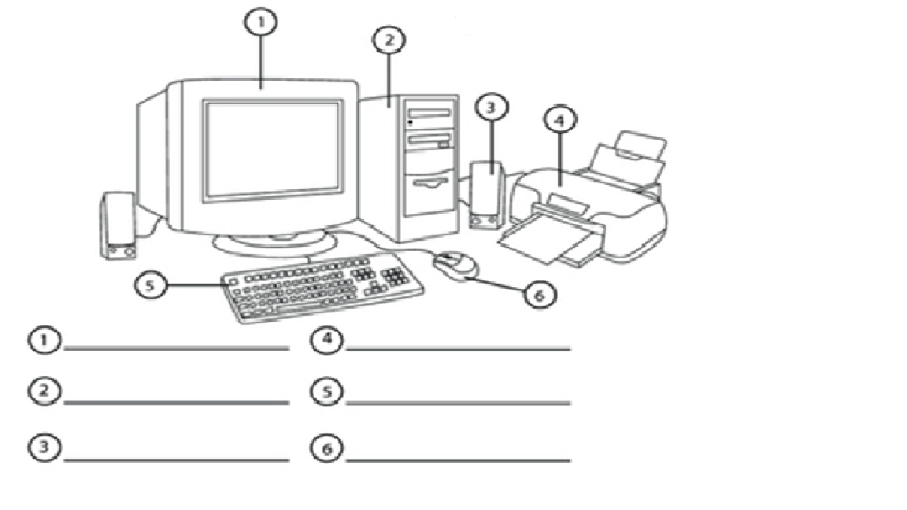
2. The diagram below shows the various parts of a computer system. Study it and name the parts 1-6. [6mks]
1-Monitor/screen/VDU
2-System unit/case
3-Speaker
4-Printer
5-Keyboard
6-Mouse

3. a) Give four basic functions of a computer. [4mks]
- Input function
- Output function
- Storage
- Processing function
b) List six characteristics of a computer. [6mks]
Speed/fast
Accuracy
Memory
Reliable
Versatile
Diligent
No IQ/No intelligence
4. Give four reasons why a mobile phone is regarded as a computer. [4mks]
It has a screen
It has a keypad
It has a memory
It is programmable
It is electronic
5. a) Who is known as the “father of modern computer?” [1mk]
Charles Babbage
a) Match the generation and the technology used in the table below. [5mks]
Computer Generation | Technology
First Generation | Integrated Circuits
Second Generation | Parallel architecture/Artificial intelligence
Third Generation | Transistors
Fourth Generation | Vacuum tube/thermionic valve
Fifth Generation | Very Large Scale Integrated (VLSI)
b) State five characteristics of the first generation of computers. [5mks]
- They used vacuum tubes or thermionic valves technology for circuitry
- The memory available was magnetic drum
- They were expensive to operate
- They were large in size and occupied a lot of space
- They generated a large amount of heat or emitted a lot of heat
- They consumed a lot of power
- They relied on machine language for data processing, hence they could only solve one problem at a time.
- Input was based on punched cards and paper tape.
- Output was displayed on printouts
- Max. memory size was approx.. 2kb – very small
- Processing speed was approx… 10-kilo instruction per second (KIPS)
6. a) State three major ways in which computers can be classified. [3mks]
Physical size and processing power
Functionality
Purpose
b) For each answer in (a) above, give two examples of computers classified under that category. [6mks] Physical size and processing power- supercomputers, mainframe, minicomputers and microcomputers.
Functionality- analog, digital, hybrid computers
Purpose – general and special purpose computers
7. Give and explain six areas where computer are applied or used in the society today. [12mks]
Education
Library services
Banks
Supermarkets
Health institutions/hospitals
Industries
Law enforcement agencies
Transport – Airports, railways, roads transports
Communication centers
Military – to design weapons and control flights
Research institutions
Home for entertainment
Offices to prepare and print office documents
7. a) What is a system unit? [2mks]
The system unit is the box-like case that contains the electronic components of a computer.
b) List two types of system units. [2mks]
Tower type system unit
Desktop type system unit
c) List six components housed inside the system unit. [6mks]
- CPU
- RAM
- ROM
- Hard disk drive
- Drives- floppy disk drive, CD/DVD drives
- BIOS
- CMOS battery
- Expansion slots
- Motherboard
- Power supply unit
- CPU fan, heat sink
- Ribbon cable / power cables
- Diodes/transistors
8. a) Define a computer laboratory. [2mks]
It is a special room set aside and prepared specifically for safe installation and use of computers.
b) State four factors that are considered when setting a computer laboratory. [4mks]
security of computer hardware and software
reliable source of power
maximum number of computers to be set
maximum number of users
well ventilated
c) State four measures that are taken to protect the users in a computer lab. [4mks]
- Avoid overcrowding in the computer laboratory to avoid suffocation
- Well laid room be laying cables in trunk to avoid stumbling on them
- All cables should be insulated to avoid electric shock
- Providing standard furniture to avoid strains injuries
- Providing anti-glare screens and adjustable screens to avoid eye strains
- Ensuring proper ventilation to avoid dizziness caused by lack of enough oxygen
- Avoid painting the computer room with over bright paints to avoid eye strain
9. Give four ways of classifying the keyboard keys. [4mks]
Alphabet/typing keys/alphanumeric keys
Numbers
Numeric keypad
Cursor movement and editing keys
Function keys
Special keys
10. a) Define the term booting. [2mks]
Starting a computer.
b) Name two types of booting. [2mks]
warm booting
cold booting
11. List four mouse terminologies or operation techniques or skills. [4mks]
Clicking
Double clicking
Right clicking
Drag and drop
Pointing

12. Complete the following abbreviations:
CPU [1mk]
Central Processing Unit
RAM [1mk]
Random Access Memory
VDU [1mk]
Visual Display Unit
ROM [1mk]
Read Only Memory
ICT [1mk]
Information and Communication Technology
UPS [1mk]
Uninterrupted Power Supply

