NAME………………………………………………INDEX NO:.…ADM NO………
SCHOOL………………………………………SIGNATURE…….…. DATE………

CHEMISTRY PAPER (THEORY)
2 HOURS

FORM 3
Kenya Certificate of Secondary Education (K.C.S.E)

INSTRUCTIONS TO CANDIDATES
- Write your name and index in the spaces provided.
- Sign and write the date the examination is done.
- Answer all the questions in the spaces provided.
- Mathematical tables and electronic calculators may be used.
- ALL workings MUST be clearly shown where necessary.
- This paper contains 12 printed pages.
- Candidates should check the question paper to ascertain that all pages are printed as indicated and that no question is missing.
- Candidates should answer questions in English.

For Examiner’s Use Only
Question | Maximum score | Candidates score
1-24 | 80

- Study the information in the table below and answer the questions that follow.
The letters do not represent the actual symbols of the elements.
Elements | Electronic configuration | Ionization energy kJmol⁻¹
R | 2:1 | 519
T | 2:8:1 | 494
Q | 2:8:8:1 | 418

- What is the general name given to the chemical family to which elements R, T and Q belong? (1 mark)
……………………………………………………………………………………………….
……………………………………………………………………………………………….
- What is meant by ionization energy? (1 mark)
……………………………………………………………………………………………….
……………………………………………………………………………………………….
- Explain why element R has the highest ionization energy. (1 mark)
……………………………………………………………………………………………….
……………………………………………………………………………………………….
- The Bunsen burner produces both luminous and non-luminous flames.
- Why is the non-luminous flame hotter than the luminous? (1 mark)
……………………………………………………………………………………………….
……………………………………………………………………………………………….
Other than the amount of heat produced, state two differences in the characteristics of the two types of flames. (2 marks)

Non-Luminous | Luminous
 | (i)
(ii) | (ii)

- Analysis of a sample of neon gas in a mass spectrometer gave the following results.

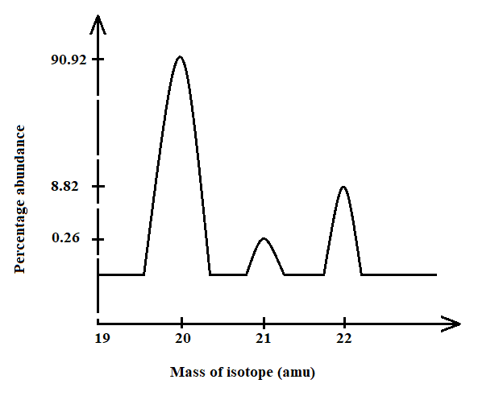

- Which of the isotope is commonly found? (1 mark)
……………………………………………………………………………………………….
- Calculate the R.A.M. of neon. (2 marks)
……………………………………………………………………………………………….
……………………………………………………………………………………………….
……………………………………………………………………………………………….
- a) State Graham’s law of diffusion. (1 mark)
……………………………………………………………………………………………….
……………………………………………………………………………………………….
b) A given volume of ozone, (O₃) diffused from a certain apparatus in 96 seconds. Calculate the time taken by an equal volume of carbon (IV) oxide (CO₂) to diffuse under the same conditions (O = 16.0, C = 12.0) (2 marks)

……………………………………………………………………………………………….
……………………………………………………………………………………………….
……………………………………………………………………………………………….
……………………………………………………………………………………………….
- The following data gives the pH values of some solutions;
Solution | pH
P  Q  R | 14.0  6.8  2.5

- What colour change would occur in solution P on addition of two drops of phenolphthalein indicator? (1 mark)
……………………………………………………………………………………………….
- State the pH value of a resulting solution when equal moles of solution P and R react. Explain. (2 marks)
……………………………………………………………………………………………….
……………………………………………………………………………………………….
- Name the process which takes place when:
- Solid Carbon (IV) oxide (dry ice) changes directly into gas. (1mark)
……………………………………………………………………………………………….

- A moist red litmus paper turns white when dropped into jar of chlorine gas. (1mark)
……………………………………………………………………………………………….

- Crystals of calcium chloride form a solution on long exposure to air. (1mark)
……………………………………………………………………………………………….

- Describe how to prepare some crystals of magnesium sulphate starting with magnesium powder. (3 marks)
……………………………………………………………………………………………….
……………………………………………………………………………………………….
……………………………………………………………………………………………….
……………………………………………………………………………………………….
……………………………………………………………………………………………….

- The diagram below represents two iron nails with some parts tightly wrapped with Zinc and Copper foils respectively.
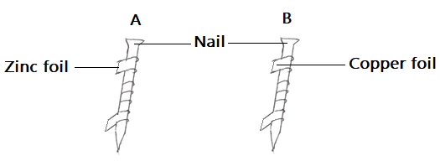
State the observations that would be made at the exposed parts of the nails A and B after being left in the open for a long time. (2 marks)
……………………………………………………………………………………………….
……………………………………………………………………………………………….
……………………………………………………………………………………………….
- a) Distinguish between a covalent and dative bond. (1 mark)

……………………………………………………………………………………………….
……………………………………………………………………………………………….
……………………………………………………………………………………………….
b) Draw a dot (●) and cross (X) diagram to show bonding in ammonium ion (NH₄⁺).
(2 marks)

- The grid below shows a part of the periodic table. The letters do not represent the actual
Symbols. Use it to answer the questions that follow: -

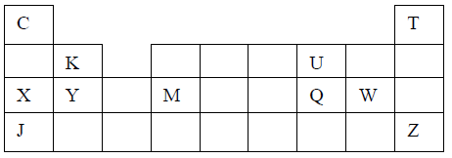
- How do the atomic radii of element X and Y compare? (1 mark)
……………………………………………………………………………………………….
……………………………………………………………………………………………….
- i) State the period and the group to which element Q belong. (1 mark)
……………………………………………………………………………………………….
……………………………………………………………………………………………….
ii) The ionic configuration of element G is 2.8. G forms an ion of the type G⁻¹. Indicate on the grid, the position of element G. (1 mark)
……………………………………………………………………………………………….
iii) State one use of element U. (1 mark)
……………………………………………………………………………………………….
iv) What is the nature of the compound formed between K and U. (1 mark)
……………………………………………………………………………………………….
- Molten lead (II) bromide undergoes decomposition when an electric current is passed through it.
- Write an equation for the reaction that occurs at the:
      - Cathode (1 mark)
……………………………………………………………………………………………….
      - Anode (1 mark)
……………………………………………………………………………………………….
- Give a reason why this experiment is carried out in a fume cupboard. (1 mark)
……………………………………………………………………………………………….

- Calcium hydrogen carbonate reacted with 12.0cm³ of 0.05M hydrochloric acid to form calcium chloride, water and carbon (IV) oxide.
- Write the chemical equation for the reaction. (1 mark)
……………………………………………………………………………………………….
- Calculate the number of moles of hydrochloric acid used. (2 marks)
……………………………………………………………………………………………….
……………………………………………………………………………………………….
……………………………………………………………………………………………….
- Determine the number of moles of calcium hydrogen carbonate used. (1 mark)
……………………………………………………………………………………………….
- State one observation that was made during the reaction. (1 mark)
……………………………………………………………………………………………….
- Name two indicators which can be used to determine the end point of a reaction during titration of a strong acid against a weak base. (2 marks)
……………………………………………………………………………………………….
……………………………………………………………………………………………….
- The figure below shows the apparatus used to burn hydrogen in air. Use it to answer the
questions that follow.
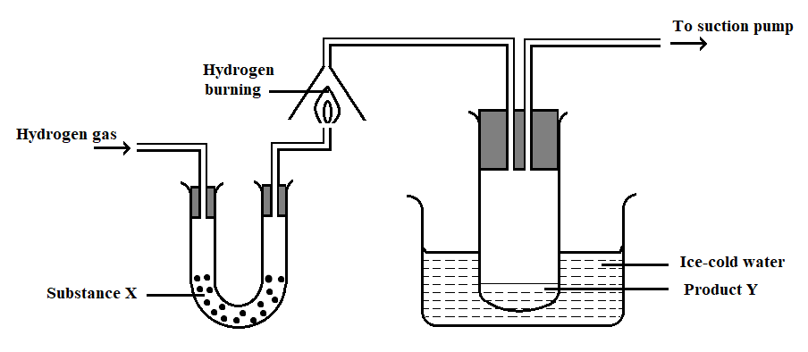
- State the role of substance X (1 mark)
……………………………………………………………………………………………….
- Give the name of the substance that could be used as X (1 mark)
……………………………………………………………………………………………….
- State the role of the suction pump (1 mark)
……………………………………………………………………………………………….
……………………………………………………………………………………………….
- Name the product Y formed (1 mark)
……………………………………………………………………………………………….
- Give a simple physical test to prove the identity of Y (1 mark)
……………………………………………………………………………………………….
……………………………………………………………………………………………….
- State the difference between “dry” and “anhydrous”. (2 marks)
……………………………………………………………………………………………….
……………………………………………………………………………………………….
……………………………………………………………………………………………….
……………………………………………………………………………………………….
- a) Give a set of reagents that can be used to prepare oxygen in the laboratory. (2 marks)
……………………………………………………………………………………………….
……………………………………………………………………………………………….
b) Write a chemical equation for the reaction that occurs between the reagents named in (a) above. (1 mark)
……………………………………………………………………………………………….
- a) Name the two oxides of carbon. (1 marks)
……………………………………………………………………………………………….
……………………………………………………………………………………………….
b) State the nature of each oxide of carbon. (1 marks)
……………………………………………………………………………………………….
……………………………………………………………………………………………….
- State the danger associated with the neutral oxide of carbon. (1 mark)
……………………………………………………………………………………………….
- A mixture contains ammonium chloride, copper (II) oxide and sodium chloride. Describe how each of the substances can be obtained from the mixture (3 marks)
……………………………………………………………………………………………….
……………………………………………………………………………………………….
……………………………………………………………………………………………….
……………………………………………………………………………………………….
……………………………………………………………………………………………….
……………………………………………………………………………………………….
- Sodium carbonate is manufactured in large scale in Kenya by the Solvay process.
a) Carbon (IV) oxide is one of the ingredients required in this process. State its source. (1 mark)
……………………………………………………………………………………………….
b) One of the by-products is calcium chloride which can be used as a source of calcium metal. How can calcium be obtained on large scale from the calcium chloride? (1 mark)
……………………………………………………………………………………………….
c) Name two substances that are recycled in this process. (1 mark)
……………………………………………………………………………………………….
……………………………………………………………………………………………….
- The graph below shows the heating curve obtained when solid naphthalene at 25℃ was heated for 15 minutes.
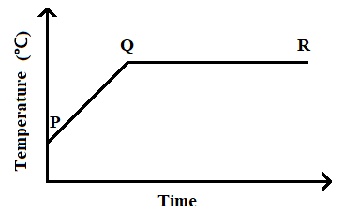
a) What happens to the naphthalene molecules between points P and Q? (1mark)
……………………………………………………………………………………………….
……………………………………………………………………………………………….
b) In which part of the curve does a change of state occur? (1mark)
……………………………………………………………………………………………….
c) Explain why the temperature does not rise between points Q and R. (1mark)
……………………………………………………………………………………………….
……………………………………………………………………………………………….
- Classify the process below as chemical or physical changes (1½ marks)
Process | Physical or chemical change
(a) Fractional distillation
(c) Sublimation
(d) Neutralization
- Name three methods of gas collection. (1½ marks)
……………………………………………………………………………………………….
……………………………………………………………………………………………….
……………………………………………………………………………………………….

- Use the information in the table below to answer the questions that follow. (The letters are not the actual symbols of the elements).
Element | State of oxide at room temperature | Type of oxide | Boding type
E | Solid | Acidic | Covalent
F | Solid | Basic | Ionic
G | Liquid | Neutral | Covalent
H | Gas | Acidic | Covalent

Identify a letter which represents an element in the table that could be calcium, silicon or sulphur. Give a reason in each case.
- Calcium …………………………………………………………………. (1 mark)
Reason …………………………………………………………………. (1 mark)
- Silicon …………………………………………………………………. (1 mark)
Reason …………………………………………………………………. (1 mark)
- Sulphur …………………………………………………………………. (1 mark)
Reason …………………………………………………………………. (1 mark)

- A compound X is made of carbon, hydrogen and oxygen whose percentage composition by mass are 62.1%, 10.3% and the rest oxygen respectively. The relative molecular mass of X is 58) Determine the molecular formula of the compound. (C = 12, H = 1, O = 16)
(3 marks)

……………………………………………………………………………………………….
……………………………………………………………………………………………….
……………………………………………………………………………………………….
……………………………………………………………………………………………….
……………………………………………………………………………………………….
- Write chemical equations to show action of heat on the following salts:
- Na₂CO₃.10H₂O
……………………………………………………………………………………………….
- MgCO₃
……………………………………………………………………………………………….
- AgNO₃
……………………………………………………………………………………………….
- Name two types of intermolecular forces of attraction. (2 marks)
……………………………………………………………………………………………….
……………………………………………………………………………………………….

The Last Printed Page

