NAME………………………………………………INDEX NO:.…ADM NO………
SCHOOL…………………………………………………………….…. DATE………

233/1
CHEMISTRY
TERM 1
MARCH 2024
2 HOURS

FORM 3
Kenya Certificate of Secondary Education (K.C.S.E)

MARKING SCHEME

For Examiner’s Use Only
Question | Maximum score | Candidates score
1-27 | 80

- Study the information in the table below and answer the questions that follow.
The letters do not represent the actual symbols of the elements.
Elements | Electronic configuration | Ionization energy kJmol⁻¹
R | 2:1 | 519
T | 2:8:1 | 494
Q | 2:8:8:1 | 418

- What is the general name given to the chemical family to which elements R, T and Q belong? (1 mark)
Alkali metals

- What is meant by ionization energy? (1 mark)
Minimum energy needed to remove an electron from the outermost energy level of an atom in gaseous state.

- Explain why element R has the highest ionization energy. (1 mark)
It has the smallest atomic radius hence its outermost electron is strongly attracted by the positive nucleus.
- The Bunsen burner produces both luminous and non-luminous flames.
- Why is the non-luminous flame hotter than the luminous? (1 mark)
In non-luminous flame there is complete combustion of laboratory gas in plenty of air hence production of more heat; in luminous flame there is incomplete combustion of laboratory gas in limited air producing less heat.
- Other than the amount of heat produced, state two differences in the characteristics of the two types of flames. (2 marks)

Non-Luminous | Luminous
- 3 zones | - 4 zones
(ii) Yellow | (ii) Blue
(iii) Less bright// produces less light | (iii) Brighter/ produces more light
(iv) Roaring/noisy | (iv) Quiet
(v) Short & steady | (v) Long & wavy
Reject-used in heating | Reject-used in lighting
Reject-produced when airhole is open | Reject-produced when airhole is closed

- Analysis of a sample of neon gas in a mass spectrometer gave the following results.

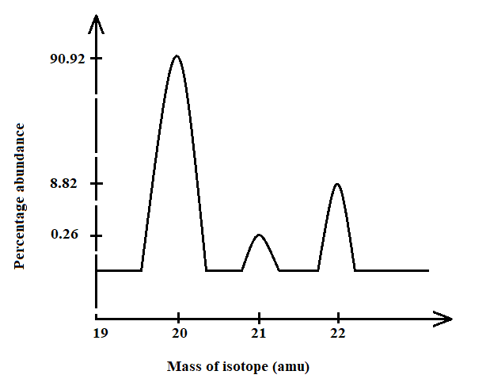
- Which of the isotope is commonly found? (1 mark)
Ne - 20
- Calculate the R.A.M. of neon. (2 marks)
$\frac{90.92 x 20+0.26 x 21+8.82 x 22}{100}$ 1 = 20.179 1
- a) State Graham’s law of diffusion. (1 mark)
The rate of diffusion of a of a gas is inversely proportional to the square root of its
density at constant temperature and pressure
b) A given volume of ozone, (O₃) diffused from a certain apparatus in 96 seconds. Calculate the time taken by an equal volume of carbon (IV) oxide (CO₂) to diffuse under the same conditions (O = 16.0, C = 12.0) (2 marks)

Molar mass CO₂ = 44 g√½
Molar mass O₃ = 48 g√½

T O₃ = √ M O₃ => 96 seconds. = √ 48 √½ = 91.9seconds√½
T CO₂ = √ M CO₂ T CO₂ √ 44

- The following data gives the pH values of some solutions;
Solution | pH
P  Q  R | 14.0  6.8  2.5

- What colour change would occur in solution P on addition of two drops of phenolphthalein indicator? (1 mark)
Pink
- State the pH value of a resulting solution when equal moles of solution P and R react. Explain. (2 marks)
pH 7. R is an acid and P is a base hence neutralization takes place.
- Name the process which takes place when:
- Solid Carbon (IV) oxide (dry ice) changes directly into gas. (1mark)
Sublimation
- A moist red litmus paper turns white when dropped into jar of chlorine gas. (1mark)
Bleaching
- Crystals of calcium chloride form a solution on long exposure to air. (1mark)
Deliquescence
- Describe how to prepare some crystals of magnesium sulphate starting with magnesium powder. (3 marks)
- To some amount of dilute sulphuric (VI) acid in beaker
- Add magnesium powder as you stir till in excess.
- Filter to obtain magnesium sulphate as filtrate.
(½ mark each)
- Heat the filtrate to saturate.
- Cool in order to form crystals.
- Dry between filter papers.

- The diagram below represents two iron nails with some parts tightly wrapped with Zinc and Copper foils respectively.
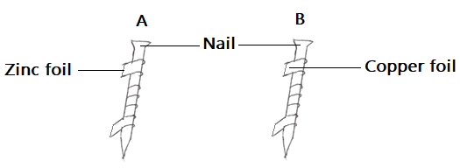
State the observations that would be made at the exposed parts of the nails A and B after being left in the open for a long time. (2 marks)
- No rusting/ no brown coating at A
- Rusting / brown coating in B
- a) Distinguish between a covalent and dative bond. (1 mark)
- Covalent bond is formed when two atoms share a pair of electrons equally.
- Dative bond is formed when the shared pair of electrons is contributed by one species forming the bond.
b) Draw a dot (●) and cross (X) diagram to show bonding in ammonium ion (NH₄⁺).
(2 marks)

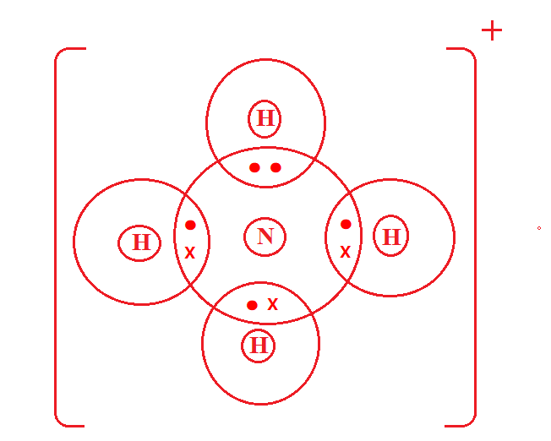

- The grid below shows a part of the periodic table. The letters do not represent the actual
Symbols. Use it to answer the questions that follow: -

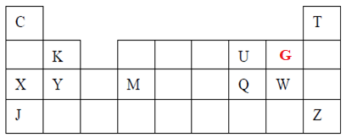
- How do the atomic radii of element X and Y compare? (1 mark)
Atomic radius of Y is smaller than that of X. The effective nuclear charger in Y is greater than in X hence outer electrons strongly pulled to the center reducing the radius.
- i) State the period and the group to which element Q belong. (1 mark)
Period – 3
Group – VI
ii) The ionic configuration of element G is 2.8. G forms an ion of the type G⁻¹. Indicate on the grid, the position of element G. (1 mark)
iii) State one use of element U. (1 mark)
  - Used in hospitals for patients with breathing difficulties
- Used by mountain climbers and deep-sea divers
- Burning fuels to propel rockets.
- Manufacture of the oxy-acetylene flame that is used in welding and cutting of metals;
- Removal of iron impurities during steel making.
iv) What is the nature of the compound formed between K and U. (1 mark)
Basic
- Molten lead (II) bromide undergoes decomposition when an electric current is passed through it.
- Write an equation for the reaction that occurs at the:
      - Cathode (1 mark)
Pb²⁺_{(l)} + 2e⁻ → Pb_{(s)}
      - Anode (1 mark)
2Br ⁻_{( l)} → Br_{2(g)} + 2e⁻
- Give a reason why this experiment is carried out in a fume cupboard. (1 mark)
The bromine vapour produced is poisonous
- Calcium hydrogen carbonate reacted with 12.0cm³ of 0.05M hydrochloric acid to form calcium chloride, water and carbon (IV) oxide.
- Write the chemical equation for the reaction. (1 mark)
Ca(HCO₃)_{2(aq)} + 2HCl_{(aq)} → CaCl_{2(aq)} + 2H₂O_{(l)} + 2CO_{2(g)} ✔1
- unbalanced eqn. – zero mark
- Penalise ½ mark for wrong or missing state symbols
- Calculate the number of moles of hydrochloric acid used. (2 marks)
Moles of HCl =$\frac{20 x 0.05}{1000}$ ✔1 = 0.0006mol ✔1
- Determine the number of moles of calcium hydrogen carbonate used. (1 mark)
Moles of Ca(HCO₃)₂ = $\frac{1}{2}$ x 0.0006 ✔ ½
= 0.0003mol ✔½
- State one observation that was made during the reaction. (1 mark)
Effervescence
- Name two indicators which can be used to determine the end point of a reaction during titration of a strong acid against a weak base. (2 marks)
Methyl orange
Screened methyl orange
- The figure below shows the apparatus used to burn hydrogen in air. Use it to answer the
questions that follow.
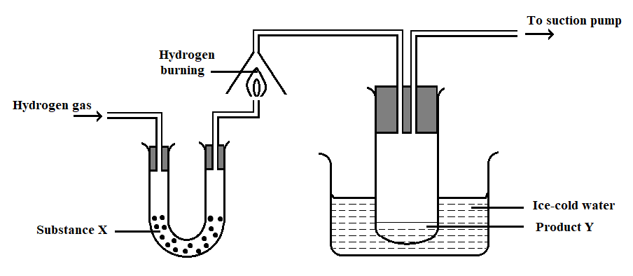
- State the role of substance X (1 mark)
To dry hydrogen gas
- Give the name of the substance that could be used as X (1 mark)
Anhydrous calcium chloride.
- State the role of the suction pump (1 mark)
To such the vapour formed when hydrogen burns.
- Name the product Y formed (1 mark)
Water.
- Give a simple physical test to prove the identity of Y (1 mark)
It has a boiling point of 100℃ at sea level
- State the difference between “dry” and “anhydrous”. (2 marks)
“dry” is a substance that is not mixed with water while “anhydrous” is a substance that does not contain chemically combined water/water of crystallization.

- a) Give a set of reagents that can be used to prepare oxygen in the laboratory. (2 marks)
Hydrogen peroxide and manganese (IV)oxide
OR
Sodium peroxide and water
b) Write a chemical equation for the reaction that occurs between the reagents named in (a) above. (1 mark)
2H₂O₂(aq) ^{Manganese (IV) oxide} 2H₂O(l) + O₂(g)
OR
2N₂O₂(s) + 2H₂O(l) 4NaOH(aq) + O₂(g)
- a) Name the two oxides of carbon. (1 marks)
Carbon (IV) oxide
Carbon (II) oxide
b) State the nature of each oxide of carbon. (1 marks)
Carbon (IV) oxide - Acidic
Carbon (II) oxide - Neutral
- State the danger associated with the neutral oxide of carbon. (1 mark)
Poisonous/causes death/suffocation when inhaled
- A mixture contains ammonium chloride, copper (II) oxide and sodium chloride. Describe how each of the substances can be obtained from the mixture (3 marks)
Heat the mixture to in a beaker covered with watch glass containing cold water. NH₄Cl sublime hence it is deposited under the watch glass
Add water to dissolve the NaCl, Copper (II) oxide does not dissolve.
Filter and evaporate the filtrate obtain sodium chloride.
Wash the residue and dry it between filter papers to obtain Copper (II) oxide
- Sodium carbonate is manufactured in large scale in Kenya by the Solvay process.
a) Carbon (IV) oxide is one of the ingredients required in this process. State its source. (1 mark)
Decomposition of limestone ✔1
Or Combustion of coke
b) One of the by-products is calcium chloride which can be used as a source of calcium metal. How can calcium be obtained on large scale from the calcium chloride? (1 mark)
Electrolysis of molten calcium chloride
c) Name two substances that are recycled in this process. (1 mark)
Ammonia gas
Carbon (IV) oxide
Water
- The graph below shows the heating curve obtained when naphthalene at 25℃ was heated for 15 minutes.
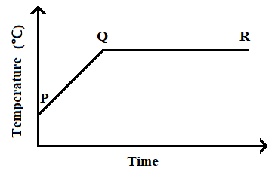
a) What happens to the naphthalene molecules between points P and Q? (1mark)
They absorb heat energy which increases their kinetic energy ✔1 and vibrate faster.
b) In which part of the curve does a change of state occur? (1mark)
QR
c) Explain why the temperature does not rise between points Q and R. (1mark)
The energy supplied is used to weaken✔1 the intermolecular forces to change molecules from solid to liquid state
- Classify the process below as chemical or physical changes (1½ marks)
Process | Physical or chemical change
(a) Fractional distillation | Physical
(c) Sublimation | Physical
(d) Neutralization | Chemical
- Name three methods of gas collection (1½ marks)
- Over water
- Upward delivery/downward displacement of air
- Downward delivery/upward displacement of air
- Syringe
- Liquefaction / liquification
- Freezing/solidification
- Use the information in the table below to answer the questions that follow. (The letters are not the actual symbols of the elements).

Element | State of oxide at room temperature | Type of oxide | Boding type
E | Solid | Acidic | Covalent
F | Solid | Basic | Ionic
G | Liquid | Neutral | Covalent
H | Gas | Acidic | Covalent

Identify a letter which represents an element in the table that could be calcium, silicon or sulphur. Give a reason in each case.
- Calcium F (1 mark)
Reason Forms a basic oxide which forms an ionic bond (1 mark)
- Silicon E (1 mark)
Reason Forms a solid oxide at room temperature, acidic with covalent bond
(1 mark)
- Sulphur H (1 mark)
Reason Forms a gaseous at room temperature, acidic with covalent bond
- mark)
- A compound X is made of carbon, hydrogen and oxygen whose percentage composition by mass are 62.1%, 10.3% and the rest oxygen respectively. The relative molecular mass of X is 58) Determine the molecular formula of the compound. (C = 12, H = 1, O = 16)
(3 marks)

C H O
62.1 10.3 27.6 ✔1
12 1 16
Moles = 5.175 10.3 1.725
1.725 1.725 1.725 ✔1
3 6 1
C₃H₆O ✔1
- Write chemical equations to show action of heat on the following salts:
- Na₂CO₃.10H₂O
Na₂CO₃.10H₂O(s) → Na₂CO₃(s) + 10H₂O(l)
- MgCO₃
MgCO₃(s) → MgO(s) + CO ₂ (g)

- AgNO₃
2AgNO₃(s) → 2Ag(s) + 2NO ₂ (g) + O ₂ (g)

- Name two types of intermolecular forces of attraction. (2 marks)
Hydrogen bonds
Van der Waals forces

