NAME: _____________________________________ CLASS______ DATE: __________
SCHOOL _________________________________________________________________

CHEMISTRY FORM 2 END TERM 1 EXAMS

INSTRUCTIONS TO THE STUDENTS:-
- Write your Name and Admission number in the spaces provided.
- Answer all the questions in the spaces provided.
- All working MUST be clearly shown where necessary.

1. a) Name two apparatus used to scoop solid substances from containers. (1mk)

b) The Bunsen burner produces two types of flames.
i) Draw a well labelled diagram of the flame produced when the air hole is fully opened. (3mk)

ii) How can the brightness of a flame be reduced? (1mk)

2.A mixture of Kerosene and water is said to be immiscible.
i) What physical property of the two makes them not to mix thoroughly? (1mk)

ii) List any two methods that can be used to separate this mixture. (1mk)

3. A group of drunk men brayo,kevo , wallace and njugush were suspected to have taken a brew containing some lethal substances. Action was taken and their saliva was tested against the lethal substances. The result is shown in the chromatograph below. The lethal substances are X and Y while their saliva are represented by letters B,K,W and N. study it and answer the questions that follow.
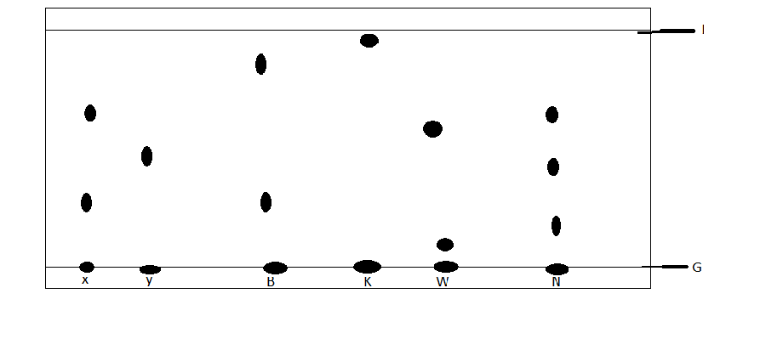
a) Identify using the letters the drunk man whose saliva; (3mk)
i) Contained the most dense substance. ------------------------------------------
ii) Contained all the components of the lethal substances------------------
iii) Did not contain any of the lethal substances------------------------------
b) What do the lines represented by letters G and J stand for? (1mk)
G----
J ----
c) Give the name of a solvent used in paper chromatography? (1mk)
4. Nitrogen, Oxygen and Argon are obtained from liquid air by fractional distillation.
a) State the physical property that makes this possible. (1mk)

b) Arrange the three gases in order of how they distil, starting with that first. (1mk)

c) List two industrial uses of oxygen gas. (1mk)

5. a) What is the chemical name of rust. (1mk)

b) Apart from sacrificial protection and oiling and greasing, list two other methods used to prevent rusting. (1mk)

c) What are the advantages of rusting? State two. (1mk)

6. a) What are isotopes. (1mk)

b) Chlorine -35 has a percentage abundance of 75% while the rest is Chlorine- 37. Calculate the relative atomic mass of chlorine. (2mk)

7. The following are the formulae of some ions and their electron configurations. Study them and answer the questions that follow ;

symbol | Electron configuration
Q²⁺ | 2,8,8
R⁻ | 2,8,8
E²⁻ | 2,8,8
T⁺ | 2,8
V³⁻ | 2,8,8
M⁻ | 2,8
J⁵⁺ | 2,8

a) If the mass number of Q²⁺ is 40, draw its electronic arrangement showing the nuclear composition. (2mk)

b) Which two ions belongs to the same element and what is the atomic number of the element. (2mk)

c) Which elements belongs to the same period. (1mk)

8. Complete the following equations and balance them. (6mk)
a) Al_{(s)} + O_{2(g)}
b) Na_{(s)} + H₂O_{(l)}
c) Mg_{(s)} + HNO₃
9. Write the formulae of the following compounds (10mk)
Calcium nitrate | Iron (iii) oxide
Manganese iv oxide | Zinc carbonate
Potassium sulphate | Lead (iv) oxide
Copper hydroxide | Ammonium phosphate

9. Indicate the colours of the following substances. (4mk)
i) copper metal –
ii) Chlorine gas –
iii) Magnesium flame-
iv) Potassium flame –
v) Hot zinc oxide -
vi) Copper ii oxide-
vii) Iodine vapour
viii) Sodium flame-
10. Explain the following observations;
a) Chlorine has a larger ionic radius than the atomic radius. (1mk)

b) The 2nd ionization energy of magnesium is larger than the 1st ionization energy. (1mk)

c) Atomic radius of Potassium is larger than the ionic radius. (1mk)

d) Ionization energy decreases down group 1 (1mk)

11. Balance the following equations. (5mk)
a) C₂H₄ _{(g)} + O_{2(g)} CO_{2(g)} + H₂O_{(l)}

b) H₂S_{(g)} + SO_{2(g)} S_{(s)} + H₂0_{(l)}

c) Na₂CO₃ _{(S)} + HCl _{(aq)} NaCl_{(aq)} + CO_{2(aq)} + H₂O_{(l)}

d) Pb(NO₃)₂ _{(S)} PbO _{(s)} + NO_{2(g)} + O_{2(g)}

e) Cl_{2(g)} + NaOH_{(aq)} NaCl_{(aq)} + NaOCl_{(aq)} + H₂O_{(l)}

12. The table below shows behaviour of metals R, X, Y and Z. Study it and
answer the questions that follow:

Metal | Appearance on exposure to air | Reaction in water | Reaction with dilute hydrochloric acid
R | slowly tarnishes | Slow | Vigorous
X | Slowly turns white | Vigorous | Violent
Y | No change | Does not react | Does not react
Z | No change | No reaction | Reacts moderately
a) Arrange the metals in the order of reactivity starting with the most reactive. (2mk)
b) Name a metal which is likely to be (1mk)
I X
Ii Y
13.The table below gives information on four elements by letters K, L, M and
N. Study it and answer the questions that follow. The letters do not represent the actual symbols of the elements.

Element | Electron arrangement | Atomic radius (nm) | Ionic radius(nm)
K  L  M  N | 2, 8, 2  2, 8, 7  2, 8, 8, 1  2, 8, 8, 2 | 0.136  0.099  0.203  0.174 | 0.065  0.181  0.133  0.099

a) Which two elements have two similar properties? Explain (2mk)

b) What is most likely formula of oxide of M? (1mk)

c) Which element is a non-metal? Explain (1mk)
14. The information below gives solutions and their pH values. Study it and answer the questions that follow.

Solution | PH value
B  C  D  E  F | 8.5  2.0  13.5  6.0  7.0

a) State and explain the observations made when a few grams of calcium carbonate are added to solution C. (2mk)

b) Which solution is likely to be used as an ant-acid (1mk)

15. The diagram below is set – up for the laboratory preparation of hydrogen gas.
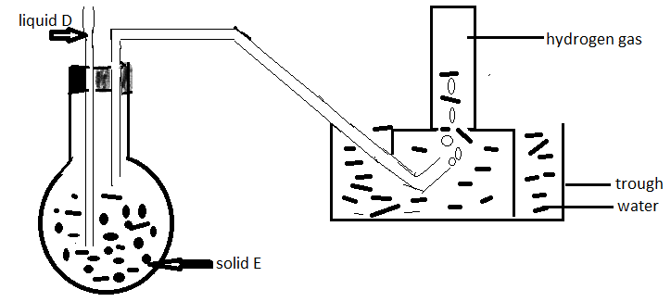
a) What property of hydrogen makes it possible to collect hydrogen using the method above. (1mk)
b) Solid E is zinc metal why liquid D dilute hydrochloric acid . Write a balanced chemical equation for the reaction that took place. (1mk)

c) Explain the observation that would be made if zinc is replaced with copper metal. (2mk).

d) List any two drying agents that can be used to dry hydrogen gas. (1mk)

16.The following is a set-up used by form 2 students in a certain school. Study it and answer the questions that follow.
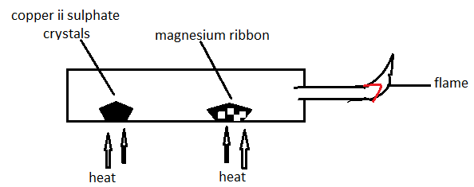
a)State and explain the observation made at the porcelain boat containing the magnesium ribbon. (2mk)

b) Name the type of change undergone by the copper ii sulphate crystals. (1mk)

c) Write the equation for the reaction taking place at the flame. (1mk)

17. The following is an extract of the periodic table . The letters do not represent the actual symbols of the elements. Study it and answer the questions that follow.

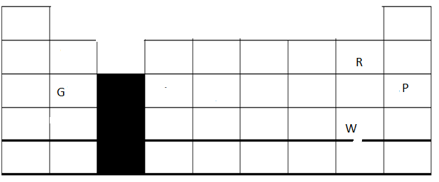

a) Select the letter that represents the most;
i) Unreactive element (1mk)
ii) Reactive non-metal (1mk)

b) Use the following letters to show the position of these elements in the periodic table; (4mk)
i) The most reactive metal, Letter L
ii ) forms a trivalent anion with the electron configuration resembling that of neon, letter D
iii) Has an amphoteric oxide, letter Y
iv) Can gain or loose four electrons and is in period 3 , letter A
c) Write the formulae of the compound formed between element W and G. (1mk)

