Chem term 1 f2 multilateral m/ks
1. a) Name two apparatus used to scoop solid substances from containers. (1mk)
- spatula ½ - tongs ½ mk
b) The Bunsen burner produces two types of flames.
i) Draw a well labelled diagram of the flame produced when the air hole is fully opened. (3mk)
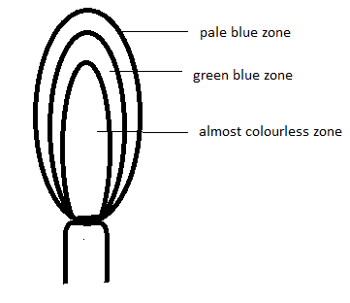
ii) How can the brightness of a flame be reduced? (1mk)
by closing the air hole
2.A mixture of Kerosene and water is said to be immiscible.
i) What physical property of the two makes them not to mix thoroughly? (1mk)
-density
ii) List any two methods that can be used to separate this mixture. (1mk)
- use of a separating funnel
- decantation
- use of a dropper/teat pipette
3. A group of drunk men brayo,kevo , wallace and njugush were suspected to have taken a brew containing some lethal substances. Action was taken and their saliva was tested against the lethal substances. The result is shown in the chromatograph below. The lethal substances are X and Y while their saliva are represented by letters B,K,W and N. study it and answer the questions that follow.
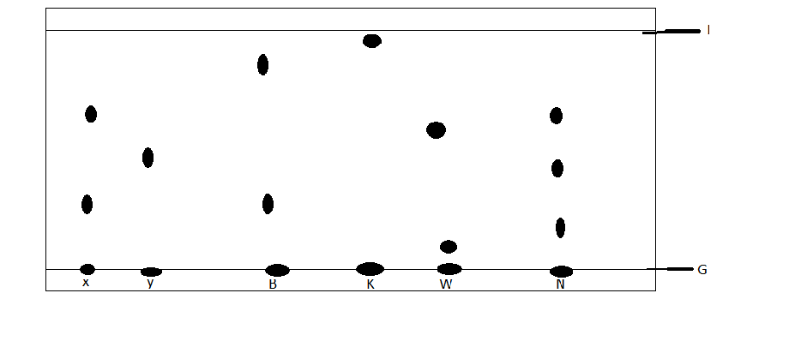
a) Identify using the letters the drunk man whose saliva; (3mk)
i) Contained the most dense substance. ------------------------------------------
ii) Contained all the components of the lethal substances------------------
iii) Did not contain any of the lethal substances------------------------------
b) What do the lines represented by letters G and J stand for? (1mk)
G---- base line
J ---- solvent front
c) Give the name of a solvent used in paper chromatography? (1mk)
- propanone/ ethanol/
4. Nitrogen, Oxygen and Argon are obtained from liquid air by fractional distillation.
a) State the physical property that makes this possible. (1mk)
-difference in boiling points
b) Arrange the three gases in order of how they distil, starting with that first. (1mk)
nitrogen- argon- oxygen
c) List two industrial uses of oxygen gas. (1mk)
- steel manufacture
- welding and cutting of metals
- as a reactant in fuel cells
5. a) What is the chemical name of rust. (1mk)
- hydrated iron iii oxide
b) Apart from sacrificial protection and oiling and greasing, list two other methods used to prevent rusting.
- alloying
- Coating with other metals (1mk)
c) What are the advantages of rusting? State two. (1mk)
-adds iron nutrients to the soil
- Helps destroy worn out iron objects
- creation of job opportunities
6. a) What are isotopes. (1mk)
- atoms of the same element with the same atomic number but different mass number.
b) Chlorine -35 has a percentage abundance of 75% while the rest is Chlorine- 37. Calculate the relative atomic mass of chlorine. (2mk)
(35 x 75) + (37 x 25) /100 = 1mk
35.5 1mk
7. The following are the formulae of some ions and their electron configurations. Study them and answer the questions that follow ;
symbol | Electron configuration
Q²⁺ | 2,8,8
R⁻ | 2,8,8
E²⁻ | 2,8,8
T⁺ | 2,8
V³⁻ | 2,8,8
M⁻ | 2,8
J⁵⁺ | 2,8

a) If the mass number of Q²⁺ is 40, draw its electronic arrangement showing the nuclear composition. (2mk)

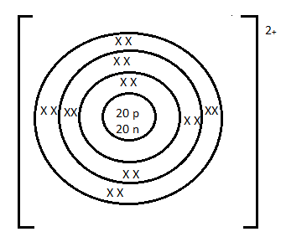
b) Which two ions belongs to the same element and what is the atomic number of the element. (2mk)
V&J 1MK
15 1MK
c) Which two elements belongs to a different period from the others (1mk)
Q & J
8. Complete the following equations and balance them. (6mk)
a) 4Al_{(s)} + 3O_{2(g)} ---------------- 2Al₂O₃
b) 2Na_{(s)} + 2H₂O_{(l)} …………….. 2NaOH + H₂
c) Mg_{(s)} + 2 HCl ……………Mg Cl₂ + H₂
9. Write the formulae of the following compounds (10mk)
Calcium nitrate  Ca(NO3)2 | Iron (iii) oxide  Fe₂O₃
Manganese iv oxide  MnO2 | Zinc carbonate  ZnCO3
Potassium sulphate  K2SO4 | Lead (iv) oxide  PbO2
Copper hydroxide  Cu(OH)2 | Ammonium phosphate  (NH₄)₃PO₄

9. Indicate the colours of the following substances. (4mk)
i) copper metal – brown
ii) Chlorine gas – greenish-yellow or green
iii) Magnesium flame- white
iv) Potassium flame – purple or lilac
v) Hot zinc oxide- yellow
vi) Copper ii oxide- black
vii) Iodine vapour -purple
viii) Sodium flame-yellow
10. Explain the following observations;
a) Chlorine has a larger ionic radius than the atomic radius. (1mk)
-upon gaining an electron, the nuclear attraction reduces or the repulsive forces increases

b) The 2nd ionization energy of magnesium is larger than the 1st ionization energy. (1mk)
-when the 1st electron is lost, the remaining electrons experience a greater nuclear attraction WTTE

c) Atomic radius of Potassium is larger than the ionic radius. (1mk)
- the ion has fewer occupied energy levels than the atom

d) Ionization energy decreases down group 1 (1mk)
-as the atomic radius increases, the valence electron experience less nuclear attraction requiring less energy to remove

11. Balance the following equations. (5mk)
a) C₂H₄ _{(g)} + 3 O_{2(g)} ………… 2CO_{2(g)} + 2H₂O_{(l)}

b) 2H₂S_{(g)} + SO_{2(g)} ………… 3S_{(s)} + 2H₂0_{(l)}

c) Na₂CO₃ _{(S)} + 2HCl _{(aq)} …………… 2NaCl_{(aq)} + CO_{2(aq)} + H₂O_{(l)}

d) 2Pb(NO₃)₂ _{(S)} …………….. 2 PbO _{(s)} + 4 NO_{2(g)} + O2_{(l)}

e) Cl_{2(g)} + 2 NaOH_{(aq)} ………… NaCl_{(aq)} + NaOCl_{(aq)} + H₂O_{(l)}

12. The table below shows behaviour of metals R, X, Y and Z. Study it and
answer the questions that follow:

Metal | Appearance on exposure to air | Reaction in water | Reaction with dilute hydrochloric acid
R | slowly tarnishes | Slow | Vigorous
X | Slowly turns white | Vigorous | Violent
Y | No change | Does not react | Does not react
Z | No change | No reaction | Reacts moderately
a) Arrange the metals in the order of reactivity starting with the most reactive. (2mk) X, R, Z, Y
b) Name a metal which is likely to be (1mk)
I X - K or potassium
Ii Y - copper or silver or mercury or gold
13.The table below gives information on four elements by letters K, L, M and
N. Study it and answer the questions that follow. The letters do not represent the actual symbols of the elements.

Element | Electron arrangement | Atomic radius (nm) | Ionic radius(nm)
K  L  M  N | 2, 8, 2  2, 8, 7  2, 8, 8, 1  2, 8, 8, 2 | 0.136  0.099  0.203  0.174 | 0.065  0.181  0.133  0.099

a) Which two elements have two similar properties? Explain (2mk)
K and N .
Belongs to the same group or have the same number of electrons in the outermost energy level

b) What is most likely formula of oxide of M? (1mk)
M2O or K2O or M2O2 or K2O2
c) Which element is a non-metal? Explain (1mk)
L. has more than 4 electrons in the outermost energy level or has 7 valence electrons or react by gaining electrons
14. The information below gives solutions and their pH values. Study it and answer the questions that follow.

Solution | pH value
B  C  D  E  F | 8.5  2.0  13.5  6.0  7.0

a) State and explain the observations made when a few grams of calcium carbonate are added to solution C. (2mk)
- effervescence or production of bubbles 1mk
- C being acidic produce CO2 gas with carbonate
b) Which solution is likely to be used as an anti-acid (1mk)
-B
15. The diagram below is set – up for the laboratory preparation of hydrogen gas.
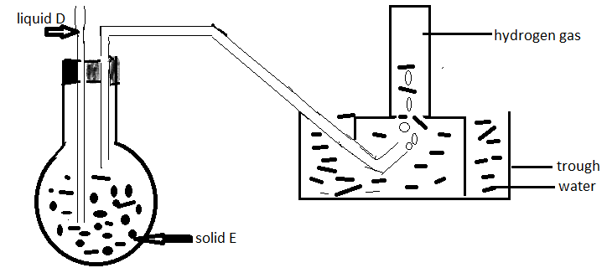
a) What property of hydrogen makes it possible to collect hydrogen using the method above. (1mk)
- hydrogen is insoluble in water
b) Solid E is zinc metal why liquid D dilute hydrochloric acid . Write a balanced chemical equation for the reaction that took place. (1mk)
Zn + 2HCl ZnCl2 + H2
c) Explain the observation that would be made if zinc is replaced with copper metal. (2mk).
-no reaction or no bubbles
- copper is below hydrogen in the reactivity series or is less reactive than hydrogen or Cu being below hydrogen cannot displace it from acid
d) List any two drying agents that can be used to dry hydrogen gas. (1mk)
- conc. Sulphuric (vi) acid or anhydrous calcium chloride or calcium oxide/quick lime
16.The following is a set-up used by form 2 students in a certain school. Study it and answer the questions that follow.
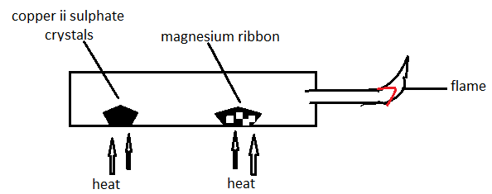
a)State and explain the observation made at the porcelain boat containing the magnesium ribbon. (2mk)
- grey Mg ribbon change to white 1mk . Heated copper ii sulphate release steam1/2 mk which oxidizes Mg to MgO ½ mk
b) Name the type of change undergone by the copper ii sulphate crystals. (1mk)
- temporary chemical change
c) Write the equation for the reaction taking place at the flame. (1mk)
2H2 + O2 2H20
17. The following is an extract of the periodic table . The letters do not represent the actual symbols of the elements. Study it and answer the questions that follow.
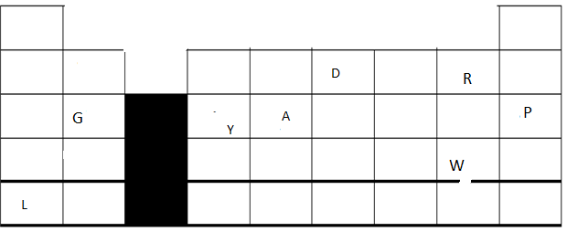

a) Select the letter that represents the most;
i) Unreactive element - P (1mk)
ii) Reactive non-metal -R (1mk)

b) Use the following letters to show the position of these elements in the periodic table; (4mk)
i) The most reactive metal, Letter L
ii ) forms a trivalent anion with the electron configuration resembling that of neon, letter D
iii) Has an amphoteric oxide, letter Y
iv) Can gain or loose four electrons and is in period 3 , letter A
c) Write the formulae of the compound formed between element W and G. (1mk)
GW2 or MgBr2
Reject W2G OR Br2Mg

