NAME: _____________________________________ CLASS______ DATE: __________
SCHOOL _________________________________________________________________
CHEMISTRY FORM 1 END TERM 1 EXAMS
INSTRUCTIONS TO THE STUDENTS:-

- Write your Name and Admission number in the spaces provided.
- Answer all the questions in the spaces provided.
- All working MUST be clearly shown where necessary.

For Examiner’s Use Only
Question | Maximum score | Student’s score
1-25 | 80

1(a) what is drug abuse? (1mk)
----------------------------------------------------------------------------------------------------------------
(b) Give two importance of studying Chemistry. (2mks)
________________________________________________________________________________________________________________________________________________
2(a). The following are laboratory apparatus used in Chemistry. Name them and give their uses.
Apparatus (Name) | Use
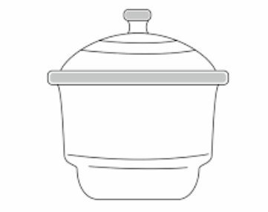 ( ½ mk) | ( ½ mk)
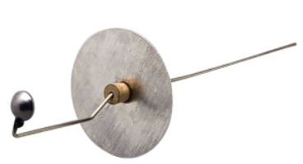( ½ mk) | ½ mk

(b). Give two reasons why most laboratory apparatus are made of glass. (2mks)
________________________________________________________________________________________________________________________________________________
3.(i) What is a flame? -------------------------------------------------------------- (1mk)

ii) A student from VUKA high school lit a Bunsen burner and got the flame shown below

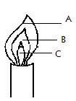

- What is the colour of the flame at part labeled A? (1mark)
----------------------------------------------------------------------------
- A wooden splint slipped through region B of the above flame laboratory. The splint was burnt as shown in the diagram below.
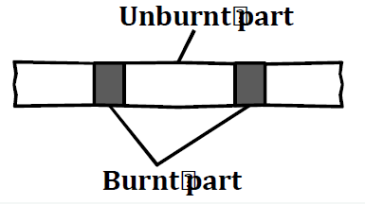
Explain why the splint was burnt the way it is shown in the diagram. (2mk)
____________________________________________________________________________________________________________________________________________________________
4. Heating solids in a test tube or boiling tube is part of the task a learner is supposed to undertake in a given class experiment. Explain the two precautions a learner should observe
(2mks)
____________________________________________________________________________________________________________________________________________________________
5. A form one student at wanted to separate and obtain iodine and sodium chloride (common table salt) from a mixture of the two. He set the experimental set up shown below.
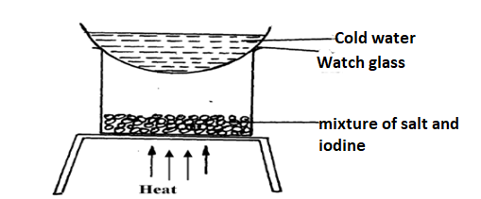

(a). The mixture was heated for some time and left to cool. On cooling, shiny black crystals and white residue were observed on the surface of the watch glass and in the beaker respectively. Name:
I. Shiny black crystals (1mks)
_______________________________________________________________________
II. White crystals. (1mks)
______________________________________________________________________________
(b). What property of iodine makes it be collected on the watch glass as shown? (1mk)
______________________________________________________________________________6. Explain why water is not used as a solvent in extraction of nuts. (2mks)
7.Salt is normally sprinkled on roads during winter in temperate countries
- State and explain why salt is put on roads during winter (2mks)
___________________________________________________________________________
- Why is this practice of great concern to motorist (1mk)
8. Substance A is highly soluble in propane while B has low solubility in propane.
- Which of the two substances will travel the shortest distance on an adsorbent material during paper chromatography? Explain (2mk)
______________________________________________________________________________________________________________________________________________________
- Which other property determine the distance travelled by the substance? (1mk)
______________________________________________________________________________________________________________________________________________________
c) Give two applications of chromatography (1mk)
9. The setup below was used to separate two miscible liquids Q and T
(Boling points; Q =98° C, T=78°C)

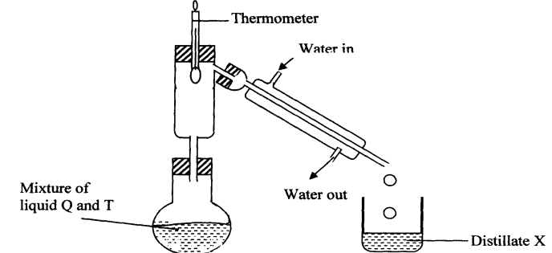

(a) Identify any 2 mistakes in the setup above (2mk)
___________________________________________________________________________
(b) Identify Distillate X (1mk)
______________________________________________________________________________
10. The laboratory rules that should be applied to prevent the following accidents
- Mistaking hydrochloric acid to be distilled water (1mk)
___________________________________________________________________________ (b) A student got burnt after secretly lighting up a magnesium ribbon (1mk)
______________________________________________________________________________c) A student got severe stomach ache after eating some bread during chemistry laboratory session ---------------------------------------------------------------------------------------- (1mk)
11.Name three apparatus that are used to measure accurate volume of liquids. (3mks)
---------------------------------------------------------------------------------------------------------------------------------------------------------------------------------------------------------------------------------------------------------------------------------------------------------------------------------------------------------------
12.Name the best method you would use to separate the following mixtures.
- Kerosene and crude oil (1mk)
-------------------------------------------------------------------------
- Salt and water. (1mk)
------------------------------------------------------------------------
- Iron fillings and sulphur powder. (1mark)
--------------------------------------------------------------------------------
- Oil from nuts. (1mark)
------------------------------------------------------------------------------------
13.The diagram below represents a paper chromatogram for three brands of juices suspected to contain banned food colourings.
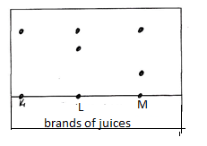
The results showed the presence or banned food colourings in L and M only.
- On the same diagram
- Circle the spots which show the banned food colourings. (2mks)
- Show the solvent front. (1mks)
14.Classify the following processes as either chemical or Physical process type of change
- obtaining Kerosene from crude oil (1mk)
-----------------------------------------------------------------------
- Souring of milk. (1mk)
--------------------------------------------------------------------------------
15.a) What is an element (1mk)
b) Give the symbols of the following elements (3mks)
- Sodium --------------------------------------------
- Calcium ------------------------------------------
- Phosphorus -------------------------------------------
- Name the elements presents in the following compounds (2mks)
- Zinc sulphide
-------------------------------------------------------------------------------------
- Sodium oxide.
16. In the boxes provided below show how molecules are spaced in solids, liquids and gases in terms of kinetic theory. (3marks).

Solid Liquid Gases

17.Study the flow chart below and answer the questions that follows.

Water
Sand
Mixture A
Liquid X
Solid Y

Process B

- Name process B. (1mark)
------------------------------------------------------------------------------------------------

- Give one reason why it’s possible to separate the mixture A above using process B.
(1mark)
------------------------------------------------------------------------------------------------------
- Give the name for
- Liquid X (1mark)
-----------------------------------------------------------------------------------------------
- Solid Y (1mark)
---------------------------------------------------------------------------------------------------

18.a) If common salt is added to wax, what will be the effect on melting point of wax? --------------------------------------------------------------------------------- (1mark)

b) When pure ethanol is heated, it changes to gas at 78.5⁰C.
i) What is the name given to this temperature? (1mark)
-------------------------------------------------------------------------------------------------

(ii) What will happen to this temperature if an impurity like water is added to ethanol? (1mark)
------------------------------------------------------------------------------------------------------
19. A student mixed iron fillings with sulphur powder in a watch glass. The mixture was heated and a new substance was formed. (3mk)
- Is this a physical or chemical change?
---------------------------------------------------------------------------------------------------------------------
- Give two reasons to support your answer in (a) above.
---------------------------------------------------------------------------------------------------------------------
- Give the chemical name of the substance formed after heating sulphur and iron together?
------------------------------------------------------------------------------------------------------------------
20.. Write simple word equations for the following reactions. (2mk)
- Magnesium and oxygen
- Carbon and oxygen (excess)
21.Name the process represented by the letter shown below (2mks)
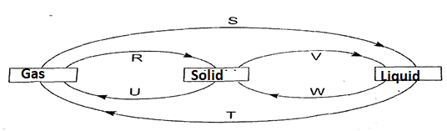
a) U…………………………………………………………………………………………
R……………………………………………………………………………………… V……………………………………………………………………………………
W…………………………………………………………………………………
(b) Name two substances which undergo the process represented by R and U (2mks)
……………………………………………………………………………………………………….---------------------------------------------------------------------------------------------------
22. The diagram below shows a commonly used apparatus in a chemistry laboratory
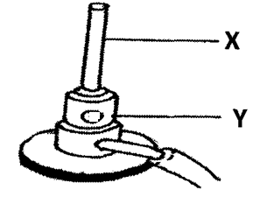
a) Give the name of the apparatus and state its use (2mks)
………………………………………………………………………………………
b) State the uses of parts labeled X and Y (2mks)
X…………………………………………………………………………………………
Y……………………………………………………………………………………………
23. In an experiment to separate a mixture of two liquids A and B, a student set up the apparatus as shown below.
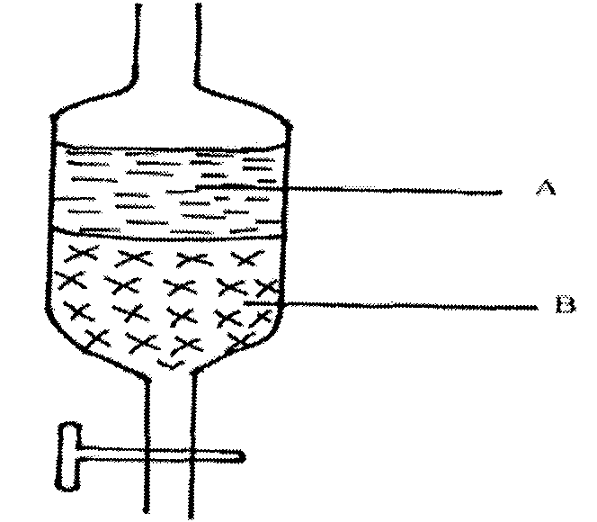
a) Name the apparatus. (1mk)
………………………………………………………………………………………………
b) Which property of the liquids make it possible to be separated as shown (1mk)
………………………………………………………………………………………………
c) Which other method can be used to separate the two liquids. (1mk)
……………………………………………………………………………………………

24. The graph below is a heating curve for ice. Study it and answer the questions that follow
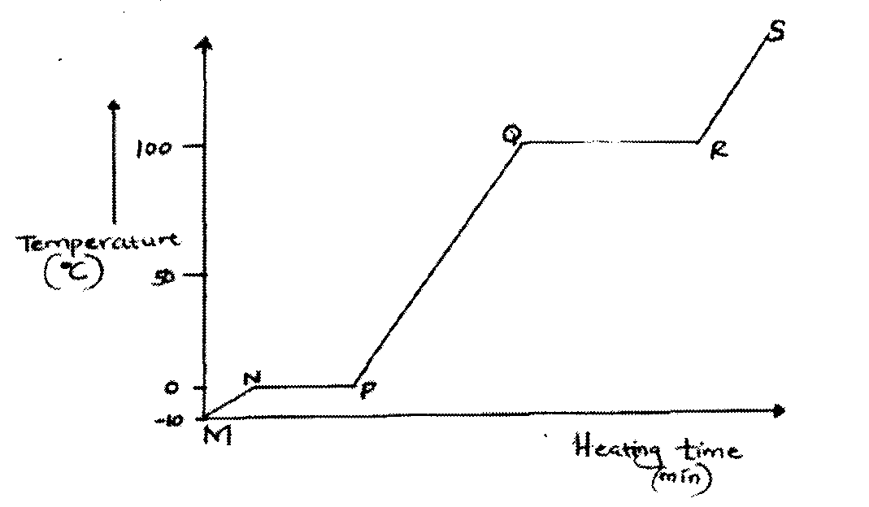
a) Explain why there is no change in temperature in section NP (1mk)
………………………………………………………………………………………………
b) In what state is the water in the region: (2mks)
RS …………………………………………………………………………………………
PQ …………………………………………………………………………………………
c) On the same axis sketch a graph that would be obtained if some salt was added to the ice before heating began. (1mk)
25 Give two reasons why a luminous flame is not used for heating purposes (2mks)
……………………………………………………………………………………………… ……………………………………………………………………………………………….

