NAME_________________________ ___ADM NO.________CLASS______

231/2
BIOLOGY (Theory)
March/April 2024
2 Hours,
MARKING SCHEME.
KENYA CERTIFICATE OF SECONDARY EDUCATION
FORM FOUR BIOLOGY PAPER 2
Instructions to Candidates
- Write your Name and admission Number in the Spaces Provided.
- Sign and write date of examination in the spaces provided.
- You should check the question paper to ascertain that all the pages are printed as indicated and that no questions are missing.

- What is meant by the term sex – linkage? (1mks)
Genes located on the sex chromosomes; and are transmitted along with those determining sex.

- Name two sex – linked traits in humans. (2mks)
      - Colour blindness;
- Hairly ears / pinna;
- Haemophilia;
- Premature baldness;

- In Drosophila Melanogaster, the inheritance of eye colour is sex – linked. The gene of red eye is dominant. A cross was made between a homozygous red – eyed female and a white – eyed male. Work out the phenotypic ration of F₁ generation. (Use R to represent the gene for red eyes). (5mks)

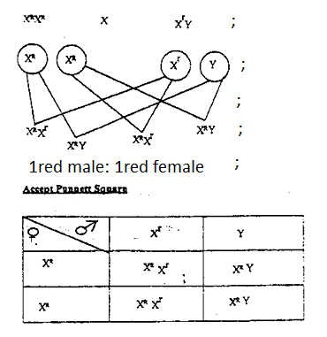

1red eyed female:1red male;

- (a) Name two substances which are found in the intercellular air spaces in a green leaf during a
hot sunny day. (2mks)
    - Oxygen;
    - Water vapour; (RJ; water alone)
(b) Name the gaseous exchange structure found in the:
- Stem of a mesophyte plant. (1mk)
Lenticels;

- Root of aquatic halophytes. (1mk)
Cuticle

- Terrestrial insects. (1mk)
Tracheoles

(c) State three ways in which the gill filaments are adapted to their functions. (3mks)
- Highly vascularized to transport respiratory gases;
- Thin / thin membrane to reduce the diffusion distance;
- Numerous/ large surface area to enhance diffusion;
- Moist to dissolve gases;

- The diagram below illustrates the relationship between variation in atmospheric temperature in the course of day and the body temperature of two animals A and B. Study it and answer the questions that follows.

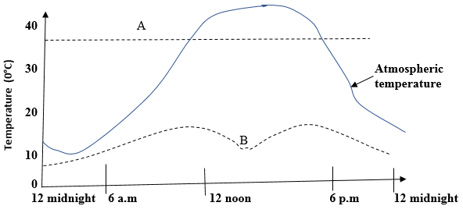

- What is the biological term used to describe animal type:
A – Endothermic; (1mk)
B – Ectothermic; (1mk)
- List three possible mechanisms that animals A may be using to regulate its body temperature between 12.00 midnight and 9.00 a.m. (3mks)
- Vasoconstriction;
- Erector pili muscle contract and hair stand upright;
- Increased metabolism;
- Shivering;
- Suggest one way in which animal B uses to regulate its body temperature between 12:00 noon and 6:00 p.m. (1mk)
    - Under shade/ rock;
    - Barrowing;
- State two advantages that animal A has over animal B. (2mks)
- Active at all time;
- Can occupy any/all habitats;

- The diagram below represents a food web in a terrestrial ecosystem.

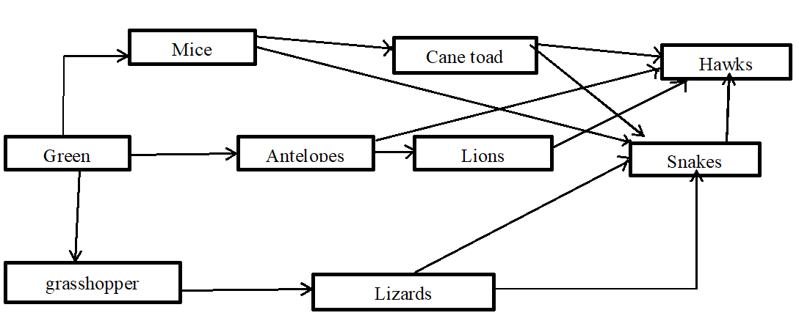

- Which organism has the highest number of preys? (1mk)
Hawks;

- Construct food chains with snakes as tertiary consumers. (2mks)

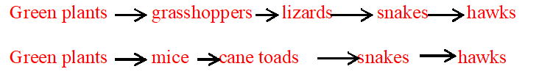
- State the trophic level occupied by hawks in the food chains constructed in (b) above. (1mk)
Quaternary consumers;

- Describe how capture-recapture method can be used in estimating the population of fishes in a lake. (4mks)
  - Capture some fish, mark and release them Record as first marked (FM);
  - After 24 hours, collect as many organisms as possible in the same area, record the number collected as second capture (SC);
  - Record the number of those previously marked as marked recaptured (MR);
  - P =FM x SC;
MR

- The figure below shows the embryo sac before fertilization.

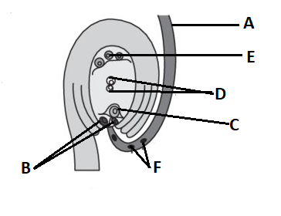

- Identify the structures labeled A, B, E and F. (4mks)
A - Pollen tube;
B - Synergids;
E –Antipodal cell;
F – Generative nuclei;

- State the ploidy of each of the following nuclei after fertilization
- C – Diploid; (1mk)

- D - Triploid; (1mk)

- Briefly outline the process of ‘double fertilization’ in flowering plants. (2mks)
Is the process by which one male nucleus fuses with the egg cell to form a zygote; and another nucleus fuses with the polar nuclei to form primary endosperm;

SECTION B: 40 (MARKS)
Answer question 6 (Compulsory) and either question 7 or 8 in the spaces provided after question 8.
6. A farmer wished to plant certain species of Erythrina trees on his farm. However, their seeds normally take time to germinate after sowing. To overcome this problem, he put the seeds in hot water maintained at 50ºC. Batches of 20 seeds were removed at one-minute intervals and then planted in trays containing moist soil.
After 15 days, the number of seeds that germinated in each tray were counted. The results obtained were as shown in the table below.
Batch order | Time intervals. (minutes) | Germinated seeds | Percentage of seeds that Germinated.
1st | 0 | 3
2nd | 1 | 3
3rd | 2 | 8
4th | 3 | 15
5th | 4 | 18
6th | 5 | 13
7th | 6 | 10
8th | 7 | 6
9th | 8 | 2
10th | 9 | 0
11th | 10 | 0

- Calculate the percentage germination rate for each batch and fill in the table. (5mks)
Batch order | Time intervals. (minutes) | Germinated seeds | Percentage of seeds that Germinated.
1st | 0 | 3 | 15
2nd | 1 | 3 | 15
3rd | 2 | 8 | 40
4th | 3 | 15 | 75
5th | 4 | 18 | 90
6th | 5 | 13 | 65
7th | 6 | 10 | 50
8th | 7 | 6 | 30
9th | 8 | 2 | 10
10th | 9 | 0 | 0
11th | 10 | 0 | 0

- Use your results to plot a graph showing percentage germination against the duration in which the seeds were soaked in hot water. (6mks)

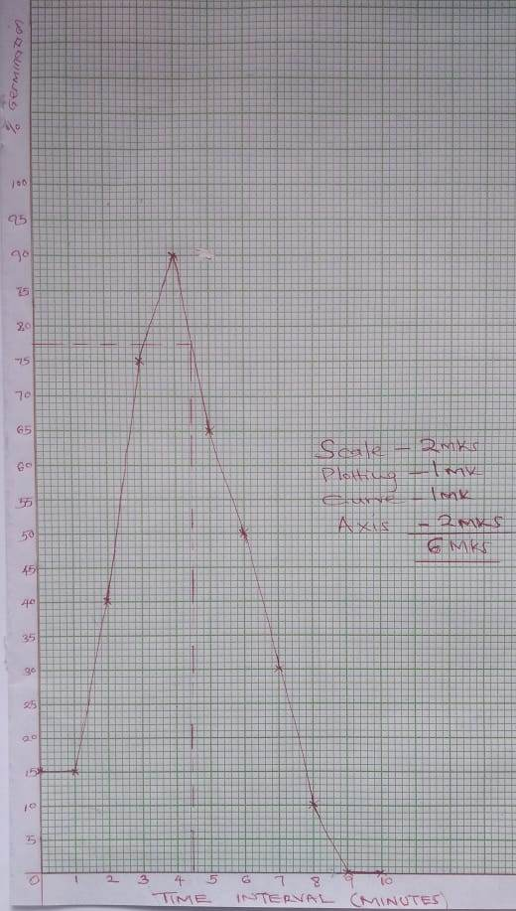

- From the graph derive the expected number of seeds that would germinate if soaked for 4.5 minutes. (1mk)
76.5% + 0.1;
- Using the graph briefly describe the effect of hot water treatment on seed germination of Erythrina. (5mks)
Increase in exposure of the seed to hot water increased number of seeds that germinated up to optimum;
where more exposure beyond optimum reduced number of seeds that germinated;
Water softened the hard seed coat; and activated germination enzymes; up to optimum where more exposure denatured the enzymes lowering germination;
- Explain why there was no germination of seeds soaked in hot water for nine to ten minutes. (1mks)
All the enzymes were denatured;
- Besides hot water treatment, suggest two other methods that can be used to speed up germination in Erythrina. (2mks)
Scarification;
Roasting;

7. Explain the role of osmosis in organisms. (10mks)
- Absorption of water from the soil;
Root hair cells of plants absorb water from the soil by osmosis; it also helps in water distribution from cell to cell in the body.

- Support;
Water taken into the cells increase cell turgor hence cells become firm /rigid/turgid; and therefore turgidity in the cells provide support to plant organs;
- Opening and closing of stomata;
Guard cells become turgid; when they take in water by osmosis; Turgid guard cells cause the stomata to open;
when the guard cells lose water by osmosis they become flaccid leading to the closure of the stomata;
- Feeding of insectivorous plants;
The plants trap insects using special structures that suddenly change there turgor pressures when disturbed; the change in turgor pressure enables the special structures/ leaves to close trapping the insect which are then digested to provide amino acids;
- Osmoregulation;
In kidney tubules of animals; water is withdrawn from the tubules through the tubular walls through osmosis; the water then enter the surrounding blood capillaries, this helps the animal to regulate its body osmotic pressure;

(b) How are lungs adapted to their function? (10mks)
- Has numerous alveoli; that provide large surface area for efficient gaseous exchange;
- Epithelial lining between alveoli wall and blood capillaries is thin; to provide a shorter diffusion distance for easy gaseous exchange;
- It is highly supplied with blood capillaries; that transport oxygen and carbon (IV) oxide to and from the body tissues respectively;
- Lungs are covered with pleural membrane; which is gas tight thus changes in pressure within the lungs can occur without external interference;
- Lungs is spongy & has numerous alveoli; that accumulate large volume of gases.

8. Describe the structure and functions of various organelles in a mature animal cell. (20mks)
- Mitochondria;
Has a double membrane surrounding it and inner membrane folded to form cristae which increases the surface area for attachment of respiratoryenzymes;
- Golgi body/apparatus, are stack of membrane bound like sac/is a system of membranes sacs/hollow spaces; that transports glycoproteins/carbohydrates and proteins; They package
glycoproteins; secrete mucus/enzymes/synthesized proteins.

- Lysosomes
Are spherical in shape and enclosed by a single membrane; contain hydrolytic enzyme which destroy worn out organelles, micro-organism/ingest food/breakdown large molecules.

- Endoplasmic reticulum
Are membrane bound cavities in cytoplasm; smooth endoplasmic reticulum site for lipid transport. Rough endoplasmic reticulum has ribosome on its surface; and transport proteins.

- Centrioles
Rod shaped; located outside the nuclear membrane, for formation of cilia and flagella; also formation of spindle fibbers in animal cell during cell division;

- Cytoplasm;
It’s a fluid medium; where chemical reaction occurs, contains organelles and inclusions (e.g. glycogen granules, fat droplets and dissolved substances).

- Cell membrane
Encloses all cell organelles; has phospholipid layer between two protein layers/it’s a lipoprotein layer has pores that selectively allows substances to pass in and out of the cell/its semipermeable.

- Nucleus
Has a double membrane/nuclear membrane around it, which has pores to allow substances in and out of the nucleus; Has nucleoplasm, which contain nucleolus/chromatin, nucleus controls all cell activities;
- Nucleolus;
manufactures ribosomes and centrioles.

- Ribosomes;
Are spherical in shape and suspended in cytoplasm and attached on endoplasmic reticulum; synthesis proteins.

(Max 20mks)

