NAME………………………………………………….. ADM NO…………CLASS………

231/1
BIOLOGY (Theory)
MARCH/APRIL 2024
2$\frac{1}{2}$ Hours
KENYA CERTIFICATE OF SECONDARY EDUCATION
FORM THREE THEORY BIOLOGY
Instructions to Candidates
- Write your Name and admission Number in the Spaces Provided.
- Sign and write date of examination in the spaces provided.
- This paper consists of ONE section .
- Answer all the questions in the spaces provided.
- You should check the question paper to ascertain that all the pages are printed as indicated and that no questions are missing.

Answer all the questions in the spaces provided.

- The diagram below represents an apparatus used to collect specimens for study.
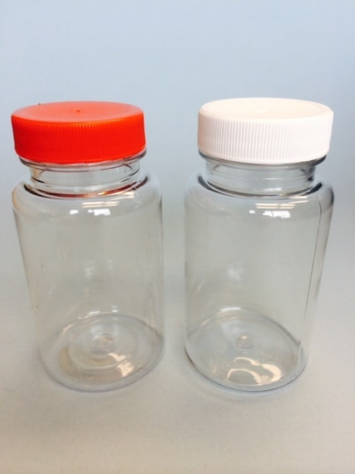

- Identify the apparatus. (1mk)

- State why it is advisable to have the apparatus illustrated above made of glass. (2mks)

- State the use of the following. (3mks)
  - Pair of forceps. -
  - Bait in a bait trap –
  - Chloroform –

- How do the following characteristics differ in plants and animals? (4mrks)
Characteristic | Plants | Animals
Nutrition.

Movement and locomotion
Excretion
Growth

- In an experiment to investigate an aspect of digestion, two test tubes A and B were set up as shown in the diagram below
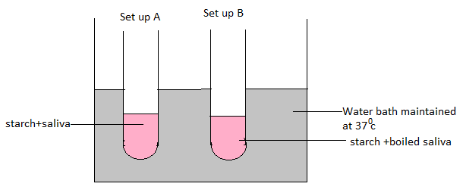
The test tubes were left in the water bath for 30 minutes. The content of each test tube was then tested for starch using iodine solution.
(a)What was the aim of the experiment? (1mk)

(b) What results were expected in test tubes A and B. (2mks)
A-
B-

( c) Why was the set-up maintained at 37⁰C. (1mk)

- a) What is the role of cristae in respiration? (1mk)

- Give an equation to show that respiration involves oxidation of a food stuff (1mk)

- Name the end products of Kreb’s cycle (2mks)

- The diagram below represents a vertical section through a mammalian skin.
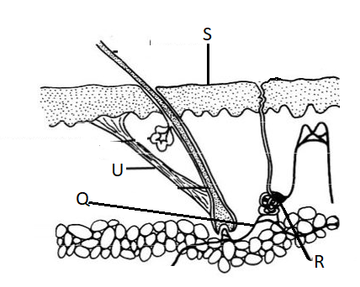
(a) What is the function of S. (1mk)
S –
(b) State the physiological changes that would occur in the following structures if the environmental temperature was raised gradually from 22$℃$ to 40$℃$. (2mks)
R -
Q-
7.a) state three external features found in the class mammalia only. (3 marks)

b) Give two differences between class Chilopoda and Diplopoda in relation to their genital aperture and division of the body. (2 marks)
Chilopoda | Diplopoda

8.Lenticels are sites of gaseous exchange in woody stems. Explain why there is no intake of carbon (IV) oxide occurring through them. (2mks)

9.State the name given to the study of :
- The cell. (1mk)

- Chemical reactions in living organisms. (1mk)

10.(a) Explain why the palisade layer in leaves of green plants is considered to be a tissue. (1mk)

(b)Name the tissue that:
(i) Transports oxygen in mammals. (1mk)

(ii) Facilitates gaseous exchange in leaves. (1mk)

11.State the roles of the following organisms in the nitrogen cycle.
- Rhizobium sp (1mk)

- Nitrobacter sp (1mk)

- Thiobacillus denitrificans. (1mk)

12.The diagram below represents a female cone.
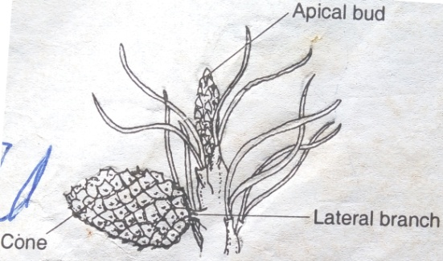

a) Name the subdivision of the plant from which the cone was obtained (1 mark)

b) Other than the presence of cones, name two other external features that identify plants in the sub-division named in (a) above. (2 marks)

13. An experiment was set up as shown in the diagram below. The set up was left for 30 minutes
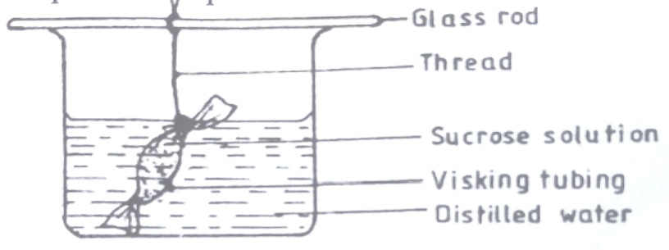
a) State the expected results after 30 minutes. (1 marks)

b) Explain your answer in (a) above. (2 marks)

14.A particular food substance is suspected to contain vitamin C.
a) What chemical would you use to confirm presence of the above named vitamin (1mk)

b) What are the expected results if vitamin C is present (1mk)

c) Give one role of vitamin C in the human body (1mk)

15.What is the effect of contraction of diaphragm muscles during breathing in mammals?(3mks)

16.a) Explain three adaptations of leaves that maximizes efficiency in trapping sunlight for photosynthesis. (3marks)

17.(a) Explain the role of oxygen in Active transport (1mk)

(b)Name two processes that depend on Active transport in animals (2mks)

18.Name the phylum whose members possess notochord (1mk)

19.The diagram below represents a transverse section through a plant organ.

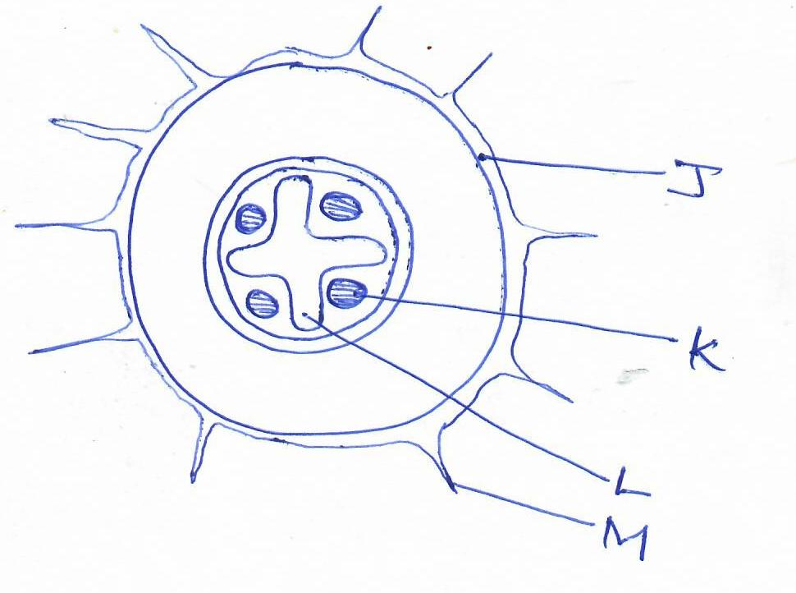
- Name the class of plants form which the section was taken. (1mk)

(b)(i) From which plant organ was the section obtained. (1mk)

(ii) Give two reasons for your answer in (a)(i) above. (2mks)

(c)Name the parts labelled K,. (1mks)

d) State the function of the part labelled M. (1mks)

e) Another section was taken through a young monocotyledonous stem. In the space below draw a diagram showing how tissues are distributed across the section. (3mks)

20.The diagram below represents a food web in a certain ecosystem
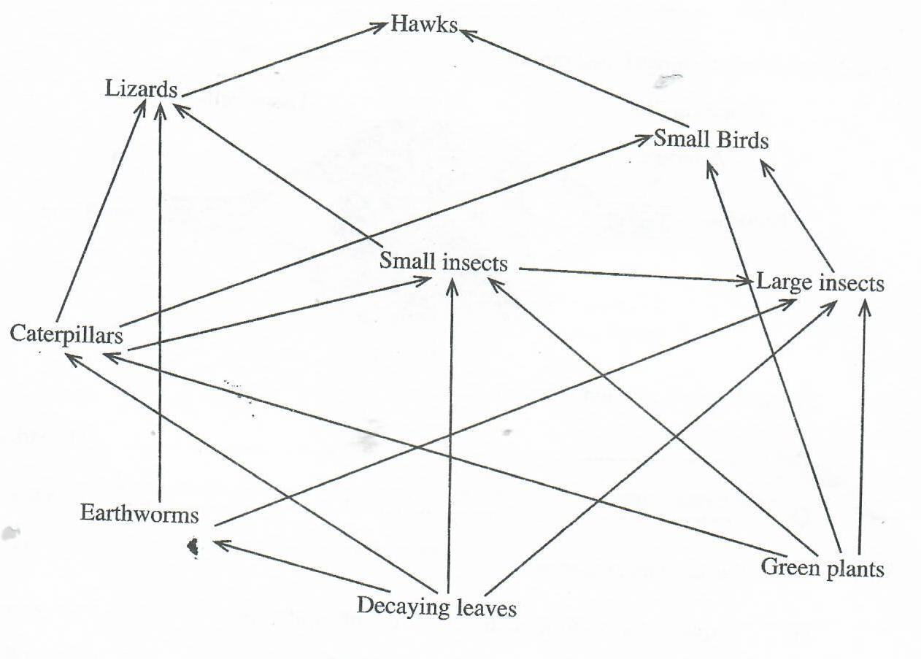

- Name the trophic level occupied by each of the following:
- Caterpillars. (1mk)

- Small insects. (1mk)

- From the food web, construct two food chains which end with lizards as a tertiary consumer. (2mks)

- (i) Which organisms have the least biomass in this ecosystem. (1mk)

(ii)Explain the answer in (c)(i) above. (3mks)

21.The graph below shows the effect of substrate concentration on the rate of enzyme reaction.

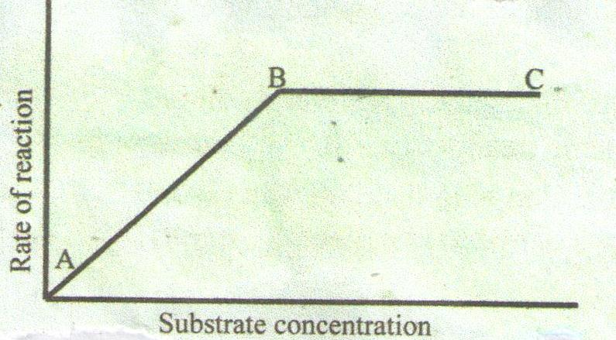

a) Account for the shape of the graph between
A and B (2 marks)

B and C (2 marks)

b) How can the rate of reaction be increased after point B (1 mark)

c) State two other factors that affect the rate of enzyme reaction (2 marks)

d) Name one appropriate food substance for this enzyme if it was ptyalin. (1 mark)

22(a). State characteristics of gaseous exchange surface. (4mrks)
b) Describe how gaseous exchange occurs in terrestrial plants. (16 marks)

