MARKING SCHEME
NAME…………………………………………………. …….. ADMISSION NO……………….
CLASS………………………
DATE…………………………..

231/1
BIOLOGY (Theory)
MARCH/APRIL 2024
2$\frac{1}{2}$ Hours
KENYA CERTIFICATE OF SECONDARY EDUCATION
FORM THREE THEORY BIOLOGY
Instructions to Candidates
- Write your Name and admission Number in the Spaces Provided.
- Sign and write date of examination in the spaces provided.
- This paper consists of ONE section .
- Answer all the questions in the spaces provided.
- You should check the question paper to ascertain that all the pages are printed as indicated and that no questions are missing.

Answer all the questions in the spaces provided.

- The diagram below represents an apparatus used to collect specimens for study.
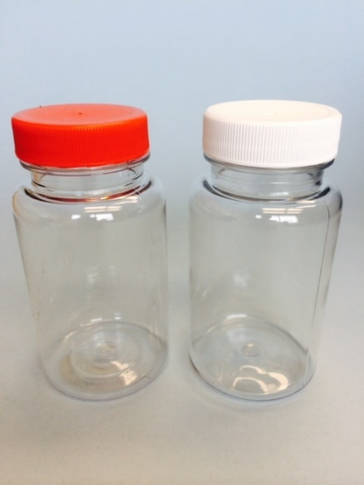

- Identify the apparatus. (1mk)
Specimen bottles;

- State why it is advisable to have the apparatus illustrated above made of glass. (2mks)
For visibility; and easier cleaning;
- State the use of the following. (3mks)
  - Pair of forceps. - Hold stinging/biting/poisonous specimens.
  - Bait in a bait trap – Attract small animals on the trap.
  - Chloroform – Immobilize mobile animals during specimen collection/observation.

- How do the following characteristics differ in plants and animals? (4mrks)
Characteristic | Plants | Animals
Nutrition. | Have autotrophic nutrition/ make their own food; | Heterotrophic nutrition/ feed on already made food;
Movement and locomotion | Move some parts of its body;/lack locomotion; | Move from one place to another;/ have locomotion;
Excretion | Lack complex excretory organs | Have complex excretory organs;
Growth | Growth occur at localized places | Growth occurs all over the body;

- In an experiment to investigate an aspect of digestion, two test tubes A and B were set up as shown in the diagram below
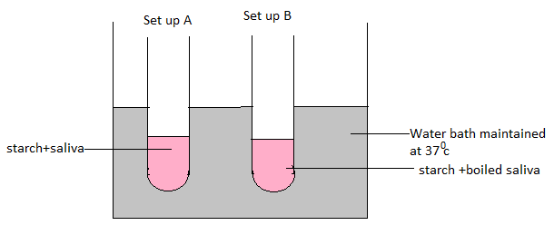
The test tubes were left in the water bath for 30 minutes. The content of each test tube was then tested for starch using iodine solution.
(a)What was the aim of the experiment? (1mk)
Effect of temperature on enzyme activity;
(b) What results were expected in test tubes A and B (2mks)
A- brown colour of iodine solution remains / iodine solution remains
brown;
B-Blue black/black colour;

( c) Why was the set-up maintained at 37⁰C. (1mk)
Provide optimum temperature for enzymatic action;

- a) What is the role of cristae in respiration? (1mk)
It increases the surface area for attachment of respiratory enzymes;
- Give an equation to show that respiration involves oxidation of a food stuff (1mk)
Glucose + Oxygen Carbon (IV) oxide + Water + Energy
C₆H₁₂O₆ + 6O₂ 6CO₂ +6H₂O + 2880Kj; must be balanced;
- Name the end products of Kreb’s cycle (2mks)
Carbon (IV) oxide; water; energy (ATP)
- The diagram below represents a vertical section through a mammalian skin.
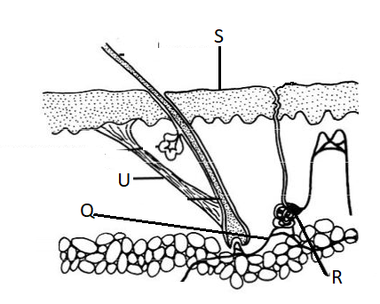
(a) What is the function of S. (1mk)
S – Protection against mechanical injury/bacteria/fungal infection;
(b) State the physiological changes that would occur in the following structures if the environmental temperature was raised gradually from 22$℃$ to 40$℃$. (2mks)
R - Will produce more sweat;
Q- Will dilate for more blood to flow near the skin surface;
7.a) state three external features found in the class mammalia only. (3 marks)
presence of mammary glands
Body covered with fur/hair
Have external ear/pinna
b) Give two difference between class Chilopoda and Diplopoda in relation to their genital aperture and division of the body. (2 marks)
chilopoda | Diplopoda
Body divided into head, thorax and trunk | Body divided into head and trunk
Anterior genital aperture | Posterior genital aperture

8.Lenticels are sites of gaseous exchange in woody stems. Explain why there is no intake of carbon (IV) oxide occurring through them. (2mks)

Cells beneath lenticels do not carry out photosynthesis; They only take in oxygen for respiration and give out carbon (IV) oxide;

9.State the name given to the study of :
- the cell. (1mk)
cytology; cell biology.

- chemical reactions in living organisms. (1mk)
Biochemistry

10.(a) Explain why the palisade layer in leaves of green plants is considered to be a tissue.
(1mk)
It is made of a group of similar cells performing the same function;

(b)Name the tissue that:
(i) Transports oxygen in mammals. (1mk)
Blood;

(ii) Facilitates gaseous exchange in leaves. (1mk)
spongy mesophyll;

11.State the roles of the following organisms in the nitrogen cycle.
- Rhizobium sp (1mk)
Converts free nitrogen into nitrates/Nitrogen fixation;

- Nitrobacter sp (1mk)
Converts nitrites to nitrates

- Thiobacillus denitrificans. (1mk)
Converts nitrates into free nitrogen/denitrification;

12.The diagram below represents a female cone.
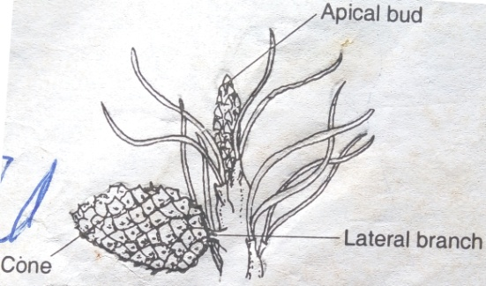

a) Name the subdivision of the plant from which the cone was obtained (1 mark)
gymnospermae / gymnaspermatophyta
b) Other than the presence of cones, name two other external features that identify plants in the sub-division named in (a) above. (2 marks)
needle-like leaves
Thick waxy cuticle
Named seeds, sunken stomata

13. An experiment was set up as shown in the diagram below. The set up was left for 30 minutes
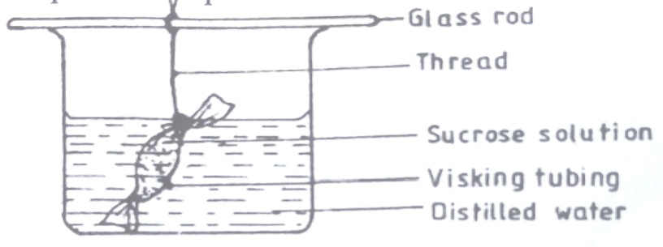
a) State the expected results after 30 minutes. (1 marks)
the visking tubing was fully filled with the solution/The level of water in the beaker decreased;
b) Explain your answer in (a) above. (2 marks)
sucrose solution in visking tubing has higher osmotic pressure creating concentration gradient; water molecules moved from distilled water to the visking tubing by osmosis

14.A particular food substance is suspected to contain vitamin C.
a)What chemical would you use to confirm presence of the above named vitamin (1mk)
DCPIP/dichlorophenol idolphenol
b)What are the expected results if vitamin C is present (1mk)
DCPIP is decolourised; rej discolourized
c) Give one role of vitamin C in the human body (1mk)
– Boosts body immunity;
- Prevents bleeding of gums; (mark 1st one)
- Acts as antioxidant;

15.What is the effect of contraction of diaphragm muscles during breathing in mammals?(3mks)
Diaphragm flattens; increasing volume of chest cavity/thoracic cavity; while pressure decreases; rej. Pressure decrease in the lungs.

16.a) Explain three adaptations of leaves that maximizes efficiency in trapping sunlight for photosynthesis. (3marks)
Broad flat lamina which provides a large surface area for the absorption of C$O_{2}$ and sunlight. Thinness of the leaf shortens the distance to be covered during the diffusion of $co_{2}$ and penetration light to reach photosynthetic cells.
Cuticle and epidermis are transparent to allow penetration of light to the palisade cells.
Palisade cells contain large number of chloroplasts and their arrangement and location next to the upper epidermis enable them receive maximum sunlight. First three (3mks)

17.(a) Explain the role of oxygen in Active transport (1mk)
Oxidize food to produce energy required in active transport rej to produce energy

(b)Name two processes that depend on Active transport in animals (2mks)
Reabsorption of sugar and some salts by kidney;
Absorption of digested food from alimentary canal;
Excretion of waste products from body cell;
Transmission of nerve impulse.

18.Name the phylum whose members possess notochord (1mk)
Chordata
19.The diagram below represents a transverse section through a plant organ.

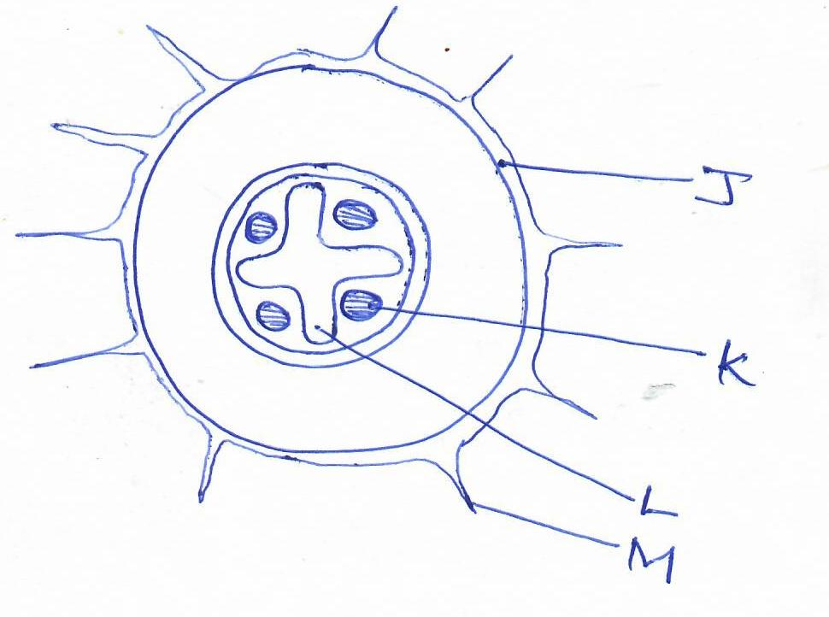
- Name the class of plants form which the section was taken. (1mk)
Dicotyledonae:

(b)(i) From which plant organ was the section obtained. (1mk)
Root;

(ii) Give two reasons for your answer in (a)(i) above. (2mks)
Presence of root hairs/structure M;
Xylem is star-shaped at the centre;
Presence of endodermis;

(c)Name the parts labelled K,. (1mks)

Phloem;
d) State the function of the part labelled M. (1mks)
Absorption of water; Rj. transport
Absorption of mineral salts;

e) Another section was taken through a young monocotyledonous stem. In the space below draw a diagram showing how tissues are distributed across the section.(3mks)
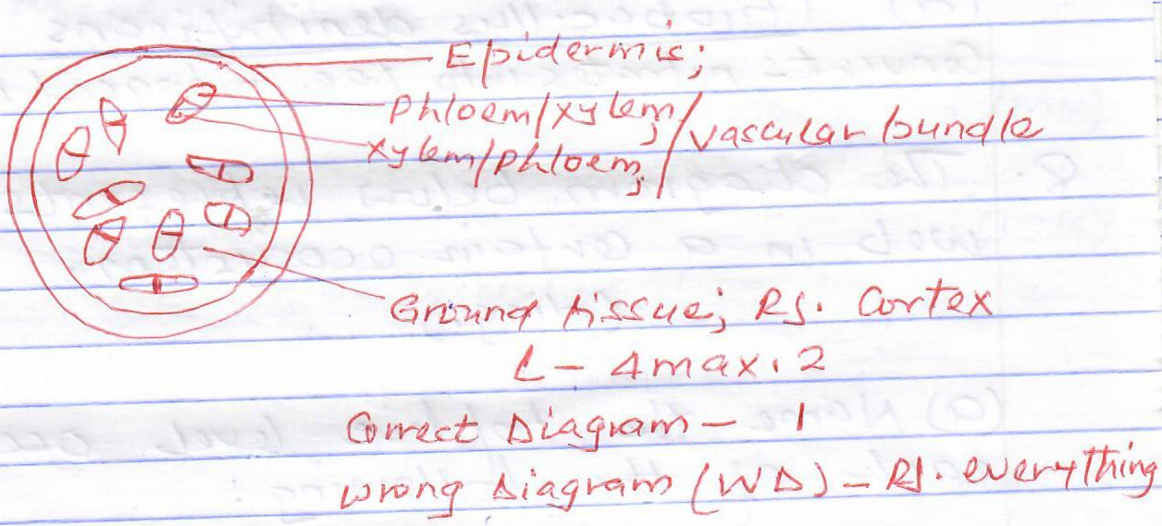

20.The diagram below represents a food web in a certain ecosystem
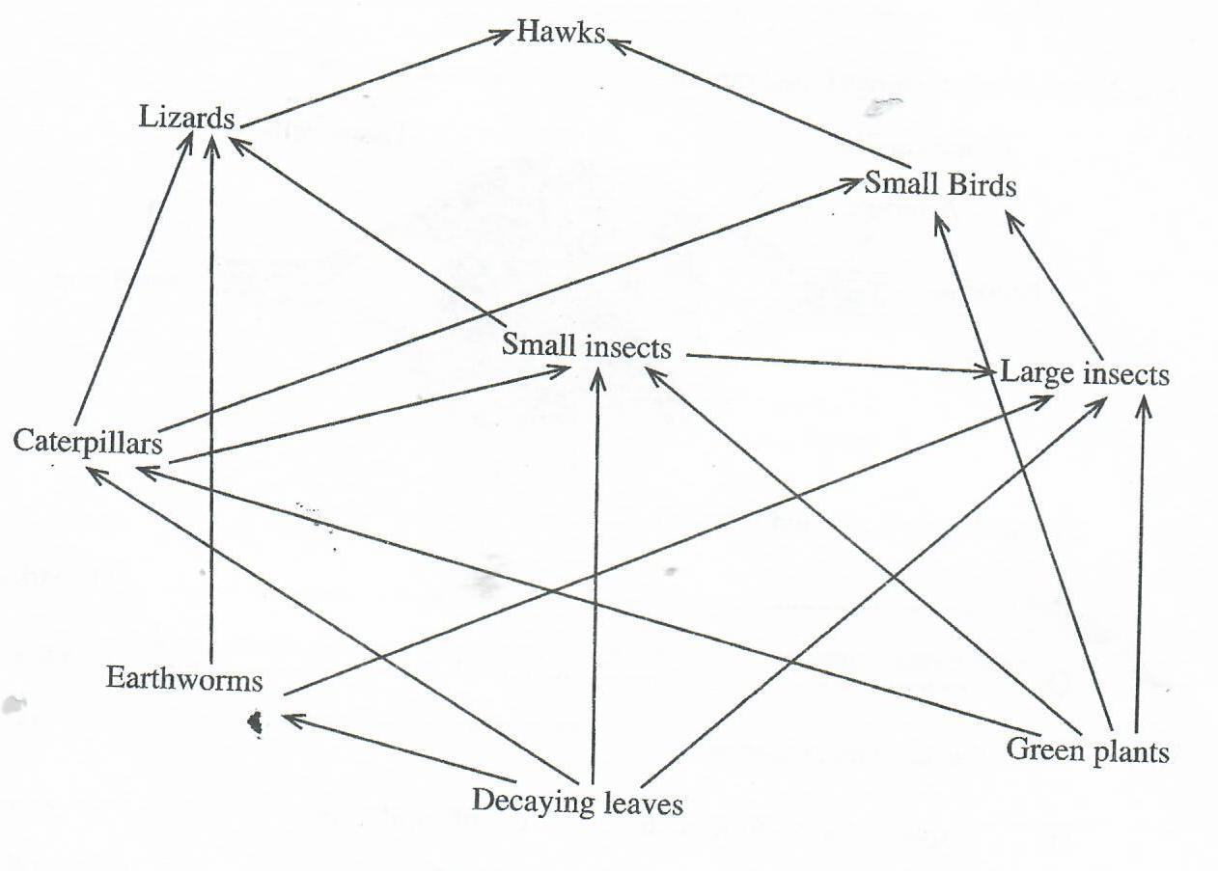

- Name the trophic level occupied by each of the following:
- Caterpillars. (1mk)
Primary consumers;

- Small insects. (1mk)
Primary consumers/secondary consumers;

- From the food web, construct two food chains which end with lizards as a tertiary consumer. (2mks)
Decaying leaves Caterpillars Small insects Lizards;

Green plants Caterpillars small insects Lizards;
- (i) Which organisms have the least biomass in this ecosystem. (1mk)
Hawk;
(ii)Explain the answer in (c)(i) above. (3mks)
Occupies the highest trophic level; hence less energy is available to them; since most of it is lost during respirational/excretion/defication/death;(of organisms in lower trophic levels)
21.The graph below shows the effect of substrate concentration on the rate of enzyme reaction.

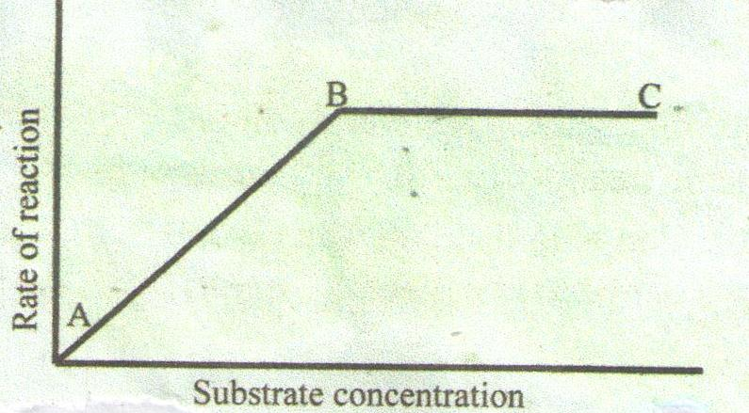

a) Account for the shape of the graph between
A and B (2 marks)
A and B - Between A and B fast increase in the rate of reaction, more active sites of enzymes available

B and C (2 marks)
B and C - Enzymes and substrate are in equilibrium because all active sites of enzymes are occupied, hence rate of reaction is constant
b) How can the rate of reaction be increased after point B (1 mark)
Increasing concentration of enzymes
c) State two other factors that affect the rate of enzyme reaction (2 marks)
pH, optimum temperature, presence of inhibitors
Presence of cofactors and coenzymes
d) Name one appropriate food substance for this enzyme if it was ptyalin. (1 mark)
starch
22(a).State characteristics of gaseous exchange surface. (4mrks)
i) They are supplied with dense network of blood capillaries/ highly vascularised for transportation of gases /to maintain high diffusion gradient
ii) They are thin walled to facilitate easy diffusion of gases and also to reduce the distance covered by the diffusing gases.
iii) They are moist dissolve gas
iv) They have a large surface area for gaseous exchange
b)Describe how gaseous exchange occurs in terrestrial plants. (16 marks)
Gaseous exchange takes place in a spongy mesophyll; During the day air diffuses into large air spaces of spongy mesophyll; through stomata; the Carbon(IV) Oxide in the air diffuses into Photosynthetic cells; in solution form; during photosynthesis. Carbon (IV) Oxide is used while oxygen is produced. Oxygen diffuses out of the leaf; through stomata; During the night; air diffuses into the air spaces (of spongy mesophyll), the air dissolves into film of moisture; then oxygen diffuses into the cells; and is used in respiration during which carbon (IV) oxide is produced, the Carbon (iv) Oxide diffuses out of the leaf; through stomata; due to concentration/diffusion gradient; Gaseous exchange takes place through epidermis (of young leaves and stems); epidermis of the root carries out gaseous exchange with air in the soil; some plants have pneumatophores/breathing roots; in which gaseous exchange occurs through lenticels; (found in older stems)

