NAME…………………………………......………………ADM.NO…………....……CLASS……

BIOLOGY
FORM 2
END TERM 1 2024
TIME: 2 HRS 15 MINUTES
Instructions: Answer all question in the spaces provided.
- Suggest a biological tool that is most suitable for collecting each of the following organisms. (3mks)
- Scorpions.

- Safari ants on a tree

- Butterfly in a coffee farm

- State two precautions taken during collection of specimens (2mks)

- Identify the discipline of biology that deals with the following.
- The relationship between organisms and their environment. (1mk)

- Study of development of living organisms. (1mk)

- Study of body functions of living organisms. (1mk)

- Study of chemical changes in an organism. (1mk)

- Study of microscopic organisms. (1mk)

- Below is a simplified diagram of a bacteria. Study it and answer the questions.
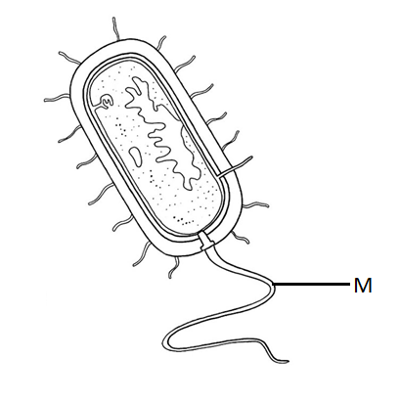
- Name the kingdom into which it belongs. (1mk)

- Name part labelled M and state its function. (2mks)
M-
Function –

- (a) How would you proof that a species of zebras in Tanzania belongs to the same species as a
similar looking zebra in Kenya. (1mk)

(b) State two principles of Binomial Nomenclature. (2mks)

c) What is meant by the term taxonomy? (1mk)

- State three properties of the cell membrane. (3mks)

- The following diagram shows onions cells captured in a field of view of a light microscope

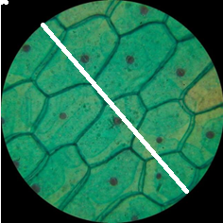

- Measure the length of the white line to determine the diameter of the field of view in millimeters (1mk)

- How many cells are found along the diameter represented by the white line? (1mk)

- Determine the actual diameter of one cell if a magnification of X1000 was used to observe the cells above (3mks)

- State a weakness of the process above of estimating cell size (1mk)

- A plant stem was put in a solution. After 30 minutes a cell from the stem looked like the one drawn below;
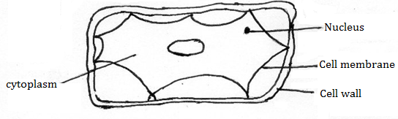
- State the type of solution the stem was put in. (1mk)

- What term is used to describe the cell (1mk)

- Explain what happened. (3mks)

- a) What is diffusion. (1mk)

b) How do the following factors affect the rate of diffusion?
i) Diffusion gradient. (1mk)

ii) Surface area volume ratio. (1mk)

iii) Temperature. (1mk)

- Outline three roles of active transport in the human body. (3mks)

- State two adaptation of leaves that maximize efficiency in trapping sunlight for photosynthesis.
(2mks)

- Below is a diagram of a cell organelle. Study it and answer the questions that follow.
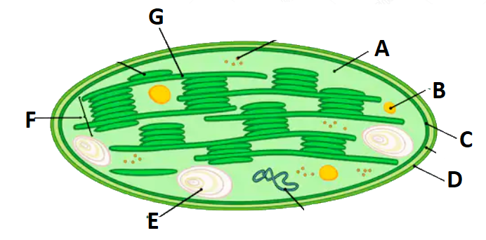
  - Identify the organelle. (1mk)

  - Name the part labelled A and C. (2mks)
A –
C –
  - State the letter that represent the part where light stage of photosynthesis occur. (1mk)

  - State two adaptations of the organelle to its function. (2mks)

  - What happens to the end products of light stage? (2mks)

- Name the carbohydrate that is
- Stored in animal cells (1mk)

- Makes up plant cell walls (1mk)

- Study the bio-chemical reactions given below.
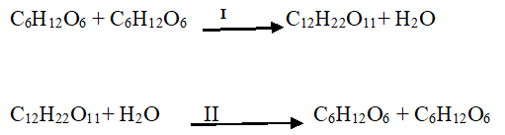
a) Identify the process marked I and II (2mks)
I –
II –

b) Explain how the process marked II can be carried out in a laboratory. (1mk)

- If glycerol is the same in all lipids, why is corn oil different from coconut oil. (1mk)

- State two functions of proteins. (2mks)

- (a) State two functions of bile juice in digestion of food. (2mks)

(b)Why is pepsin secreted in its inactive form? (1mk)

(c)Name one other enzyme that is also secreted in an in active form. (1mk)

- State two roles of hydrochloric acid produced by wall of human stomach. (2mks)

- State two functions of the large intestine in humans. (2mks)

- The diagram below is a transverse section of a certain part of a dicotyledonous plant.
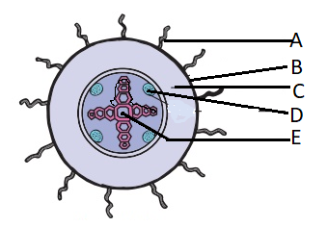

- Name the part labelled A, C and E. (3mks)
A –
C –
E –

- State the functions of the parts labeled B and D. (2mks)
B –
D –
- State three ways in which part A adapted to its function. (3mks)

- The diagram below shows the internal structure of a mammalian heart
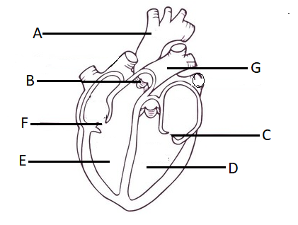
- Name the parts labeled. (3mks)
A –
B –
C -
- The muscular wall of chamber D is at least three times thicker than the wall of chamber E. Give a reason for this difference. (1mk)

- Name two special characteristics of heart muscles. (2mks)

- In what way does the artery labeled G differ from other arteries in the body (2mks)

- a) State and explain five factors that determine energy requirements in human beings. (10mks)

b) State and explain five environmental factors that increase the rate of transpiration. (10mks)

