NAME…………………………………......………………ADM. NO…………....……CLASS………

BIOLOGY
FORM 2
END TERM 1 2024
TIME: 2 HRS 15 MINUTES
MARKING SCHEME.
Instructions: Answer all question in the spaces provided.
- Suggest a biological tool that is most suitable for collecting each of the following organisms. (3mks)
- Scorpions.
Pair of forceps;

- Safari ants on a tree
Pooter;

- Butterfly in a coffee farm
Sweep net;

- State two precautions taken during collection of specimens (2mks)
      - Do not destroy the habitat of the organism;
      - Do not harm the organism;
      - For live specimens after study return to their habitats;

- Identify the discipline of biology that deals with the following.
- The relationship between organisms and their environment. (1mk)
Ecology;
- Study of development of living organisms. (1mk)
Embryology;
- Study of body functions of living organisms. (1mk)
Physiology;
- Study of chemical changes in an organism. (1mk)
Biochemistry;
- Study of microscopic organisms. (1mk)
Micro biology;
- Below is a simplified diagram of a bacteria. Study it and answer the questions.
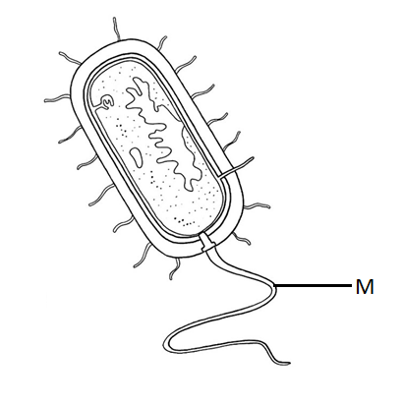
- Name the kingdom into which it belongs. (1mk)
Monera;
- Name part labelled M and state its function. (2mks)
M- Flagellum;
Function – movement;

- (a) How would you proof that a species of zebras in Tanzania belongs to the same species as a
similar looking zebra in Kenya. (1mk)
If they can interbreed to produce a fertile offspring;
(b) State two principles of Binomial Nomenclature. (2mks)
  - The generic name is first written followed by the specific name;
  - The first letter in the generic name must be a capital letter and the rest are small
letters;
  - The two parts of the name are underlined separately when typed or hand
written. In printed manuscripts should be in italics;
c) What is meant by the term taxonomy? (1mk)
It is the science of classification;
- State three properties of the cell membrane. (3mks)
  - Semipermeable;
  - Possess electric charges/ polarized;
  - Sensitive to changes in temperature and pH;

- The following diagram shows onions cells captured in a field of view of a light microscope

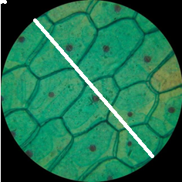

- Measure the length of the white line to determine the diameter of the field of view in millimeters (1mk)
Xmm;
- How many cells are found along the diameter represented by the white line? (1mk)
6 (cells);
- Determine the actual diameter of one cell if a magnification of X1000 was used to observe the cells above (3mks)

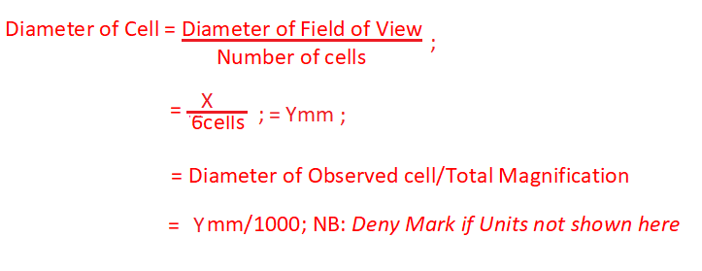

- State a weakness of the process above of estimating cell size (1mk)
Cells are not linearly/uniformly arranged along the diameter of field of vies; Cells are of different Size; Cells are of different Shapes;

- A plant stem was put in a solution. After 30 minutes a cell from the stem looked like the one drawn below;
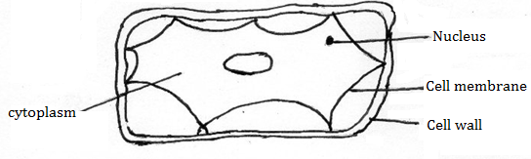
- State the type of solution the stem was put in. (1mk)
Hypertonic solution;
- What term is used to describe the cell (1mk)
Plasmolysed;
- Explain what happened. (3mks)
Water molecules moved out of the cell by osmosis; due to hypertonic solution; therefore, the cell membrane detached from the cell wall;

- a) What is diffusion. (1mk)
The movement of molecules from a region of high concentration to a region of low concentration; until the molecules are uniformly distributed in the medium)

b) How do the following factors affect the rate of diffusion?
i) Diffusion gradient. (1mk)
The higher diffusion gradient between (two points) the rate of diffusion; acc converse.
ii) Surface area volume ratio. (1mk)
The higher the surface area: Volume ratio, the faster is the rate of diffusion; acc converse
iii) Temperature. (1mk)
Increasing temperature increases the rate of diffusion; acc converse.

- Outline three roles of active transport in the human body. (3mks)
  - Reabsorption of useful material /glucose/ some salts into the kidney/ by kidney tubules; from the blood stream.
  - Absorption of some digested food/ from the alimentary canal;
  - Accept sodium pump mechanism in the nervous system, the nerve cell

- State two adaptation of leaves that maximize efficiency in trapping sunlight for photosynthesis.
(2mks)
- Flat and broad;
- Presence of transparent cuticle and epidermis;
- Thinness of the leaf;
- Arrangement of palisade layer beneath the upper epidermis;
- Numerous chloroplasts in the palisade layer; any 2
- Below is a diagram of a cell organelle. Study it and answer the questions that follow.
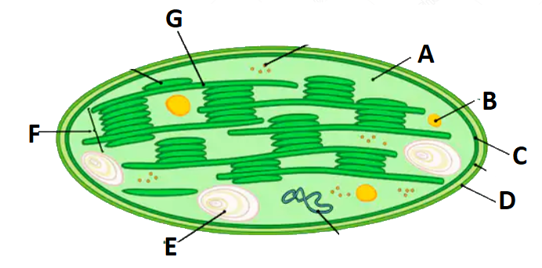
  - Identify the organelle. (1mk)
Chloroplast;
  - Name the part labelled A and C. (2mks)
A – Stroma;
C – Inner membrane;
  - State the letter that represent the part where light stage of photosynthesis occur. (1mk)
G;
  - State two adaptations of the organelle to its function. (2mks)
- It has lamellae/grana that contains chlorophyll that traps light energy;
- The grana have a large surface area for accommodation or packing of the chlorophyll.
- The stroma contains numerous enzymes that speed up/catalyze the process of photosynthesis; (any two)

  - What happens to the end products of light stage? (2mks)
- Hydrogen atoms enter the dark stage;
- Oxygen atoms are released to the atmosphere as a gas or used for respiration;

- Name the carbohydrate that is
- Stored in animal cells (1mk)
Glucose;
- Makes up plant cell walls (1mk)
Cellulose;
- Study the bio-chemical reactions given below.
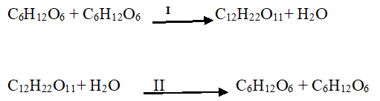
a) Identify the process marked I and II (2mks)
I – condensation;
II – Hydrolysis;

b) Explain how the process marked II can be carried out in a laboratory. (1mk)
Boiling (the solution) with a dilute acid;
- If glycerol is the same in all lipids, why is corn oil different from coconut oil. (1mk)
They have different fatty acids;
- State two functions of proteins. (2mks)
- They are components of structures in living organisms; (e.g. plasma/ cell membranes, connective tissue, hair, hooves, nails, muscle fibre, skeletal materials).
- They are used for making, repair and replacement of worn-out tissues in plants and animals;
- They act as metabolic regulators; (e.g. enzymes which speed up metabolic reactions, hormones which regulate body processes like growth, reproduction, antibodies that provide immunity against diseases)
- They are broken down to give energy during starvation;

- (a) State two functions of bile juice in digestion of food. (2mks)
  - Emulsification;
  - Neutralizes acidic chyme;
  - Provides alkaline conditions for digestive enzymes;
(b)Why is pepsin secreted in its inactive form? (1mk)
So that it doesn’t digest the cells that secrete it;
(c)Name one other enzyme that is also secreted in an in active form. (1mk)
Trypsin; Rennin;

- State two roles of hydrochloric acid produced by wall of human stomach. (2mks)
- Provide optimum pH/acidic medium for enzyme activity;
- Kill bacterial that may be present in food;
- Stimulate conversion of inactive pepsinogen to active pepsin;
- Unfold proteins molecules for action of pepsin (any two correct)
- State two functions of the large intestine in humans. (2mks)
- Absorption of water; accept absorption of salts / calcium / iron;
- Secretion of mucus;
- Synthesis of vitamin K

- The diagram below is a transverse section of a certain part of a dicotyledonous plant.
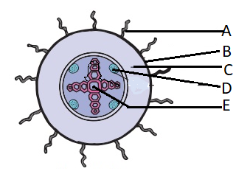

- Name the part labelled A, C and E. (3mks)
A – Root hair;
C – Cortex;
E – Xylem;

- State the functions of the parts labeled B and D. (2mks)
B – protect internal organs;
D – translocation of food;
- State three ways in which part A adapted to its function. (3mks)
- The walls are one cell thick to shorten diffusion distance of absorption of substances;
- They are numerous to increase surface area for absorption of water and mineral salts;
- They are elongated to provide a large surface area for absorption of water and mineral salts;

- The diagram below shows the internal structure of a mammalian heart
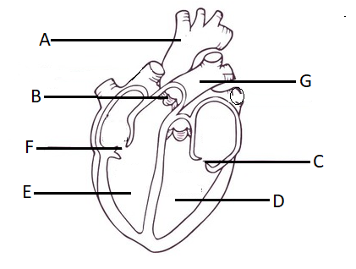
- Name the parts labeled. (3mks)
A – Aorta;
B – Semi lunar valve;
C - Bicuspid valve;
- The muscular wall of chamber D is at least three times thicker than the wall of chamber E. Give a reason for this difference. (1mk)
To generate high pressure required to pump blood to the furthest tissue;

- Name two special characteristics of heart muscles. (2mks)
    - Myogenic;
    - Contract and relax without fatigue;

- In what way does the artery labeled G differ from other arteries in the body (2mks)
- Carry deoxygenated blood;
- Have valves at the base;

- a) State and explain five factors that determine energy requirements in human beings. (10mks)
- Basal metabolism;
This is the minimum amount of energy required to maintain life when body is at rest;
- Sex;
Males require more energy than females because males are more masculine than female; Females have more fats males use more energy compared to females;
- Body size;
Small bodies people have a large surface area to volume ratio; hence their bodies lose a lot of heat to the surrounding; They therefore require more energy than big bodied people who have small surface area to volume ratio;
- Occupation/activity;
Manual workers require more energy than for example an office worker (any correct explanation by use of an example);
- Age;
Young children have many actively dividing cells and they are physically active; Therefore, their Basal metabolic rate is higher than that of adults;
(Max 10mks.)

b) State and explain five environmental factors that increase the rate of transpiration. (10mks)
- High Temperature;
High temperature increases the internal temperature of the leaf; which in turn increases kinetic energy of water molecules which increases evaporation; increasing the rate of transpiration;
High temperatures dry the air around the leaf surface maintaining a high concentration gradient. More water vapour is therefore lost from the leaf to the air;

- Low Humidity;
When humidity is low, (in dry atmosphere) the saturation deficit is high and hence transpiration rate is high;

- Wind;
Wind carries away water vapour as fast as it diffuses out of the leaves. This prevents the air around the leaves from becoming saturated with vapour. On a windy day, therefore the rate of transpiration is high.

- High Light intensity;
When light intensity is high; more stomata open and open fully hence high rate of transpiration;

- Lower Atmospheric Pressure.
When the atmospheric pressure is low, the force acting on the leaf surface is low hence increasing the rate of transpiration

